Table S1: Cumulative survival of COVID-19 patients according to their viral load

Type of viral load | Time  (day) | no. at risk | no. of event | Cumulative survival¹ | Cumulative mortality  (1- survival) | 95%CI
High load  N=208 | 0 | 208 | 0 | 1.000 | 0.00 | (1.00-1.00)
High load  N=208 | 5 | 208 | 1 | 0.995 | 0.005 | (0.986- 1.00)
High load  N=208 | 10 | 197 | 13 | 0.933 | 0.067 | (0.899-0.967)
High load  N=208 | 15 | 163 | 33 | 0.773 | 0.227 | (0.717-0.832)
High load  N=208 | 20 | 136 | 20 | 0.671 | 0.329 | (0.610- 0.739)
High load  N=208 | 25 | 92 | 8 | 0.628 | 0.372 | (0.564 -0.699)
High load  N=208 | 30 | 62 | 0 | 0.628 | 0.372 | (0.564-0.699)
High load  N=208 | 35-40 | 16 | 0 | 0.628 | 0.372 | (0.564-0.699)
Moderate load  N=222 | 0 | 222 | 0 | 1.000 | 0.00 | (1.00-1.00)
Moderate load  N=222 | 5 | 222 | 0 | 1.000 | 0.00 | (1.00-1.00)
Moderate load  N=222 | 10 | 218 | 5 | 0.977 | 0.023 | (0.958 -0.997)
Moderate load  N=222 | 15 | 171 | 18 | 0.890 | 0.110 | (0.848-0.933)
Moderate load  N=222 | 20 | 128 | 5 | 0.859 | 0.141 | (0.811-0.909)
Moderate load  N=222 | 25 | 48 | 0 | 0.859 | 0.141 | (0.811-0.909)
Moderate load  N=222 | 30 | 18 | 0 | 0.859 | 0.141 | (0.811-0.909)
Moderate load  N=222 | 35 | 1 | 0 | 0.859 | 0.141 | (0.811-0.909)
Low load  N=89 | 0 | 89 | 0 | 1.000 | 0.00 | (1.00-1.00)
Low load  N=89 | 5 | 89 | 0 | 1.000 | 0.00 | (1.00-1.00)
Low load  N=89 | 10 | 88 | 1 | 0.989 | 0.011 | (0.967-1.00)
Low load  N=89 | 15 | 44 | 0 | 0.989 | 0.011 | (0.967-1.00)
Low load  N=89 | 20 | 8 | 2 | 0.880 | 0.120 | (0.743-1.00)
Low load  N=89 | 25 | 2 | 0 | 0.880 | 0.120 | (0.743-1.00)
¹ Cumulative survival is calculated as the proportion surviving on this day/ cumulative survival over the previous period.

Table S2: Cumulative survival among COVID-19 patients according to location of isolation: wards, intermediate-care, and ICU

Location of admission | Time  (days) | no. at risk | no. of events | Cumulative survival | Cumulative mortality  (1- survival) | 95%CI
Ward  N=319 | 0 | 319 | 0 | 1.000 | 0 | (1.00 -1.00)
Ward  N=319 | 5 | 319 | 0 | 1.000 | 0 | (1.00 -1.00)
Ward  N=319 | 10 | 318 | 1 | 0.997 | 0.003 | (0.991-1.00)
Ward  N=319 | 15 | 240 | 3 | 0.986 | 0.014 | (0.972-1.00)
Ward  N=319 | 20 | 166 | 3 | 0.970 | 0.030 | (0.949-0.993)
Ward  N=319 | 25 | 83 | 1 | 0.963 | 0.037 | (0.938-0.990)
Ward  N=319 | 30 | 197 | 0 | 0.963 | 0.037 | (0.938-0.990)
Ward  N=319 | 35 | 193 | 0 | 0.963 | 0.037 | (0.938-0.990)
Intermediate- care  N=76 | 0 | 76 | 0 | 1.000 | 0 | (1.00 -1.00)
Intermediate- care  N=76 | 5 | 76 | 0 | 1.000 | 0 | (1.00 -1.00)
Intermediate- care  N=76 | 10 | 75 | 4 | 0.947 | 0.053 | (0.898-0.999)
Intermediate- care  N=76 | 15 | 58 | 14 | 0.760 | 0.240 | (0.669-0.863)
Intermediate- care  N=76 | 20 | 48 | 8 | 0.648 | 0.352 | (0.548-0.767)
Intermediate- care  N=76 | 25 | 28 | 1 | 0.634 | 0.366 | (0.532-0.754)
Intermediate- care  N=76 | 30 | 14 | 0 | 0.634 | 0.366 | (0.532-0.754)
Intermediate- care  N=76 | 35 | 2 | 0 | 0.634 | 0.366 | (0.532-0.754)
ICU  N=124 | 0 | 124 | 0 | 1.00 | 0 | (1.00 -1.00)
ICU  N=124 | 5 | 124 | 1 | 0.992 | 0.008 | (0.976-1.000)
ICU  N=124 | 10 | 110 | 14 | 0.879 | 0.121 | (0.823-0.938)
ICU  N=124 | 15 | 80 | 34 | 0.602 | 0.398 | (0.522-0.695)
ICU  N=124 | 20 | 58 | 16 | 0.468 | 0.532 | (0.387-0.566)
ICU  N=124 | 25 | 31 | 6 | 0.411 | 0.589 | (0.331-0.510)
ICU  N=124 | 30 | 15 | 0 | 0.411 | 0.589 | (0.331-0.510)
ICU  N=124 | 35 | 2 | 0 | 0.411 | 0.589 | (0.331-0.510)
¹ Cumulative survival is calculated as the proportion surviving on this day! cumulative survival over the previous period.

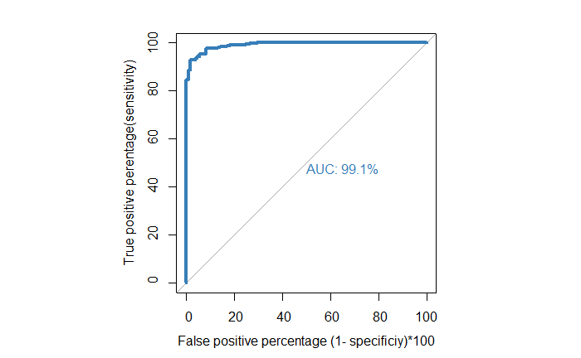
Figure S1: Receiver Operating Characteristic (ROC) curve to evaluate the discriminative ability of potentially significant predictors

