Supplemental Information (SI)

Development and Evaluation of Deuterated [¹⁸F]JHU94620 Isotopologues for the Non-invasive Assessment of the Cannabinoid Type 2 Receptor in Brain

Authors:
Daniel Gündel ^{a, *}, Mudasir Maqbool ^{b}, Rodrigo Teodoro ^{a, c}, Friedrich-Alexander Ludwig ª, Anne Heerklotz ª, Magali Toussaint ª, Winnie Deuther-Conrad ª, Guy Bormans ^{d}, Peter Brust ^{a, e}, Klaus Kopka ^{a, f}, Rareş-Petru Moldovan ^{a, *}

Affiliations:
ª Helmholtz-Zentrum Dresden-Rossendorf, Institute of Radiopharmaceutical Cancer Research Department of Neuroradiopharmaceuticals, 04318 Leipzig/01328 Dresden, Germany;
^{b} Molecular Imaging Branch, National Institute of Mental Health, National Institutes of Health, 10 Center Drive, Bldg. 10, Rm B1D43, Bethesda, MD, 20892-1026, USA
^{c} Life Molecular Imaging GmbH, 13353 Berlin, Germany
^{d} Radiopharmaceutical Research, Department of Pharmaceutical and Pharmacological Sciences, KU Leuven, BE-3000 Leuven, Belgium
^{e} The Lübeck Institute of Experimental Dermatology, University Medical Center Schleswig-Holstein, 23562 Lübeck, Germany
^{f} Faculty of Chemistry and Food Chemistry, School of Science, TU Dresden, 01069 Dresden, Germany

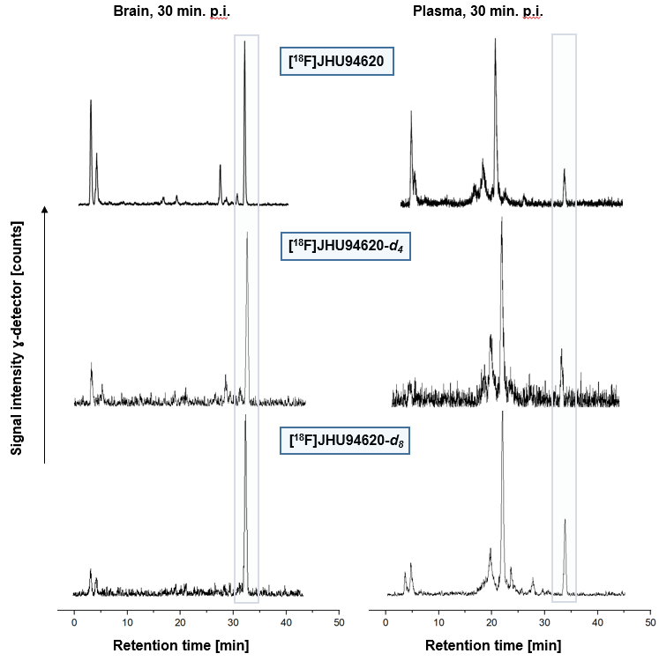
Figure S1: In vivo metabolism. Representative radio-HPLC chromatograms (method A) of tissue and organ samples of female CD-1 mice obtained at 30 min p.i. [extraction with MeOH/H₂O (9:1); extraction yield: >94%].

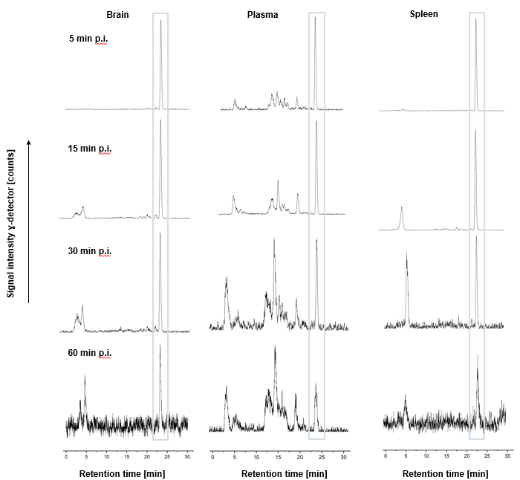
Figure S2: In vivo metabolism. Representative radio-HPLC chromatograms (method B) of tissue and organ samples of rats obtained at 5, 15, 30 and 60 min p.i. [extraction with MeOH/H₂O (9:1); extraction yield: >94%].

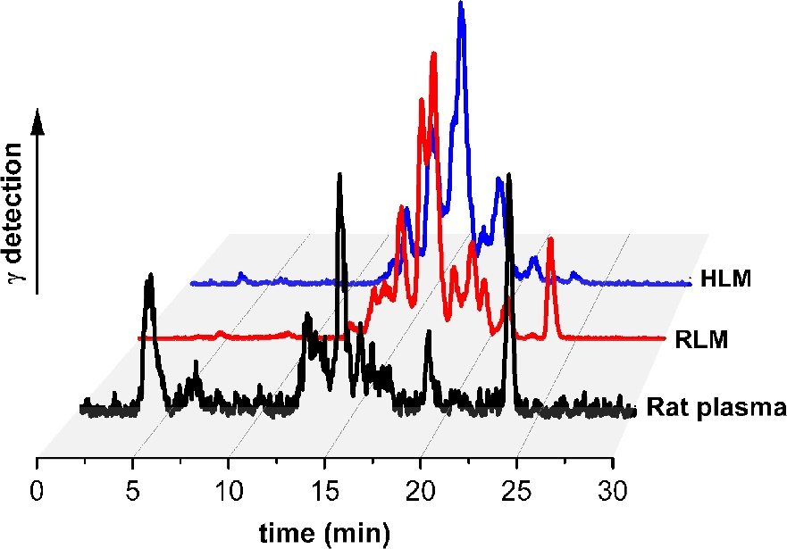
Figure S3: Comparison of in vivo and in vitro radiometabolite patterns of [¹⁸F]JHU94620-d₈ (t_{R}= 23.2 min). Representative radio-HPLC chromatograms (method B) of samples from rat plasma (60 min p.i.), as well as from rat (RLM) and human (HLM) liver microsomes after incubation in presence of NADPH, for 60 min each.
Figure S4: Plasma-brain radiometabolite plot. Linear regression analysis of radiometabolite distribution between blood plasma and brain (r² = 0.77).

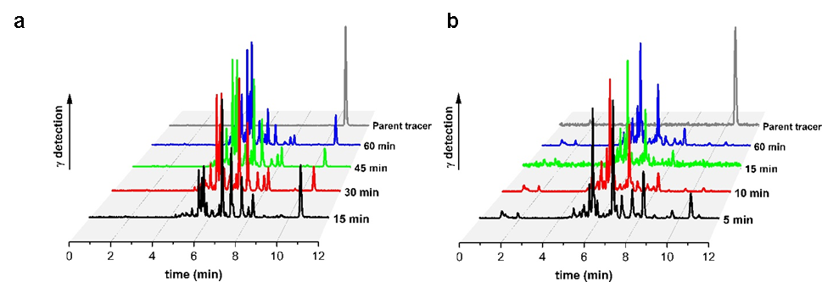

Figure S5: Comparison of the radiometabolite patterns detected for metabolic depletion of [¹⁸F]JHU94620-d₈ in vitro. Representative radio-HPLC (method C) chromatograms of samples from RLM (a) and HLM (b) at different time points.

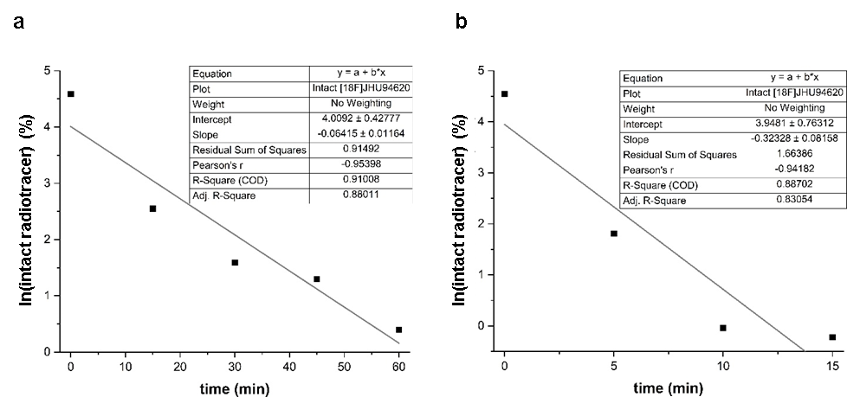

Figure S6: Graphical analysis of time-dependent depletion of [¹⁸F]JHU94620-d₈ in vitro and linear regression for calculation of in vitro half-life (t_{1/2}) for RLM (a) and HLM (b) using the following equations: ln(intact radiotracer in %) = ln100 – slope × t, and t_{1/2} = ln2 / slope.

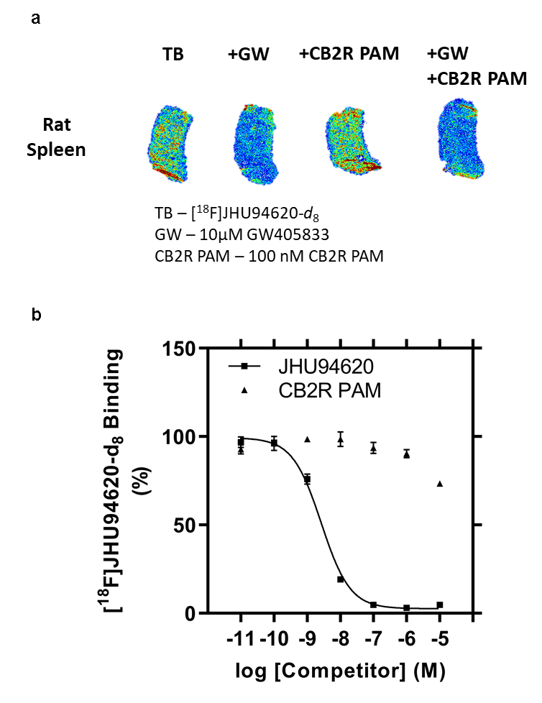
Figure S7: Effect of the CB2R positive allosteric modulator (CB2R PAM) on the in vitro binding of [¹⁸F]JHU94620-d₈ to rat and human CB2R. (a) Representative autoradiographic images of rat spleen cryosections (10 µm) showing total radiotracer binding without co-incubation of competitor (TB), with 100 nM CB2R PAM and/or 10 µM GW405833 (GW) under the same conditions, (b) homologous competition (JHU94620) or CB2R PAM binding assay with cell membrane isolates of CHO(hCB2R) (n = 3).

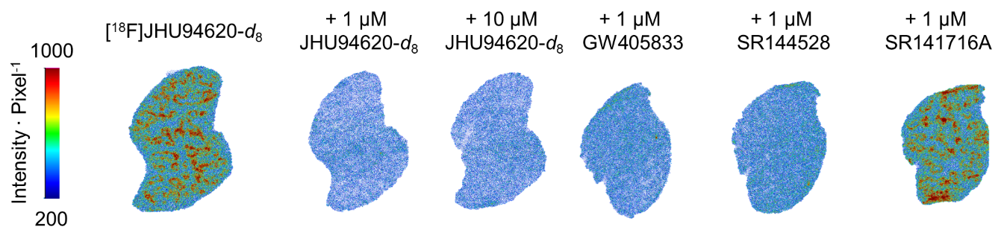
Figure S8: Exemplary autoradiography images of rat spleen cryosections (10µm) using [¹⁸F]JHU94620-d₈ co-incubated with the reference compound (JHU94620-d₈), the partial CB2R agonist GW405933, CB2R antagonist SR124528 or the CB1R antagonist SR141716A at given concentrations.

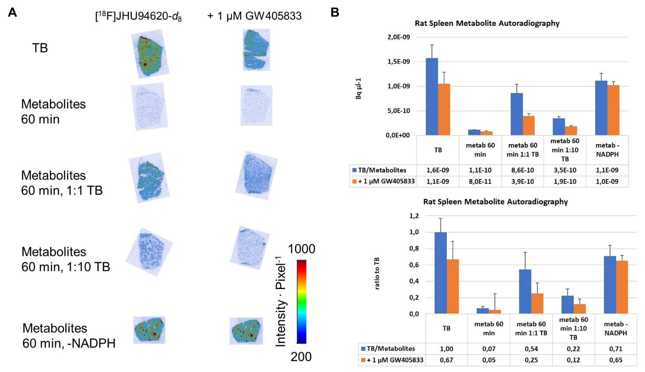
Figure S9: CB2R specific binding of [¹⁸F]JHU94620-d₈ and radiometabolites of the radioligand derived after a 60 min incubation with human liver microsomes to rat spleen cryosections (10 µm). 200 kBq mL⁻¹ was use of the radioligand alone (TB), only radiometabolites (Metabolites), a 1:1 or 1:10 mixture of TB and metabolites, as well as a metabolite assay negative control without using NADPH. (A) Exemplary autoradiography images and (B) spleen bound radioactivity concentrations in Bq mL⁻¹ or bound ratio compared to TB (n = 3, mean ± SD).

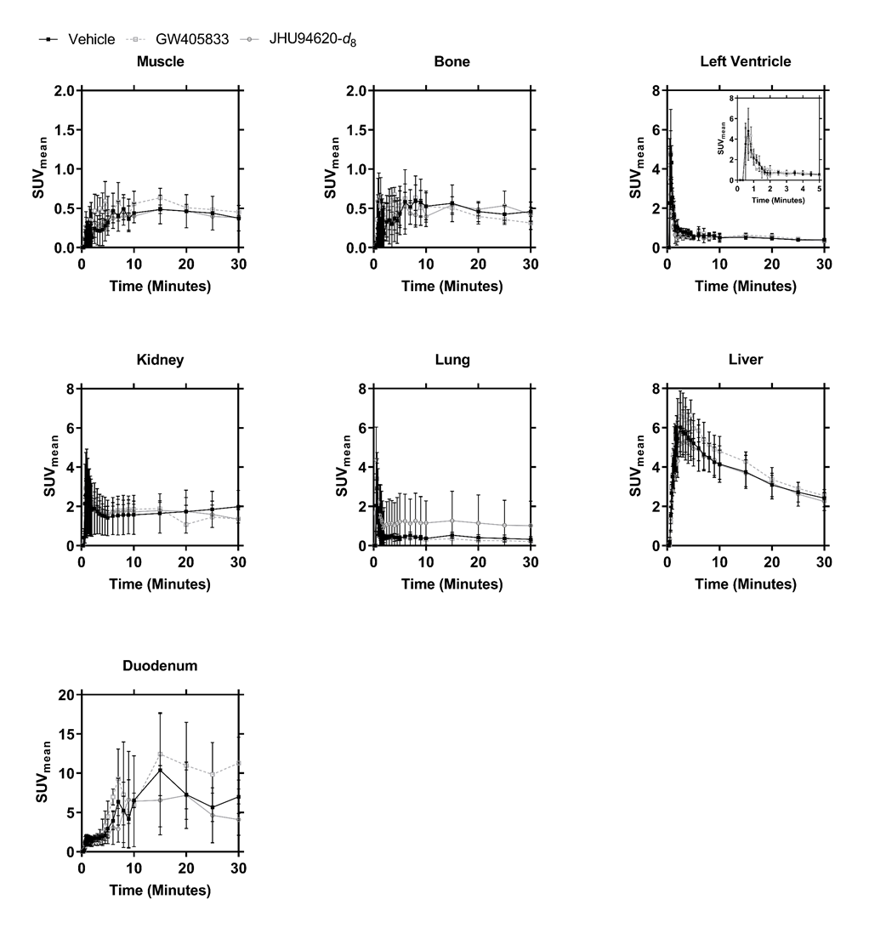
Figure S10: Biodistribution of [¹⁸F]JHU94620-d₈ in Wistar rats derived by 30 min small-animal PET acquisitions under baseline (Vehicle) or with pre-blocking with 1.5 mg kg⁻¹ bodyweight GW405833 or JHU94620-d₈. Time–activity curves (TACs) for tissue uptake are expressed as mean standard uptake values (SUV_{mean}), n = 3, mean ± SD.

Figure S11: Time activity curves of the contralateral side and the cerebellum, with GW405833 (5 mg/kg, n = 3) and without (Vehicle) administered at 20 min post injection of [¹⁸F]JHU94620-d₈ (n = 3; Mean ± SD).

Table S1. Non-compartmental (semiquantitative) analysis of TACs, obtained from the regions of local overexpression of the hCB2R(D80N) in the right striatum of rats, the contralateral region in the left striatum, and the cerebellum after i.v. injection of [¹⁸F]JHU94620-d₈ (n = 3).

TAC parameter | hCB2R(D80N) | Contralateral | Cerebellum | p-Value (Contralateral vs. Cerebellum)
Time-to-peak  (min) | 10 | 3.5 | 2.5 | 0.054
TAC peak value (SUV_{mean}) | 7.5 ± 1.5  (10 to 60 min) | 3.3 ± 0.5 | 2.8 ± 0.2 | 0.148
AUC  (SUV ∙ min) | 412 ± 90 | 74 ± 16 | 30 ± 4 | 0.218
SUVr_{60min} hCB2R(D80N)-to- |  | 10 ± 4 | 47 ± 4
Mean ± SD; p-value - one-sided Student’s t-test; TAC – Time-activity curve, AUC -Area under the curve 0 to 60 min p.i.,

Table S3. Uptake of [¹⁸F]JHU94620-d₈ into the hCB2R overexpressing right striatum normalized to the contralateral left striatum as well as cerebellum (SUV ratio, SUVr) with (n = 3) or without (vehicle, n = 3) administration of GW405833 (5mg/kg body weight, i.v.) at 20 minutes after radiotracer administration, expressed as area under the curve before (AUC_{0-20min}) and after (AUC_{20-60min}) injection of the interventional drug.

hCB2R D80N-to- | Treatment | AUC_{0-20min} (CI_{95%})  in SUVr ∙ min | AUC_{20-60min} (CI_{95%})  in SUVr ∙ min
Contralateral | Vehicle | 67 (44 to 90) | 291 (226 to 355)
Contralateral | Displacement | 90 (60 to 121) | 272 (233 to 311)  - 6.5%
Cerebellum | Vehicle | 153 (136 to 170) | 1128 (1058 to 1198)
Cerebellum | Displacement | 164 (150 to 178) | 435 (367 to 502)  - 61.4 %
Mean; 95% confidence interval (CI_{95%}).

