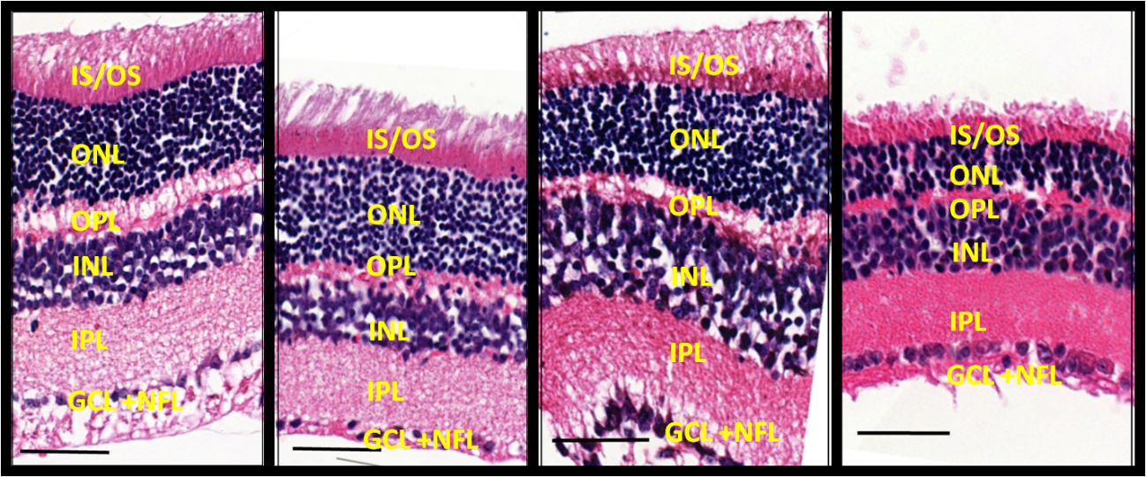
A
D
C
B
Supplementary File 3: Photomicrographs of histological cross sections of the mouse retina. (A) 60 days – control; (B) 360 days – control; (C) 60 days – Cannabis; (D) 360 days – Cannabis. GCL+NFL: Ganglion Cell Layer + Nerve Fiber Layer; IPL: Inner Plexiform Layer; INL: Inner Nuclear Layer; OPL: Outer Plexiform Layer; ONL: Outer Nuclear Layer; IS-OS: Inner Boundary of Inner Segment-Outer Segment. Bars = 50 µm.

