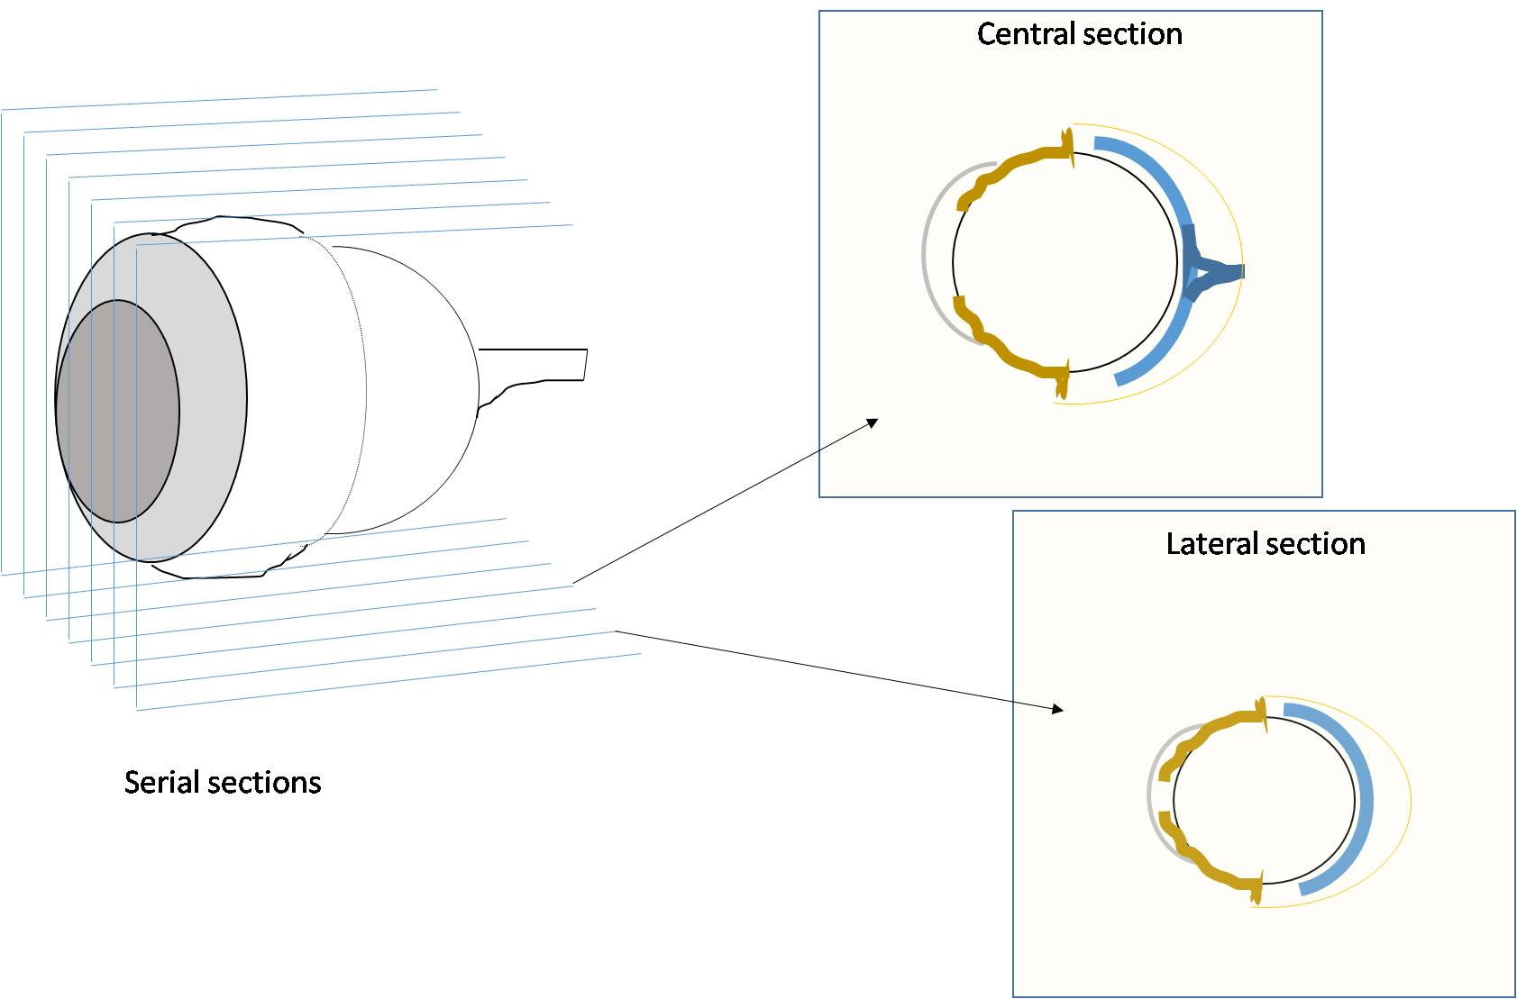
A
B
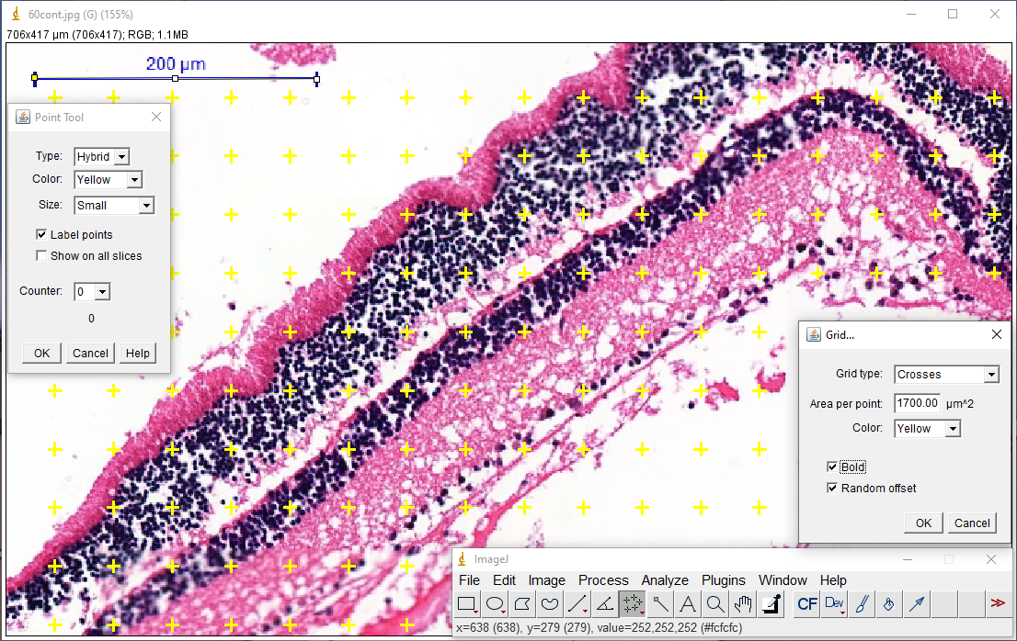
B

Supplementary File 2: Stereological analysis of the retina. (A) Representation of serial sections of the eye collected for stereological analysis. (B) Application of Cavalieri’s Principle for the volume analysis of retinal layers using the software ImageJ.

