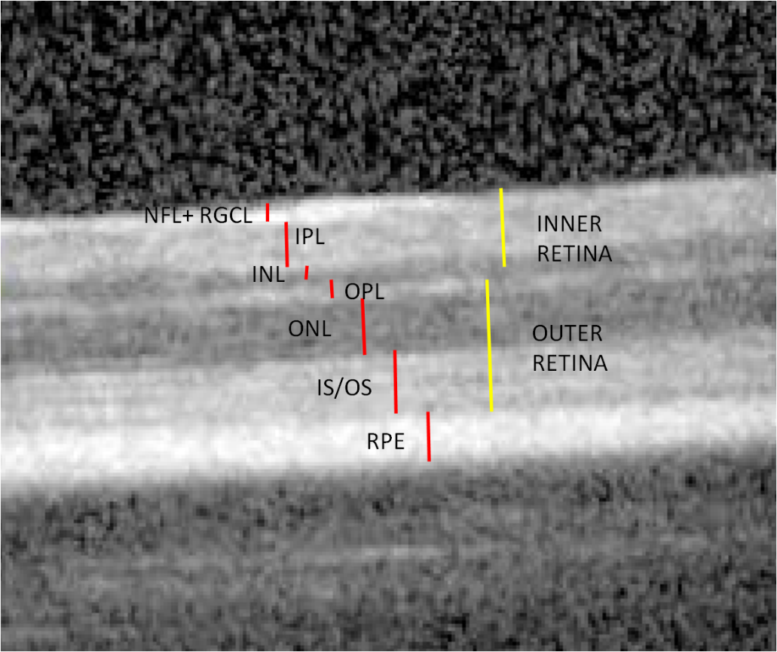
Supplementary File 1: Retinal segmentation in a BALB/c mouse SD-OCT B-scan. NFL+RGCL: Nerve Fiber Layer-Retinal Ganglion Cell Layer; IPL: Inner Plexiform Layer; INL: Inner Nuclear Layer; OPL: Outer Plexiform Layer; ONL: Outer Nuclear Layer; IS-OS: Inner Boundary of Inner Segment-Outer Segment; RPE: Retinal Pigment Epithelium

