Supporting Information
Effervescent cannabidiol solid dispersion-doped dissolving microneedles for boosted melanoma therapy via the “TRPV1-NFATc1-ATF3” pathway and tumor microenvironment engineering
Jiachen Shi^{1†}, Qiuling Ma^{1†}, Wenting Su¹, Congyan Liu^{1,2}, Huangqin Zhang^{1,2}, Yuping Liu^{1,2}, Xiaoqi Li^{1,2}, Xi Jiang¹, Chang Ge¹, Fei Kong¹, Yan Chen ^{1,2}, Ding Qu^{1,2,*}
¹ Affiliated Hospital of Integrated Traditional Chinese and Western Medicine, Nanjing University of Chinese Medicine, Nanjing, 210028, China.
² Jiangsu Province Academy of Traditional Chinese Medicine, Nanjing, 210028, China.
*Corresponding author: Ding Qu, Ph.D., Professor, Jiangsu Province Academy of Chinese Medicine, 100 Shizi Road, Nanjing 210028, China. E-mail: quding1985@hotmail.com
*Correspondence to: Ding Qu (E-mail: quding1985@hotmail.com)
† These authors contributed equally to this work.
Full list of author information is available at the end of the article.

Figure S1. Cumulative dissolution of CBD from CBD-SD@DMNs at different pH values. Data are represented as mean ± SD, n = 6.
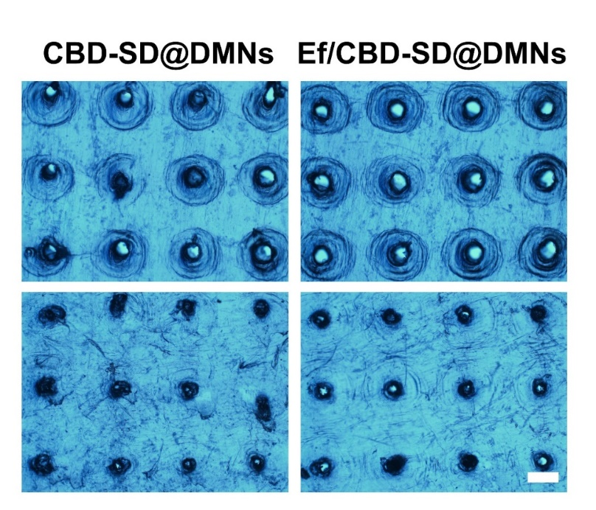
Figure S2. The front (top) and back (bottom) of three-layer pierced parafilm of Ef/CBD-SD@DMNs and CBD-SD@DMNs. The bar is 400 μm.

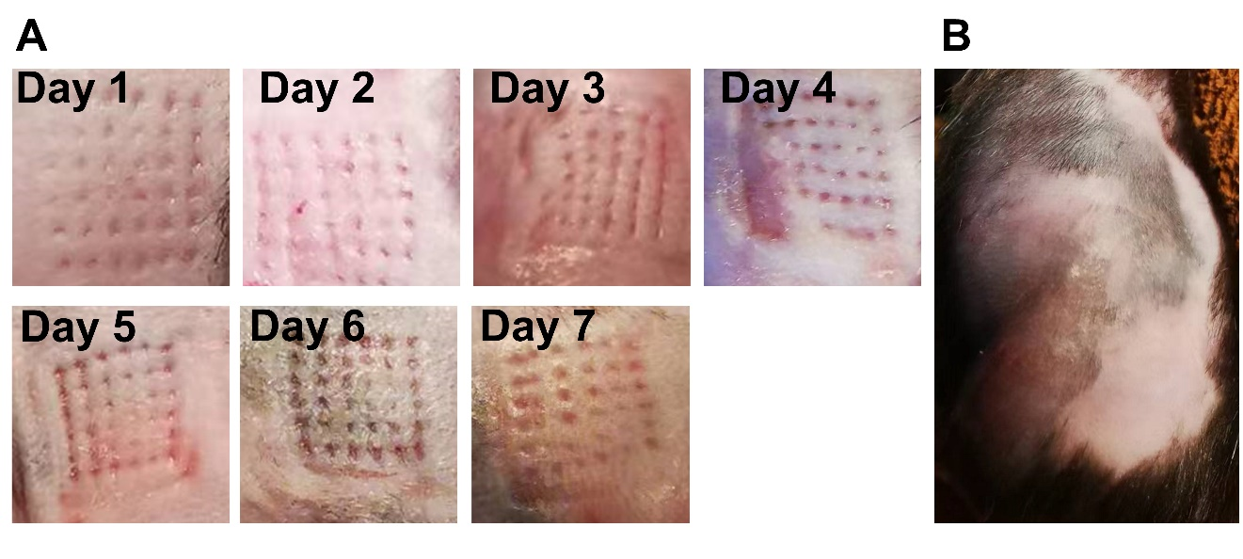
Figure S3. (A) The image of mouse skin after Ef/CBD-SD@DMNs inserted from day one to seven. (B) The image of mouse skin after 10 min of puncture on the seventh day.

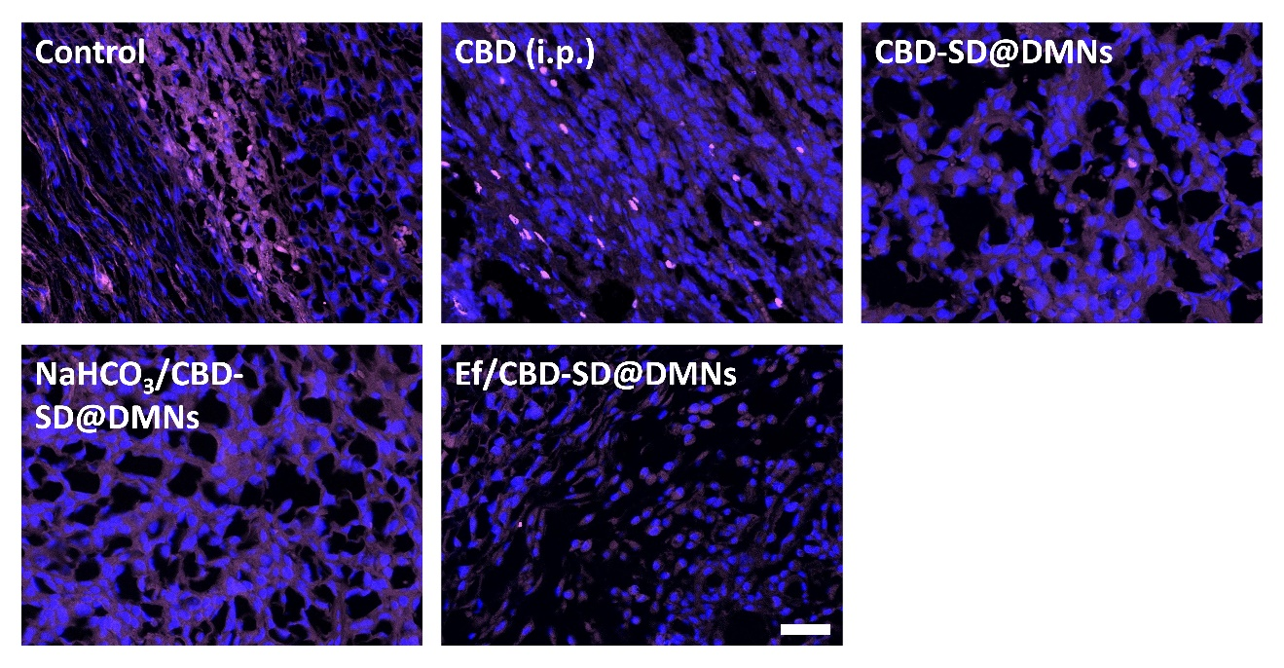
Figure S4. Representative immunofluorescence images of tumours showing Foxp3⁺ regulatory T cell for each experimental group. The bar is 40 μm.
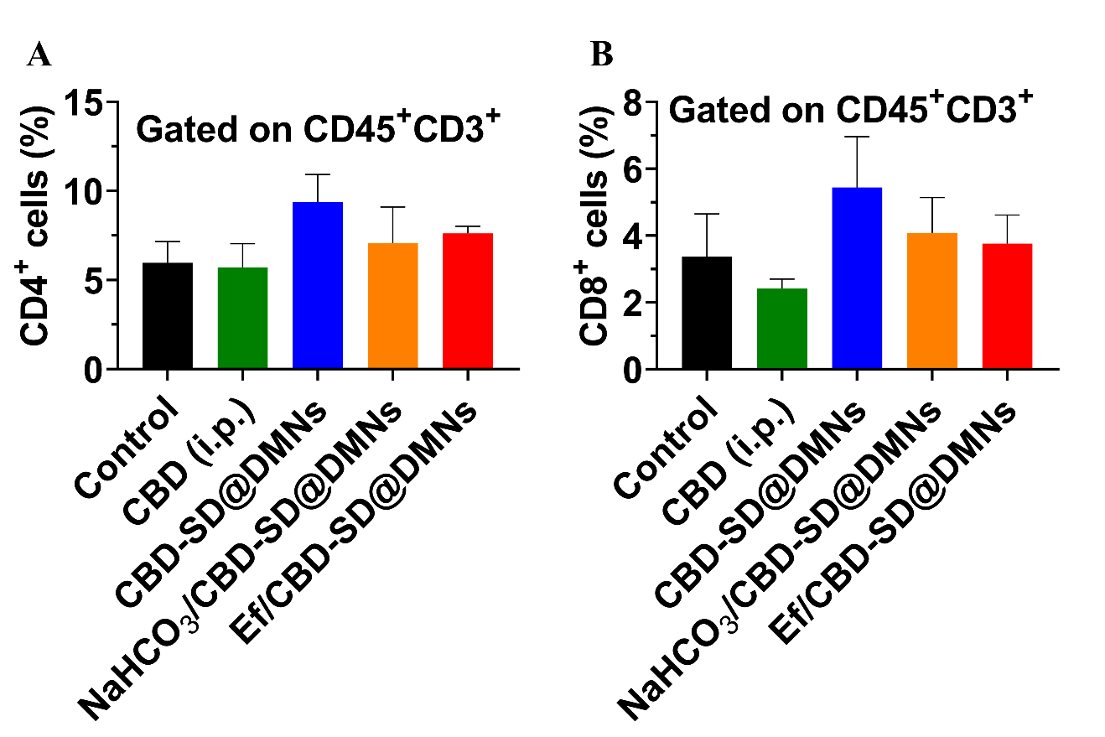
Figure S5. Flow cytometric quantification of (A) helper T cells and (B) killer T cells in spleen tissue from each experimental group. (n = 3,x ± s)

