Supplementary materials

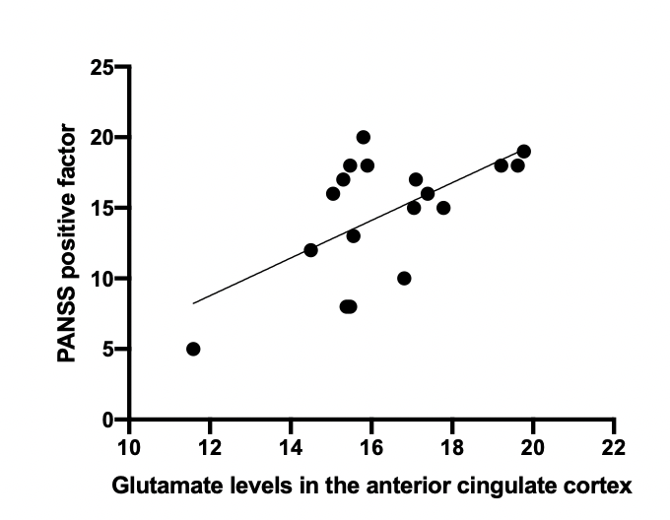
Supplementary figure 1. Association between positive factor, generated from a PANSS 5-factor model and glutamate levels in the anterior cingulate cortex (R=0.613, p=0.007).

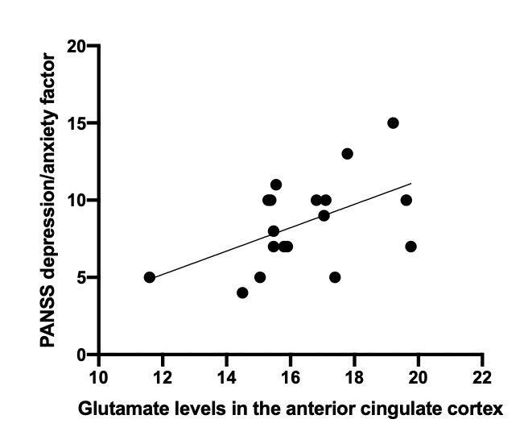
Supplementary figure 2. Association between depression/anxiety factor, generated from a PANSS 5-factor model and glutamate levels in the anterior cingulate cortex (R=0.514, p=0.029).

