Supplemental Information
Endocannabinoid System Upregulates the Enrichment and Differentiation of Human iPSC- derived Spermatogonial Stem Cell via CB2R Agonism
Merve Gizer ^{1,2}, Selin Önen ², Özgür Doğuş Erol ^{1,3,4}, Fatima Aerts Kaya ^{1,3,4,5}, Tuba Reçber⁶, Emirhan Nemutlu⁶, Petek Korkusuz ^{2,7} *
¹ Department of Stem Cell Sciences, Graduate School of Health Sciences, Hacettepe University, Ankara, 06100, Turkey
² METU MEMS Center, Ankara, 06530, Turkey
³ Center for Stem Cell Research and Development (PEDI-STEM), Hacettepe University, Ankara, 06100, Turkey
⁴ Hacettepe University Advanced Technologies Application and Research Center (HÜNİTEK), Ankara, Turkey
⁵ Hacettepe University Laboratory Animals Research and Research Center (HÜDHAM), Ankara, Turkey
⁶ Department of Analytical Chemistry, Faculty of Pharmacy, Hacettepe University, 06100 Sıhhiye, Ankara, Turkey
⁷ Department of Histology and Embryology, Faculty of Medicine, Hacettepe University, Ankara, 06100, Turkey
*Corresponding Author: Petek Korkusuz, MD, PhD
Address: Department of Histology and Embryology, Faculty of Medicine, Hacettepe University, Sihhiye, 06100, Ankara, Turkey
E-mail: petek@hacettepe.edu.tr
Phone: +90-312-3052165
Mobile: +90-532-2968138
ORCID ID: 0000-0002-7553-3915

Supplemental Table 1. The antibodies that were used in this study were listed.
 | Target Protein | Host | Dilution | Brand/ Catalog No | Application in This Study
Primary Antibody | Anti- Human OCT4 | Rabbit | 1:200 | Abcam/ab19857 | FCM, IF
Primary Antibody | Anti- Human SOX2 | Rabbit | 1:200 | Abcam/ab97959 | FCM, IF
Primary Antibody | Anti- Human Nanog | Rabbit | 1:200 | Abcam/ab109250 | FCM, IF
Primary Antibody | Anti- Human TRA-1-60 | Mouse | 1:200 | Abcam/ab16288 | FCM, IF
Primary Antibody | Anti- Human SSEA4 | Mouse | 1:200 | Abcam/ab16287 | FCM, IF
Primary Antibody | Anti- Human ID4 | Rabbit | 1:200 | Invitrogen/PA5-26976 | FCM, IF
Primary Antibody | Anti- Human PLZF | Rabbit | 1:200 | Boster/A00817 | FCM, IF
Primary Antibody | Anti- Human SCP3 | Rabbit | 1:200 | Abcam/ab15093 | FCM
Primary Antibody | Anti- Human ACR | Rabbit | 1:200 | Abcam/ab203289 | FCM
Primary Antibody | Anti- Human CB1R | Rabbit | 1:200 | Abcam/ab3558 | FCM, IF
Primary Antibody | Anti- Human CB2R | Rabbit | 1:200 | Abcam/ab3561 | FCM, IF
Primary Antibody | Anti- Human TRPV1 | Rabbit | 1:200 | Invitrogen/PA1-748 | FCM, IF
Primary Antibody | Anti- Human GPR55 | Rabbit | 1:200 | Abcam/ab203663 | FCM, IF
Primary Antibody | FITC Anti-Rabbit | Goat | 1:200 | Abcam/ab7086 | FCM
Primary Antibody | Anti- Human PAX6 | Mouse | 1:200 | Biolegend/862002 | IF
Primary Antibody | Anti- Human SOX17 | Mouse | 1:200 | Biolegend/628152 | IF
Primary Antibody | Anti- Human Brachyury | Rabbit | 1:200 | Abcam/ab209665 | IF
Secondary Antibody | Alexa FluorTM 488 Anti- Mouse | Rabbit | 1:200 | Invitrogen/A-11059 | FCM, IF
Secondary Antibody | Alexa FluorTM 488 Anti- Rabbit | Goat | 1:200 | Abcam/ ab150077 | IF
Secondary Antibody | SureLight™ APC Anti-Rabbit | Goat | 1:200 | Cayman/16596 | FCM

Supplemental Table 2. The primer sequences for qPCR that were used in this study were listed.
Primer sequences
OCT4 | Forward | GCAAAACCCGGAGGAGTC
OCT4 | Reverse | TCCCAGGGTGATCCTCTTCT
SOX2 | Forward | ATGGGTTCGGTGGTCAAGT
SOX2 | Reverse | GGAGGAAGAGGTAACCACAGG
NANOG | Forward | ATGCCTCACACGGAGACTGT
NANOG | Reverse | CTGCAGAAGTGGGTTGTTTG
ID4 | Forward | CGGGTGGGCTACTTTTCTT
ID4 | Reverse | AGGGAATCTTTGCTCAGTGG
PLZF | Forward | CTCCCCTTCAATCTCATCCAC
PLZF | Reverse | CCTCCCTACTTTACCATCCCTA
SCP3 | Forward | CTTGTGGAGGAGTTGTGGAG
SCP3 | Reverse | GGCTCTCGTAAACTGATCTTCC
ACR | Forward | CAGCCACAGGTACCACACAT
ACR | Reverse | CCAGTCATGCACATTATTTTTGCC
CB1R | Forward | TACCTGATGTTCTGGATCGG
CB1R | Reverse | CCATGCGGGCTTGGTCTG
CB2R | Forward | CTATCCACCTTCCTACAAAGC
CB2R | Reverse | TGAGGCACAGCATGGAGCAG
TRPV1 | Forward | GGCTGTCTTCATCATCCTGCTGCT
TRPV1 | Reverse | GTTCTTGCTCTCCTGTGCGATCTTGT
GPR55 | Forward | AGGGAAGGGTGAGGAAGAG
GPR55 | Reverse | CTCTGTGGCTGTGGTTCTTAG
GAPDH | Forward | GGTGTGAACCATGAGAAGTATGA
GAPDH | Reverse | GAGTCCTTCCACGATACCAAG
B2M | Forward | CCGTGTGAACCATGTGACTTT
B2M | Reverse | CCTCCATGATGCTGCTTACA

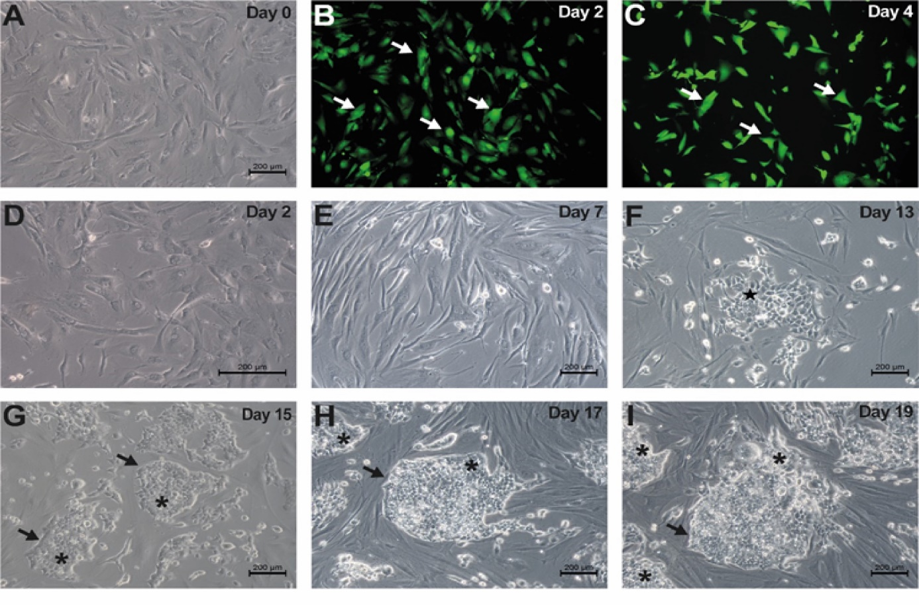
Supplemental Figure 1 hiPSCs were re-programmed from hDFs. a hDFs were transfected with b, c Sendai virus showed GFP (White Arrow), d, e Elongated hDFs, f Epithelial round cell group (*) on the thirteenth day, g small colonies (*) with clear borders (Black Arrow). On the nineteenth day, i cells formed cubical, tightly packed, and well-defined (Black Arrow) hiPSC colonies (*). Scale bar is 200 µm.
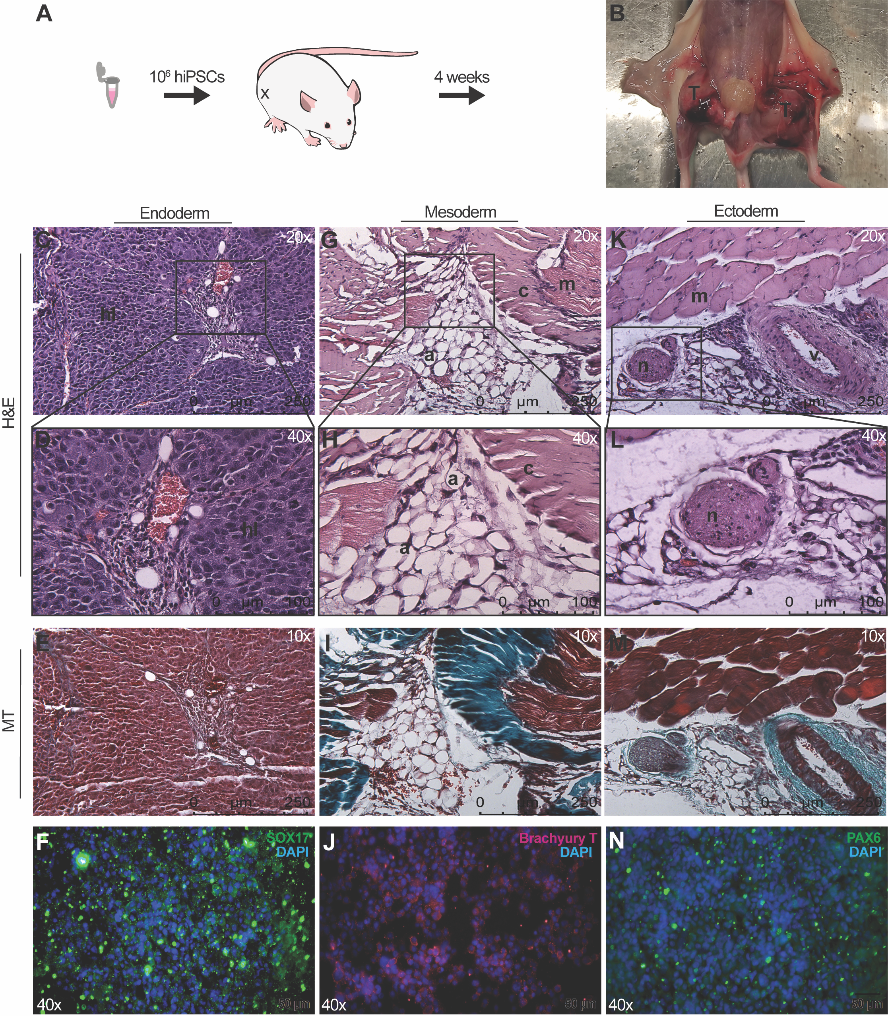
Supplemental Figure 2. The hiPSCs were differentiated to three- germ layers in vivo (A- E, G- I, K- M) and in vitro (F, J, N). a The teratoma formation assay was illustrated. b The hiPSCs formed teratoma (T) at the end of 4 weeks. c – e Liver- lobules (hl) were formed the parenchyme as an endodermal lineage. f The SOX17 labelled endodermal cells were differentiated from hiPSCs. g- i Striated muscle (m), vessel (v), adipose (a) and connective (c) tissue layers were shaped as mesodermal lineages. j The Brachyury T labelled mesodermal cells were obtained by differentiation of hiPSCs. k- m Peripheral neural- like (n) was formed as ectodermal lineage. n The Pax6 labelled cells were differentiated from hiPSCs. Hematoxylin- eosin (H&E), Masson’s Trichrome (MT).
Supplemental Table 3. Descriptive statistics of cannabinoid ligands at the supernatants of hiPSCs and hSSCs.
Descriptive Statistics of Endocannabinoid Ligands Levels in Supenatants (Mean±SD)
 | AEA | 2-AG
hiPSCs | 7.618x10⁻¹⁰±9.511x10⁻¹⁰ M | 4.840 x10⁻⁹±5.225 x10⁻¹⁰ M
hSSCs | 5.620 x10⁻¹⁰±1.128 x10⁻¹⁰ M | 5.880 x10⁻⁹±1.182 x10⁻⁹ M

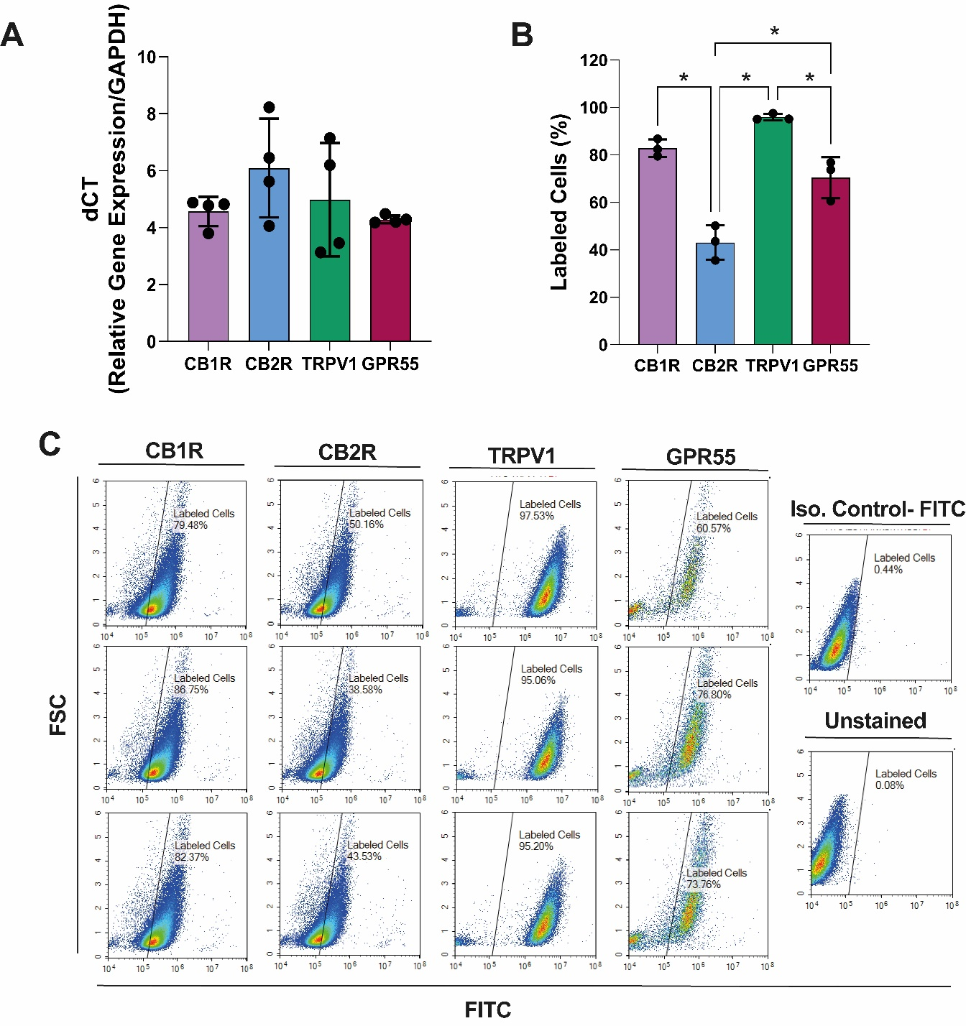
Supplemental Figure 3 Cannabinoid system in hDFs. a hDFs expressed CB1R, CB2R, TRPV1 and GPR55 relative to GAPDH. b CB2R presented a significantly lower ratio compared to CB1R, TRPV1, and GPR55 c CB1R, CB2R, TRPV1, and GPR55 immune distribution in hiPSCs on a range of 79.48- 86.75%, 38.58- 50.16%, 95.06- 95.20%, and 60.57- 76.80% respectively by FCM. * p<0.05.

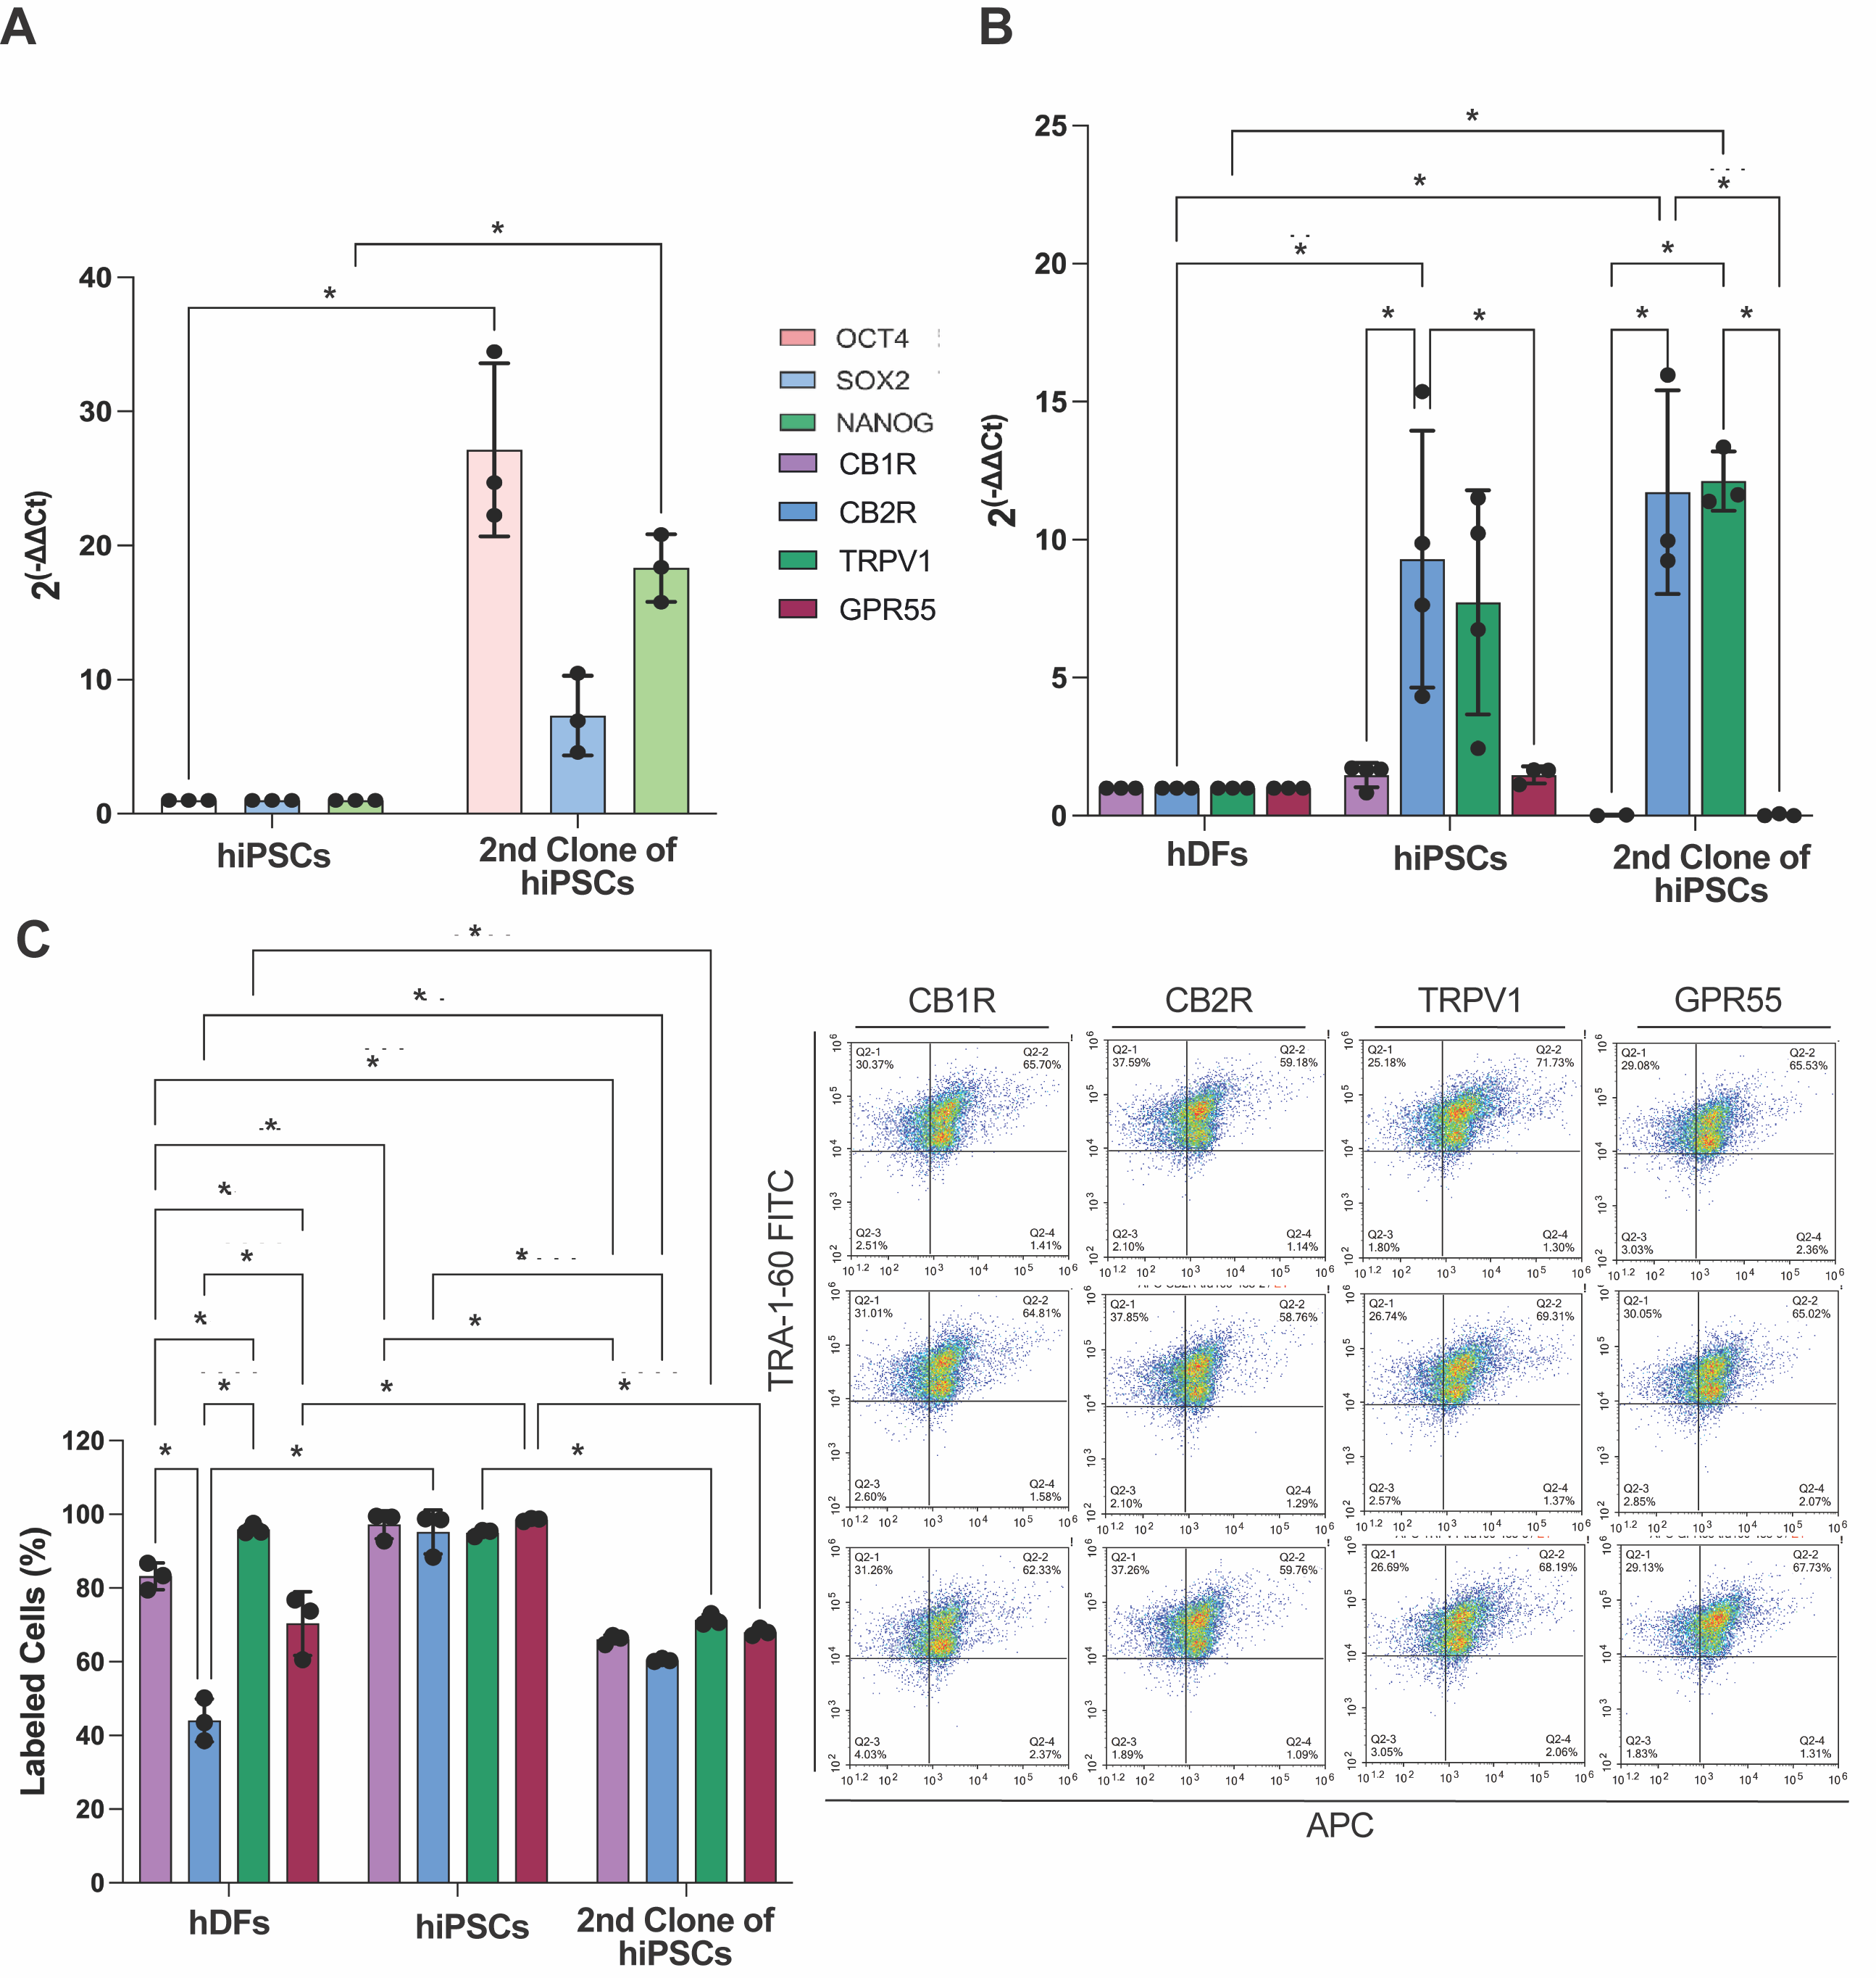
Supplemental Figure 4. The second clone of hiPSCs expressed pluripotency markers and endocannabinoid receptors. a The second clone of hiPSCs expressed OCT4, SOX2 and NANOG. b The second clone of hiPSCs expressed CB1R, CB2R, TRPV1 and GPR55 similar to first clone of hiPSCs. c The percentages of CB1R, CB2R, TRPV1, and GPR55 labeling were slightly lower in the second clone compared to the first clone of hiPSCs.
Supplemental Table 4. Relative gene expression levels of CB1R, CB2R, TRPV1 and GPR55 normalized to GAPDH gene expression.
2 ^{ΔCt} (Relative Gene Expression/GAPDH)
 | CB1R | CB2R | TRPV1 | GPR55
hDFs | 0.04500±0.01732 | 0.02250±0.02630 | 0.05500±0.05260 | 0.05000±0.008165
hiPSCs | 0.06000±0.02000 | 0.1350 ±0.07141 | 0.2050±0.1570 | 0.1450±0.1436
hSSCs | 2.193±0.3202 | 26.38±4.699 | 0.2250±0.07724 | 0.2467±0.01528

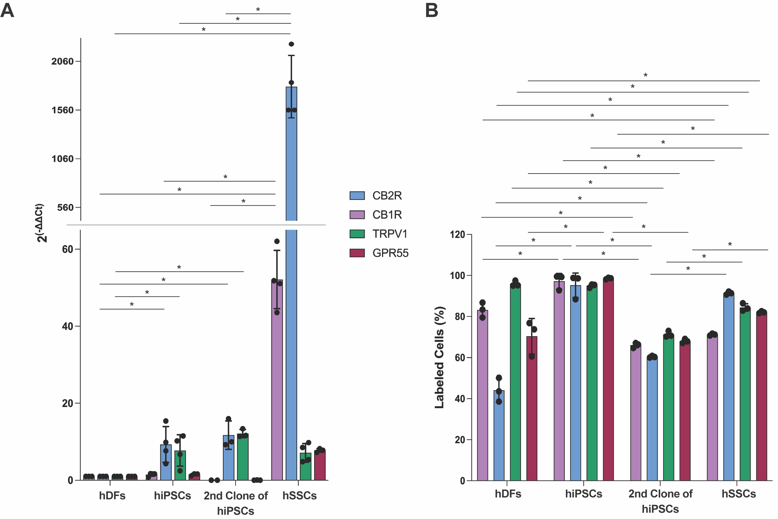
Supplemental Figure 5. Tracking of endocannabinoid system receptors thorough cellular reprograming and differentiation. a Expression levels of CB1R, CB2R, TRPV1 and GPR55 in hDFs, hiPSCs, second clone of hiPSCs and hSSCs relative to GAPDH by qPCR. b CB1R, CB2R, TRPV1, and GPR55 immune distribution in hDFs, hiPSCs, second clone of hiPSCs and hSSCs. *p<0.05.

