Supplementary figures

Fig. S1 Heterogeneous distribution of globular glial tau pathology across GGT samples.
Fig. S2 Phospho-tau staining of GGT and AD brain sections.
Fig. S3 Sarkosyl-insoluble AD-tau is fibril-like.
Fig. S4 Sarkosyl-insoluble GGT-tau promotes intracellular tau aggregation in HEK293T cells.

Figure S1

Fig. S1 Heterogeneous distribution of globular glial tau pathology across GGT samples. Motor cortex and entorhinal cortex of GGT cases used in the FRET tau seeding assay were stained with CP13 p-tau antibody to examine different distribution of tau pathology between motor and entorhinal cortex, as well as grey and white matter (MTR motor cortex; ERC entorhinal cortex; GM grey matter; WM white matter). Immunohistochemical images of GGT cases are shown in the order of tau seeding activity rank measured by the FRET tau seeding assay (1 – highest; 5 – lowest).

Figure S2

Fig. S2 Phospho-tau staining of GGT and AD brain sections. Brain sections of GGT cases (a) and AD cases (b) that correspond to the samples used in the FRET tau seeding assay were stained with CP13 p-tau antibody to determine p-tau burden in each case.

Fig. S3

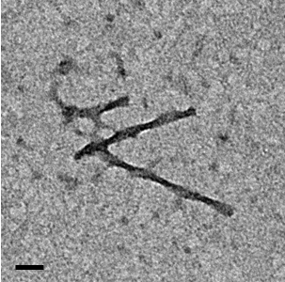

Fig. S3 Sarkosyl-insoluble AD-tau is fibril-like. A representative EM image confirming the presence of tau filament in the sarkosyl-insoluble AD-tau fraction used in the experiment. The filaments have a paired helical filament morphology, which is markedly different from straight filaments in GGT (scale bar = 50 nm).

Fig. S4

Fig. S4 Sarkosyl-insoluble GGT-tau promotes intracellular tau aggregation in HEK293T cells. Seeding potency of sarkosyl-insoluble (P3) GGT-tau was demonstrated in HEK293T cells overexpressing wild-type or K317N mutant tau. Western blot using total tau antibody tau5 (210-241 amino acid) detected a robust increase in triton-insoluble tau in cells treated with P3 GGT-tau, compared to cells treated with P3 AD-tau or PBS.

