Supplementary material 2. The inhibitors of METTL protein family (METTL3)
Inhibitor | Inhibitor type | IUPAC Name | Structures | References
Cmpd2 | SAM analogs | 5-bromo-N-[(2S,4R)-2-[(4-chlorophenyl)methyl]piperidin-4-yl]-1H-indole-3-carboxamide | 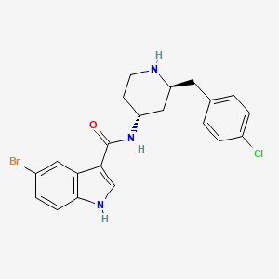 | ^{132, 209}
Sinefungin | SAM analogs | (2S,5S)-2,5-diamino-6-[(2R,3S,4R,5R)-5-(6-aminopurin-9-yl)-3,4-dihydroxyoxolan-2-yl]hexanoic acid | 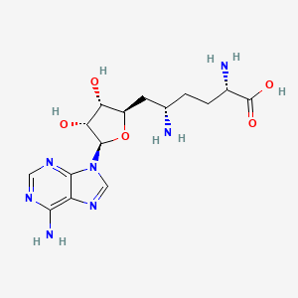 | ^{132, 209}
Cpd-564 | SAM analogs | (2S)-2-amino-4-[[(2S,3S,4R,5R)-3,4,5-trihydroxyoxolan-2-yl]methylsulfanyl]butanoic acid | 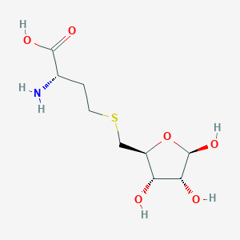 | ^{132, 209}
STM2457 | Non-SAM analogs | N-[[6-[(cyclohexylmethylamino)methyl]imidazo[1,2-a]pyridin-2-yl]methyl]-4-oxopyrido[1,2-a]pyrimidine-2-carboxamide | 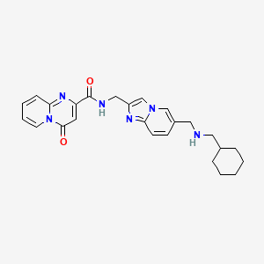 | ^{124, 188, 211, 212}
STC-15 | Non-SAM analogs | -[[2-[(cyclobutylmethylamino)methyl]-1H-indol-6-yl]methyl]-4-oxopyrido[1,2-a]pyrimidine-2-carboxamide | 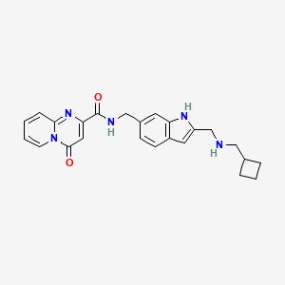 | ¹⁸⁸
UZH 2 | Non-SAM analogs | 4-[4-[(4,4-dimethylpiperidin-1-yl)methyl]-2,5-difluorophenyl]-9-[6-(methylamino)pyrimidin-4-yl]-1,4,9-triazaspiro[5.5]undecan-2-one | 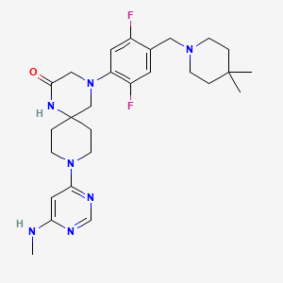 | ^{213, 214}
UZH 1a | Non-SAM analogs | N-[[(3R)-1-[6-(benzylamino)pyrimidin-4-yl]-3-hydroxypiperidin-3-yl]methyl]-4-[(4,4-dimethylpiperidin-1-yl)methyl]-2-hydroxybenzamide | 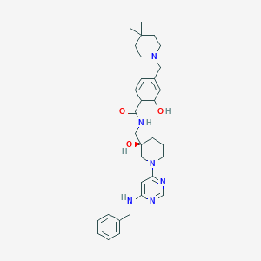 | ^{213, 214}
Quercetin | Non-SAM analogs | 2-(3,4-dihydroxyphenyl)-3,5,7-trihydroxychromen-4-one | 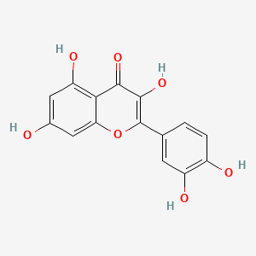 | ²¹⁵
CDIBA | Mutagenic inhibitor | 4-[2-(1-benzhydryl-5-chloro-2-methylindol-3-yl)ethoxy]benzoic acid | 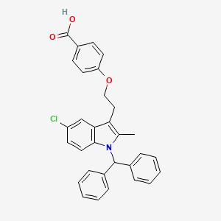 | ^{213, 214}
Eltrombopag | Mutagenic inhibitor | 3-[3-[[2-(3,4-dimethylphenyl)-5-methyl-3-oxo-1H-pyrazol-4-yl]diazenyl]-2-hydroxyphenyl]benzoic acid | 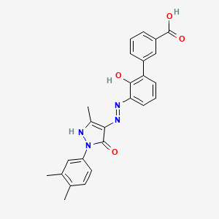 | ^{213, 214}
Hesperidin | Chinese Medicine Active Ingredient | (2S)-5-hydroxy-2-(3-hydroxy-4-methoxyphenyl)-7-[(2S,3R,4S,5S,6R)-3,4,5-trihydroxy-6-[[(2R,3R,4R,5R,6S)-3,4,5-trihydroxy-6-methyloxan-2-yl]oxymethyl]oxan-2-yl]oxy-2,3-dihydrochromen-4-one | 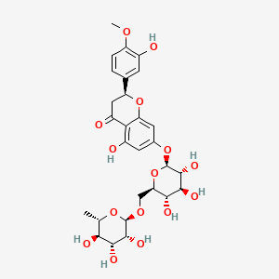 | ¹⁸³

