Western Blots Used for Analysis
- DNMT1
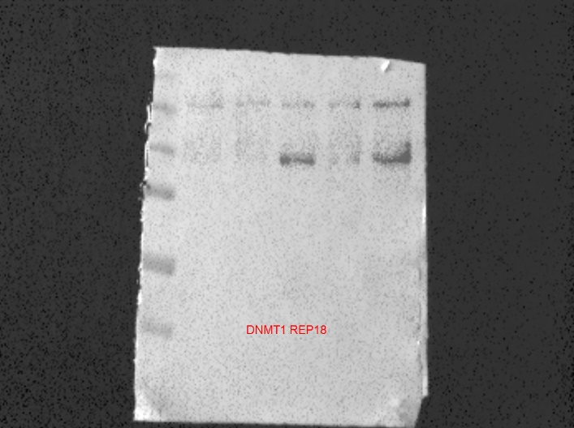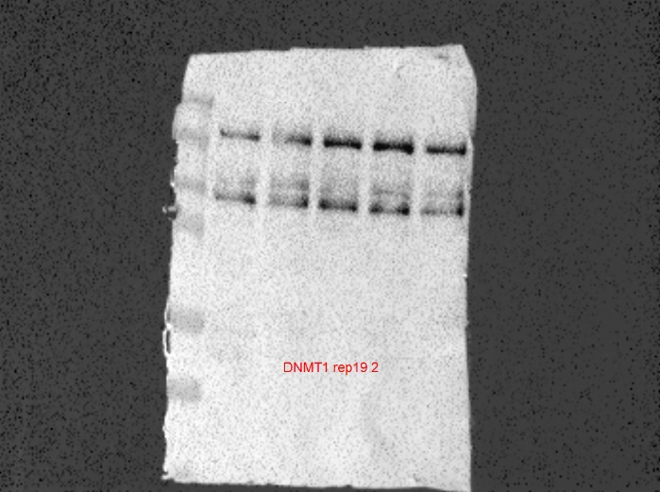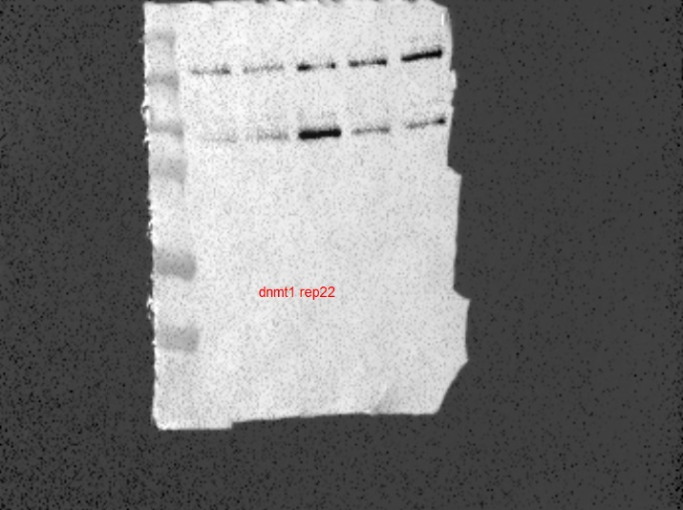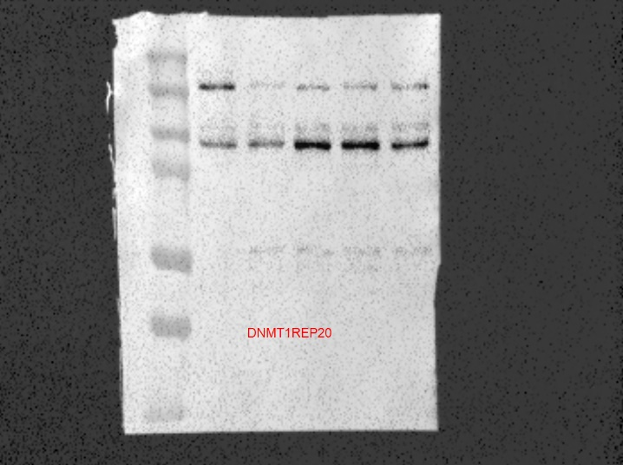
211 kDa
211 kDa
211 kDa
Cont. Veh. Low Mid High
Cont. Veh. Low Mid High
Cont. Veh. Low Mid High
Cont. Veh. Low Mid High
211 kDa

- B-actin
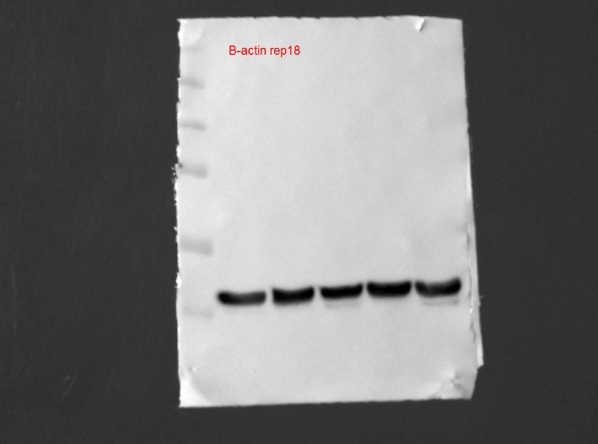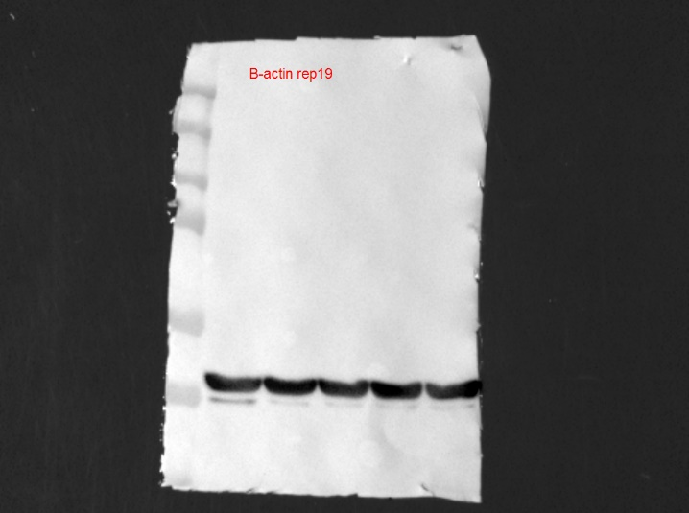
Cont. Veh. Low Mid High
Cont. Veh. Low Mid High
42 kDa
42 kDa
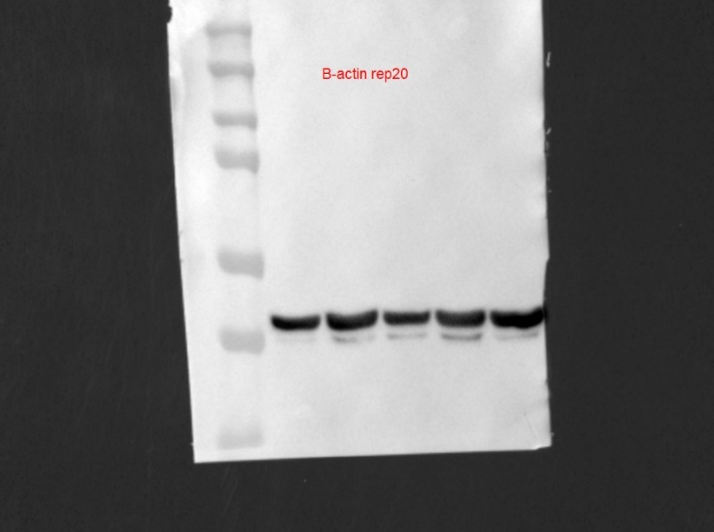
Cont. Veh. Low Mid High
Cont. Veh. Low Mid High
42 kDa
42 kDa

