Supplementary Materials:

Reference Gene Selection
Appropriate reference genes were selected following THC treatment using the reference gene software, geNorm and qPCR. The five candidate genes considered were the following: Beta-2 microglobulin (B2M), Glyceraldehyde 3-phosphate dehydrogenase (GAPDH), Beta-Actin (ACTB), Tyrosine 3-monooxygenase/tryptophan 5-monooxygenase activation protein zeta (YWHAZ) and Peptidylprolyl isomerase A (PPIA) (Supplementary Table 1). YWHAZ and PPIA were selected as the most stable (Supplementary Figure 1).
Supplementary Table 1. mRNA housekeeping primer candidates
Gene Symbol | Gene Full Name | GenBank Accession # | Primer Sequence (5’-3’) | Efficiency (%) | Source
GAPDH | Glyceraldehyde 3-phosphate dehydrogenase | NM_001034034.2 | F:TTCCTGGTACGACAATGAATTTG  R: GGAGATGGGGCAGGACTC | 99.50 | Ferris et al., 2016
ACTB | Beta-actin | NM_173979.3 | F: CCTTCCTGGGCATGGAATCCT  R:TCTTCATTGTGCTGGGTGCC | 97.00 | Tscherner, 2017
YWHAZ | Tyrosine 3-monooxygenase/ tryptophan 5-monooxygenase activation protein zeta | NM_174813.2 | F: GCARCCCACAGACTATTTCC  R: GCAAAGACAATGACAGACCA | 99.0 | Sharma, 2016
PPIA | Peptidylprolyl isomerase A | NM_178320.2 | F: TCTTGTCCATGGCAAATGCTG  R: TTTCACCTTGCCAAAGTACCAC | 102.3 | Ferris et al., 2016
B2M | Beta-2 microglobulin | NM_004048.2 | F: ACGCTGAGTTCACTCCCAACAGCAA  R: TCGATGGTGCTGCTTACAGGTCTCG | 100.0 | Baddela et al., (2014)

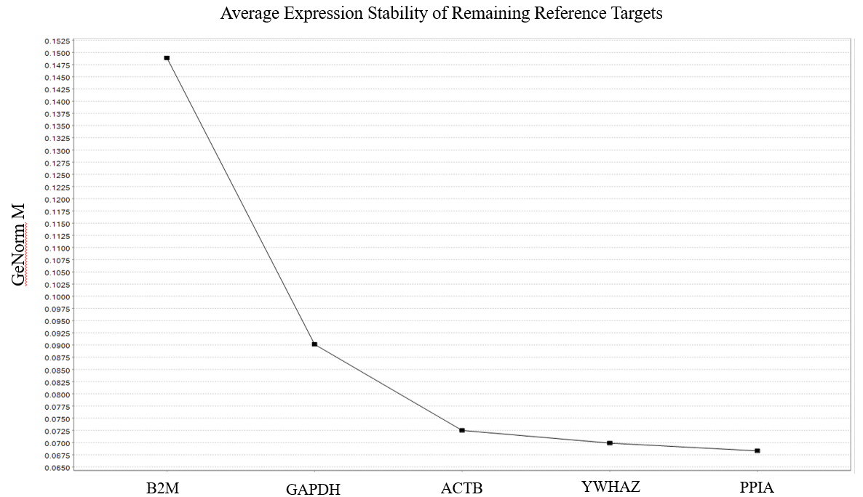
Supplementary Figure 1 - mRNA reference gene selection for THC-treated GCs using GeNorm (n=3). Reference gene candidates include B2M, GAPDH, ACTB, YWHAZ and PPIA. All candidate genes were below the cut-off value for stability (M=0.5), although YWHAZ and PPIA (M<0.07) were most stable.

Primer Efficiency Testing
Primer efficiencies were tested for each primer set via standard curves using qPCR. Standard curves were established using the following serial dilution: 50 ng, 25ng, 12.5 ng, 6.25ng, 3.125ng, 1.56ng, 0.78ng, 0.39ng. The CFX96 Touch Real-Time PCR Detection System (Biorad, 1725201) and SsoFast EvaGreen Supermix (Biorad, 1725201) were used following the protocol: 5 minutes at 95°C, followed by 44 cycles at 95°C for 10 seconds, 60°C for 10 seconds and 72°C for 10 seconds. miRNA primer efficiencies were tested following the same serial dilution as mentioned above, under the following conditions: 95℃ for 2 minutes followed by 40 cycles of 95℃ for 10 seconds and 56℃ for 60 seconds. Only efficiency values between 90-100% were accepted. Primer efficiencies are summurized in Table 1, Table 2 and supplementary Table 1.

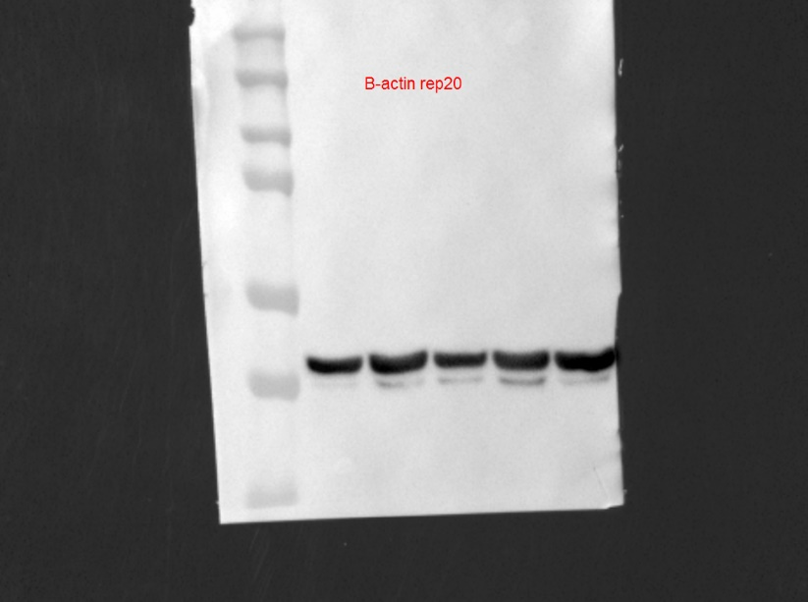
42 kDa
Mid
[THC]
High
[THC]
Low
[THC]
Vehicle
Control
211 kDa
Control
Low
[THC]
Mid
[THC]
High
[THC]
Vehicle
Supplementary Figure 2 – Original Western Blots. The original uncropped western blots as represented in the manuscript in Figure 5.

