Supplementary Figure 1 The differences of SYT11 expression in various tumors and adjacent normal tissues
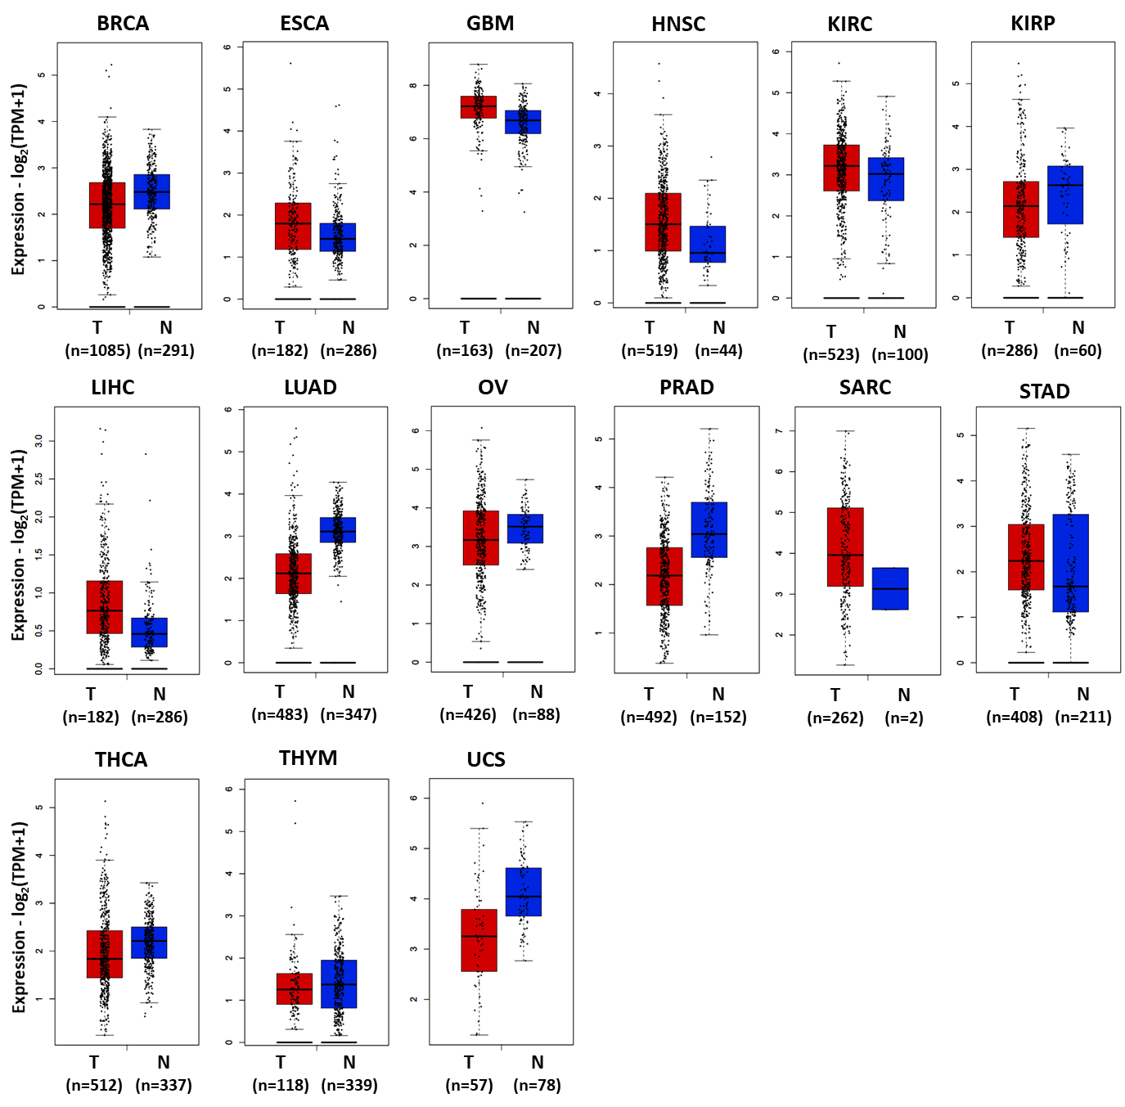

Supplementary Figure 2. Pathological stage-dependent (stage I, II, III, IV and V) SYT11 expression level in various tumors
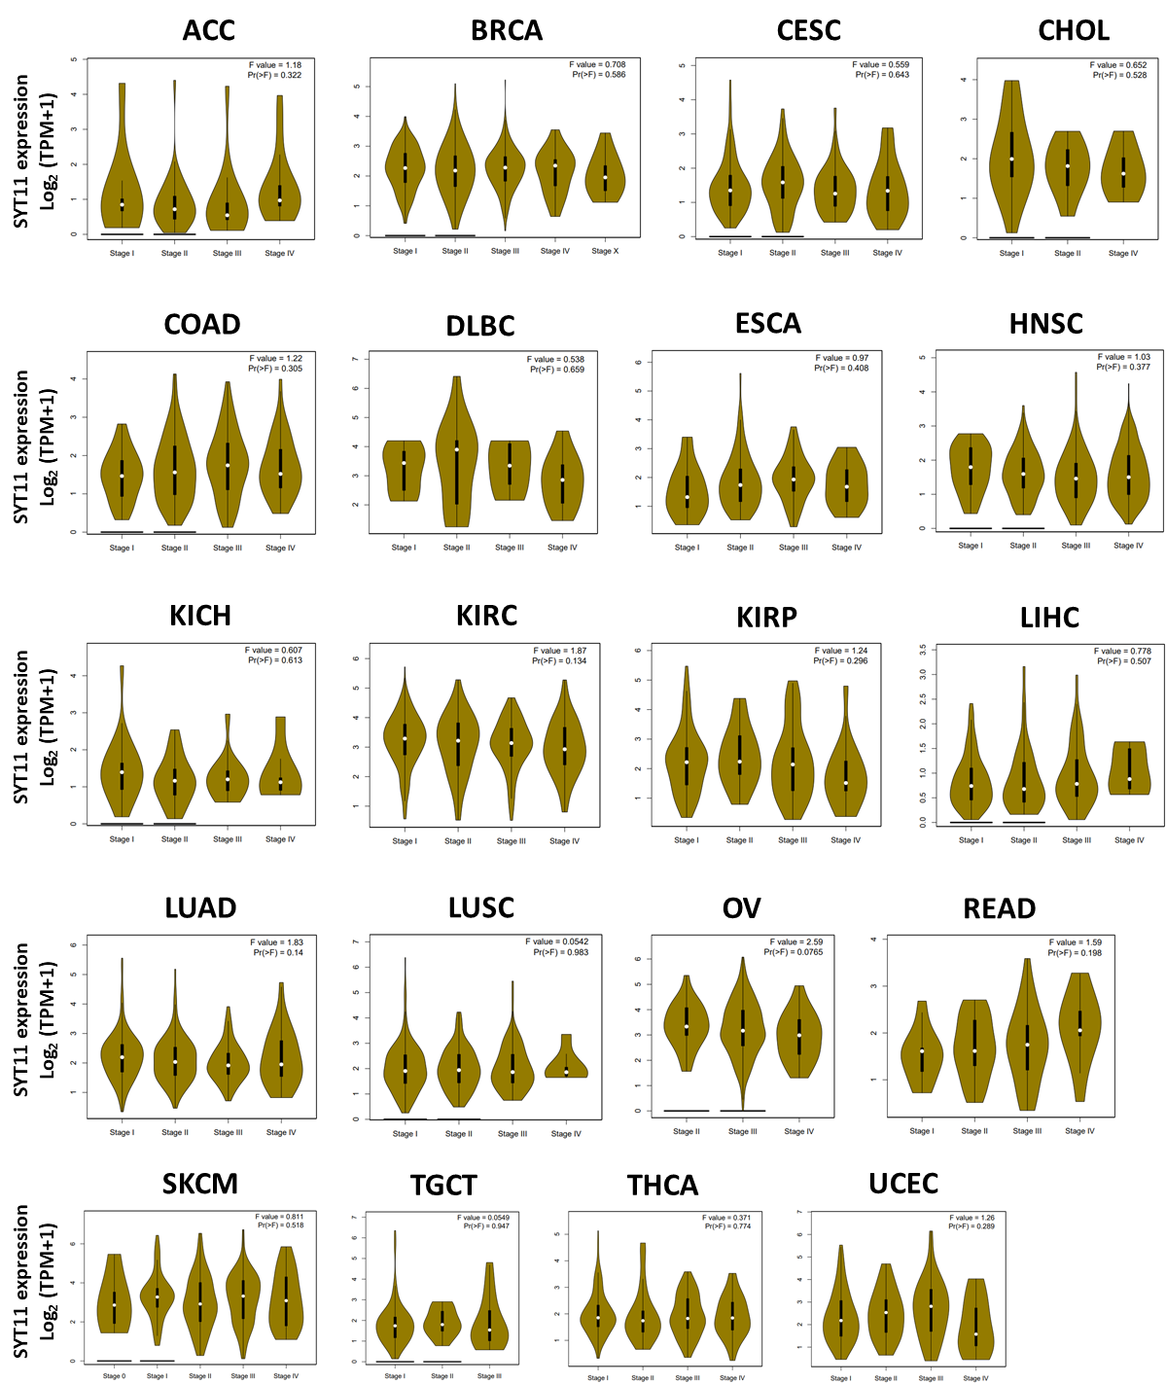

Supplementary Figure 3 Overall survival analysis in various cancer types from TCGA database
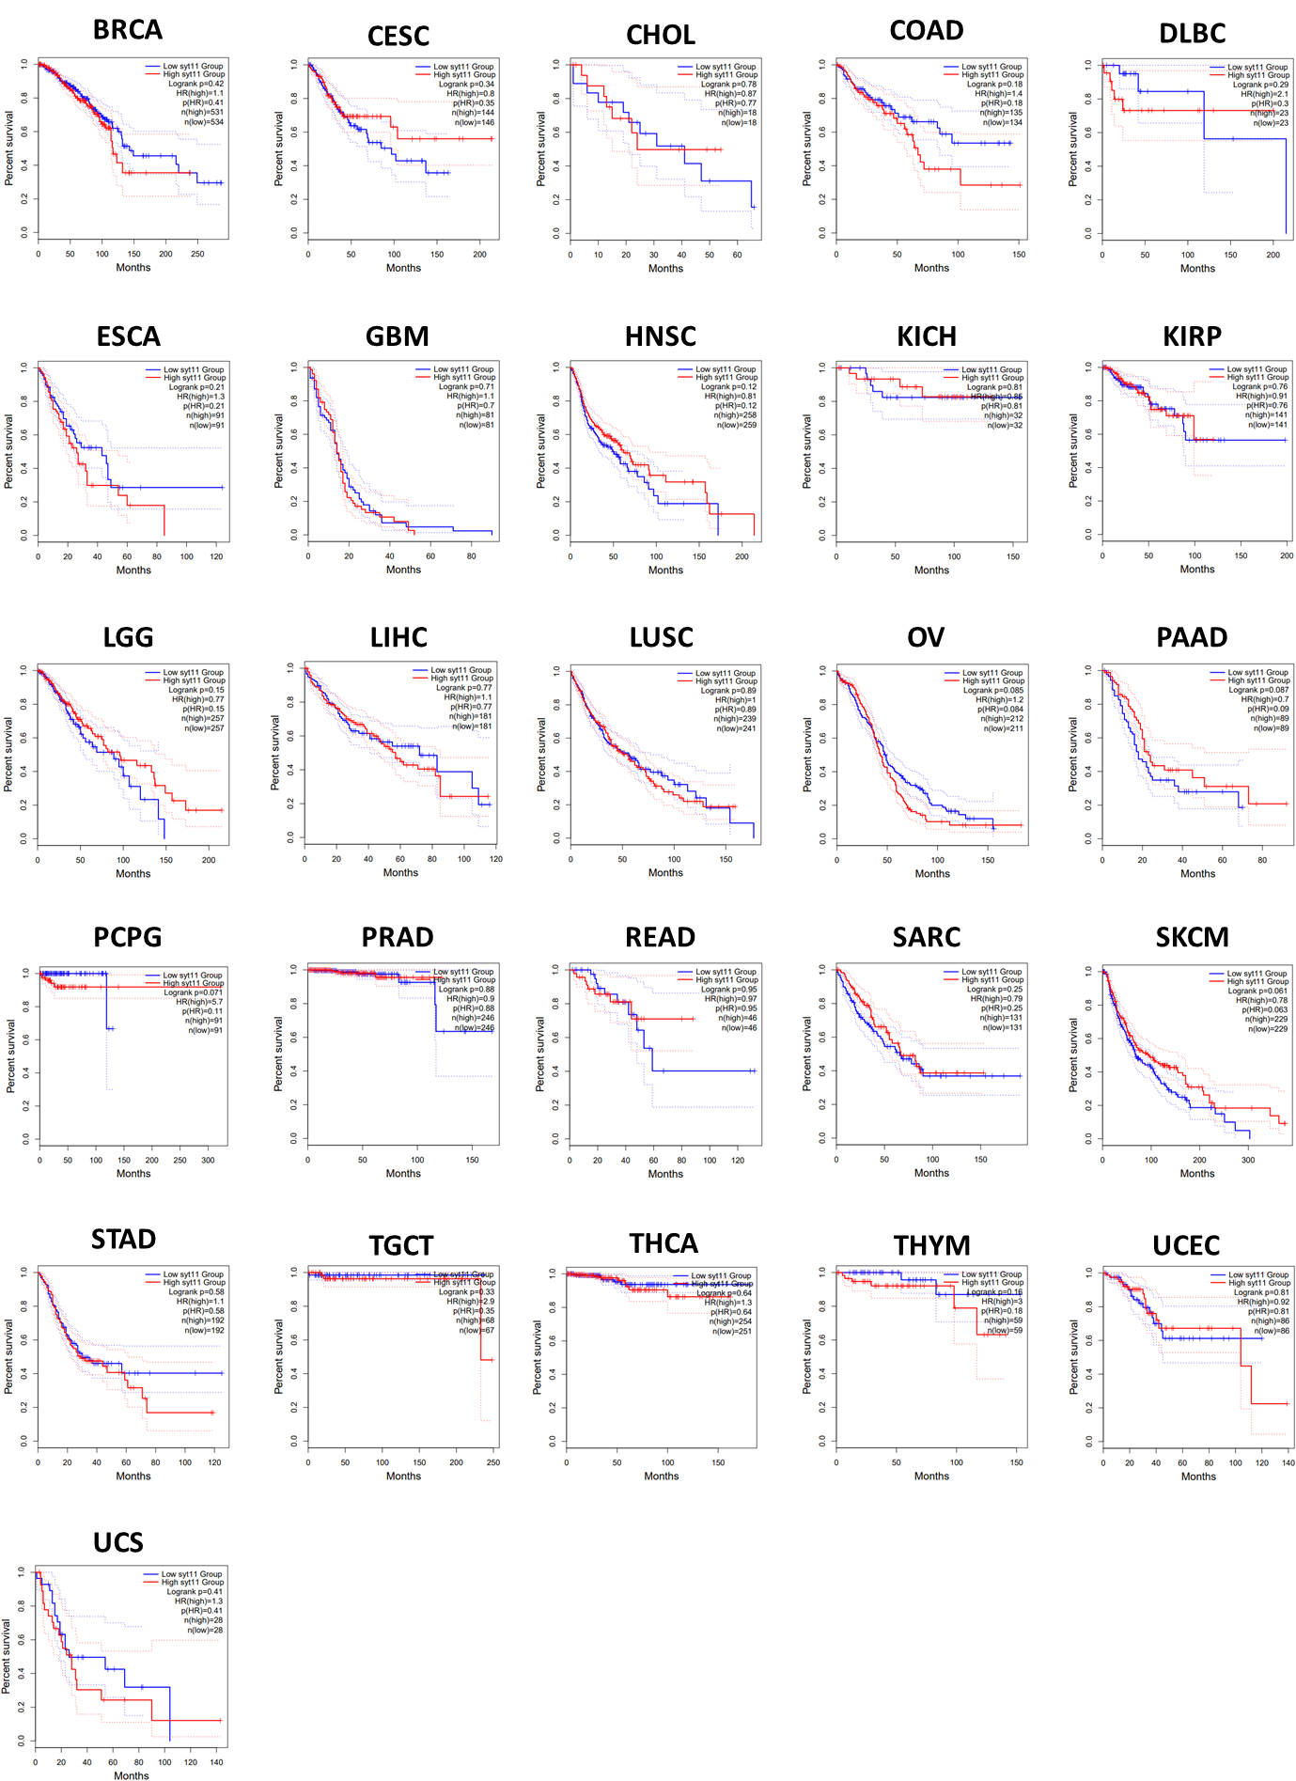

Supplementary Figure 4 Disease-free survival analysis in various cancer types from TCGA database
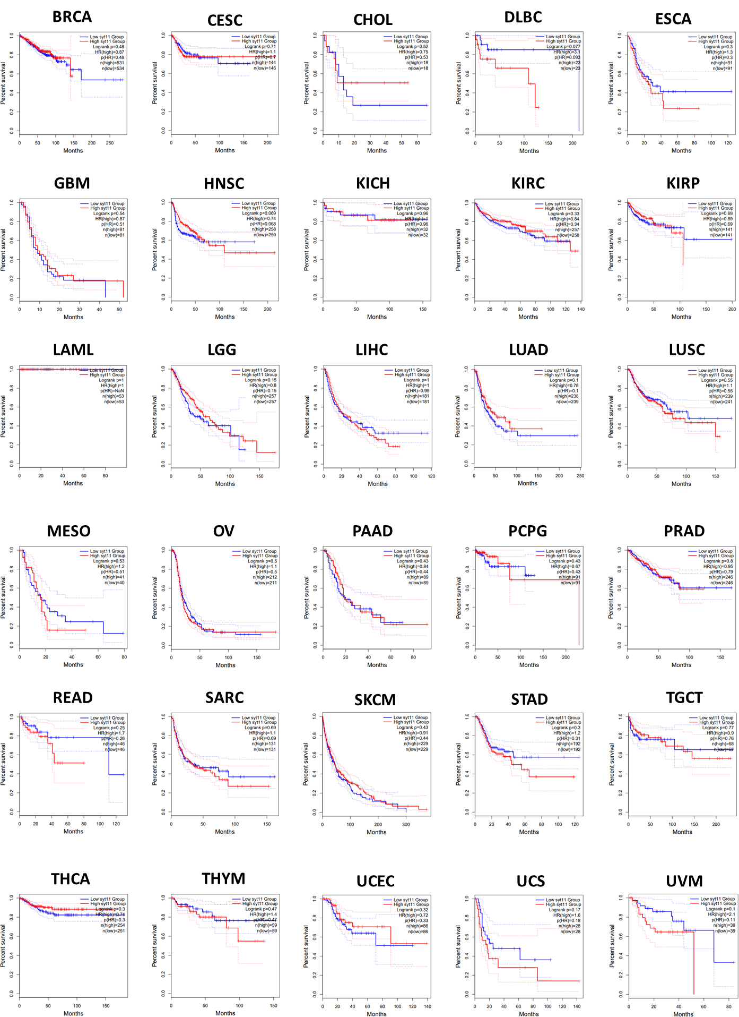

Supplementary Figure 5 Correlation between candidate miRNAs and prognosis in various cancers.
