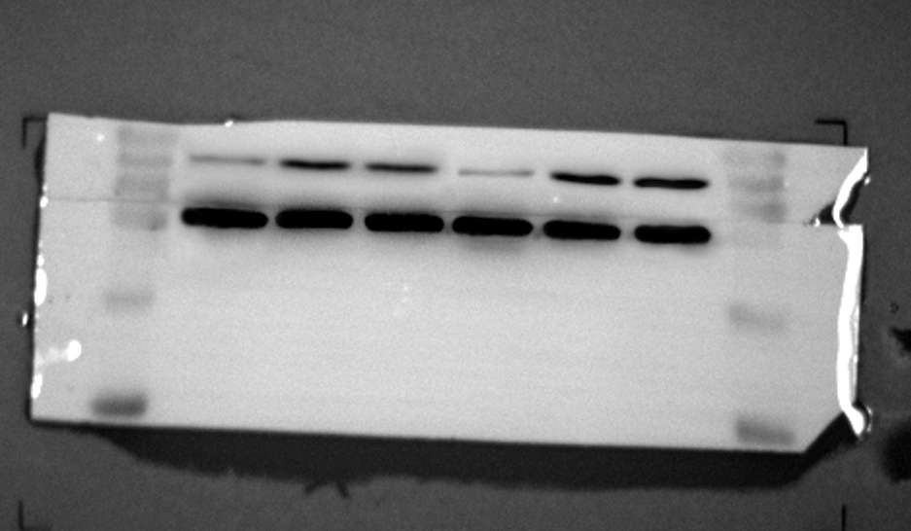
Naked2
GAPDH
8305C
SW579
SW579
8305C
NTHY-ORI3-1
NTHY-ORI3-1

