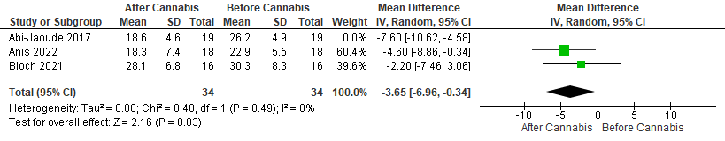
Analysis after removal of Abi-Jaoude 2017
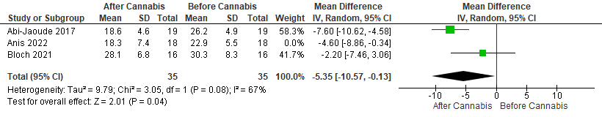
Analysis after removal of Anis 2022
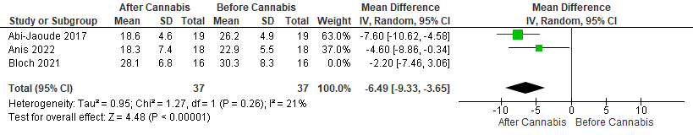
Analysis after removal of Bloch 2021

