YGTSS-total

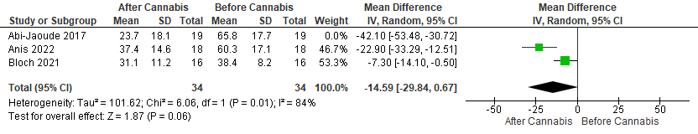
Heterogeneity after removal of Abi-Jaoude 2017

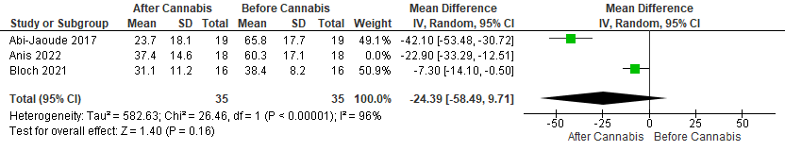

Heterogeneity after removal of Anis 2022
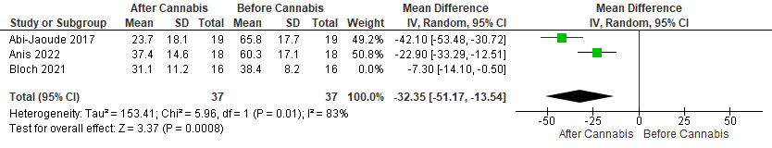
Heterogeneity after removal of Bloch 2021

