A novel approach to the production of Δ⁹-THC and CBN certified reference materials
Lucas J. de Carvalho^{1*}, Silvia R. P. Lopes¹, Lívia C. R. M. da Frota^{2§}, Karine E. Cesar¹, Douglas S. A. Chaves³, Neide M. de M. Epifanio⁴, Fernanda G. Finelli², Bruno C. Garrido^{1#}

¹National Institute of Metrology, Standardization and Industrial Quality (Inmetro) Avenida Nossa Sra. das Graças, 50, Duque de Caxias, Rio de Janeiro, Brazil.
*Email: ljcarvalho@inmetro.gov.br

²Instituto de Pesquisa de Produtos Naturais, Universidade Federal do Rio de Janeiro, 21941-599, Rio de Janeiro, RJ, Brazil.

³Departamento de Ciências Farmacêuticas, Universidade Federal Rural do Rio de Janeiro.

⁴Laboratorio de Farmacognosia, Universidade Federal Rural do Rio de Janeiro.

§Present Address: Departamento de Química Orgânica, Instituto de Química, Universidade Federal do Rio Grande do Sul, 91501-970, Porto Alegre, RS, Brazil.

#Present Address: National Research Council of Canada, Metrology Research Centre, 1411 Oxford Street, Halifax, Nova Scotia, Canada.

Summary

S1) General information S3
S2) Sample preparation S4
S2.1) Standard solutions of cannabinoids S4
S2.2) Cannabis samples S4
S2.3) ¹H NMR-PULCON samples S4
S3) NMR and chromatography instrumentation conditions S4
S3.1) Preparative HPLC S4
S3.2) HPLC–DAD–MS/MS (UPLC) S5
S3.3) Nuclear Magnetic Ressonance (NMR) S5
S3.4) PULCON ¹H NMR conditions S6
S3.5) Gas Chromatography–Mass Spectrometry (GC–MS) S6
S4) Caffeine determination by GC-MS and PULCON qNMR: validation of qNMR-PULCON approach S7
S4.1) Preparation of Yerba mate (Ilex paraguariensis) extracts and determination of the acquisition conditions S7
S4.2) Validation of quantification methods using PULCON S8
S4.3) Quantification of Δ⁹-THC and CBN in cannabis extracts S12
S5) Isolation and synthesis of cannabinoids S12
S5.1) Cannabinoids extract preparation from Cannabis plant S12
S5.2) Optimization of the conditions for the synthesis of CBN from Δ⁹-THC S13
S5.3) Synthesis of CBN from Δ⁹-THC-rich extracts S14
S5.4) Isolation of Δ⁹-THC and CBN from cannabis extract S15
S5.5) Characterization of cannabinoids S16
S6) Cannabis and Cannabinoid Certified Reference Materials S21
S6.1) Estimation of uncertainties S21
S6.2) Homogeneity studies S22
S6.3) Transport study S23
S7) References S23

S1) General information
The following materials and reagents were used as received: methanol and acetone (HPLC/spectra grade; Tedia, Fairfield, USA); ultrapure water (Milli-Q, Millipore, Bedford, USA); CDCl₃ containing 0.03% v/v TMS (Cambridge Isotope Laboratories, Andover, USA); acetone-d₆ (Merck, Darmstadt, Germany); formic acid (FA; Sigma-Aldrich, Missouri, USA); anhydrous sodium sulfate (Sigma-Aldrich, São Paulo, Brazil); Δ⁹–THC standard (Cerilliant® Analytical Reference Standards, Texas, USA); CBD and CBN reference samples (UNODC); dimethylsulfone (DMSO₂, CRM 8783.0001; Inmetro, Duque de Caxias, RJ, Brazil); dimethyl terephthalate (DMTP, CRM 8784.0001; Inmetro); and caffeine standard (United States Pharmacopeial Convention, Rockville, MD, USA).
Flash chromatography was performed on silica gel 60 (200–400 mesh) and thin layer chromatography was performed on Silicycle® TLC plates pre-coated with silica S2 gel 60 F254 using UV light as the visualizing agent or ethanolic phosphomolybdic acid and heating as developing agents. Eluants used for flash chromatography are described in each experimental procedure.
All PULCON qNMR determinations were performed using Equation 1, derived from previously reported equations [1, 2], which enable the application to complex matrix materials. Caffeine determination by standard addition using coordinate swapping followed the procedure of Meija et al. [3]. The certified reference material (CRM) property value corresponded to the mass fraction determined by ¹H qNMR. The combined standard uncertainty of the CBN and Δ⁹–THC mass fractions (u_{c}(w_{A})) determined by ¹H qNMR using PULCON was estimated using the method of propagation of uncertainties by taking into account the uncertainties associated with each input quantity in equation 1.

$$w_{g/g} = \frac{m_{ref}{×I}_{s }×Θ_{a}× N_{ref}× {MM}_{a}}{ {{MM}_{ref}×m_{total sol ref}×I}_{ref}×Θ_{ref}×N_{s}}×P_{ref}$$ | 1

$s$: Sample; $ref$: Reference; $P_{ref}$: Reference purity (g/g);$I$: Signal integration;$Θ$: Calibrated 90° pulse duration$; N$: Number of transients;$MM$: Molecular mass (g/mol);${ m}_{total sol ref}$ : Total mass of reference solution (g).

S2) Sample preparation

S2.1) Standard solutions of cannabinoids
For HPLC-DAD-MS/MS identification of cannabinoids, a reference standard mixture containing cannabidiol (CBD, 300 μg mL⁻¹), cannabinol (CBN, 300 μg mL⁻¹), and Δ⁹-tetrahydrocannabinol (Δ⁹-THC, 150 μg mL⁻¹) was prepared in methanol and used for comparison with sample extract.

S2.2) Cannabis samples
Cannabis products (skunk type) in plant form were supplied by Federal Police under judicial authorization through a technical cooperation agreement. The samples were ground using a Retsch Grindomix GM 200 (4 cycles of 1 min at 3000 rpm, impact function) and dried under vacuum at room temperature. Particle-size fractionation was performed by sieving with mesh openings of 0.850 mm (20 mesh), 0.500 mm (32 mesh), and 0.250 mm (60 mesh) arranged sequentially in a Bertel sieve shaker and operated for three cycles of 30 min each. The fractions retained between the 32–60 mesh sieves and those passing through the 60 mesh sieve were collected. The <0.250 mm fraction was homogenized in a POWDERMIX mixer for 10 min, transferred to amber glass vials, and stored at −20 °C under controlled conditions until analysis.

S2.3) ¹H NMR-PULCON samples
For PULCON quantification, CDCl₃ solutions with known mass fractions were prepared using certified reference materials (CRMs) of DMTP and DMSO₂ as the external and internal standards, respectively. DMSO₂ was weighed on an analytical balance with 0.01 mg resolution, and DMTP on a microbalance with 0.0001 mg resolution (Mettler Toledo UMX5). The PULCON reference solution was prepared by dissolving 2.0 mg of DMTP in 4.0 g of CDCl₃ and transferring the solution to an NMR tube. DMSO₂ calibration solutions were prepared over a broad concentration range, including an initial solution at 0.386 mg g⁻¹, nine solutions spanning 0.004–20.8 mg g⁻¹, and three additional solutions at 0.5, 5.0, and 20 mg g⁻¹.

S3) NMR and chromatography instrumentation conditions

S3.1) Preparative HPLC
Large-scale isolation of CBN and Δ⁹–THC was performed using a preparative HPLC–DAD system (Waters, Milford, MA, USA) equipped with a binary pump and a C18 preparative column (250 × 19 mm, 10 μm; Waters). Mobile phase A was water with 0.01% (v/v) formic acid and mobile phase B was methanol; the system was operated in isocratic mode (10:90, v/v). The flow rate was 17.06 mL min⁻¹, injection volume was 5 mL, and cannabinoids were detected by PDA at 210 nm. The total run time was 14 min. Fractions were collected at retention time intervals of 7.40–8.55 min for CBN and 8.70–10.25 min for Δ⁹–THC.

S3.2) HPLC–DAD–MS/MS (UPLC)
Preliminary purity, homogeneity, and transport stability studies were conducted using an ACQUITY UPLC–PDA–MS/MS system (Waters) with a Xevo TQ detector. Chromatographic separation was achieved on an ACQUITY UPLC BEH C18 column (50 × 2.1 mm, 1.7 μm) at 27.5 °C with an FTN automatic injector. DAD scanning was performed from 190–500 nm and cannabinoids were monitored at 210 nm. Mobile phase A was water containing 0.01% (v/v) formic acid and mobile phase B was methanol; analyses were performed in isocratic mode (18:82, v/v). The flow rate was 0.61 mL min⁻¹, injection volume 2 μL, and total run time 5 min.
Mass spectrometric detection was performed in positive ion mode via electrospray ionization (ESI⁺) with the following settings: nebulizing gas (N₂) pressure, 2.0 bar; source temperature, 150 °C; desolvation temperature, 400 °C; cone gas flow, 20 L h⁻¹; drying gas (N₂) flow, 800 L h⁻¹. The MS scan range was m/z 50–700 with a spectral rate of 0.5 spectra s⁻¹. ESI(⁺)–MS/MS experiments were conducted using a collision energy of 30 eV for ions at m/z 311 and 315 (CBN, CBD, and Δ⁹–THC), with argon collision gas at 1.5 mTorr. Two transition ions were monitored for cannabinoid identification using multiple reaction monitoring (MRM); transitions and voltages were based on McRae and Melanson [4].

S3.3) Nuclear Magnetic Resonance (NMR)
NMR spectra were acquired on an Avance III 500 MHz spectrometer (Bruker Daltonics, MA, USA) equipped with a 5 mm Prodigy cryoprobe (CPP TCI 500S1 H&F‑C/N‑D‑05 Z), operating at 11.7 T and 298 K. Experiments were performed at 20.0 ± 0.1 °C using a zg pulse sequence, with the 90° pulse calibrated for each acquisition (centered at 5.8 ppm). The acquisition time was 3.28 s, with 8 transients and a relaxation delay of 40 s, maintaining an FID resolution of 0.31 Hz pt⁻¹. ¹H NMR spectra were referenced to the CDCl₃ solvent signal at 7.24 ppm. Cannabinoid quantification was performed by external standardization with pulse width correction using the PULCON method and dimethylsulfone CRM as the external standard. Both the dry extract of the Cannabis CRM candidate material and the dimethylsulfone CRM were analyzed in deuterated chloroform; all samples were weighed gravimetrically. Data were processed using TopSpin 3.6.5 (Bruker) and MestreNova 14.1.1 (Mestrelab Research SL, Santiago de Compostela, Spain).

S3.4) PULCON ¹H NMR conditions
Samples were placed in 5 mm borosilicate NMR tubes and inserted into the spectrometer. Locking was performed according to the solvent, followed by automatic tuning, matching, shimming, and pulse calibration. Measurements were conducted at 298 K using Bruker triple‑resonance Prodigy cryoprobe and broadband observe (BBO) probes. Acquisition parameters were: spectral width, 40 ppm; acquisition time, 3.28 s; 128k data points; 4 dummy scans; 8 transients; and automatic receiver gain adjustment via the rga command. Spectral data processing was performed using MestreNova 14.1.1. Pulse calibration was automated using pulsecal. Signal integration followed Inmetro’s qNMR Guide (item 6.7), integrating within a 30 Hz window around ¹³C satellite signals or, when unavailable, ±30 Hz from the chemical shift of the target signal. Baseline adjustment was performed within MestreNova.
T₁ relaxation times were measured using an inversion‑recovery sequence (t1ir1d pulse program) with delay (D7) increments of 0.5 s. Repetition times matched the longest measured T₁ values. T₁ values obtained were: DMTP at 8.1 ppm (2.0 s) and 3.9 ppm (3.9 s) in CDCl₃; DMSO₂ at 4.33 s in CDCl₃ and 5.78 s in acetone‑d₆; caffeine’s four signals averaged 4.3 s in acetone‑d₆. These ensured accurate, reproducible PULCON qNMR measurements.

S3.5) Gas Chromatography–Mass Spectrometry (GC–MS)
Caffeine analysis in yerba mate extract by standard addition was performed using an Agilent 6890N gas chromatograph coupled to a 5975C mass spectrometer (Agilent, Santa Clara, CA, USA). Chromatographic separation used an Agilent DB‑5MS column (30 m × 250 μm i.d. × 0.25 μm film thickness). Injection volume was 1.0 µL with an injector temperature of 280 °C and split ratio of 1:10. Carrier gas flow was 1.0 mL min⁻¹. The oven was isothermal at 190 °C. Mass spectrometer acquisition was in scan mode monitoring m/z 50–550. Source and quadrupole temperatures were 230 °C and 150 °C, respectively. Caffeine quantification was based on m/z 194.

S4) Caffeine determination by GC-MS and PULCON qNMR: validation of qNMR-PULCON approach

S4.1) Preparation of Yerba mate (Ilex paraguariensis) extracts and determination of the acquisition conditions
Yerba mate (Ilex paraguariensis) extract for caffeine analysis was prepared by weighing 1.0 g of commercial mate and extracting with 20 mL of a 1:1 (v/v) mixture of HPLC-grade methanol and acetone in an ultrasonic bath (Elma, Hohentwiel, Germany) at 40 °C for 15 min. All solvent fractions were combined and concentrated under reduced pressure (500 mbar, 40 °C) using a rotary evaporator (Büchi, Flawil, Switzerland). The concentrated extract was divided into three 10 mL flasks and evaporated to dryness under nitrogen. Each dried extract was dissolved in 5 mL of acetone-d₆, filtered through a 0.45 µm nylon membrane (Merck/Millipore), and split into two portions: one for NMR analysis and one for GC–MS analysis.
For NMR quantification, the PULCON method was applied using DMSO₂ in acetone-d₆ as the reference. All extracts and references were prepared gravimetrically and analyzed in triplicate. Caffeine chemical shifts at 3.33, 3.50, and 3.94 ppm (all triplets) and at 7.80 ppm (singlet) were observed; the 3.33 ppm signal was selected for quantification due to superior baseline stability and signal definition. The DMSO₂ singlet at 3.00 ppm (multiplicity = 6) served as the reference signal.
To stablish the linearity of qNMR calibration using PULCON, we prepared one sample of a dimethylsulfone (DMSO₂) CRM gravimetrically at 0.386 mg/g and used a CRM of a different compound (dimethylterephtalate – DMTP) as the reference for calibration at different mass fractions. Our validation studies demonstrated that a PULCON reference at a mass fraction level equal to or greater than the analyte was needed to ensure accurate results. The results are shown in Figure S1.
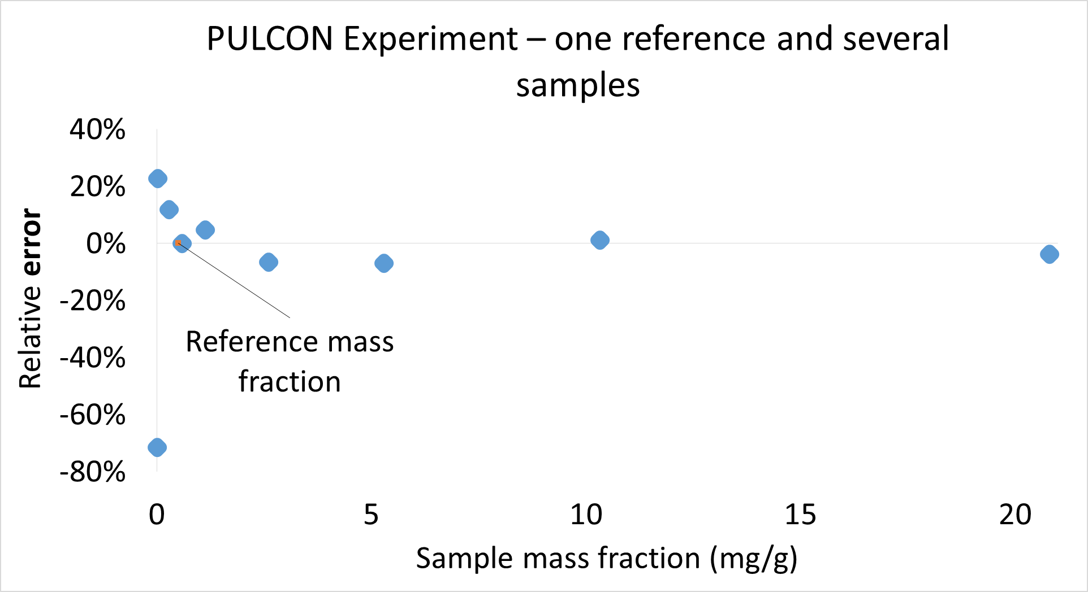
Figure S1: Linearity of qNMR calibration using PULCON.
To assess the impact of receiver gain on acquisitions, three DMSO₂ samples (AF) and three DMTP references (REF) were prepared at mass fractions of 0.5 mg/g, 5 mg/g and 20 mg/g. Extremely poor quantitative performance was observed when different gain settings were used in the samples and the reference tubes and therefore, we decided to use fixed receiver gains. Using a fixed gain value, we achieved relative errors between -0.9% and 9.57%.

S4.2) Validation of quantification methods using PULCON
An aliquot of each of the extracts was quantitated by qNMR using PULCON method with DMSO₂ as reference. The results were compared with those obtained from a second aliquot of the same extracts analyzed by gas chromatography-mass spectrometry (GC-MS) using a standard addition calibration with coordinate swapping[3], which served as the reference method.
¹H NMR spectra were acquired using a standard delay-pulse-acquire (zg) sequence with 90° pulses, calibrated by automated pulsecal routine. The pulse offset was set to 5.6 ppm, with a spectral width of 40 ppm and a time domain of 128k points, resulting in an acquisition time of 3.28 s. The relaxation delay was set to 10 times the longest measured T₁ value (57.72 s). Spectra were recorded at 298.1 K, with 8 scans and 4 dummy scans. The receiver gain was adjusted using reference samples and subsequently kept constant for all measurements. Figure S2 presents the ¹H NMR of yerba mate extract, with caffeine signals indicated by the black arrows.

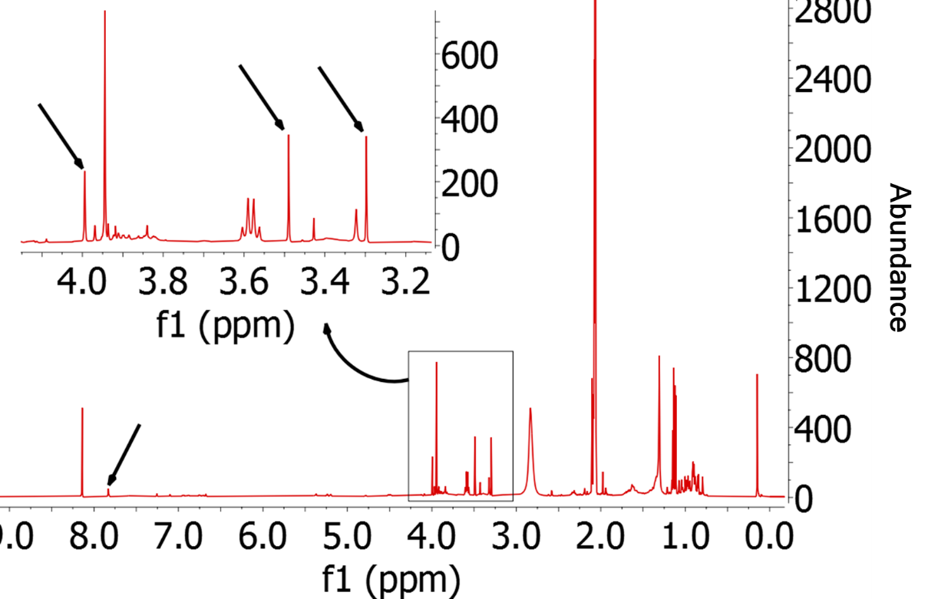
Figure S2: ¹H NMR spectra of yerba mate extract in acetone-d6 – black arrows indicated the peaks from caffeine.
GC-MS quantification was performed using the standard addition method combined with coordinate swapping approach. In this method, the caffeine concentration in the extract was obtained directly from the linear coefficient of the calibration curve [3]. The associated measurement uncertainty was derived from the uncertainty of this coefficient, as determined by regression analysis, thereby simplifying both quantification and uncertainty evaluation [5]. Calibration curves were constructed for each extract, and the linear coefficient of each curve corresponded to the absolute caffeine concentration in the respective extract.
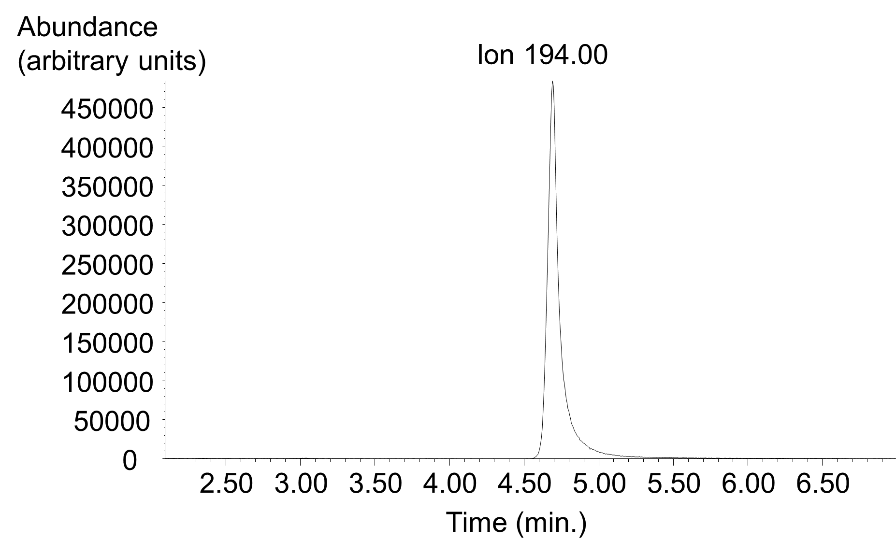
Figure S3: Extracted ion chromatogram (m/z 194) of the third calibration level used for caffeine quantification in yerba mate extract.

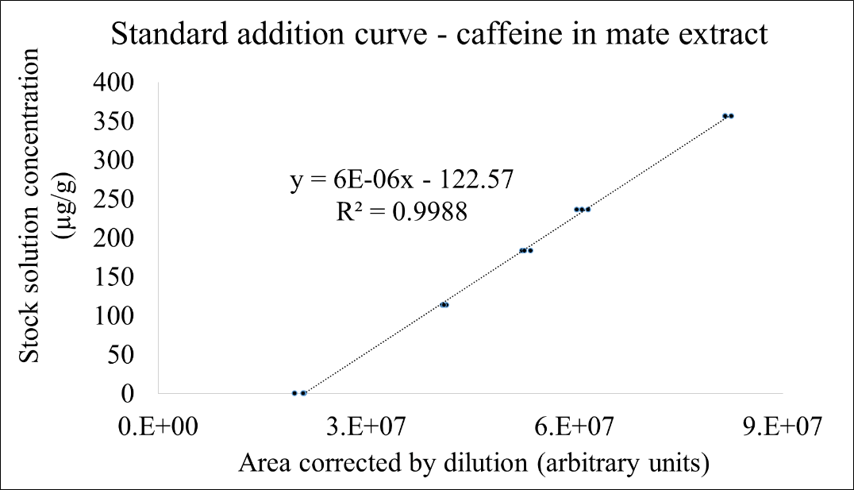
Figure S4: Standard addition calibration curve for GC-MS quantification of caffeine in yerba mate extract.

Method comparison was performed using the normalized error approach in accordance with Section 10.2.1.5.2 of DOQ-CGRE-008[6], applying Equation 2. The normalized error was calculated by comparing the value obtained by NMR-PULCON with the reference value obtained by GC-MS using standard addition, considering the respective expanded uncertainties (coverage factor k = 2). A normalized error value ≤ 1 was used as the criterion for method equivalence. Quantitative results from both methods and their associated uncertainties are summarized in Table S1, and the method comparison illustrated in Figure S5. For all extracts analyzed, normalized error values were below 1, demonstrating equivalence between the NMR-PULCON and GC-MS methods.

$$E_{n} = \frac{{(X}_{NMR}{- X}_{ref })}{ \sqrt{U_{NMR}^{2}+U_{ref}^{2} }}$$ | 2

Table S1: Quantitative results for yerba mate extract obtained by NMR-PULCON and GC-MS, including comparison and expanded uncertainties (k = 2).
Sample | CG-MS result in µg/g | CG-MS expanded uncertainty in µg/g (U) | PULCON-qNMR result in µg/g | PULCON-qNMR expanded uncertainty in µg/g (U) | Normalized error
Extract 1 | 122.6 | 8.9 | 130.4 | 3.3 | 0.821
Extract 2 | 173.2 | 10 | 176.8 | 2.9 | 0.343
Extract 3 | 147.0 | 9.5 | 153.5 | 1.7 | 0.654

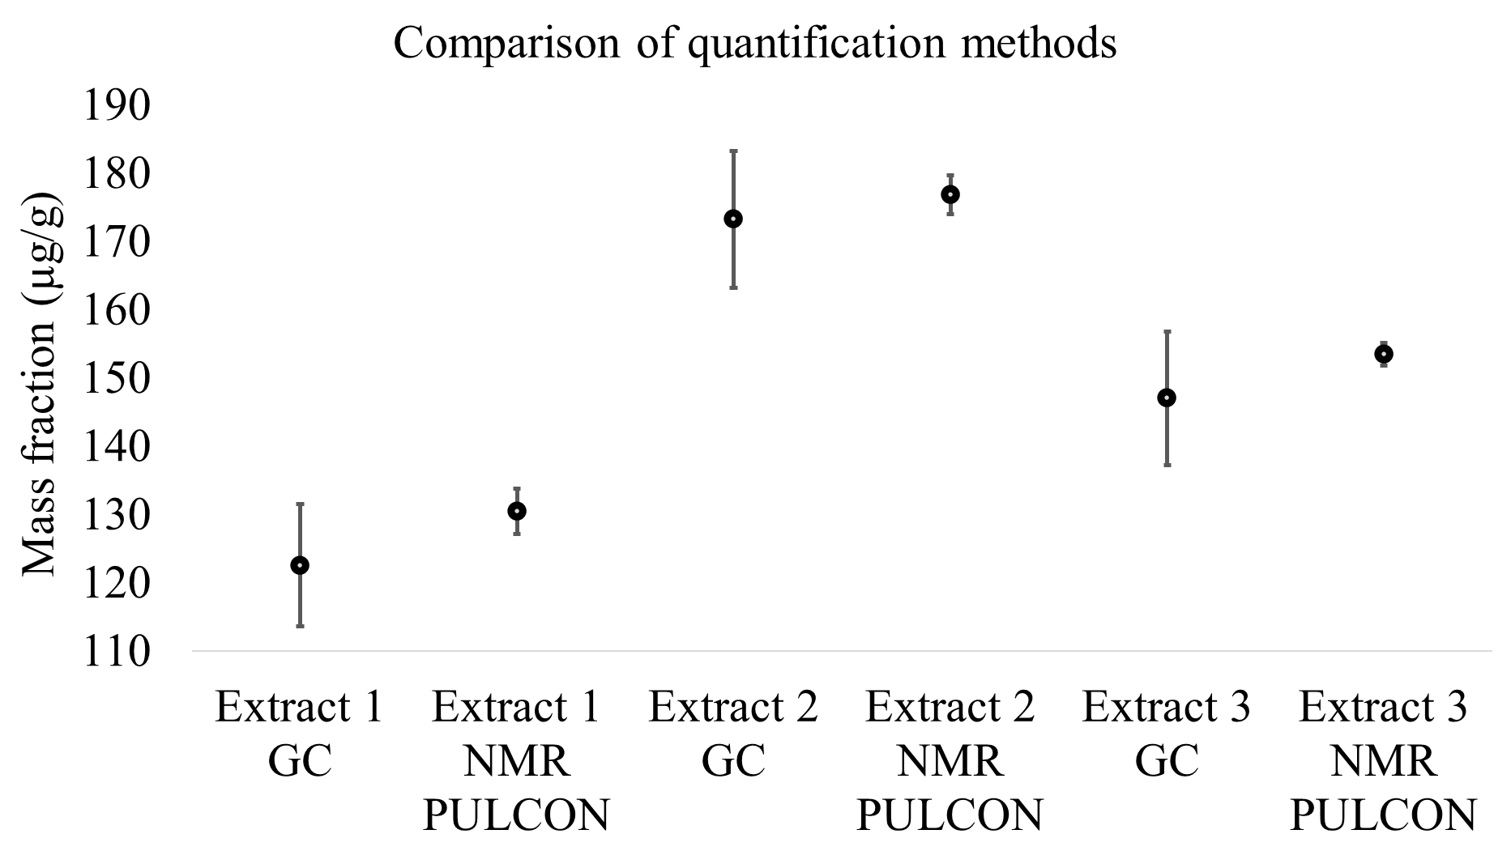
Figure S5: Comparison of GC-MS (standard addition) and NMR-PULCON methods for caffeine quantification in yerba mate extracts (data from Table 1). Error bars represent expanded uncertainties (k = 2).

S4.3) Quantification of Δ⁹-THC and CBN in cannabis extracts
The validated quantitative ¹H NMR (qNMR) method was applied to cannabinoid analysis in extracts for the determination of cannabinol (CBN) and Δ⁹-tetrahydrocannabinol (Δ⁹-THC). Cannabis samples from different origins were first evaluated by ¹H-qNMR using the PULCON approach with dimethylsulfone CRM as the calibration reference. Cannabinoid mass fractions were calculated using Equation 8. Quantification was performed using two characteristic, non-overlapping signals for each analyte: δ 8.16 ppm (s, 1H) and 6.44 ppm (d, 1H) for CBN, and δ 6.14 ppm (d, 1H) and 3.20 ppm (dd, 1H) for Δ⁹-THC, in agreement with literature data [8]. Final concentrations were obtained by averaging the values derived from the individual signals. The mass fractions of Δ⁹-THC and CBN in the analyzed extracts are summarized in Table S2.

Table S2: Quantification of cannabis extracts by ¹H-NMR-PULCON method.
Sample  (genotype) | Mass fraction CBN  (g/100 g) | Expanded uncertainty CBN (k = 2; 95 %) (g/100 g) | Mass fraction Δ⁹–THC (g/100 g) | Expanded uncertainty Δ⁹–THC (k = 2; 95 %) (g/100 g)
Ia (Preta knush) | 2.70 | 0.02 | 19.4 | 0.15
IIa (Barbara knush) | 0.91 | 0.01 | 14.5 | 0.11
IIIa (Whitewindow) | 1.57 | 0.01 | 10.8 | 0.10
Aa (Nightingale) | 6.24 | 0.05 | 16.9 | 0.13
Ba (Sano 7) | 8.71 | 0.16 | 26.6 | 0.50
Ca (Peach pure) | 8.59 | 0.10 | 24.3 | 0.27
In (213) | 4.75 | 1.27 | 31.23 | 1.27

S5) Isolation and synthesis of cannabinoids

S5.1) Cannabinoids extract preparation from Cannabis plant
Cannabinoids were extracted to produce CBN and Δ⁹-THC certified reference materials (CRM) using ultrasonic-assisted extraction. Direct pulsed ultrasonication was performed with a Qsonica ultrasonic tip sonicator housed in an acoustic cabinet. Extraction amplitudes of 18, 27, and 60 were evaluated to optimize energy transfer. Approximately 10 g of ground sample was extracted with 100 mL of methanol using an 8:2 s pulse on/off cycle for 30 min in an ice bath. The resulting extract was filtered, concentrated by rotary evaporation, dried under a nitrogen stream and weighed, furnishing 18% yield of crude extract.
In parallel, ultrasonic bath extraction was evaluated. Dried and sieved material (200 mg) was extracted with 2 mL of methanol in centrifuge tubes using an ultrasonic bath operating at 80 kHz and 60 W for 30 min with an ice bath. Extracts were filtered, concentrated, dried under nitrogen, and weighed, furnishing 19% yield of crude extract. The extracts were protected from light and stored under refrigeration. These results demonstrate comparable performance from both methods.

S5.2) Optimization of the conditions for the synthesis of CBN from Δ⁹-THC
The isolated Δ⁹-THC was subjected to aromatization under various oxidative conditions to investigate its conversion to CBN (Table S3). Reactions employing a combination of I₂ and DDQ as oxidants were evaluated for up to 12 h. The optimal conditions for Δ⁹-THC aromatization to CBN were established as treatment with 2 equivalents of iodine for 4 h (Table S3, entry 7).
Optimized experimental procedure: In a 25 mL round-bottom flask containing Δ⁹-THC (20 mg, 0.063 mmol, 1.0 equiv), iodine (2.0 equiv, 0.126 mmol, 32 mg) and toluene (10 mL) were added. The reaction mixture was heated under reflux with magnetic stirring for 4h. After completion, the crude reaction mixture was treated with 5 mL of an aqueous 5% sodium thiosulfate (Na₂S₂O₃) solution and extracted with ethyl acetate (5 mL). The organic phase was dried over MgSO₄, filtered, and concentrated under reduced pressure. The product was purified by silica gel column chromatography using 10% ethyl acetate in hexane as eluent. Cannabinol (CBN) was obtained as an orange oil in 52% yields.

Table S3: Optimization of the aromatization reaction of Δ⁹–THC.
Entry | Conditions | Time (hours) | Yieldª
1 | I₂ (0.5 equiv.)  DDQ (0.5 equiv) | 4 | 24%
2 | I₂ (0.5 equiv.)  DDQ (0.5 equiv) | 6 | 29%
3 | I₂ (0.5 equiv.)  DDQ (0.5 equiv) | 12 | 24%
4 | I₂ (2 equiv.) | 1 | 13%
5 | I₂ (2 equiv.) | 2 | 33%
6 | I₂ (2 equiv.) | 3 | 40%
7 | I₂ (2 equiv.) | 4 | 52%
8 | I₂ (2 equiv.) | 6 | 42%
9 | I₂ (2 equiv.) | 12 | 39%
a: yields were determined by NMR using 1,3-benzodioxole as internal standard.

S5.3) Synthesis of CBN from Δ⁹-THC-rich extracts
Aromatization reactions were performed following the optimized procedure, on each extract using iodine (2.0 equiv), calculated based on the Δ⁹-THC mass fraction determined by ¹H qNMR (Table S2). To standardize the reaction conditions with respect to the amount of iodine employed, an additional set of reactions was carried out assuming the total mass of extract used (50 mg) as equivalent to pure Δ⁹-THC (50 mg, 0.159 mmol). This approach resulted in a significant effective excess of iodine relative to the actual Δ⁹-THC content. Results are shown in Table S4. The value of the combined relative uncertainty (u_{c} rel%), in the fifth column, indicates the dispersion of the measurement of the respective extracts, showing how large the error is in relation to the value being measured.

Table S4: Quantification of reactions with cannabis extracts by ¹H-qNMR.
Extract | Mass fraction of Δ⁹–THC in the extract  (g/100 g) | I₂ (mg) | Mass fraction of CBN after reaction  (g/100 g) | u_{c} rel%
Ia (207) | 19.4 | 15.23ª | 21.83 | 1.08
Ia (207) | 19.4 | 39.95^{b} | 22.45 | 1.16
IIa (208) | 14.5 | 11.67ª | 19.79 | 1.35
IIa (208) | 14.5 | 39.95^{b} | 22.49 | 1.09
IIIa (209) | 10.8 | 8.62ª | 13.82 | 1.07
IIIa (209) | 10.8 | 39.95^{b} | 12.61 | 1.05
Aa (210) | 16.9 | 13.70ª | 14.49 | 1.05
Aa (210) | 16.9 | 39.95^{b} | 26.95 | 1.06
Ba (211) | 26.6 | 21.82ª | 25.69 | 1.05
Ba (211) | 26.6 | 39.95^{b} | 33.65 | 1.08
Ca (212) | 24.3 | 19.80ª | 25.02 | 1.28
Ca (212) | 24.3 | 39.95^{b} | 28.12 | 1.27
In (213) | 31.23 | 23.4 | 31.58 | 1.28
In (213) | 31.23 | 39.95 | 30.91 | 1.35
Reaction conditions: all reactions were run using 50 mg of extract in toluene under reflux for 4 hours. a: 2 equivalents in mmol of iodine considering the mass fraction of Δ⁹–THC in 50 mg of extract; b: 1 equivalent in mmol of iodine considering 50mg of extract as the total mass of Δ⁹–THC.

S5.4) Isolation of Δ⁹-THC and CBN from cannabis extract
From cannabis plant extract: Δ⁹-THC and cannabinol (CBN) were isolated by preparative liquid chromatography (see section 3.1), eluting at retention times of 8.75 and 7.57 min, respectively. From 12 g of crude plant extract, Δ⁹-THC was obtained in 4.74% yield (568.80 mg) and CBN was obtained in 1.48% yield (177.60 mg).
From CBN-enriched crude extract: Preparative LC (see section 3.1) of crude extract enriched in CBN (586.51 mg) using the optimized synthetic protocol afforded CBN in a significantly higher yield of 24.05% (141.06 mg).
Figure S6 illustrates the preparative LC-DAD chromatograms comparing the chromatograms of both extracts, monitored at 210 nm.

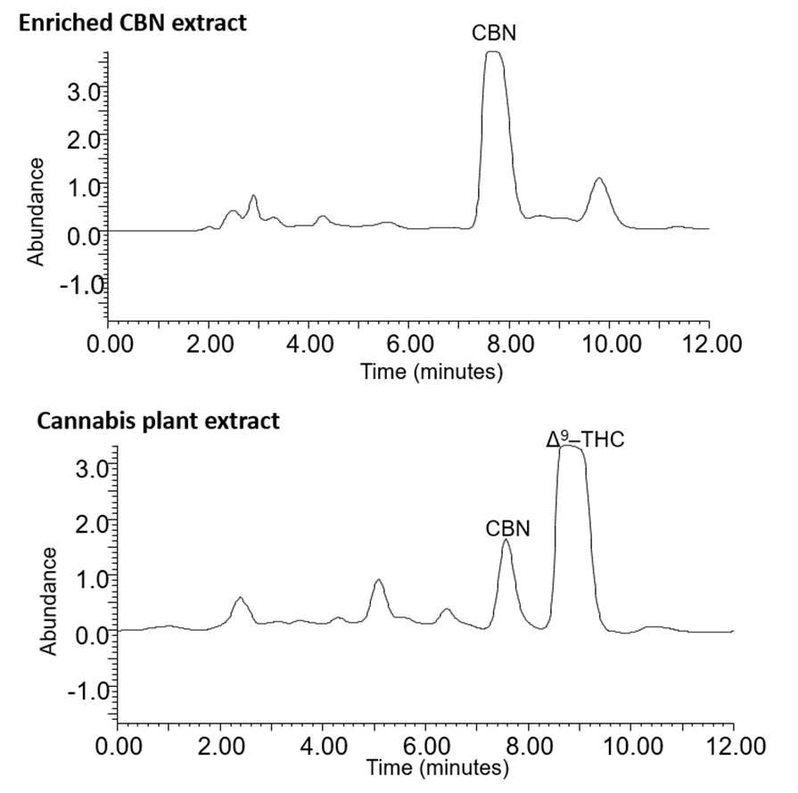
Figure S6: Preparative LC-DAD chromatograms of cannabis plant extract and CBN-enriched extract.

S5.5) Characterization of cannabinoids
Cannabis extracts and isolated cannabinoids (CBN, Δ⁹–THC) were analyzed using HPLC‑DAD‑MS/MS with electrospray ionization in positive mode. Collision energies ranged from 16 to 32 eV with a dwell time of 40 ms. Identification was based on comparison of MS and MS/MS spectra and retention times with cannabinoid standards and library references [4].
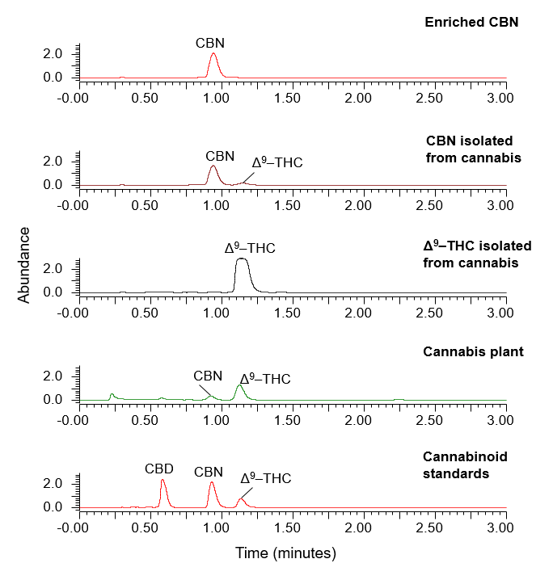
Figure S7: HPLC-DAD-MS/MS chromatograms of cannabinoids isolated from cannabis extracts, monitored at 210 nm. From top to bottom: CBN isolated from synthetically enriched extract; CBN isolated from cannabis plant extract; Δ⁹-THC isolated from cannabis plant extract; cannabis plant extract; cannabinoids standards.
The ESI-MS spectra of the cannabinoids present in the cannabis CRM candidate showed the following diagnostic ions positive acquisition mode: CBN [M+H]⁺ (m/z 311) and Δ⁹–THC [M+H]⁺ (m/z 315). In the ESI-MS/MS analysis, CBN [M+H]⁺ m/z 311 presented product ion m/z 223 and Δ⁹-THC [M+H]⁺ m/z 315 presented product ions m/z 193 and m/z 135, as illustrated in Figure S8. The fragmentation mechanisms of CBN and THC were elucidated following Citti et al [7].

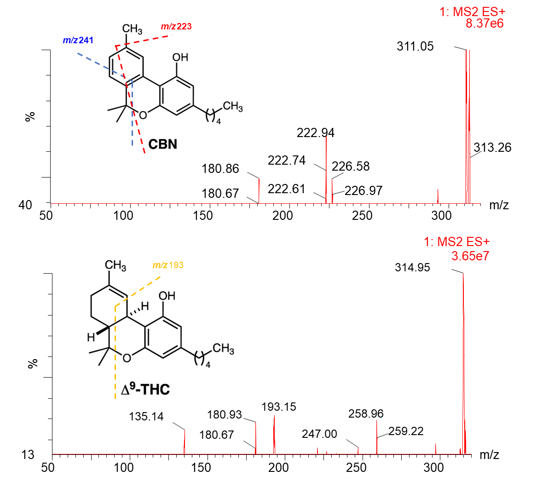
Figure S8: ESI (+)-MS/MS fragmentation spectrum of CBN and Δ9-THC in the Cannabis CRM candidate, CE 15 eV.

Cannabinoids in the CRM candidates were also confirmed by HPLC–PDA–MS/MS using multiple reaction monitoring (MRM). Two transitions were monitored for each analyte: CBN (m/z 311→223, CE 22 eV; m/z 311→241, CE 18 eV) and Δ⁹-THC (m/z 315→193, CE 21 eV; m/z 315→135, CE 20 eV). Identification was achieved by comparison of retention times and MRM transitions with authentic cannabinoid standards (CBD, CBN, and Δ⁹-THC).
MRM analysis detected trace amounts of Δ⁹-THC in the CBN fraction isolated from cannabis plant extracts and trace amounts of CBN in the Δ⁹-THC fraction, reflecting the similar polarity and chromatographic behavior of Phyto cannabinoids. In contrast, CBN obtained from Δ⁹-THC-rich Cannabis sativa extracts subjected to the optimized synthetic conversion showed no detectable Δ⁹-THC or other impurities under the conditions employed, demonstrating the advantage of producing CBN via controlled conversion of THC rather than direct isolation from the complex plant matrix.
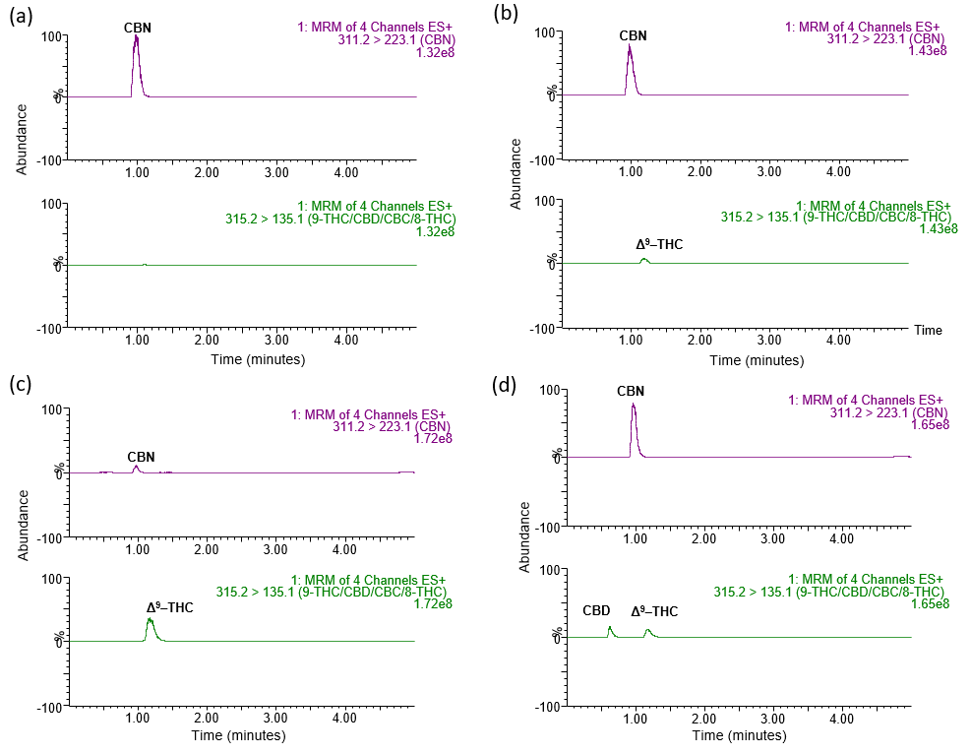
Figure S9: HPLC-PDA-MS/MS ion chromatogram using MRM method monitoring the transition ions (CBN m/z 311→m/z 223; Δ9-THC m/z 315→ m/z 135), to identify cannabinoids in MRC candidates. (a) CBN obtained from Δ9–THC-rich extract; (b) CBN isolated from cannabis; (c) Δ⁹-THC isolated from cannabis; (d) cannabinoid standards

Cannabinoids CRM candidates in isolates obtained from synthetic material and plant sources, were confirmed by quantitative ¹H NMR using external calibration by the PULCON method. The characteristic chemical shifts (δ, ppm) corresponding to CBN and Δ⁹-THC were assigned in accordance with reported values[8]. Representative ¹H qNMR spectra of plant-based CRM candidates and isolated cannabinoids are shown in Figure S10.
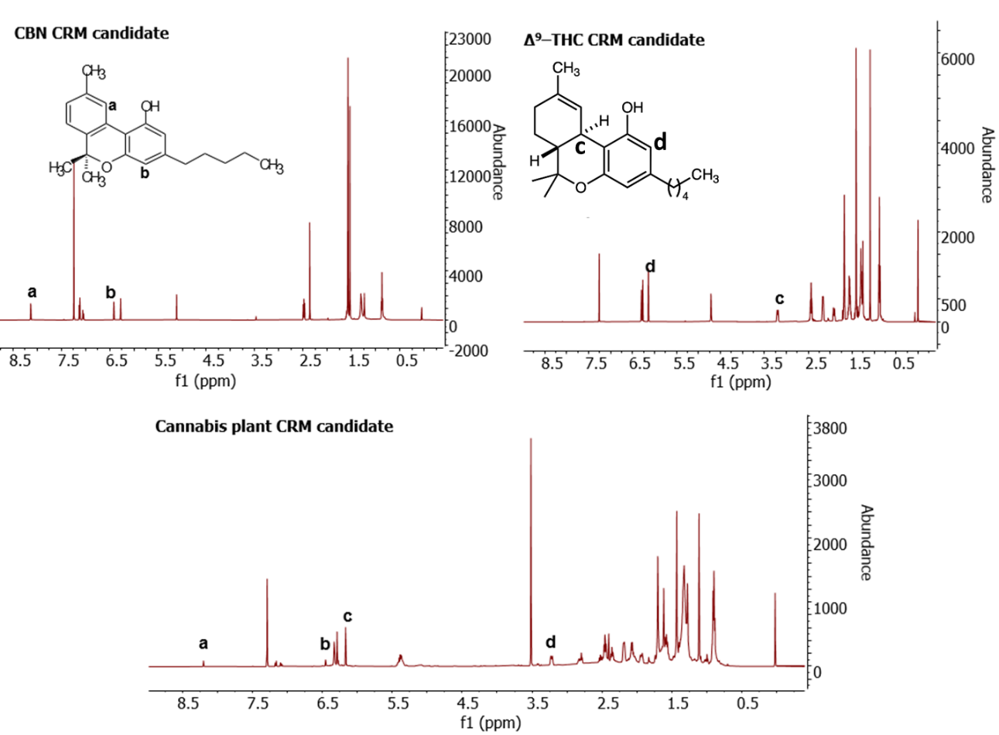
Figure S10: ¹H NMR spectra (500 MHz, CDCl₃) of the CRM candidates. Top left: CBN obtained from conversion of Δ⁹-THC in plant extract; top right: Δ⁹-THC isolated from cannabis plant extract; bottom: cannabis plant extract. Chemical shifts for CBN: (a) δ 8.15 ppm (1H, s); (b) δ 6.44 ppm (1H, d); chemical shifts for Δ⁹-THC: (c) δ 6.14 ppm (1H, d); (d) δ 3.20 ppm (1H, dm).

Table S5: Characterization of Cannabis CRM candidate by ¹H-qNMR.
Cannabis  Extract | Mass fraction CBN  (g/100 g) | Expanded uncertainty CBN (k = 2; 95 %) (g/100 g) | Mass fraction Δ⁹–THC  (g/100 g) | Expanded uncertainty  Δ⁹–THC (k = 2; 95 %)  (g/100 g)
Replicate A | 5.17 | 0.04 | 30.14 | 0.23
Replicate B | 5.15 | 0.04 | 29.58 | 0.25
Replicate C | 4.99 | 0.04 | 28.93 | 0.21

Measurement uncertainty was estimated using the law of propagation of uncertainties, considering all sources of uncertainty associated with the input quantities of the measurand, as defined in Equation 8 and illustrated in Figure S11.
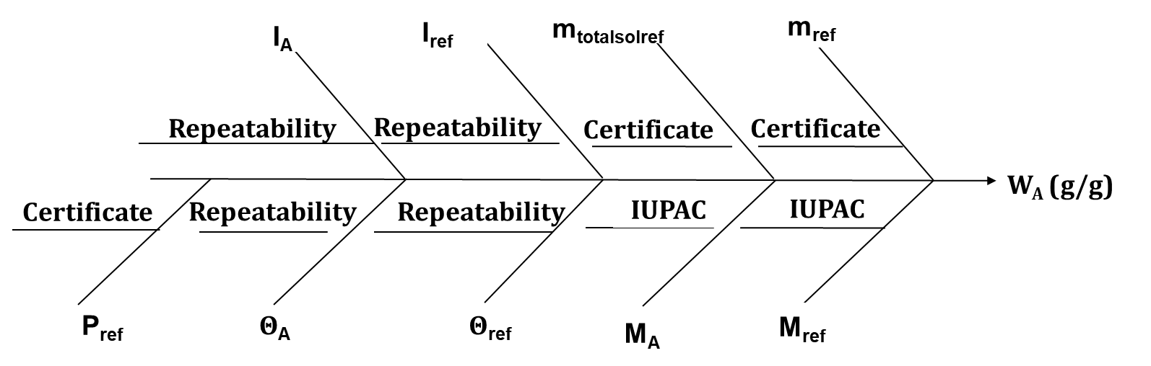
Figure S11: Ishikawa diagram showing sources of uncertainty for ¹H qNMR analysis.

The relative contributions of uncertainty sources to the determination of CBN and Δ⁹-THC mass fractions by quantitative ¹H NMR were evaluated individually for each selected cannabinoid signal in the CRM candidate extract. Uncertainty components associated with all input quantities were considered in the calculation of the combined uncertainty, with the uncertainty related to weighing of the reference standard (DMSO₂) representing the dominant contribution. Quantification of cannabinoids was performed using the PULCON method, and mass fractions obtained by ¹H qNMR (k = 2) were 5.1 g/100 g for CBN and 29.6 g/100 g for Δ⁹-THC in the extract. Based on an extraction yield of 18%, the corresponding mass fractions in the original plant material were calculated as approximately 0.9 g/100 g for CBN and 5.4 g/100 g for Δ⁹-THC.

S6) Cannabis and Cannabinoid Certified Reference Materials

S6.1) Estimation of uncertainties
The uncertainty due to between unit (bu) homogeneity was calculated with Equation 3 [8].

$$u_{bu}^{}=\sqrt{\frac{{MS}_{between}-{MS}_{within}}{n_{r}}}$$ | 3

Where u_{bu} is the uncertainty due to between unit homogeneity, MS_{within} is mean square within groups (different replicates of the same unit), MS_{between} is mean square between groups (different units), and n_{r} is number of replicates.
The uncertainty due to within unit (wu) homogeneity was calculated with Equation 4.

$$u_{wu}^{}=\sqrt{\frac{{MS}_{between}-{MS}_{within}}{n_{r}}}$$ | 4

Where u_{wu} is the within-unit component of variance from a homogeneity study, expressed as a standard deviation, MS_{between} is the mean square between aliquots, and MS_{within} is the mean square within aliquots.
The uncertainty associated with heterogeneity ($u_{h}$) was calculated according to Equation 5[8].
$u_{hom}=\sqrt{u_{bu}^{2}+{u_{wu}^{2}}^{}}$ 5

The percentage contribution of heterogeneity was calculated with Equation 6 [8].

$C \%=u_{hom}^{}×100/ X$ 6

Where, $u_{hom}^{}$ IS standard uncertainty associated with heterogeneity; X is the mean of all results.
The short-term stability uncertainty (u_{sts}) was estimated using Equation 7 [8].

$$u_{sts}{=S}_{(b1)}t$$ | 7

Where, s(b1) is estimate of the standard error of the slope (g.100 g day⁻¹ or g.100 g week⁻¹), and t is the time (days, weeks).
The percentage contribution of thermal instability of the material batch during transportation was calculated with Equation 8 [8].

$C \%=u_{sts}^{}×100/ X$ 8

S6.2) Homogeneity studies
Between-unit homogeneity was assessed by analyzing three true replicates from 10 units selected via random stratified sampling. Within-unit homogeneity was evaluated through three true replicates of three units. Cannabis samples were prepared at 5 mg mL⁻¹ of plant material. From each flask, three aliquots of approximately 50 mg were weighed and extracted with 10 mL methanol in an ultrasonic bath (60 W, 80 kHz) for 30 min. Extracts were centrifuged at 4000 rpm for 5 min at temperatures below 25 °C. A 1 mL aliquot of the supernatant was filtered through a 0.22 µm membrane directly into 2 mL vials and injected in triplicate into the ACQUITY UPLC–PDA–MS/MS system within a single injection sequence. To minimize block effects or trends within the sequence, the first injection block (group) was analyzed in ascending filling order, the second in random order, and the third in descending order. Results were evaluated by the analyte peak area (Δ⁹–THC and CBN) corrected by the mass fraction of the solution, determined as shown in Equation 9 [8].

A_{corrected =} A_{analyte}/ MF_{solution} 9

Where, A_{corrected} = HPLC peak area corrected by mass fraction of the cannabinoid in the analyzed solution, A_{analyte}= cannabinoids peak area (5 mg mL⁻¹ solution); MF_{solution} = mass fraction of cannabinoid in the solution.
This result does not correspond to the concentration or mass fraction of analyte in the sample. Nevertheless, the variation of this relative parameter in the samples was employed as a measure of material homogeneity, given that all samples were analyzed under repeatability conditions within the same chromatographic sequence [9].

S6.3) Transport study
Transport stability (short-stability) was assessed over 28 days at 4 °C and 20 °C, simulating typical transport conditions, using an isochronous design. Ten units were selected via stratified random sampling for each study. Every 7 days, two units from each temperature condition were removed and stored at the reference temperature (−20 °C) until analysis. At the end of the study, the 16 flasks collected at 7, 14, 21, and 28 days were combined with two additional units continuously stored at −20 °C as controls. Twenty candidate CRM flasks were prepared in triplicate and analyzed on the same day (5 mg mL⁻¹ cannabis plant solutions) by HPLC–DAD, with three replicate injections. The analytical methods and data evaluation followed the procedures established in the homogeneity study.

S7) References
1. Wider G, Dreier L (2006) Measuring Protein Concentrations by NMR Spectroscopy. J Am Chem Soc 128:2571–2576. https://doi.org/10.1021/ja055336t
2. Garrido BC, de Carvalho LJ (2014) Nuclear magnetic resonance using electronic referencing: method validation and evaluation of the measurement uncertainties for the quantification of benzoic acid in orange juice. Magnetic Resonance in Chemistry n/a-n/a. https://doi.org/10.1002/mrc.4166
3. Meija J, Pagliano E, Mester Z (2014) Coordinate swapping in standard addition graphs for analytical chemistry: A simplified path for uncertainty calculation in linear and nonlinear plots. Anal Chem 86:8563–8567. https://doi.org/10.1021/ac5014749
4. McRae G, Melanson JE (2020) Quantitative determination and validation of 17 cannabinoids in cannabis and hemp using liquid chromatography-tandem mass spectrometry. Anal Bioanal Chem 412:7381–7393. https://doi.org/10.1007/s00216-020-02862-8
5. (2008) GUM - Guia para Expressão de Incerteza de Medição
6. Inmetro (2020) DOQ-CGCRE-008 - Orientação sobre Validação de Métodos Analíticos
7. Citti C, Linciano P, Forni F, Vandelli MA, Gigli G, Laganà A, Cannazza G (2019) Analysis of impurities of cannabidiol from hemp. Isolation, characterization and synthesis of cannabidibutol, the novel cannabidiol butyl analog. J Pharm Biomed Anal 175:112752. https://doi.org/https://doi.org/10.1016/j.jpba.2019.06.049
8. ABNT ISO GUIA 35 (2012) Reference materials - General and statistical principles for certification
9. Domingo V, Prieto C, Silva L, Rodilla JML, Quílez del Moral JF, Barrero AF (2016) Iodine, a Mild Reagent for the Aromatization of Terpenoids. J Nat Prod 79:831–837. https://doi.org/10.1021/acs.jnatprod.5b00914

