Quantitative Determination and Validation of 96 Pesticides in Cannabis by LC-MS/MS and GC-MS/MS
MacKenzie, D.A.*¹, Anyanwu, A.M.², McRae, G.¹, and Melanson, J.E.¹
¹ National Research Council of Canada, Metrology, 1200 Montreal Road, Ottawa, ON, K1A 0R6, Canada
² Environment and Climate Change Canada, Air Quality Research Division, 335 River Road, Ottawa, ON, K1V 1C7, Canada
* Corresponding Author
E-mail Address: Douglas.MacKenzie@nrc-cnrc.gc.ca
Supplementary Information
Contents
Supplementary Tables 3
Table S 1 - Global Settings for TSQ Altis 3
Table S 2 - Vanquish Flex LC-MS/MS Gradient Parameters 3
Table S 3 - TSQ 9000 Global Settings 3
Table S 4 - GC-MS/MS PTV Inlet Parameters 3
Table S 5 - GC-MS/MS Oven Temperature Program 4
Table S 6 - LC-MS/MS Transitions (Quantification Transitions Identified in Bold) 4
Table S 7 - GC-MS/MS Transitions (Quantification Transitions Identified in Bold) 9
Table S 8 - Master Calibration Solution Preparation 10
Table S 9 - Spiking Solution Preparation 11
Table S 10 - Internal Standard Spiking Solution 11
Table S 11 - Spiking Volumes Used 11
Table S 12 - LC-MS/MS Between Sample Accuracy at 25 ppb (Individually Calibrated Analytes) 12
Table S 13 - LC-MS/MS Between-Sample Accuracy at 25 ppb (Group Calibrated Analytes) 14
Table S 14 - LC-MS/MS Between-Sample Accuracy at 250 ppb (Individually Calibrated Analytes) 14
Table S 15 - LC-MS/MS Between Sample Accuracy at 250 ppb (Group Calibrated Analytes) 16
Table S 16 - GC-MS/MS Between-Sample Accuracy at 25 ppb (Individually Calibrated Analytes) 17
Table S 17 – GC-MS/MS Between-Sample Accuracy at 25 ppb (Group Calibrated Analytes) 17
Table S 18 - GC-MS/MS Between-Sample Accuracy at 75 ppb (Individually Calibrated Analytes) 17
Table S 19 - GC-MS/MS Between-Sample Accuracy at 75 ppb (Group Calibrated Analytes) 18
Table S 20 - GC-MS/MS Between-Sample Accuracy at 1250 ppb (Individually Calibrated Analytes) 18
Table S 21 - GC-MS/MS Between-Sample Accuracy at 1250 ppb (Group Calibrated Analytes) 18
Table S 22 - LC-MS/MS Analyte Recovery (Individually Calibrated Analytes) 19
Table S 23 - LC-MS/MS Ion Suppression 21
Supplementary Figures 25
Figure S 2 - LC-MS/MS Calibration Curves (1 of 8) 26
Figure S 3 - LC-MS/MS Calibration Curves (2 of 8) 27
Figure S 4 - LC-MS/MS Calibration Curves (3 of 8) 28
Figure S 5 - LC-MS/MS Calibration Curves (4 of 8) 29
Figure S 6 - LC-MS/MS Calibration Curve (5 of 8) 30
Figure S 7 - LC-MS/MS Calibration Curves (6 of 8) 31
Figure S 8 - LC-MS/MS Calibration Curves (7 of 8) 32
Figure S 9 - LC-MS/MS Calibration Curves (8 of 8) 33
Figure S 10 - GC-MS/MS Calibration Curves (1 of 3) 34
Figure S 11 - GC-MS/MS Calibration Curves (2 of 3) 35
Figure S 12 - GC-MS/MS Calibration Curves (3 of 3) 36
Figure S 13 - LC-MS/MS Selected Ion Chromatograms at 75 ppb (1 of 9)
Figure S 14 - LC-MS/MS Selected Ion Chromatograms at 75 ppb (2 of 9)
Figure S 15 - LC-MS/MS Selected Ion Chromatograms at 75 ppb (3 of 9)
Figure S 16 - LC-MS/MS Selected Ion Chromatograms at 75 ppb (4 of 9)
Figure S 17 - LC-MS/MS Selected Ion Chromatograms at 75 ppb (5 of 9)
Figure S 18 - LC-MS/MS Selected Ion Chromatograms at 75 ppb (6 of 9)
Figure S 19 - LC-MS/MS Selected Ion Chromatograms at 75 ppb (7 of 9)
Figure S 20 - LC-MS/MS Selected Ion Chromatograms at 75 ppb (8 of 9)
Figure S 21 - LC-MS/MS Selected Ion Chromatograms at 75 ppb (9 of 9)
Figure S 22 - GC-MS/MS Selected Ion Chromatograms at 75 ppb (1 of 3). Note: Kinoprene and Methoprene, highlighted with a bold outline, are displayed at 1250 ppb.
Figure S 23 - GC-MS/MS Selected Ion Chromatograms at 75 ppb (2 of 3). Note: cis and trans permethrins, highlighted with a bold outline, are displayed at 1250 ppb.
Figure S 24 - GC-MS/MS Selected Ion Chromatograms at 75 ppb. Note: Cypermethrins 1-4, highlighted with a bold border, are displayed at 250 ppb.
Figure S 25 - Effect of THCA and dilution on peak shape of dodemorph (RT = 4.9 min).
Figure S 26 - LC-MS/MS Chromatogram of Dodemorph, Spiroxamine, and Cyprodinil spiked at 75 ppb on matrix 50

Supplementary Tables

Table S 1 - Global Settings for TSQ Altis
Parameter | MS/MS Setting
Scan Type | MRM
Ion Source | H-ESI
Probe Position | 2.0 and M
Polarity | Positive / Negative
ISV (V) | 4000 / 3000
Sheath Gas (arb) | 70
Aux Gas (arb) | 25
Sweep Gas (arb) | 2
Transfer Tube Temperature (°C) | 310
Vaporizer Temperature (°C) | 150
RF Lens | Analyte Specific
Collision Gas (mTorr) | 2
Cycle Time (s) | 0.4

Table S 2 - Vanquish Flex LC-MS/MS Gradient Parameters
Time (min) | Flow (mL/min) | %A | %B
0 | 0.5 | 80 | 20
5.5 | 0.5 | 25 | 75
10.5 | 0.5 | 2 | 98
13 | 0.5 | 2 | 98
13.1 | 0.5 | 80 | 20
16 | 0.5 | 80 | 20

Table S 3 - TSQ 9000 Global Settings
Parameter | Setting
Method Type | Acquisition - Timed
MS Transfer Line Temperature (°C) | 325
Ion Source Temperature (°C) | 330
Ionization Mode | EI

Table S 4 - GC-MS/MS PTV Inlet Parameters and Temperature Settings
PTV Step | Rate (°C/s) | Inlet Temperature (°C) | Time (min) | Flow (mL/min)
Injection | - | 100 | 0.05 | 50
Evap | 2.5 | 120 | 0.5
Transfer | 2.5 | 325 | 1
Cleaning | 14.5 | 340 | 20 | 100
Temperature Settings
Enable Temperature Control | Yes
Temperature | 100 °C
Inlet Parameters
Operating mode | Splitless
Split flow control | Yes
Split flow | 60.0 mL/min
Split Ratio | 50
Splitless Time | 1.00 min
Purge flow control | Yes
Purge flow | 20.000 mL/min
Constant septum purge | Yes
Vacuum compensation | Yes
Enable gas saver mode | Yes
Gas saver flow | 20.0 mL/min
Gas saver time | 5.00 min

Table S 5 - GC-MS/MS Oven Temperature Program
Retention Time (min) | Rate (°C/min) | Target Value (°C) | Hold Time (min)
1.5 | 0 | 40 | 1.5
7.1 | 25 | 180 | 0
18.975 | 8 | 275 | 0
30.308 | 15 | 325 | 8

Table S 6 - LC-MS/MS Transitions (Quantification Transitions Identified in Bold)
Analyte | RT (min) | RT Window (min) | Polarity | Precursor (m/z) | Product (m/z) | CE (V) | RF Lens (V)
Daminozide | 0.61 | 0.5 | + | 161.09 | 44 | 21 | 36
Daminozide | 0.61 | 0.5 | + | 161.09 | 142.917 | 10 | 36
Daminozide-d4 | 0.61 | 0.5 | + | 165.112 | 44 | 20 | 36
Daminozide-d4 | 0.61 | 0.5 | + | 165.112 | 45.083 | 22 | 36
Daminozide-d4 | 0.61 | 0.5 | + | 165.112 | 62.073 | 13 | 36
Daminozide-d4 | 0.61 | 0.5 | + | 165.112 | 147.083 | 12 | 36
Acephate | 0.91 | 0.5 | + | 183.95 | 124.8 | 18 | 30
Acephate | 0.91 | 0.5 | + | 183.95 | 142.97 | 9 | 30
Dinotefuran | 1.4 | 0.5 | + | 203.047 | 113.071 | 10.23 | 30
Dinotefuran | 1.4 | 0.5 | + | 203.047 | 129.071 | 11.63 | 30
Oxamyl (+NH4) | 1.42 | 0.5 | + | 237.1 | 72.125 | 12 | 30
Oxamyl (+NH4) | 1.42 | 0.5 | + | 237.1 | 90.125 | 9 | 30
Flonicamid | 2 | 1 | + | 230.1 | 174.04 | 17 | 41
Flonicamid | 2 | 1 | + | 230.1 | 203.11 | 16 | 41
Methomyl | 1.81 | 0.5 | + | 162.85 | 88.042 | 9 | 30
Methomyl | 1.81 | 0.5 | + | 162.85 | 106.113 | 10 | 30
Thiamethoxam | 2.13 | 1 | + | 292.03 | 181.04 | 23 | 52
Thiamethoxam | 2.13 | 1 | + | 292.03 | 211.1 | 12 | 52
Thiamethoxam-d4 | 2.13 | 1 | + | 296.175 | 183 | 23 | 54
Thiamethoxam-d4 | 2.13 | 1 | + | 296.175 | 214.083 | 11 | 54
Thiamethoxam-d4 | 2.13 | 1 | + | 296.175 | 215.083 | 13 | 54
Mevinphos Iso 1 | 2.9 | 2 | + | 224.988 | 126.988 | 10.23 | 31
Mevinphos Iso 1 | 2.9 | 2 | + | 224.988 | 192.97 | 8 | 31
Pirimicarb | 2.7 | 1 | + | 239.088 | 72.125 | 21.49 | 47
Pirimicarb | 2.7 | 1 | + | 239.088 | 182.071 | 16.07 | 47
Imidacloprid | 2.8 | 1 | + | 256.1 | 175.125 | 19 | 41
Imidacloprid | 2.8 | 1 | + | 256.1 | 209.113 | 16 | 41
Dimethoate | 3.08 | 1 | + | 230 | 124.887 | 21 | 30
Dimethoate | 3.08 | 1 | + | 230 | 199.03 | 11 | 30
Clothianidin | 3.26 | 1 | + | 249.974 | 112.93 | 27 | 34
Clothianidin | 3.26 | 1 | + | 249.974 | 131.917 | 16.56 | 34
Acetamiprid | 3.27 | 1 | + | 223.1 | 55.889 | 16.32 | 47
Acetamiprid | 3.27 | 1 | + | 223.1 | 125.92 | 20 | 47
Aldicarb (+NH4) | 3.5 | 1 | + | 208.1 | 89.04 | 17 | 68
Aldicarb (+NH4) | 3.5 | 1 | + | 208.1 | 116.04 | 10 | 68
Imazalil | 4.5 | 2 | + | 297.1 | 159.042 | 22 | 64
Imazalil | 4.5 | 2 | + | 297.1 | 255.071 | 18.24 | 64
Thiacloprid | 4.03 | 1 | + | 253.1 | 90.1 | 36 | 56
Thiacloprid | 4.03 | 1 | + | 253.1 | 125.91 | 21 | 56
Dichlorvos | 4.17 | 1 | + | 220.866 | 109.042 | 17.77 | 86
Dichlorvos | 4.17 | 1 | + | 220.866 | 145.042 | 13.87 | 86
Propoxur | 4.2 | 1 | + | 210.1 | 111.04 | 14 | 30
Propoxur | 4.2 | 1 | + | 210.1 | 168.11 | 8 | 30
Carbofuran | 4.3 | 1 | + | 222.1 | 122.988 | 21 | 32
Carbofuran | 4.3 | 1 | + | 222.1 | 165.125 | 12 | 32
Dodemorph | 5 | 2 | + | 282.225 | 98.13 | 26.53 | 52
Dodemorph | 5 | 2 | + | 282.225 | 116.1 | 20.92 | 52
Imazalil-d5 | 4.5 | 1 | + | 302.2 | 159 | 24 | 71
Imazalil-d5 | 4.5 | 1 | + | 302.2 | 203 | 19 | 71
Imazalil-d5 | 4.5 | 1 | + | 302.2 | 255.083 | 19 | 71
Thiophanate Methyl | 4.8 | 1 | + | 342.962 | 151.04 | 19.82 | 47
Thiophanate Methyl | 4.8 | 1 | + | 342.962 | 268 | 10.25 | 47
Metalaxyl | 4.9 | 1 | + | 280.1 | 192.14 | 20 | 50
Metalaxyl | 4.9 | 1 | + | 280.1 | 220.13 | 15 | 50
Carbaryl | 5.05 | 1 | + | 202.1 | 126.97 | 28 | 30
Carbaryl | 5.05 | 1 | + | 202.1 | 145.042 | 11 | 30
Azadirachtin | 5.05 | 1 | + | 703.222 | 585.2 | 13.79 | 77
Azadirachtin | 5.05 | 1 | + | 703.222 | 685.2 | 10.23 | 77
Cyantraniliprole | 5.24 | 1 | + | 474.95 | 285.905 | 14.25 | 70
Cyantraniliprole | 5.24 | 1 | + | 474.95 | 443.93 | 18.83 | 70
Spiroxamine | 5.8 | 2 | + | 298.3 | 100.2 | 30 | 48
Spiroxamine | 5.8 | 2 | + | 298.3 | 144.2 | 20 | 48
Fensulfothion | 5.3 | 1 | + | 308.962 | 235 | 22.44 | 58
Fensulfothion | 5.3 | 1 | + | 308.962 | 280.935 | 14.93 | 58
Naled | 5.4 | 1 | + | 380.8 | 126.97 | 18 | 72
Naled | 5.4 | 1 | + | 382.8 | 126.97 | 15 | 72
Dimethomorph | 6 | 2 | + | 388 | 165.2 | 35 | 76
Dimethomorph | 6 | 2 | + | 388 | 301 | 25 | 76
Azoxystrobin | 5.8 | 1 | + | 404.1 | 344.111 | 25.12 | 49
Azoxystrobin | 5.8 | 1 | + | 404.1 | 372.1 | 13 | 49
Chlorantraniliprole | 5.86 | 1 | + | 481.9 | 283.9 | 13 | 54
Chlorantraniliprole | 5.86 | 1 | + | 481.9 | 450.9 | 17 | 54
Phosmet | 6.04 | 1 | + | 318 | 160 | 10 | 77
Phosmet | 6.04 | 1 | + | 335 | 160 | 20 | 77
Methiocarb | 6.1 | 1 | + | 226.1 | 121.042 | 19 | 36
Methiocarb | 6.1 | 1 | + | 226.1 | 169.054 | 10 | 36
Ethoprophos | 6.1 | 1 | + | 243.1 | 96.917 | 32.44 | 45
Ethoprophos | 6.1 | 1 | + | 243.1 | 130.9 | 20 | 45
Iprodione | 6.1 | 1 | + | 330.125 | 216.125 | 34.61 | 103
Iprodione | 6.1 | 1 | + | 330.125 | 298.054 | 22.23 | 103
Malathion | 6.1 | 1 | + | 330.95 | 126.99 | 12 | 63
Malathion | 6.1 | 1 | + | 330.95 | 284.92 | 10.23 | 63
Spirotetramat | 6.1 | 1 | + | 374.2 | 216.08 | 34.41 | 55
Spirotetramat | 6.1 | 1 | + | 374.2 | 330.165 | 15.56 | 55
Paclobutrazol | 6.17 | 1 | + | 294.1 | 70.12 | 22 | 52
Paclobutrazol | 6.17 | 1 | + | 294.1 | 124.97 | 33 | 52
Cyprodinil | 6.69 | 2 | + | 226.1 | 93.1 | 33 | 86
Cyprodinil | 6.69 | 2 | + | 226.1 | 108.054 | 26.79 | 86
Myclobutanil | 6.28 | 1 | + | 289.1 | 70 | 18 | 62
Myclobutanil | 6.28 | 1 | + | 289.1 | 125 | 31 | 62
Myclobutanil-d4 | 6.28 | 1 | + | 293.1 | 70 | 18 | 62
Myclobutanil-d4 | 6.28 | 1 | + | 293.1 | 129 | 31 | 62
Boscalid | 6.29 | 1 | + | 343.05 | 272.111 | 31.34 | 71
Boscalid | 6.29 | 1 | + | 343.05 | 307.1 | 19 | 71
Propiconazole | 6.8 | 2 | + | 342 | 69 | 20 | 64
Propiconazole | 6.8 | 2 | + | 342 | 159.03 | 29 | 64
Bifenazate | 6.4 | 1 | + | 301.2 | 170.12 | 21 | 34
Bifenazate | 6.4 | 1 | + | 301.2 | 198.13 | 8 | 34
Fluopyram | 6.4 | 1 | + | 397.012 | 145.02 | 51.21 | 70
Fluopyram | 6.4 | 1 | + | 397.012 | 208.04 | 21.79 | 70
Spinosyn A | 7 | 2 | + | 732.42 | 98.155 | 45 | 94
Spinosyn A | 7 | 2 | + | 732.42 | 142.125 | 29 | 94
Tetrachlorvinphos | 6.6 | 1 | + | 364.95 | 127.042 | 12.77 | 73
Tetrachlorvinphos | 6.6 | 1 | + | 364.95 | 203.804 | 38.17 | 73
Kresoxim Methyl | 6.65 | 1 | + | 314.09 | 235.071 | 16.22 | 30
Kresoxim Methyl | 6.65 | 1 | + | 314.09 | 267.13 | 7 | 30
Kresoxim Methyl | 6.65 | 1 | + | 331.3 | 235.071 | 16 | 31
Kresoxim Methyl (+NH4) | 6.65 | 1 | + | 331.3 | 267.13 | 7 | 31
Kresoxim Methyl (+NH4) | 6.65 | 1 | + | 331.3 | 314.09 | 5 | 31
Kresoxim-Methyl-d7(+NH4) | 6.65 | 1 | + | 338.338 | 116 | 19 | 31
Kresoxim-Methyl-d7(+NH4) | 6.65 | 1 | + | 338.338 | 206.083 | 10 | 31
Kresoxim-Methyl-d7(+NH4) | 6.65 | 1 | + | 338.338 | 321.25 | 5 | 31
Tebufenozide | 6.7 | 1 | + | 353.15 | 133.071 | 19.29 | 30
Tebufenozide | 6.7 | 1 | + | 353.15 | 297.15 | 10.23 | 30
Spinetoram L | 7.2 | 2 | + | 760.462 | 98.083 | 47 | 116
Spinetoram L | 7.2 | 2 | + | 760.462 | 142.125 | 29.9 | 116
Fenoxycarb | 6.8 | 1 | + | 302.1 | 88.113 | 18 | 46
Fenoxycarb | 6.8 | 1 | + | 302.1 | 116.042 | 11 | 46
Diazinon | 6.8 | 1 | + | 305.1 | 153.1 | 21 | 75
Diazinon | 6.8 | 1 | + | 305.1 | 169.1 | 20 | 75
Diazinon-d10 | 6.8 | 1 | + | 315.235 | 98.917 | 36 | 75
Diazinon-d10 | 6.8 | 1 | + | 315.235 | 154.083 | 22 | 75
Diazinon-d10 | 6.8 | 1 | + | 315.235 | 170.083 | 22 | 75
Tetramethrin Iso 1 | 7.4 | 2 | + | 332.188 | 135.083 | 18.19 | 33
Tetramethrin Iso 1 | 7.4 | 2 | + | 332.188 | 164.054 | 23.61 | 33
Tebuconazole | 7 | 1 | + | 308.2 | 70.1 | 24 | 55
Tebuconazole | 7 | 1 | + | 308.2 | 151 | 25 | 55
Spinosyn D | 7.5 | 2 | + | 746.446 | 98.125 | 44.92 | 104
Spinosyn D | 7.5 | 2 | + | 746.446 | 142.155 | 29.68 | 104
Spinetoram J | 7.5 | 2 | + | 748.499 | 98.071 | 42.91 | 114
Spinetoram J | 7.5 | 2 | + | 748.499 | 142.125 | 29.03 | 114
Fludioxonil | 7 | 1 | - | 247 | 126.14 | 32 | 89
Fludioxonil | 7 | 1 | - | 247 | 180.05 | 28 | 89
Fenthion | 7.1 | 1 | + | 279 | 169 | 18.4 | 55
Fenthion | 7.1 | 1 | + | 279 | 246.9 | 19 | 55
Prallethrin | 7.2 | 1 | + | 301.18 | 123.125 | 14.74 | 75
Prallethrin | 7.2 | 1 | + | 301.18 | 151.125 | 10.23 | 75
Pyraclostrobin | 7.2 | 1 | + | 388.068 | 163.054 | 24.03 | 42
Pyraclostrobin | 7.2 | 1 | + | 388.068 | 194.06 | 12.27 | 42
Benzovindiflupyr | 7.2 | 1 | + | 398.063 | 342.125 | 17.39 | 77
Benzovindiflupyr | 7.2 | 1 | + | 398.063 | 378.042 | 13.75 | 77
Fipronil | 7.2 | 1 | - | 434.9 | 249.958 | 26 | 77
Fipronil | 7.2 | 1 | - | 434.9 | 329.958 | 15 | 77
Pyrethrin II | 7.33 | 1 | + | 373.2 | 143.083 | 19 | 53
Pyrethrin II | 7.33 | 1 | + | 373.2 | 161.083 | 12 | 53
Trifloxystrobin | 7.35 | 1 | + | 409.09 | 186.07 | 17 | 60
Trifloxystrobin | 7.35 | 1 | + | 409.09 | 206.13 | 14 | 60
Coumaphos | 7.4 | 1 | + | 362.912 | 226.97 | 25.85 | 61
Coumaphos | 7.4 | 1 | + | 362.912 | 334.988 | 16.79 | 61
Clofentezine | 7.6 | 1 | + | 303.09 | 102.04 | 35 | 84
Clofentezine | 7.6 | 1 | + | 303.09 | 138.04 | 13 | 84
Buprofezin | 7.8 | 1 | + | 306.098 | 115.97 | 16.14 | 37
Buprofezin | 7.8 | 1 | + | 306.098 | 201.08 | 12.05 | 37
Piperonyl Butoxide (+NH4) | 7.8 | 1 | + | 356.2 | 119.1 | 33 | 32
Piperonyl Butoxide (+NH4) | 7.8 | 1 | + | 356.2 | 177.1 | 12 | 32
Piperonylbutoxide-d9 | 7.8 | 1 | + | 365.315 | 91 | 52 | 32
Piperonylbutoxide-d9 | 7.8 | 1 | + | 365.315 | 119.083 | 36 | 32
Piperonylbutoxide-d9 | 7.8 | 1 | + | 365.315 | 177.083 | 13 | 32
Allethrin | 7.9 | 1 | + | 303.208 | 123.07 | 17.01 | 30
Allethrin | 7.9 | 1 | + | 303.208 | 135 | 10.23 | 30
Etoxazole | 8.2 | 1 | + | 360.2 | 140.97 | 29 | 66
Etoxazole | 8.2 | 1 | + | 360.2 | 177.04 | 19.51 | 66
Novaluron | 8.2 | 1 | + | 493.02 | 140.95 | 44.73 | 78
Novaluron | 8.2 | 1 | + | 493.02 | 157.97 | 19.21 | 78
Hexythiazox | 8.3 | 1 | + | 353.1 | 168.1 | 25 | 43
Hexythiazox | 8.3 | 1 | + | 353.1 | 227.99 | 16 | 43
Pyrethrin I | 8.33 | 1 | + | 329.2 | 143.083 | 17 | 47
Pyrethrin I | 8.33 | 1 | + | 329.2 | 161.083 | 11 | 47
Spiromesifen (+NH4) | 8.4 | 1 | + | 371.125 | 273.183 | 10.25 | 30
Spiromesifen (+NH4) | 8.4 | 1 | + | 388.023 | 273.083 | 15.31 | 30
Resmethrin | 9 | 2 | + | 339.112 | 171.071 | 14.97 | 70
Resmethrin | 9 | 2 | + | 339.112 | 293.083 | 13.72 | 70
Fenpyroximate | 8.52 | 1 | + | 422.2 | 215.111 | 25.42 | 60
Fenpyroximate | 8.52 | 1 | + | 422.2 | 366.1 | 16 | 60
Chlorpyrifos | 8.6 | 1 | + | 349.9 | 197.9 | 19 | 49
Chlorpyrifos | 8.6 | 1 | + | 349.9 | 321.9 | 12 | 49
Spirodiclofen | 8.61 | 1 | + | 411.074 | 71.083 | 16.56 | 69
Spirodiclofen | 8.61 | 1 | + | 411.074 | 312.97 | 11.18 | 69
Abamectin B1a (+NH4) | 8.9 | 1 | + | 890.526 | 305.238 | 25 | 61
Abamectin B1a (+NH4) | 8.9 | 1 | + | 890.526 | 567.304 | 14 | 61
Pyridaben | 9 | 1 | + | 365.1 | 147.13 | 25 | 64
Pyridaben | 9 | 1 | + | 365.1 | 309.07 | 12 | 64
Teflubenzuron | 9.1 | 1 | - | 379.025 | 195.917 | 22 | 55
Teflubenzuron | 9.1 | 1 | - | 379.025 | 338.917 | 11 | 55
Teflubenzuron | 9.1 | 1 | - | 379.025 | 358.917 | 5 | 55
Methoprene | 9.2 | 1 | + | 279.29 | 191.17 | 8 | 35
Methoprene | 9.2 | 1 | + | 311.07 | 191.083 | 12.92 | 30
Fenvalerate | 9.28 | 1 | + | 437.32 | 125 | 39.5 | 52
Fenvalerate | 9.28 | 1 | + | 437.32 | 167.2 | 17 | 52
Deltamethrin (+NH4) | 9.5 | 1 | + | 522.95 | 280.905 | 16.33 | 69
Deltamethrin (+NH4) | 9.5 | 1 | + | 522.95 | 505.84 | 10.23 | 69
Deltamethrin-d5 | 9.5 | 1 | + | 528.142 | 185.083 | 39 | 69
Deltamethrin-d5 | 9.5 | 1 | + | 528.142 | 280.917 | 17 | 69
Deltamethrin-d5 | 9.5 | 1 | + | 528.142 | 511 | 11 | 69
Permethrin (Both) (+NH4) | 9.7 | 1 | + | 408.09 | 183.054 | 19 | 62
Permethrin (Both) (+NH4) | 9.7 | 1 | + | 408.09 | 355 | 8 | 62
trans-Permethrin-d6 | 9.7 | 1 | + | 414.3 | 153.083 | 45 | 53
trans-Permethrin-d6 | 9.7 | 1 | + | 414.3 | 168.083 | 42 | 53
trans-Permethrin-d6 | 9.7 | 1 | + | 414.3 | 183.083 | 18 | 53
Phenothrin | 9.75 | 1 | + | 351.212 | 183.083 | 20 | 51
Phenothrin | 9.75 | 1 | + | 351.212 | 249.083 | 19 | 51
Phenothrin | 9.75 | 1 | + | 351.212 | 305.167 | 13 | 51
Etofenprox (+NH4) | 9.9 | 1 | + | 394.1 | 106.982 | 39.83 | 36
Etofenprox (+NH4) | 9.9 | 1 | + | 394.1 | 177.13 | 13 | 36
Bifenthrin (+NH4) | 9.92 | 1 | + | 440.2 | 166.1 | 39 | 75
Bifenthrin (+NH4) | 9.92 | 1 | + | 440.2 | 181.1 | 12 | 75
Acequinocyl (+NH4) | 11.07 | 1 | + | 343.2 | 189 | 22 | 91
Acequinocyl (+NH4) | 11.07 | 1 | + | 402.3 | 189 | 28 | 40
Acequinocyl (+NH4) | 11.07 | 1 | + | 402.3 | 343.2 | 15 | 40

Table S 7 - GC-MS/MS Transitions (Quantification Transitions Identified in Bold)
Analyte | RT (min) | RT Window (min) | Ion Polarity | Mass | Product Mass | CE (V)
Etridiazole | 8.02 | 1 | + | 183 | 140 | 12
Etridiazole | 8.02 | 1 | + | 211 | 183 | 12
Quintozene | 10.38 | 1 | + | 141.9 | 106.9 | 30
Quintozene | 10.38 | 1 | + | 248.8 | 213.9 | 20
Quintozene-13C6 | 10.4 | 1 | + | 148 | 113 | 25
Quintozene-13C6 | 10.4 | 1 | + | 219.9 | 185 | 10
Quintozene-13C6 | 10.4 | 1 | + | 254.9 | 219.9 | 10
Quintozene-13C6 | 10.4 | 1 | + | 300.9 | 241.8 | 15
Diazinon-d10 | 10.43 | 1 | + | 138.1 | 85 | 10
Diazinon-d10 | 10.43 | 1 | + | 153.1 | 138.1 | 5
Diazinon | 10.49 | 1 | + | 137 | 84 | 10
Diazinon | 10.49 | 1 | + | 304 | 179 | 10
Methyl Parathion | 11.54 | 1 | + | 125 | 47 | 10
Methyl Parathion | 11.54 | 1 | + | 263 | 109 | 10
Chlorpyrifos | 12.28 | 1 | + | 197 | 169 | 14
Chlorpyrifos | 12.28 | 1 | + | 314 | 258 | 12
Kinoprene | 12.29 | 1 | + | 149.1 | 77 | 15
Kinoprene | 12.29 | 1 | + | 149.1 | 103.1 | 5
Fenthion | 12.35 | 1 | + | 278 | 109 | 18
Fenthion | 12.35 | 1 | + | 278 | 169 | 17
MGK-264 I | 12.75 | 1 | + | 164.1 | 98 | 14
MGK-264 I | 12.75 | 1 | + | 210 | 98 | 10
MGK-264 II | 12.99 | 1 | + | 164.1 | 98 | 14
MGK-264 II | 12.99 | 1 | + | 210 | 98 | 10
Endosulfan alpha | 13.9 | 1 | + | 195 | 159 | 6
Endosulfan alpha | 13.9 | 1 | + | 240.9 | 206 | 10
Methyl Kresoxim | 14.47 | 1 | + | 116 | 89 | 15
Methyl Kresoxim | 14.47 | 1 | + | 206.1 | 116.1 | 10
Chlorfenapyr | 14.67 | 1 | + | 59 | 31 | 5
Chlorfenapyr | 14.67 | 1 | + | 247 | 227 | 10
Endosulfan beta | 15.17 | 1 | + | 207 | 172 | 15
Endosulfan beta | 15.17 | 1 | + | 241 | 206 | 12
Endosulfan sulfate | 15.98 | 1 | + | 239 | 204 | 12
Endosulfan sulfate | 15.98 | 1 | + | 273.84 | 238.93 | 10
Permethrin, cis- | 19.22 | 2 | + | 127 | 91 | 10
Permethrin, cis- | 19.22 | 2 | + | 163 | 127 | 5
Permethrin, trans- | 19.37 | 2 | + | 163 | 127 | 5
Permethrin, trans- | 19.37 | 2 | + | 183 | 153 | 10
trans-Permethrin-d6 | 19.4 | 2 | + | 169.1 | 96.1 | 10
trans-Permethrin-d6 | 19.4 | 2 | + | 169.1 | 133.1 | 5
trans-Permethrin-d6 | 19.4 | 2 | + | 171.1 | 96.1 | 10
Cyfluthrin 1 | 19.83 | 1 | + | 163 | 127 | 6
Cyfluthrin 1 | 19.83 | 1 | + | 226 | 206 | 10
Cyfluthrin 2 | 19.93 | 1 | + | 163 | 127 | 6
Cyfluthrin 2 | 19.93 | 1 | + | 226 | 206 | 10
Cyfluthrin 3 | 20 | 1 | + | 163 | 127 | 6
Cyfluthrin 3 | 20 | 1 | + | 226 | 206 | 10
Cyfluthrin 4 | 20.05 | 1 | + | 163 | 127 | 6
Cyfluthrin 4 | 20.05 | 1 | + | 226 | 206 | 10
Cypermethrin 1 | 20.17 | 1 | + | 163 | 127 | 6
Cypermethrin 1 | 20.17 | 1 | + | 165 | 129 | 6
Cypermethrin 2 | 20.28 | 1 | + | 163 | 127 | 6
Cypermethrin 2 | 20.28 | 1 | + | 165 | 129 | 6
Cypermethrin 3 | 20.34 | 1 | + | 163 | 127 | 6
Cypermethrin 3 | 20.34 | 1 | + | 165 | 129 | 6
Cypermethrin 4 | 20.38 | 1 | + | 163 | 127 | 6
Cypermethrin 4 | 20.38 | 1 | + | 165 | 129 | 6
Etofenprox | 20.5 | 1 | + | 163 | 107 | 18
Etofenprox | 20.5 | 1 | + | 163 | 135 | 10
Fenvalerate I | 21.06 | 1 | + | 167 | 125 | 8
Fenvalerate I | 21.06 | 1 | + | 419 | 225 | 5
Fenvalerate II | 21.25 | 1 | + | 167 | 125 | 8
Fenvalerate II | 21.25 | 1 | + | 419 | 225 | 5

Table S 8 - Master Calibration Solution Preparation
Stock Solution | Concentration (µg/mL) | Volume used (µL) | Concentration in mixture (µg/mL)
SPEX CAN-CAN-1 | 100 | 1000 | 8.33
SPEX CAN-CAN-2 | 100 | 1000 | 8.33
SPEX CAN-CAN-3 | 100 | 1000 | 8.33
SPEX CAN-CAN-4 | 100 | 1000 | 8.33
SPEX CAN-CAN-5 | 100 | 1000 | 8.33
SPEX CAN-CAN-6 | 100 | 1000 | 8.33
SPEX LCS-2650 (Naled) | 1000 | 100 | 8.33
SPEX LCS-3970-ACN (Dimethomorph) | 1000 | 100 | 8.33
Acetonitrile | Neat | 5800 | -

Table S 9 - Spiking Solution Preparation
Spiking Solution | Stock Used | Volume of Stock (µL) | Volume of Acetonitrile (µL) | Final Spiking Solution Volume (µL) | Concentration (µg/mL)
Spike 1 | MCS | 10 | 990 | 1000 | 0.08
Spike 2 | MCS | 20 | 980 | 1000 | 0.17
Spike 3 | MCS | 40 | 960 | 1000 | 0.33
Spike 4 | MCS | 100 | 900 | 1000 | 0.83
Spike 5 | MCS | 200 | 800 | 1000 | 1.67
Spike 6 | MCS | 400 | 600 | 1000 | 3.33
Spike 7 | MCS | 500 | 500 | 1000 | 4.17
Spike 8 | MCS | 8000 | 0 | 8000 | 8.33
Spike 9 | MCS | 50 | 950 | 1000 | 0.42
Spike 10 | MCS | 150 | 850 | 1000 | 1.25

Table S 10 - Internal Standard Spiking Solution
Dissolution |  |  |  | Dilution
Pesticide | Mass (mg) | Initial Solvent Volume (mL ACN) | Concentration (mg/mL) | Volume Used (µL) | Final Volume (mL) | Final Concentration (µg/mL)
Daminozide-d4 | 0.207 | 1 | 0.207 | 290 | 20.00 | 3.00
Myclobutanil-d4 | 0.204 | 1 | 0.204 | 196 | 20.00 | 2.00
Deltamethrin-d5 | 0.313 | 1 | 0.313 | 192 | 20.00 | 3.00
Piperonylbutoxide-d9 | 0.763 | 1 | 0.763 | 52 | 20.00 | 2.00
Diazinon-d10 | 0.570 | 1 | 0.57 | 70 | 20.00 | 2.00
Kresoxim-Methyl-d7 | 0.169 | 1 | 0.1686 | 474 | 20.00 | 4.00
Trans-permethrin-d6 | 0.405 | 1 | 0.405 | 99 | 20.00 | 2.00
Thiamethoxam-d4 | 0.571 | 1 | 0.571 | 70 | 20.00 | 2.00
Quintozene 13C6 | 1.000 | 1 | 1 | 60 | 20.00 | 3.00
Imazalil-d5 | 0.735 | 1 | 0.735 | 109 | 20.00 | 4.00

Table S 11 - Spiking Volumes Used
Calibrant | Mass of Cannabis Used (g) | Spiking Solution Used | Analyte Spiking Volume (µL) | Internal Standard Spiking Volume (µL)
5 ppb | 1.00 | Spike 1 | 60 | 100
10 ppb | 1.00 | Spike 2 | 60 | 100
20 ppb | 1.00 | Spike 3 | 60 | 100
50 ppb | 1.00 | Spike 4 | 60 | 100
100 ppb | 1.00 | Spike 5 | 60 | 100
200 ppb | 1.00 | Spike 6 | 60 | 100
500 ppb | 1.00 | Spike 8 (MCS) | 60 | 100
1000 ppb | 1.00 | Spike 8 (MCS) | 120 | 100
1500 ppb | 1.00 | Spike 8 (MCS) | 180 | 100
2000 ppb | 1.00 | Spike 8 (MCS) | 240 | 100
QC 25 | 1.00 | Spike 9 | 60 | 100
QC 75 | 1.00 | Spike 10 | 60 | 100
QC 250 | 1.00 | Spike 7 | 60 | 100
QC 1250 | 1.00 | Spike 8 (MCS) | 150 | 100

Table S 12 - LC-MS/MS Between Sample Accuracy at 25 ppb (Individually Calibrated Analytes)
Analyte | CS-1 | CS-2 | CS-3 | CS-4 | CS-5 | CS-6 | Hemp | Cal Blend
THCA (mg/g) | 127 | 5.0 | 0.4 | 146 | 272 | 47.1 | 1.0 | 57.3
CBDA (mg/g) | 0.3 | 146 | 56.4 | 0.4 | 0.6 | 108 | 14.6 | 84.5
Accuracy (%)
Daminozide | 178.8 | 119.9 | 98.0 | 145.1 | 139.5 | 141.3 | 51.1 | 99.3
Acephate | 114.5 | 108.5 | 107.1 | 108.6 | 104.8 | 102.1 | 107.5 | 106.0
Dinotefuran | 105.5 | 104.1 | 99.5 | 102.6 | 101.7 | 101.4 | 94.9 | 102.2
Oxamyl (+NH4) | 114.1 | 104.5 | 100.5 | 102.5 | 98.1 | 101.3 | 98.3 | 98.6
Methomyl | 108.5 | 102.4 | 99.3 | 105.1 | 101.3 | 96.2 | 99.1 | 103.2
Flonicamid | 105.2 | 100.8 | 91.1 | 107.0 | 103.3 | 101.0 | 95.5 | 103.7
Thiamethoxam | 110.2 | 105.0 | 95.2 | 99.0 | 98.5 | 96.8 | 99.3 | 99.0
Pirimicarb | 109.7 | 110.2 | 95.9 | 104.7 | 116.5 | 99.0 | 91.7 | 99.0
Imidacloprid | 109.3 | 98.4 | 82.4 | 94.5 | 88.6 | 90.5 | 88.4 | 96.4
Dimethoate | 112.3 | 100.3 | 97.5 | 96.1 | 99.7 | 95.8 | 97.6 | 99.5
Clothianidin | 100.4 | 101.8 | 95.7 | 95.7 | 96.7 | 97.2 | 81.6 | 99.5
Acetamiprid | 111.7 | 103.6 | 93.0 | 99.5 | 99.6 | 97.7 | 90.0 | 100.7
Aldicarb (+NH4) | 104.4 | 88.6 | 94.1 | 103.3 | 97.2 | 98.4 | 95.6 | 97.4
Thiacloprid | 111.2 | 98.1 | 87.2 | 101.7 | 101.4 | 90.4 | 83.2 | 99.4
Dichlorvos | 115.9 | 102.3 | 91.3 | 100.6 | 96.2 | 105.8 | 96.8 | 108.7
Propoxur | 114.3 | 107.8 | 93.5 | 104.6 | 105.6 | 95.0 | 93.6 | 102.7
Carbofuran | 105.6 | 106.4 | 94.0 | 100.1 | 99.9 | 95.0 | 87.7 | 99.5
Imazalil | 107.7 | 91.8 | 93.3 | 102.9 | 122.0 | 99.9 | 89.2 | 100.8
Dodemorph | 132.5 | 89.7 | 105.1 | 75.8 | 100.5 | 85.2 | 114.1 | 96.0
Thiophanate Methyl | 128.7 | 87.6 | 67.0 | 77.3 | 39.3 | 84.4 | 121.8 | 101.0
Metalaxyl | 97.8 | 102.2 | 96.1 | 95.6 | 89.6 | 99.7 | 85.4 | 101.1
Azadirachtin | 109.0 | 73.4 | 100.4 | 117.8 | 42.2 | 113.9 | 104.5 | 96.0
Carbaryl | 96.5 | 103.9 | 93.5 | 89.9 | 93.7 | 102.9 | 90.1 | 104.0
Spiroxamine | 143.5 | 84.8 | 73.0 | 136.3 | 158.6 | 81.6 | 82.7 | 95.5
Cyantraniliprole | 85.4 | 122.2 | 100.7 | 87.6 | 64.8 | 87.7 | 71.0 | 98.1
Fensulfothion | 105.1 | 109.6 | 107.1 | 103.0 | 105.9 | 97.0 | 95.8 | 102.8
Naled | 104.2 | 103.0 | 101.5 | 110.0 | 96.8 | 95.5 | 90.6 | 104.9
Azoxystrobin | 129.7 | 100.9 | 97.4 | 112.9 | 122.3 | 99.2 | 64.8 | 108.8
Chlorantraniliprole | 122.0 | 106.3 | 95.9 | 110.2 | 105.5 | 95.9 | 105.3 | 106.8
Phosmet | 111.1 | 93.5 | 91.1 | 93.7 | 86.5 | 86.6 | 89.2 | 104.8
Iprodione | 111.5 | 81.8 | 63.2 | 78.1 | 111.6 | 75.0 | 64.0 | 78.0
Spirotetramat | 131.4 | 67.9 | 82.2 | 100.1 | 91.6 | 81.0 | 100.6 | 97.0
Malathion | 100.3 | 110.6 | 101.7 | 108.8 | 106.2 | 90.5 | 93.2 | 109.6
Methiocarb | 100.4 | 104.7 | 103.0 | 105.3 | 96.6 | 94.9 | 94.2 | 103.3
Ethoprophos | 102.4 | 110.0 | 98.5 | 93.5 | 102.1 | 91.7 | 101.9 | 103.3
Paclobutrazol | 124.7 | 100.7 | 102.6 | 114.0 | 129.0 | 102.9 | 116.9 | 101.9
Myclobutanil | 116.3 | 94.6 | 100.1 | 104.9 | 100.9 | 93.3 | 96.0 | 101.3
Boscalid | 113.4 | 104.3 | 115.2 | 105.2 | 112.4 | 109.9 | -229.3 | 110.0
Fluopyram | 94.0 | 104.8 | 117.1 | 87.3 | 85.3 | 104.0 | 86.2 | 99.4
Bifenazate | 108.2 | 108.2 | 108.6 | 95.2 | 98.8 | 100.5 | 97.2 | 103.3
Tetrachlorvinphos | 117.3 | 101.2 | 98.7 | 97.5 | 100.9 | 93.9 | 123.9 | 105.0
Kresoxim Methyl | 99.6 | 96.8 | 96.6 | 102.4 | 108.1 | 92.4 | 122.8 | 98.2
Tebufenozide | 107.9 | 92.5 | 85.8 | 95.2 | 92.2 | 97.0 | 114.3 | 99.6
Propiconazole | 132.1 | 96.1 | 92.5 | 108.9 | 118.9 | 116.1 | 108.3 | 108.3
Cyprodinil | 143.8 | 76.8 | 69.1 | 141.5 | * | 87.7 | 80.9 | 97.9
Diazinon | 110.1 | 103.1 | 98.2 | 93.9 | 98.8 | 101.0 | 105.6 | 102.3
Fenoxycarb | 119.8 | 96.9 | 97.3 | 97.1 | 113.4 | 104.9 | 126.2 | 107.0
Fludioxonil | 97.6 | 121.2 | 117.3 | 105.3 | 70.9 | 93.0 | 124.3 | 88.8
Tebuconazole | 133.8 | 106.9 | 110.5 | 117.3 | 92.4 | 103.0 | 106.2 | 106.6
Fenthion | 119.9 | 108.6 | 110.6 | 104.5 | 116.2 | 100.5 | 109.4 | 111.3
Fipronil | 101.0 | 101.7 | 89.4 | 96.4 | 99.2 | 101.1 | 103.6 | 95.4
Benzovindiflupyr | 114.8 | 95.8 | 101.8 | 104.6 | 112.8 | 88.7 | 100.0 | 100.1
Prallethrin | 99.1 | 48.6 | 74.4 | 75.6 | 94.6 | 101.2 | -131.4 | 85.8
Pyraclostrobin | 109.0 | 101.1 | 102.5 | 102.3 | 105.9 | 93.7 | 98.8 | 100.6
Trifloxystrobin | 105.7 | 100.4 | 100.4 | 101.9 | 97.5 | 98.0 | 105.0 | 102.3
Coumaphos | 111.9 | 95.2 | 89.2 | 96.5 | 107.5 | 92.2 | 73.0 | 100.3
Buprofezin | 118.2 | 101.5 | 99.1 | 100.3 | 102.8 | 99.5 | 99.4 | 100.9
Piperonyl Butoxide (+NH4) | 107.9 | 99.0 | 102.8 | 97.2 | 104.5 | 91.3 | 97.1 | 98.6
Clofentezine | 54.3 | 62.2 | 85.4 | 27.4 | 24.1 | 66.5 | 49.0 | 94.3
Allethrin | 64.3 | 60.9 | -179.0 | 48.6 | 46.0 | 92.4 | -68.6 | 74.7
Novaluron | 147.4 | 104.1 | 86.6 | 94.9 | 113.9 | 87.8 | 135.8 | 95.8
Spiromesifen (+NH4) | 110.8 | 113.3 | 100.5 | 99.6 | 116.2 | 104.9 | 101.5 | 99.0
Etoxazole | 93.0 | 106.2 | 107.1 | 84.8 | 87.9 | 107.1 | 100.6 | 101.4
Hexythiazox | 127.5 | 103.5 | 114.7 | 81.5 | 105.2 | 87.2 | 137.1 | 99.8
Chlorpyrifos | 118.4 | 107.2 | 113.8 | 94.7 | 109.6 | 99.7 | 109.5 | 104.0
Fenpyroximate | 87.4 | 120.0 | 87.3 | 74.7 | 117.8 | 104.2 | 89.4 | 98.8
Spirodiclofen | 82.8 | 144.3 | 128.1 | 118.4 | 134.8 | 127.1 | -40.4 | 103.1
Abamectin B1a (+NH4) | BLQ | BLQ | BLQ | BLQ | BLQ | BLQ | BLQ | BLQ
Teflubenzuron | 125.2 | 135.3 | 61.3 | 89.5 | 114.4 | 51.7 | 93.2 | 92.7
Methoprene | 105.3 | 105.5 | 99.4 | 99.7 | 95.5 | 74.4 | 89.9 | 101.2
Pyridaben | 107.4 | 101.4 | 102.0 | 98.5 | 103.7 | 103.0 | 114.4 | 101.4
Deltamethrin (+NH4) | 111.8 | 98.6 | 89.3 | 98.5 | 86.5 | 82.2 | 82.6 | 94.9
Fenvalerate | 145.1 | 73.3 | 142.6 | 167.2 | 130.4 | 100.1 | 21.0 | 85.8
trans-Permethrin (+NH4) | 51.1 | 108.0 | 109.2 | 72.6 | 63.1 | 98.5 | 96.0 | 96.0
Phenothrin | 114.9 | 133.8 | 115.7 | 105.8 | 138.5 | 97.0 | 168.2 | 97.4
Etofenprox (+NH4) | -62.8 | 128.2 | 18.9 | -141.0 | -134.7 | 124.4 | -99.9 | 94.8
Bifenthrin (+NH4) | 97.6 | 128.7 | 103.5 | 97.8 | 133.0 | 98.7 | 56.6 | 106.8
Acequinocyl (+NH4) | 22.8 | 115.1 | 115.6 | 105.7 | 112.3 | 104.5 | 123.1 | 85.5
* Cyprodinil gives a poor peak shape in high THCA samples such that it is indistinguishable from noise at 25 ppb in this sample. Dilution (10x in 20:80 MP-A:MP-B) restores peak shape.

Table S 13 - LC-MS/MS Between-Sample Accuracy at 25 ppb (Group Calibrated Analytes)
Analyte | CS-1 | CS-2 | CS-3 | CS-4 | CS-5 | CS-6 | Hemp | Cal Blend
THCA (mg/g) | 127 | 5.0 | 0.4 | 146 | 272 | 47.1 | 1.0 | 57.3
CBDA (mg/g) | 0.3 | 146 | 56.4 | 0.4 | 0.6 | 108 | 14.6 | 84.5
Accuracy (%)
Dimethomorph Group | 130.5 | 91.5 | 90.5 | 104.1 | 113.3 | 91.5 | 92.1 | 103.1
Mevinphos Group | 109.6 | 101.2 | 98.5 | 103.6 | 103.6 | 96.5 | 88.8 | 96.0
Pyrethrins | 192.9 | 91.5 | 169.3 | 148.4 | 161.5 | 110.7 | -27.1 | 147.0
Resmethrin Group | 41.6 | 76.3 | 45.8 | 35.2 | 46.3 | 49.5 | 31.5 | 85.7
Spinetoram Group | 119.1 | 105.1 | 102.1 | 107.0 | 104.1 | 94.8 | 169.2 | 86.9
Spinosad Group | 113.5 | 108.2 | 109.6 | 105.5 | 81.2 | 82.5 | 162.9 | 86.0
Tetramethrin Group | 96.1 | 83.1 | -13.6 | 81.9 | 112.9 | 84.4 | -26.8 | 93.8

Table S 14 - LC-MS/MS Between-Sample Accuracy at 250 ppb (Individually Calibrated Analytes)
Analyte | CS-1 | CS-2 | CS-3 | CS-4 | CS-5 | CS-6 | Hemp | Cal Blend
THCA (mg/g) | 127 | 5.0 | 0.4 | 146 | 272 | 47.1 | 1.0 | 57.3
CBDA (mg/g) | 0.3 | 146 | 56.4 | 0.4 | 0.6 | 108 | 14.6 | 84.5
Accuracy (%)
Daminozide | 102.7 | 90.8 | 90.9 | 86.8 | 104.1 | 104.9 | 74.8 | 98.3
Acephate | 103.1 | 106.0 | 107.3 | 108.6 | 104.0 | 107.4 | 105.0 | 105.9
Dinotefuran | 99.3 | 101.4 | 101.3 | 99.8 | 99.4 | 107.9 | 96.3 | 103.0
Oxamyl (+NH4) | 101.1 | 100.5 | 102.7 | 99.1 | 98.8 | 107.9 | 97.8 | 102.6
Methomyl | 99.9 | 99.0 | 104.0 | 96.6 | 103.8 | 105.1 | 100.3 | 103.8
Flonicamid | 90.4 | 94.0 | 92.1 | 100.4 | 99.9 | 107.7 | 91.4 | 102.6
Thiamethoxam | 97.5 | 96.8 | 95.5 | 98.2 | 100.4 | 102.5 | 95.3 | 101.6
Pirimicarb | 91.8 | 102.5 | 90.8 | 107.0 | 112.2 | 106.5 | 91.7 | 100.8
Imidacloprid | 105.7 | 93.5 | 92.1 | 99.5 | 101.0 | 108.1 | 90.0 | 103.9
Dimethoate | 98.0 | 97.4 | 100.4 | 97.3 | 99.6 | 102.8 | 97.7 | 103.2
Clothianidin | 94.6 | 97.1 | 97.0 | 96.1 | 104.9 | 109.6 | 90.3 | 103.1
Acetamiprid | 100.8 | 96.5 | 94.4 | 97.3 | 103.3 | 107.5 | 87.7 | 103.4
Aldicarb (+NH4) | 101.7 | 99.0 | 102.4 | 99.6 | 108.1 | 107.1 | 98.8 | 102.3
Thiacloprid | 100.9 | 92.9 | 90.0 | 100.9 | 106.9 | 97.5 | 84.0 | 97.9
Dichlorvos | 102.0 | 99.8 | 99.2 | 101.3 | 107.0 | 106.7 | 103.5 | 104.3
Propoxur | 102.3 | 100.1 | 98.1 | 100.8 | 107.3 | 104.3 | 93.9 | 102.8
Carbofuran | 95.7 | 100.0 | 96.0 | 95.0 | 98.5 | 102.3 | 89.9 | 99.4
Imazalil | 90.1 | 87.8 | 93.9 | 74.6 | 92.2 | 97.0 | 93.9 | 99.0
Dodemorph | 137.9 | 82.3 | 111.7 | 107.7 | 103.2 | 103.9 | 93.2 | 94.4
Thiophanate Methyl | 127.6 | 70.7 | 67.9 | 96.6 | 44.2 | 96.3 | 122.8 | 102.8
Metalaxyl | 88.3 | 100.0 | 99.4 | 100.5 | 95.8 | 98.8 | 83.9 | 97.4
Azadirachtin | 77.6 | 104.4 | 103.2 | 95.2 | 39.7 | 100.4 | 81.2 | 98.8
Carbaryl | 77.3 | 105.9 | 98.4 | 93.5 | 87.2 | 98.7 | 85.0 | 99.7
Spiroxamine | 146.1 | 68.5 | 93.6 | 169.1 | 162.4 | 108.3 | 46.4 | 93.7
Cyantraniliprole | 77.8 | 116.6 | 98.8 | 90.0 | 78.6 | 98.5 | 68.1 | 99.5
Fensulfothion | 90.5 | 104.1 | 112.0 | 103.2 | 96.7 | 102.1 | 92.6 | 99.5
Naled | 89.1 | 103.3 | 95.1 | 105.8 | 86.8 | 95.9 | 84.0 | 101.0
Azoxystrobin | 104.0 | 102.7 | 99.5 | 105.0 | 112.8 | 96.6 | 81.0 | 99.4
Chlorantraniliprole | 108.4 | 103.4 | 99.1 | 100.7 | 101.1 | 98.2 | 98.3 | 102.6
Phosmet | 96.1 | 91.7 | 90.6 | 92.8 | 87.4 | 95.4 | 84.5 | 101.9
Iprodione | 126.7 | 100.3 | 98.1 | 110.3 | 126.4 | 98.0 | 85.1 | 103.0
Spirotetramat | 115.6 | 92.1 | 93.7 | 103.7 | 93.5 | 92.7 | 87.5 | 99.6
Malathion | 92.5 | 106.4 | 111.7 | 103.0 | 99.6 | 103.7 | 94.5 | 102.8
Methiocarb | 91.6 | 104.1 | 107.0 | 101.0 | 93.2 | 102.6 | 91.7 | 100.4
Ethoprophos | 95.7 | 103.4 | 109.9 | 102.3 | 106.6 | 101.8 | 95.6 | 99.6
Paclobutrazol | 111.8 | 94.9 | 100.9 | 115.7 | 95.0 | 100.8 | 102.3 | 98.6
Myclobutanil | 96.2 | 99.6 | 102.4 | 96.5 | 101.9 | 102.1 | 96.3 | 100.6
Boscalid | 90.8 | 99.8 | 103.2 | 101.2 | 98.7 | 96.5 | 60.3 | 102.6
Fluopyram | 81.0 | 104.0 | 119.2 | 89.8 | 88.2 | 111.4 | 87.0 | 99.6
Bifenazate | 90.9 | 100.3 | 115.1 | 94.7 | 95.4 | 107.8 | 93.9 | 99.5
Tetrachlorvinphos | 101.5 | 97.1 | 103.5 | 94.1 | 94.6 | 101.4 | 132.4 | 103.9
Kresoxim Methyl | 98.0 | 97.9 | 106.4 | 94.7 | 93.6 | 106.2 | 133.3 | 103.4
Tebufenozide | 93.1 | 98.9 | 107.5 | 101.7 | 89.8 | 106.9 | 136.6 | 101.1
Propiconazole | 116.8 | 93.4 | 102.0 | 111.9 | 113.9 | 112.8 | 98.8 | 105.3
Cyprodinil | 127.7 | 86.1 | 74.8 | 136.5 | 122.2 | 108.9 | 69.7 | 101.0
Diazinon | 101.0 | 98.0 | 99.5 | 96.0 | 98.6 | 106.3 | 94.5 | 98.3
Fenoxycarb | 107.9 | 101.5 | 104.5 | 102.8 | 106.7 | 105.8 | 138.6 | 105.7
Fludioxonil | 81.2 | 108.3 | 118.9 | 81.2 | 92.7 | 103.5 | 126.1 | 107.3
Tebuconazole | 127.1 | 102.6 | 111.4 | 111.5 | 129.5 | 105.9 | 111.0 | 107.2
Fenthion | 109.5 | 103.6 | 112.1 | 102.8 | 110.5 | 105.6 | 101.6 | 106.7
Fipronil | 94.7 | 110.1 | 104.9 | 107.9 | 99.5 | 112.0 | 101.2 | 100.7
Benzovindiflupyr | 110.8 | 100.2 | 112.1 | 105.0 | 118.5 | 104.8 | 99.8 | 102.5
Prallethrin | 107.3 | 99.6 | 104.5 | 102.0 | 120.0 | 99.5 | 77.9 | 98.9
Pyraclostrobin | 104.9 | 101.5 | 108.2 | 102.5 | 107.9 | 106.6 | 101.2 | 100.4
Trifloxystrobin | 99.4 | 99.0 | 101.6 | 101.5 | 96.1 | 102.8 | 104.4 | 102.3
Coumaphos | 116.4 | 92.3 | 99.1 | 104.3 | 111.7 | 102.2 | 93.6 | 103.1
Buprofezin | 107.8 | 99.3 | 102.4 | 103.8 | 107.4 | 106.8 | 96.0 | 104.4
Piperonyl Butoxide (+NH4) | 105.9 | 103.8 | 109.1 | 105.7 | 106.5 | 104.5 | 94.2 | 102.4
Clofentezine | 74.0 | 91.2 | 117.1 | 48.1 | 41.0 | 96.9 | 79.2 | 101.0
Allethrin | 50.9 | 98.1 | 89.5 | 29.8 | 28.5 | 99.1 | 40.9 | 101.6
Novaluron | 151.7 | 93.0 | 91.3 | 88.5 | 122.2 | 94.5 | 153.0 | 100.6
Spiromesifen (+NH4) | 98.5 | 104.8 | 104.3 | 99.2 | 115.2 | 110.8 | 96.9 | 101.1
Etoxazole | 101.1 | 103.0 | 105.2 | 97.8 | 108.4 | 107.5 | 99.7 | 100.3
Hexythiazox | 126.7 | 102.7 | 121.8 | 91.6 | 114.5 | 98.1 | 140.1 | 103.1
Chlorpyrifos | 107.6 | 103.5 | 115.5 | 99.2 | 112.4 | 107.1 | 114.0 | 103.9
Fenpyroximate | 82.6 | 112.7 | 91.9 | 80.3 | 119.2 | 115.1 | 83.1 | 100.2
Spirodiclofen | 92.1 | 115.9 | 98.4 | 97.2 | 128.0 | 112.9 | 86.9 | 97.8
Abamectin B1a (+NH4) | 72.2 | 98.5 | 120.0 | 70.8 | 70.2 | 112.9 | 96.0 | 86.0
Teflubenzuron | 111.5 | 122.8 | 75.8 | 97.6 | 112.4 | 106.1 | 113.5 | 95.7
Methoprene | 103.7 | 101.4 | 103.9 | 98.9 | 99.9 | 105.9 | 107.0 | 98.4
Pyridaben | 102.5 | 100.6 | 103.7 | 99.4 | 101.3 | 106.0 | 108.3 | 101.1
Deltamethrin (+NH4) | 102.3 | 98.8 | 103.1 | 97.7 | 100.7 | 104.3 | 102.5 | 97.7
Fenvalerate | 110.4 | 103.9 | 106.0 | 99.9 | 101.3 | 102.0 | 103.2 | 99.6
trans-Permethrin (+NH4) | 85.6 | 102.3 | 105.5 | 101.1 | 99.8 | 108.1 | 98.5 | 102.4
Phenothrin | 115.9 | 102.3 | 93.6 | 109.6 | 126.5 | 102.0 | 115.4 | 100.9
Etofenprox (+NH4) | -77.3 | 126.6 | 12.5 | -145.8 | -124.3 | 127.8 | -113.2 | 101.4
Bifenthrin (+NH4) | 85.8 | 122.0 | 103.2 | 95.1 | 136.3 | 109.0 | 56.4 | 100.1
Acequinocyl (+NH4) | 100.7 | 93.2 | 112.0 | 103.8 | 104.2 | 103.0 | 113.6 | 98.3

Table S 15 - LC-MS/MS Between Sample Accuracy at 250 ppb (Group Calibrated Analytes)
Analyte | CS-1 | CS-2 | CS-3 | CS-4 | CS-5 | CS-6 | Hemp | Cal Blend
THCA (mg/g) | 127 | 5.0 | 0.4 | 146 | 272 | 47.1 | 1.0 | 57.3
CBDA (mg/g) | 0.3 | 146 | 56.4 | 0.4 | 0.6 | 108 | 14.6 | 84.5
Accuracy (%)
Dimethomorph Group | 124.9 | 96.3 | 99.6 | 112.4 | 113.6 | 96.5 | 90.7 | 102.3
Mevinphos Group | 97.6 | 95.6 | 102.0 | 95.3 | 100.1 | 99.5 | 95.4 | 98.9
Pyrethrins | 103.4 | 107.2 | 116.9 | 106.1 | 107.8 | 101.1 | 107.7 | 101.0
Resmethrin Group | 65.7 | 100.6 | 103.0 | 76.4 | 84.2 | 109.2 | 66.1 | 101.0
Spinetoram Group | 141.1 | 81.3 | 136.2 | 172.7 | 105.4 | 124.2 | 128.6 | 97.7
Spinosad Group | 123.4 | 87.6 | 129.7 | 165.2 | 90.3 | 125.5 | 125.5 | 97.2
Tetramethrin Group | 98.8 | 93.2 | 93.1 | 87.5 | 93.8 | 103.7 | 82.8 | 102.6

Table S 16 - GC-MS/MS Between-Sample Accuracy at 25 ppb (Individually Calibrated Analytes)
Analyte | CS-1 | CS-6 | CS-7 | CS-8 | CS-9 | CS-10 | Hemp | Cal Blend
THCA (mg/g) | 127 | 47.1 | 3.4 | 37 | 177 | 44.5 | 1.0 | 57.3
CBDA (mg/g) | 0.3 | 108 | 135 | 102 | 0.4 | 87.5 | 14.6 | 84.5
Accuracy (%)
Etridiazole | 105.0 | 91.6 | 99.1 | 99.4 | 100.5 | 99.4 | 128.1 | 95.3
Quintozene | 81.4 | 98.0 | 87.8 | 94.6 | 99.5 | 94.6 | 108.5 | 91.2
Diazinon | 87.2 | 97.9 | 87.0 | 86.0 | 85.5 | 86.0 | 105.3 | 90.9
Methyl Parathion | 93.4 | 94.9 | 103.8 | 88.0 | 104.5 | 88.0 | 121.3 | 93.5
Chlorpyrifos | 77.4 | 108.2 | 99.3 | 107.4 | 122.5 | 107.4 | -69.5 | 90.1
Kinoprene | BLQ | BLQ | BLQ | BLQ | BLQ | BLQ | BLQ | BLQ
Fenthion | 73.5 | 90.5 | 97.5 | 94.6 | 79.2 | 94.6 | 108.5 | 92.0
Endosulfan alpha | 84.9 | 57.4 | 107.6 | 23.3 | 63.4 | 23.3 | 103.5 | 91.7
Chlorfenapyr | BLQ | BLQ | BLQ | BLQ | BLQ | BLQ | BLQ | BLQ
Endosulfan beta | 65.5 | 87.5 | 136.3 | 122.0 | 107.9 | 122.0 | 76.9 | 90.3
Endosulfan Sulfate | 87.0 | 97.8 | 90.3 | 92.8 | 96.3 | 92.8 | 86.9 | 93.9
Etofenprox | BLQ | BLQ | BLQ | BLQ | BLQ | BLQ | BLQ | BLQ

Table S 17 – GC-MS/MS Between-Sample Accuracy at 25 ppb (Group Calibrated Analytes)
Analyte | CS-1 | CS-6 | CS-7 | CS-8 | CS-9 | CS-10 | Hemp | Cal Blend
THCA (mg/g) | 127 | 47.1 | 3.4 | 37 | 177 | 44.5 | 1.0 | 57.3
CBDA (mg/g) | 0.3 | 108 | 135 | 102 | 0.4 | 87.5 | 14.6 | 84.5
Accuracy (%)
Cyfluthrin group | BLQ | BLQ | BLQ | BLQ | BLQ | BLQ | BLQ | BLQ
Cypermethrin group | BLQ | BLQ | BLQ | BLQ | BLQ | BLQ | BLQ | BLQ
Fenvalerate group | BLQ | BLQ | BLQ | BLQ | BLQ | BLQ | BLQ | BLQ
MGK group | 90.2 | 109.5 | 111.9 | 103.3 | 85.8 | 103.3 | 101.4 | 95.8
Permethrin group | BLQ | BLQ | BLQ | BLQ | BLQ | BLQ | BLQ | BLQ

Table S 18 - GC-MS/MS Between-Sample Accuracy at 75 ppb (Individually Calibrated Analytes)
Analyte | CS-1 | CS-6 | CS-7 | CS-8 | CS-9 | CS-10 | Hemp | Cal Blend
THCA (mg/g) | 127 | 47.1 | 3.4 | 37 | 177 | 44.5 | 1.0 | 57.3
CBDA (mg/g) | 0.3 | 108 | 135 | 102 | 0.4 | 87.5 | 14.6 | 84.5
Accuracy (%)
Etridiazole | 98.1 | 92.9 | 104.1 | 93.3 | 93.9 | 93.3 | 106.5 | 96.1
Quintozene | 91.4 | 88.3 | 97.3 | 102.9 | 88.6 | 102.9 | 104.8 | 96.8
Diazinon | 88.6 | 97.2 | 94.3 | 99.5 | 89.6 | 99.5 | 93.1 | 95.0
Methyl Parathion | 108.4 | 106.2 | 113.4 | 101.6 | 104.9 | 101.6 | 103.2 | 98.3
Chlorpyrifos | 96.9 | 103.7 | 103.2 | 95.7 | 100.9 | 95.7 | 79.6 | 96.1
Kinoprene | BLQ | BLQ | BLQ | BLQ | BLQ | BLQ | BLQ | BLQ
Fenthion | 91.6 | 97.7 | 112.8 | 90.4 | 85.8 | 90.4 | 99.7 | 96.6
Endosulfan alpha | 104.3 | 84.6 | 111.0 | 80.8 | 89.7 | 80.8 | 89.2 | 96.1
Chlorfenapyr | 106.4 | 82.3 | 99.6 | 98.9 | 109.1 | 98.9 | 87.9 | 94.5
Endosulfan beta | 92.8 | 98.8 | 105.0 | 87.6 | 97.1 | 87.6 | 77.4 | 91.3
Endosulfan Sulfate | 94.5 | 100.9 | 97.5 | 96.7 | 107.2 | 96.7 | 77.6 | 97.1
Etofenprox | 110.6 | 112.8 | 113.9 | 103.0 | 106.4 | 103.0 | 87.1 | 91.0

Table S 19 - GC-MS/MS Between-Sample Accuracy at 75 ppb (Group Calibrated Analytes)
Analyte | CS-1 | CS-6 | CS-7 | CS-8 | CS-9 | CS-10 | Hemp | Cal Blend
THCA (mg/g) | 127 | 47.1 | 3.4 | 37 | 177 | 44.5 | 1.0 | 57.3
CBDA (mg/g) | 0.3 | 108 | 135 | 102 | 0.4 | 87.5 | 14.6 | 84.5
Accuracy (%)
Cyfluthrin group | 107.0 | 99.4 | 107.5 | 97.8 | 112.1 | 97.8 | 70.8 | 94.8
Cypermethrin group | BLQ | BLQ | BLQ | BLQ | BLQ | BLQ | BLQ | BLQ
Fenvalerate group | 108.8 | 109.9 | 119.8 | 94.2 | 99.7 | 94.2 | 76.2 | 97.2
MGK group | 91.7 | 102.9 | 103.9 | 104.3 | 97.5 | 104.3 | 90.4 | 95.8
Permethrin group | BLQ | BLQ | BLQ | BLQ | BLQ | BLQ | BLQ | BLQ

Table S 20 - GC-MS/MS Between-Sample Accuracy at 1250 ppb (Individually Calibrated Analytes)
Analyte | CS-1 | CS-6 | CS-7 | CS-8 | CS-9 | CS-10 | Hemp | Cal Blend
THCA (mg/g) | 127 | 47.1 | 3.4 | 37 | 177 | 44.5 | 1.0 | 57.3
CBDA (mg/g) | 0.3 | 108 | 135 | 102 | 0.4 | 87.5 | 14.6 | 84.5
Accuracy (%)
Etridiazole | 93.3 | 90.2 | 92.2 | 97.9 | 93.5 | 97.9 | 96.8 | 95.5
Quintozene | 94.4 | 95.6 | 97.1 | 101.5 | 99.5 | 101.5 | 87.5 | 96.5
Diazinon | 91.8 | 93.1 | 95.0 | 102.4 | 99.1 | 102.4 | 83.6 | 96.5
Methyl Parathion | 101.7 | 101.1 | 104.1 | 106.3 | 98.8 | 106.3 | 101.5 | 97.6
Chlorpyrifos | 94.2 | 92.0 | 94.8 | 102.6 | 99.3 | 102.6 | 112.5 | 95.6
Kinoprene | 92.2 | 100.6 | 95.0 | 112.9 | 113.5 | 112.9 | 93.1 | 97.1
Fenthion | 88.3 | 88.5 | 96.7 | 100.6 | 92.8 | 100.6 | 96.0 | 98.3
Endosulfan alpha | 91.0 | 91.0 | 97.8 | 102.1 | 101.3 | 102.1 | 83.2 | 97.6
Chlorfenapyr | 105.8 | 90.0 | 96.2 | 103.3 | 108.1 | 103.3 | 80.1 | 97.1
Endosulfan beta | 97.6 | 93.0 | 92.8 | 103.1 | 102.7 | 103.1 | 76.8 | 97.2
Endosulfan Sulfate | 114.2 | 105.0 | 92.0 | 103.1 | 102.0 | 103.1 | 76.3 | 95.5
Etofenprox | 96.7 | 97.6 | 97.1 | 98.6 | 93.8 | 98.6 | 80.8 | 95.9

Table S 21 - GC-MS/MS Between-Sample Accuracy at 1250 ppb (Group Calibrated Analytes)
Analyte | CS-1 | CS-6 | CS-7 | CS-8 | CS-9 | CS-10 | Hemp | Cal Blend
THCA (mg/g) | 127 | 47.1 | 3.4 | 37 | 177 | 44.5 | 1.0 | 57.3
CBDA (mg/g) | 0.3 | 108 | 135 | 102 | 0.4 | 87.5 | 14.6 | 84.5
Accuracy (%)
Cyfluthrin group | 146.0 | 126.6 | 94.4 | 101.2 | 95.8 | 101.2 | 76.0 | 93.9
Cypermethrin group | 140.6 | 123.9 | 102.4 | 99.8 | 95.2 | 99.8 | 68.3 | 92.8
Fenvalerate group | 127.6 | 115.1 | 100.6 | 98.6 | 88.9 | 98.6 | 73.1 | 95.2
MGK group | 93.5 | 98.8 | 96.9 | 107.8 | 103.2 | 107.8 | 83.3 | 99.4
Permethrin group | 103.5 | 95.8 | 100.7 | 100.2 | 91.3 | 100.2 | 87.6 | 95.9

Table S 22 - LC-MS/MS Analyte Recovery (Individually Calibrated Analytes)
 |  | Recovery (%)
Analyte | RT (min) |  | 25 ppb | 75 ppb | 250 ppb | Mean
Daminozide | 0.624 |  | 74.5 | 55.4 | 43.5 | 49.4
Acephate | 0.86 |  | 90.2 | 86.7 | 84.0 | 87.0
Dinotefuran | 1.33 |  | 89.0 | 94.7 | 91.8 | 91.8
Oxamyl (+NH4) | 1.342 |  | 95.5 | 99.3 | 95.0 | 96.6
Methomyl | 1.74 |  | 95.6 | 104.3 | 101.4 | 100.4
Flonicamid | 1.98 |  | 98.2 | 104.1 | 98.1 | 100.1
Thiamethoxam | 2.13 |  | 89.1 | 95.4 | 97.3 | 93.9
Mevinphos Iso 1 | 2.53 |  | 100.5 | 90.5 | 95.4 | 95.5
Pirimicarb | 2.77 |  | 87.8 | 90.3 | 83.4 | 87.1
Imidacloprid | 2.88 |  | 94.9 | 99.1 | 97.6 | 97.2
Dimethoate | 3.1 |  | 93.0 | 101.3 | 99.7 | 98.0
Mevinphos Iso 2 | 3.2 |  | 93.7 | 102.6 | 95.5 | 97.3
Clothianidin | 3.22 |  | 90.3 | 97.3 | 95.3 | 94.3
Acetamiprid | 3.3 |  | 88.4 | 94.7 | 92.2 | 91.8
Aldicarb (+NH4) | 3.55 |  | 80.8 | 93.9 | 95.2 | 89.9
Thiacloprid | 4.03 |  | 93.2 | 103.0 | 96.6 | 97.6
Dichlorvos | 4.2 |  | 95.1 | 97.9 | 93.9 | 95.6
Propoxur | 4.233 |  | 94.5 | 112.3 | 97.3 | 101.4
Carbofuran | 4.3 |  | 94.8 | 103.8 | 94.9 | 97.8
Imazalil | 4.35 |  | 65.3 | 73.4 | 72.3 | 70.3
Dodemorph | 4.65 |  | 61.7 | 61.1 | 52.9 | 58.5
Thiophanate Methyl | 4.71 |  | 87.9 | 85.6 | 76.2 | 83.2
Metalaxyl | 4.875 |  | 94.6 | 94.0 | 87.8 | 92.1
Azadirachtin | 5.02 |  | 111.8 | 99.1 | 100.8 | 103.9
Carbaryl | 5.06 |  | 99.2 | 104.0 | 96.5 | 99.9
Spiroxamine | 5.19 |  | 55.9 | 62.9 | 47.6 | 55.5
Cyantraniliprole | 5.212 |  | 103.9 | 101.8 | 97.1 | 100.9
Fensulfothion | 5.31 |  | 86.5 | 96.3 | 87.2 | 90.0
Naled | 5.43 |  | 118.7 | 97.5 | 93.3 | 103.2
Azoxystrobin | 5.78 |  | 94.9 | 108.7 | 99.0 | 100.8
Chlorantraniliprole | 5.86 |  | 95.5 | 94.3 | 91.3 | 93.7
Dimethomorph Iso 1 | 5.87 |  | 77.7 | 91.5 | 86.2 | 85.2
Phosmet | 6.038 |  | 96.0 | 100.9 | 98.2 | 98.4
Dimethomorph Iso 2 | 6.08 |  | 79.6 | 85.2 | 83.1 | 82.6
Iprodione | 6.09 |  | 124.5 | 94.2 | 93.5 | 93.8
Spirotetramat | 6.09 |  | 109.7 | 99.7 | 91.3 | 100.2
Malathion | 6.11 |  | 107.7 | 105.3 | 99.1 | 104.0
Methiocarb | 6.121 |  | 93.2 | 96.3 | 95.3 | 94.9
Ethoprophos | 6.129 |  | 76.2 | 90.6 | 81.3 | 82.7
Paclobutrazol | 6.19 |  | 99.0 | 90.7 | 85.7 | 91.8
Myclobutanil | 6.27 |  | 86.4 | 92.2 | 88.4 | 89.0
Boscalid | 6.3 |  | 130.9 | 105.2 | 91.7 | 109.3
Fluopyram | 6.37 |  | 100.5 | 100.4 | 96.3 | 99.1
Bifenazate | 6.4 |  | 105.0 | 95.3 | 99.8 | 100.0
Spinosyn A | 6.47 |  | 47.0 | 59.7 | 44.8 | 52.2
Tetrachlorvinphos | 6.6 |  | 87.2 | 92.1 | 91.6 | 90.3
Kresoxim Methyl | 6.69 |  | 83.0 | 112.1 | 106.1 | 100.4
Tebufenozide | 6.7 |  | 95.9 | 103.7 | 93.1 | 97.6
Spinetoram J | 6.76 |  | 46.7 | 52.1 | 40.0 | 46.3
Cyprodinil | 6.77 |  | 43.7 | 61.0 | 31.7 | 45.4
Propiconazole | 6.77 |  | 73.5 | 85.2 | 71.4 | 78.3
Spinosyn D | 6.78 |  | 40.4 | 51.6 | 41.5 | 46.6
Diazinon | 6.8 |  | 90.6 | 96.6 | 90.9 | 92.7
Fenoxycarb | 6.8 |  | 91.6 | 97.3 | 92.4 | 93.8
Fludioxonil | 6.96 |  | 98.6 | 124.4 | 101.4 | 108.1
Tebuconazole | 7 |  | 74.4 | 82.4 | 77.2 | 78.0
Spinetoram L | 7.12 |  | 44.1 | 47.2 | 40.4 | 43.9
Fipronil | 7.15 |  | 111.6 | 103.5 | 107.4 | 107.5
Fenthion | 7.16 |  | 110.3 | 114.4 | 93.2 | 106.0
Benzovindiflupyr | 7.2 |  | 104.5 | 106.4 | 96.0 | 102.3
Prallethrin | 7.21 |  | 111.3 | 73.4 | 94.1 | 83.8
Pyraclostrobin | 7.227 |  | 96.6 | 99.9 | 101.3 | 99.3
Pyrethrin II | 7.34 |  | 89.2 | 99.3 | 93.0 | 96.1
Trifloxystrobin | 7.36 |  | 102.3 | 99.9 | 101.7 | 101.3
Coumaphos | 7.37 |  | 95.0 | 100.3 | 93.6 | 96.3
Tetramethrin Iso 1 | 7.44 |  | 108.8 | 102.1 | 95.4 | 102.1
Buprofezin | 7.6 |  | 106.2 | 97.8 | 86.7 | 96.9
Tetramethrin Iso 2 | 7.65 |  | 108.9 | 91.2 | 89.9 | 96.6
Clofentezine | 7.67 |  | 146.1 | 87.5 | 93.9 | 109.2
Piperonyl Butoxide (+NH4) | 7.67 |  | 87.6 | 97.1 | 91.7 | 92.1
Allethrin | 7.71 |  | 63.9 | 96.0 | 89.1 | 92.6
Novaluron | 8.2 |  | 102.4 | 101.4 | 96.7 | 100.2
Spiromesifen (+NH4) | 8.2 |  | 97.3 | 104.7 | 96.8 | 99.6
Etoxazole | 8.27 |  | 87.8 | 90.7 | 87.0 | 88.5
Hexythiazox | 8.35 |  | 91.9 | 87.5 | 88.7 | 89.3
Pyrethrin I | 8.37 |  | 101.4 | 143.2 | 94.9 | 119.0
Chlorpyrifos | 8.42 |  | 96.8 | 101.1 | 96.0 | 98.0
Fenpyroximate | 8.6 |  | 82.9 | 85.3 | 80.0 | 82.7
Spirodiclofen | 8.67 |  | 90.4 | 89.3 | 87.1 | 88.9
Abamectin B1a (+NH4) | 8.89 |  | 60.8 | 109.0 | 76.3 | 92.7
Teflubenzuron | 8.91 |  | 116.3 | 82.6 | 90.1 | 96.4
Methoprene | 9.06 |  | 82.1 | 78.9 | 76.5 | 79.2
Pyridaben | 9.1 |  | 90.0 | 90.7 | 88.8 | 89.8
Resmethrin Iso 1 | 9.1 |  | 69.7 | 76.5 | 86.3 | 81.4
Resmethrin Iso 2 | 9.21 |  | 68.0 | 85.3 | 80.6 | 82.9
Deltamethrin (+NH4) | 9.29 |  | 94.6 | 99.0 | 98.1 | 97.3
Fenvalerate | 9.34 |  | 72.5 | 141.3 | 96.0 | 118.7
trans-Premethrin (+NH4) | 9.551 |  | 91.8 | 102.4 | 89.9 | 96.2
Phenothrin | 9.59 |  | 102.2 | 100.9 | 90.8 | 98.0
Etofenprox (+NH4) | 9.78 |  | 87.5 | 98.1 | 85.3 | 90.3
Bifenthrin (+NH4) | 10 |  | 89.4 | 91.0 | 88.2 | 89.5
Acequinocyl (+NH4) | 11.17 |  | 160.9 | 93.2 | 80.7 | 111.6

Table S 23 - LC-MS/MS Ion Suppression
 | Ion Suppression (%)
Analyte | 25 ppb | 75 ppb | 250 ppb
Daminozide | 2.8 | -1.3 | 2.6
Acephate | 1.3 | 8.0 | 8.1
Dinotefuran | 3.8 | 9.7 | 5.5
Oxamyl (+NH4) | -0.1 | 5.5 | 2.7
Methomyl | -4.9 | 4.1 | 5.7
Flonicamid | 22.5 | 27.4 | 23.2
Thiamethoxam | -3.4 | 8.8 | 8.1
Mevinphos Iso 1 | 18.4 | 7.1 | 7.8
Pirimicarb | 19.2 | 23.0 | 18.8
Imidacloprid | -4.5 | 4.5 | 2.2
Dimethoate | 8.2 | 16.7 | 13.6
Mevinphos Iso 2 | 1.4 | 17.5 | 6.8
Clothianidin | 8.2 | 23.9 | 21.5
Acetamiprid | 10.0 | 16.5 | 15.4
Aldicarb (+NH4) | -17.9 | 20.1 | 7.8
Thiacloprid | 13.6 | 21.7 | 15.8
Dichlorvos | 22.4 | 17.6 | 11.5
Propoxur | -3.1 | 16.4 | 4.1
Carbofuran | 10.5 | 20.8 | 10.7
Imazalil | 29.5 | 35.2 | 35.2
Dodemorph | -3.0 | 8.4 | 9.4
Thiophanate Methyl | 57.5 | 54.2 | 53.8
Metalaxyl | 15.0 | 14.5 | 8.1
Azadirachtin | 16.1 | -0.4 | 2.2
Carbaryl | 13.5 | 17.3 | 15.3
Spiroxamine | 25.8 | 35.1 | 29.6
Cyantraniliprole | 16.2 | 25.1 | 22.5
Fensulfothion | 10.6 | 14.2 | 10.9
Naled | 28.0 | 22.3 | 16.7
Azoxystrobin | 27.1 | 28.8 | 14.2
Chlorantraniliprole | -4.2 | -0.6 | -7.7
Dimethomorph Iso 1 | -15.4 | -4.8 | -7.7
Phosmet | 24.9 | 30.8 | 24.0
Dimethomorph Iso 2 | 5.5 | 0.2 | -2.6
Iprodione | -15.4 | -23.6 | -30.0
Spirotetramat | -37.3 | -18.3 | -33.2
Malathion | 21.6 | 18.6 | 15.2
Methiocarb | 18.2 | 21.7 | 19.1
Ethoprophos | 15.1 | 19.3 | 16.1
Paclobutrazol | 35.8 | 21.9 | 11.0
Myclobutanil | 7.8 | 18.9 | 15.1
Boscalid | 46.5 | 33.7 | 28.0
Fluopyram | 27.4 | 29.1 | 30.2
Bifenazate | 23.5 | 20.5 | 25.2
Spinosyn A | 8.5 | 17.7 | 17.5
Tetrachlorvinphos | 32.2 | 27.8 | 26.1
Kresoxim Methyl | 24.1 | 23.0 | 20.6
Tebufenozide | 5.6 | 17.6 | 8.6
Spinetoram J | 11.5 | 17.2 | 14.0
Cyprodinil | 59.8 | 55.4 | 31.8
Propiconazole | 40.3 | 33.7 | 18.2
Spinosyn D | 14.6 | 20.1 | 9.1
Diazinon | 17.3 | 21.6 | 14.7
Fenoxycarb | 23.6 | 26.7 | 25.3
Fludioxonil | 7.0 | 21.1 | 13.2
Tebuconazole | 9.1 | 12.2 | 8.9
Spinetoram L | 5.1 | 21.4 | 14.0
Fipronil | -39.5 | -28.6 | -22.8
Fenthion | 40.4 | 37.0 | 29.9
Benzovindiflupyr | 17.2 | 27.1 | 18.3
Prallethrin | 38.6 | 11.0 | 13.6
Pyraclostrobin | 19.0 | 18.8 | 17.9
Pyrethrin II | -12.4 | 10.0 | 17.9
Trifloxystrobin | 18.3 | 18.7 | 19.4
Coumaphos | 26.4 | 24.7 | 24.7
Tetramethrin Iso 1 | -19.4 | 11.6 | 12.6
Buprofezin | 23.2 | 22.7 | 18.1
Tetramethrin Iso 2 | 7.3 | 11.7 | 11.1
Clofentezine | 84.6 | 68.2 | 59.8
Piperonyl Butoxide (+NH4) | 9.3 | 14.2 | 15.5
Allethrin | 48.9 | 41.9 | 44.3
Novaluron | -20.0 | -20.8 | -23.0
Spiromesifen (+NH4) | 18.9 | 26.9 | 24.0
Etoxazole | 13.1 | 22.7 | 20.7
Hexythiazox | 26.6 | 28.4 | 24.8
Pyrethrin I | -937.3 | -121.9 | -23.4
Chlorpyrifos | 19.7 | 23.9 | 19.6
Fenpyroximate | 13.7 | 21.4 | 18.2
Spirodiclofen | 24.3 | 31.5 | 25.8
Abamectin B1a (+NH4) | -40.1 | 39.0 | 34.4
Teflubenzuron | 9.5 | 22.2 | 29.3
Methoprene | 1.6 | 13.8 | 19.8
Pyridaben | 16.9 | 21.8 | 24.1
Resmethrin Iso 1 | 29.0 | 23.4 | 26.1
Resmethrin Iso 2 | 35.6 | 38.4 | 30.7
Deltamethrin (+NH4) | 14.7 | 18.0 | 16.8
Fenvalerate | 32.2 | 37.0 | 27.6
trans-Permethrin (+NH4) | 31.4 | 36.2 | 32.2
Phenothrin | 14.8 | 23.8 | 20.5
Etofenprox (+NH4) | 77.4 | 79.2 | 76.7
Bifenthrin (+NH4) | 60.3 | 65.5 | 63.2
Acequinocyl (+NH4) | 15.1 | 36.7 | 36.7

Table S 24 - GC-MS/MS Recovery
Analyte | RT (min) | 25 ppb | 75 ppb | 250 ppb | 1250 ppb
Etridiazole | 8.05 | 85% | 96% | 94% | 88%
Quintozene | 10.4 | 76% | 88% | 78% | 83%
Diazinon | 10.52 | 92% | 85% | 83% | 82%
Methyl Parathion | 11.5 | 83% | 86% | 100% | 93%
Kinoprene | 12.3 | BLQ | BLQ | BLQ | 87%
Chlorpyrifos | 12.31 | 66% | 90% | 92% | 90%
Fenthion | 12.37 | 82% | 81% | 93% | 93%
MGK-264 I | 12.77 | 87% | 90% | 83% | 81%
MGK-264 II | 13.03 | 87% | 83% | 81% | 79%
Endosulfan alpha | 13.97 | 93% | 89% | 89% | 82%
Chlorfenapyr | 14.66 | BLQ | 88% | 98% | 93%
Endosulfan beta | 15.2 | 93% | 111% | 97% | 92%
Endosulfan Sulfate | 16 | 95% | 109% | 105% | 101%
Permethrin, cis- | 19.23 | BLQ | BLQ | 94% | 83%
Permethrin, trans- | 19.37 | BLQ | BLQ | 97% | 90%
Cyfluthrin 1 | 19.84 | BLQ | 147% | 116% | 116%
Cyfluthrin 2 | 19.95 | BLQ | 95% | 136% | 116%
Cyfluthrin 3 | 20 | BLQ | 139% | 121% | 134%
Cyfluthrin 4 | 20.06 | BLQ | 120% | 103% | 107%
Cypermethrin 1 | 20.18 | BLQ | BLQ | 120% | 114%
Cypermethrin 2 | 20.3 | BLQ | BLQ | 119% | 126%
Cypermethrin 3 | 20.35 | BLQ | BLQ | 130% | 120%
Cypermethrin 4 | 20.39 | BLQ | BLQ | 116% | 100%
Etofenprox | 20.5 | BLQ | 85% | 86% | 82%
Fenvalerate I | 21.06 | BLQ | 108% | 127% | 118%
Fenvalerate II | 21.25 | BLQ | 116% | 128% | 120%

Table S 25 - GC-MS/MS Ion Suppression
Analyte | RT (min) | 25 ppb | 75 ppb | 250 ppb | 1250 ppb
Etridiazole | 8.05 | -26% | -45% | -49% | -52%
Quintozene | 10.4 | -88% | -92% | -113% | -94%
Diazinon | 10.52 | -170% | -189% | -140% | -117%
Methyl Parathion | 11.5 | -240% | -346% | -340% | -318%
Kinoprene | 12.3 | BLQ | BLQ | BLQ | -326%
Chlorpyrifos | 12.31 | -260% | -244% | -187% | -141%
Fenthion | 12.37 | -218% | -221% | -198% | -142%
MGK-264 I | 12.77 | -143% | -199% | -192% | -175%
MGK-264 II | 13.03 | -101% | -213% | -187% | -166%
Endosulfan alpha | 13.97 | -72% | -101% | -114% | -117%
Chlorfenapyr | 14.66 | BLQ | -163% | -189% | -204%
Endosulfan beta | 15.2 | -11% | -45% | -71% | -69%
Endosulfan Sulfate | 16 | -146% | -189% | -148% | -121%
Permethrin, cis- | 19.23 | BLQ | BLQ | -395% | -369%
Permethrin, trans- | 19.37 | BLQ | BLQ | -645% | -466%
Cyfluthrin 1 | 19.84 | BLQ | -257% | -237% | -190%
Cyfluthrin 2 | 19.95 | BLQ | -110% | -297% | -80%
Cyfluthrin 3 | 20 | BLQ | -41% | -330% | -138%
Cyfluthrin 4 | 20.06 | BLQ | -10% | -204% | -119%
Cypermethrin 1 | 20.18 | BLQ | BLQ | -203% | -133%
Cypermethrin 2 | 20.3 | BLQ | BLQ | -137% | -128%
Cypermethrin 3 | 20.35 | BLQ | BLQ | -271% | -151%
Cypermethrin 4 | 20.39 | BLQ | BLQ | -283% | -151%
Etofenprox | 20.5 | BLQ | -305% | -319% | -329%
Fenvalerate I | 21.06 | BLQ | #DIV/0! | -227% | -130%
Fenvalerate II | 21.25 | BLQ | -1015% | -571% | -280%

Supplementary Figures
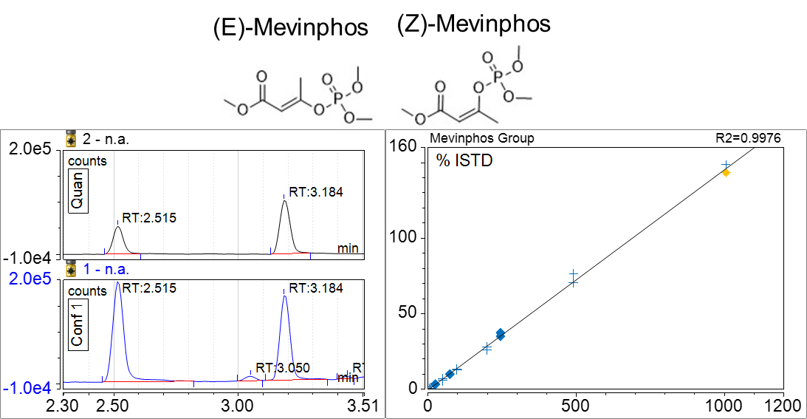Figure S 1 - Example (Mevinphos Group) of group calibration - Two or more resolved signals contributing to a single calibration curve. Blue cross symbols indicate calibration standard injections. Blue diamonds indicate QC samples. Yellow diamond indicates the standard selected for the figure.
Figure S 2 - LC-MS/MS Calibration Curves (1 of 8). Blue cross symbols indicate calibration standard injections. Blue diamonds indicate QC samples. Yellow diamond indicates the standard selected for the figure.

Figure S 3 - LC-MS/MS Calibration Curves (2 of 8)

Figure S 4 - LC-MS/MS Calibration Curves (3 of 8)

Figure S 5 - LC-MS/MS Calibration Curves (4 of 8)

Figure S 6 - LC-MS/MS Calibration Curve (5 of 8)

Figure S 7 - LC-MS/MS Calibration Curves (6 of 8)

Figure S 8 - LC-MS/MS Calibration Curves (7 of 8)

Figure S 9 - LC-MS/MS Calibration Curves (8 of 8)
Figure S 10 - GC-MS/MS Calibration Curves (1 of 3). Blue cross symbols indicate calibration standard injections. Blue diamonds indicate QC samples. Yellow diamond indicates the standard selected for the figure.

Figure S 11 - GC-MS/MS Calibration Curves (2 of 3)

Figure S 12 - GC-MS/MS Calibration Curves (3 of 3)

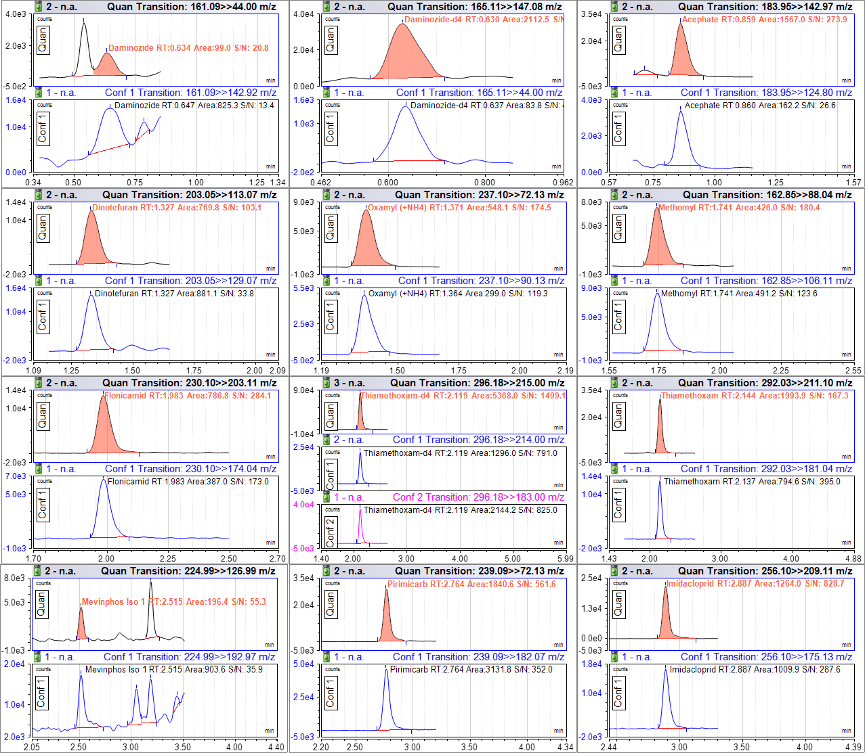

Figure S 13 - LC-MS/MS Selected Ion Chromatograms at 75 ppb (1 of 9)

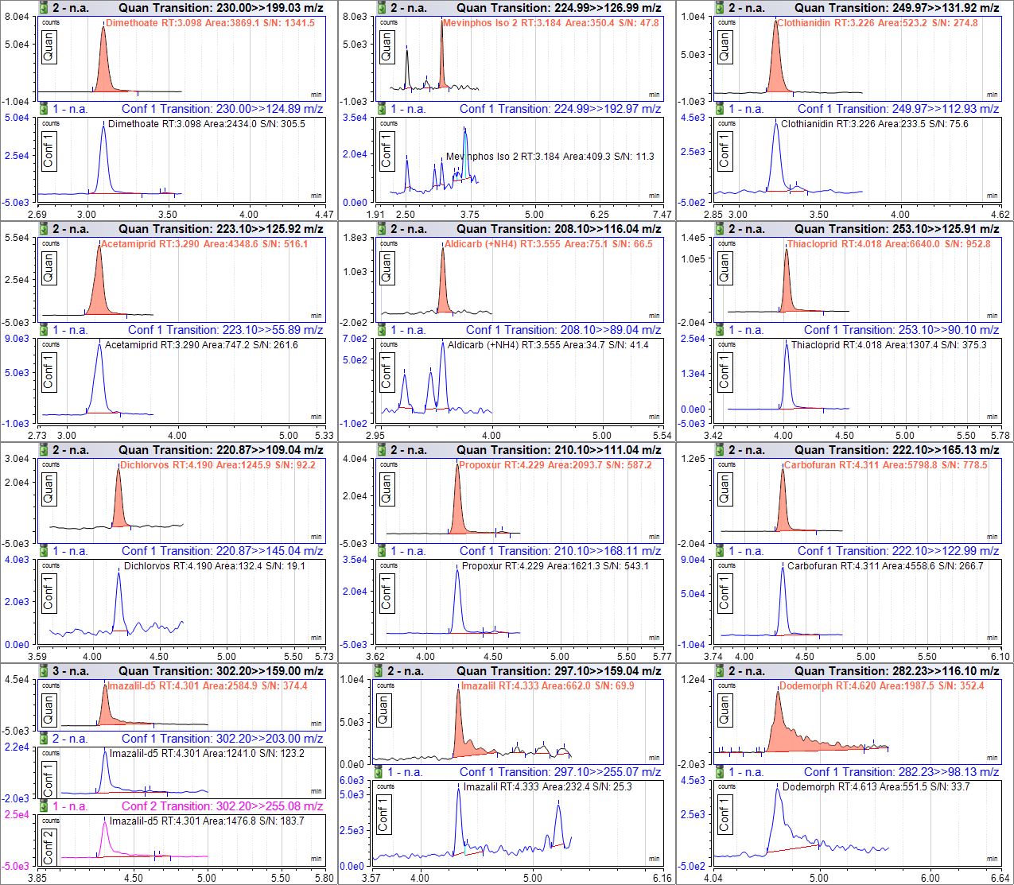

Figure S 14 - LC-MS/MS Selected Ion Chromatograms at 75 ppb (2 of 9)

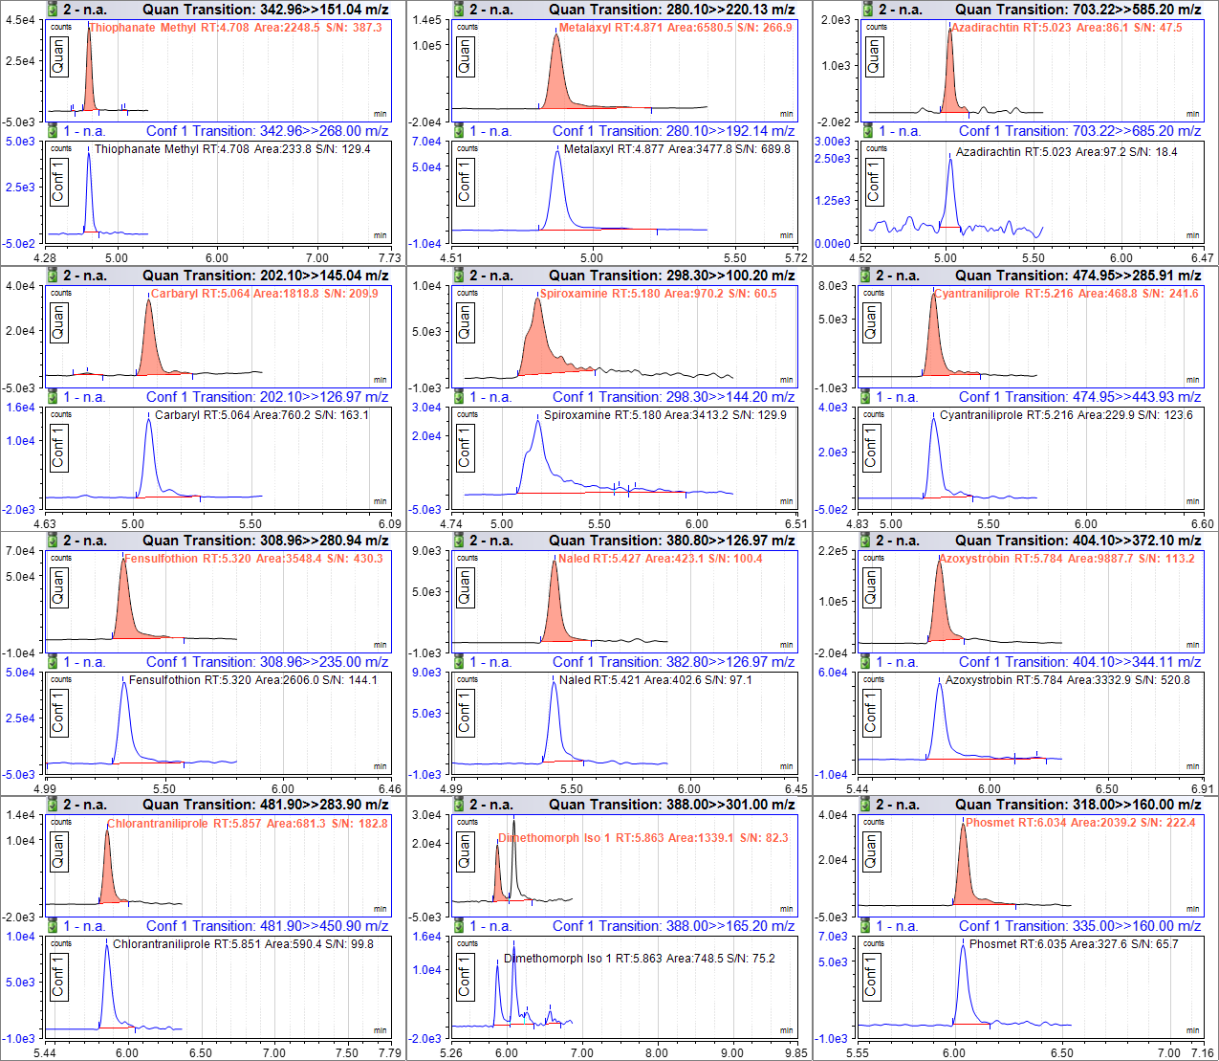

Figure S 15 - LC-MS/MS Selected Ion Chromatograms at 75 ppb (3 of 9)

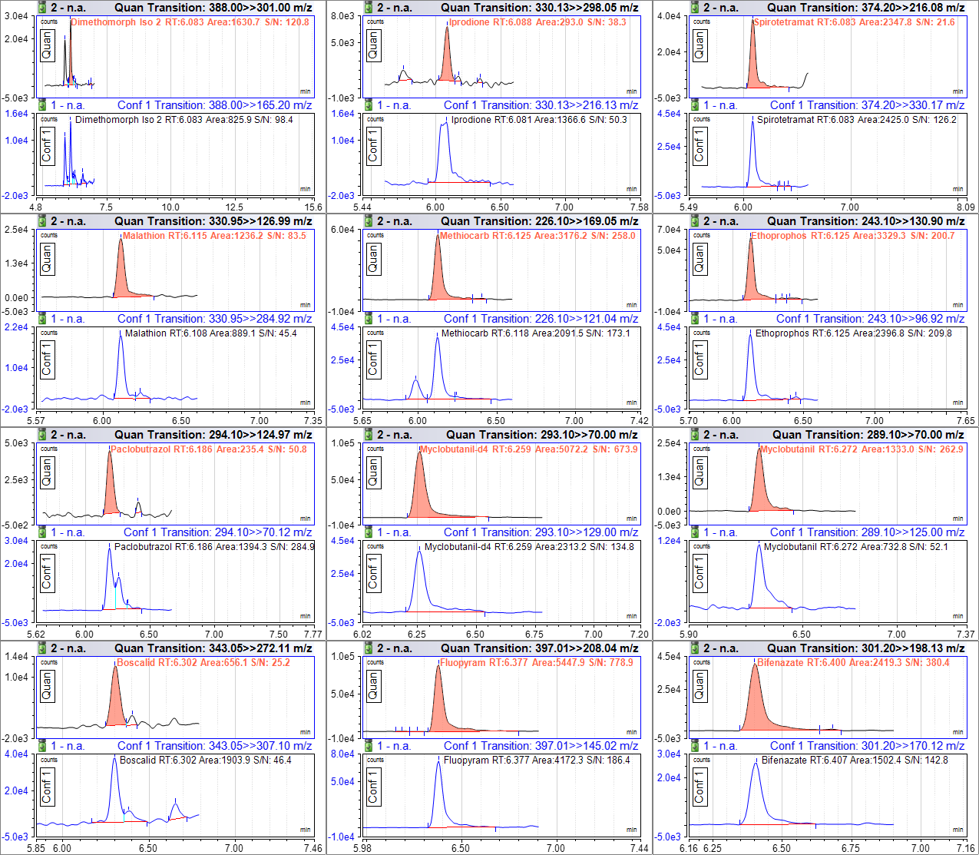

Figure S 16 - LC-MS/MS Selected Ion Chromatograms at 75 ppb (4 of 9)

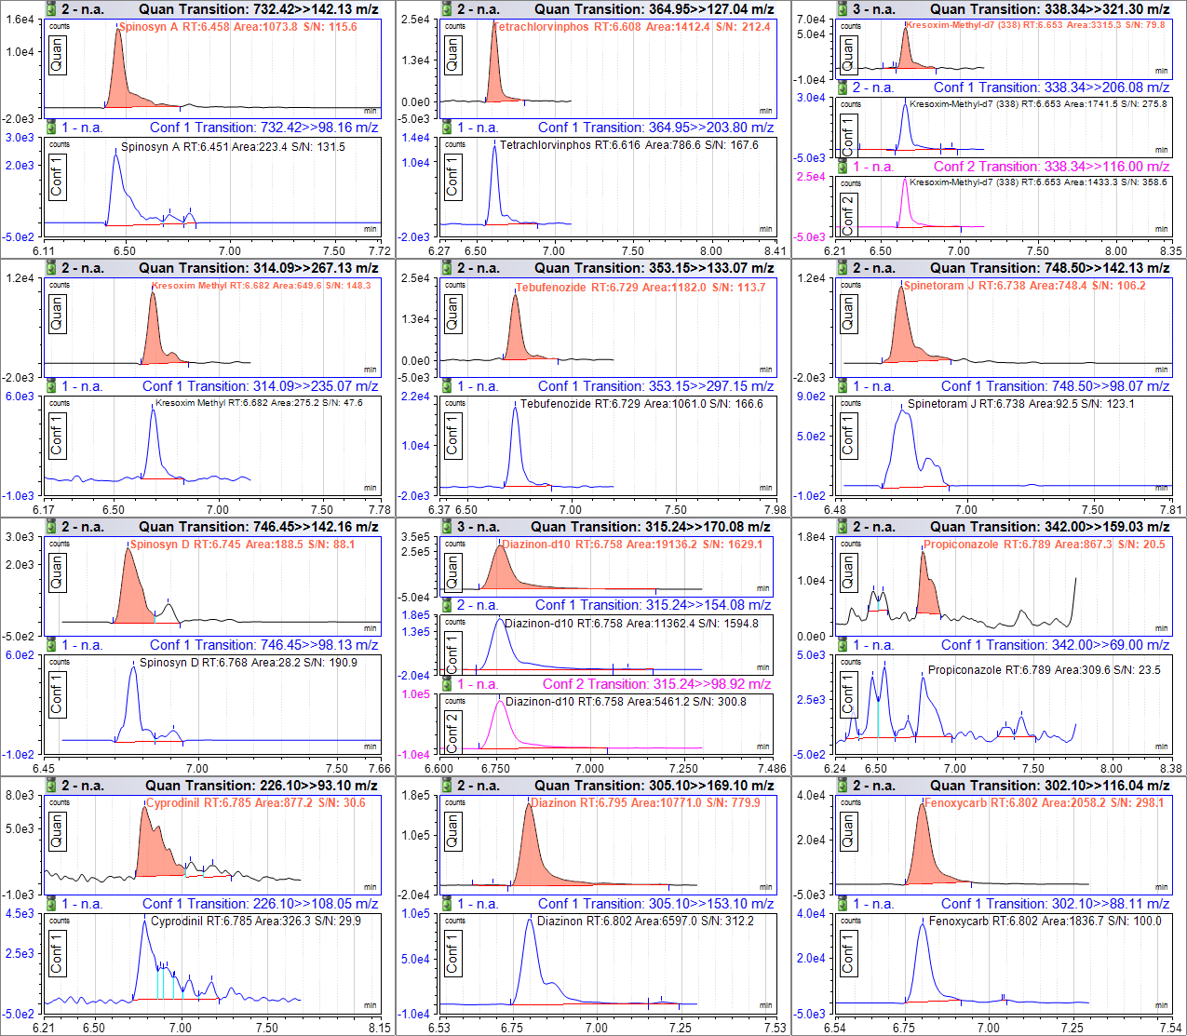

Figure S 17 - LC-MS/MS Selected Ion Chromatograms at 75 ppb (5 of 9)

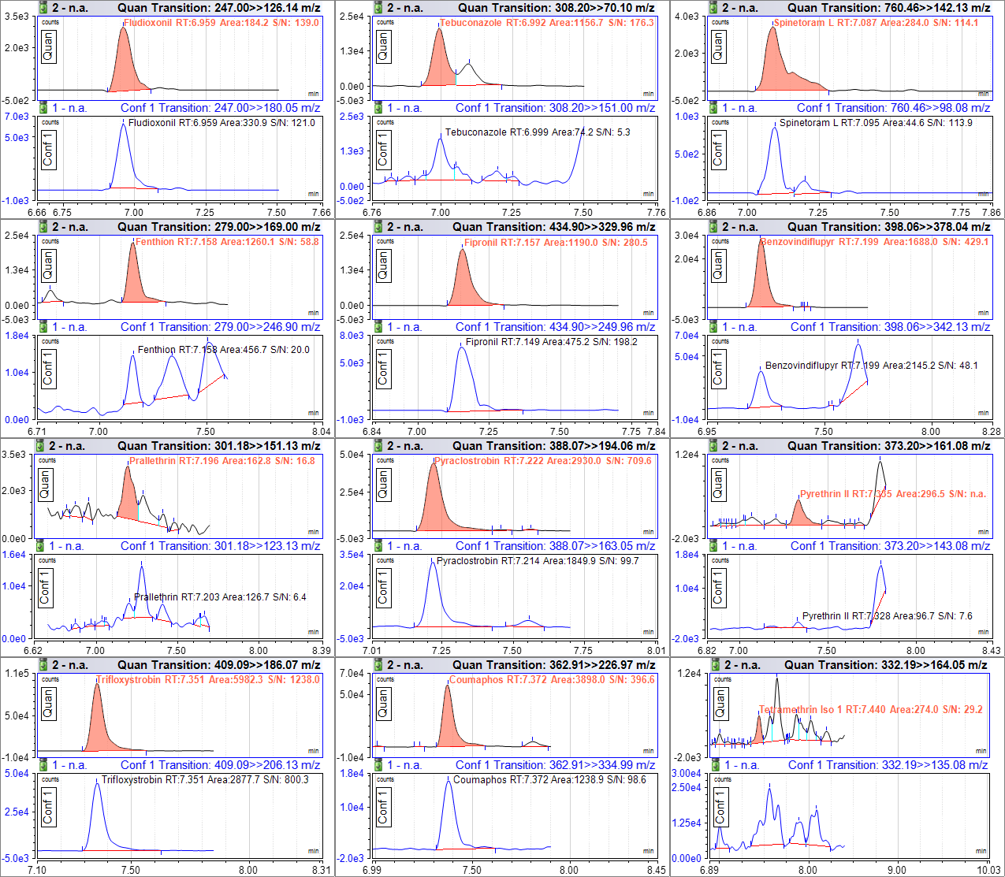

Figure S 18 - LC-MS/MS Selected Ion Chromatograms at 75 ppb (6 of 9)

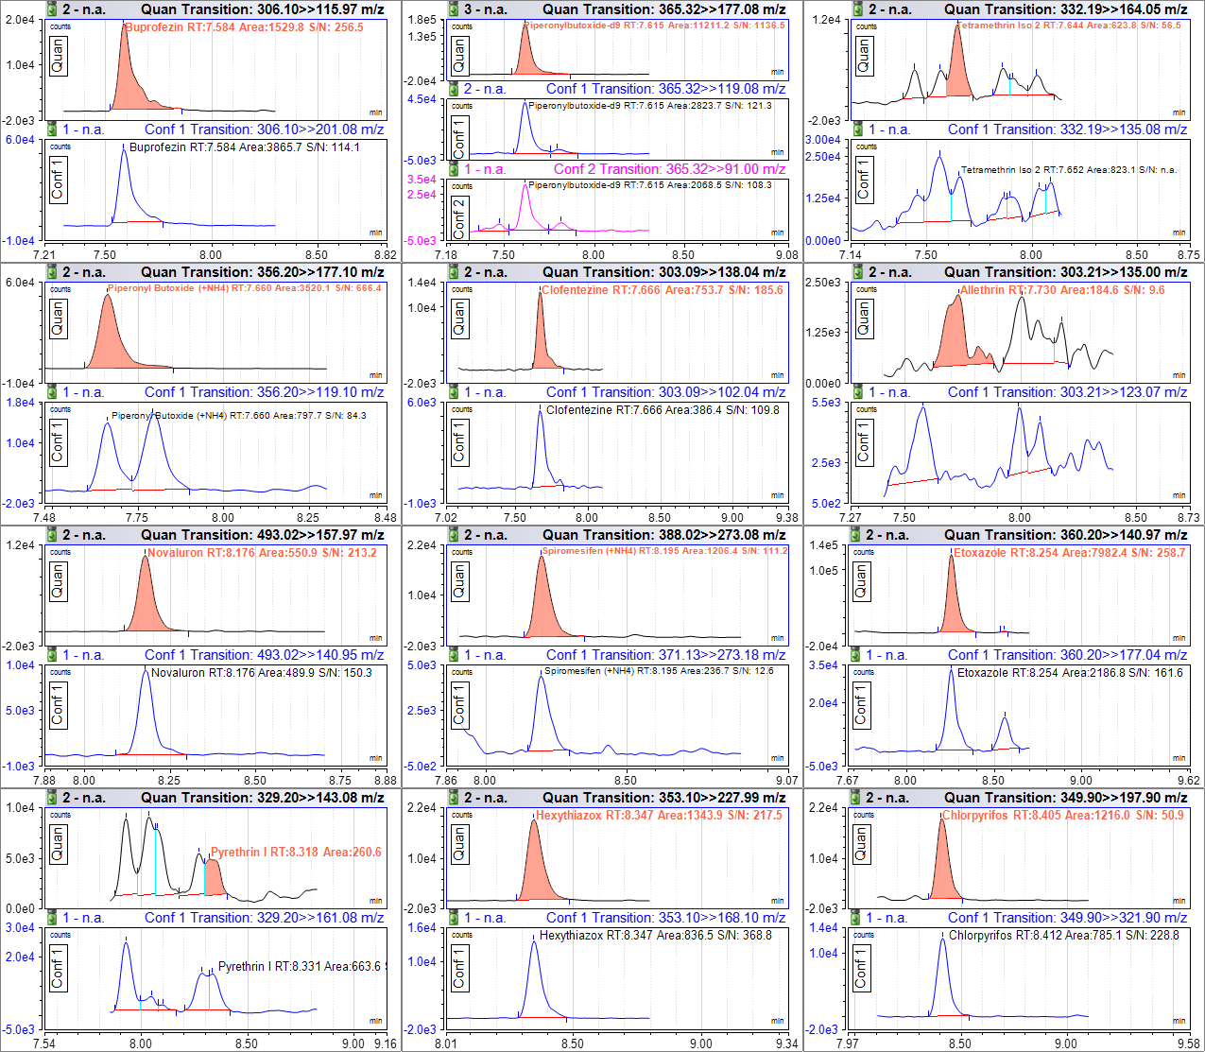

Figure S 19 - LC-MS/MS Selected Ion Chromatograms at 75 ppb (7 of 9)

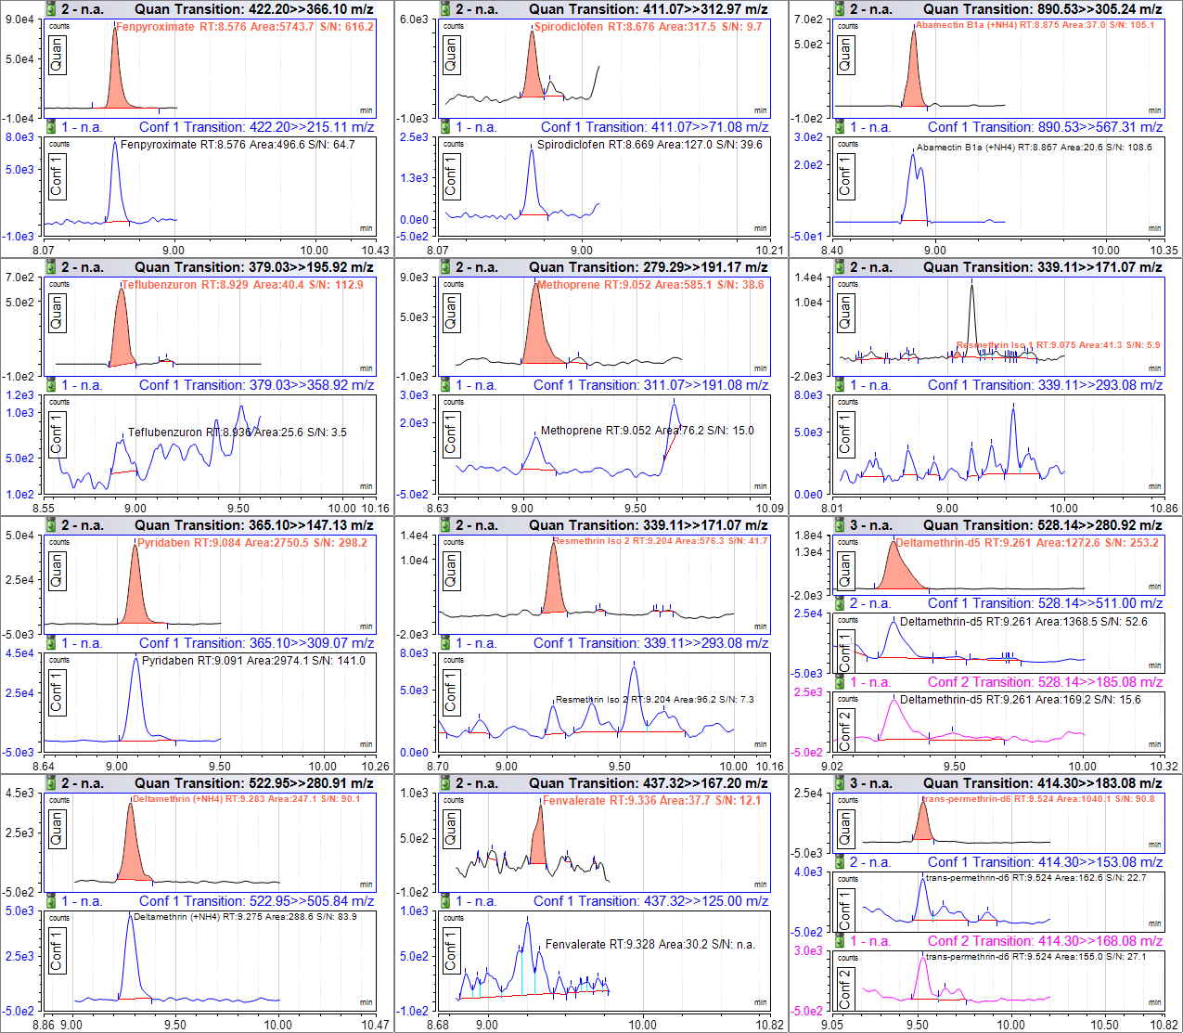

Figure S 20 - LC-MS/MS Selected Ion Chromatograms at 75 ppb (8 of 9)

Figure S 21 - LC-MS/MS Selected Ion Chromatograms at 75 ppb (9 of 9)

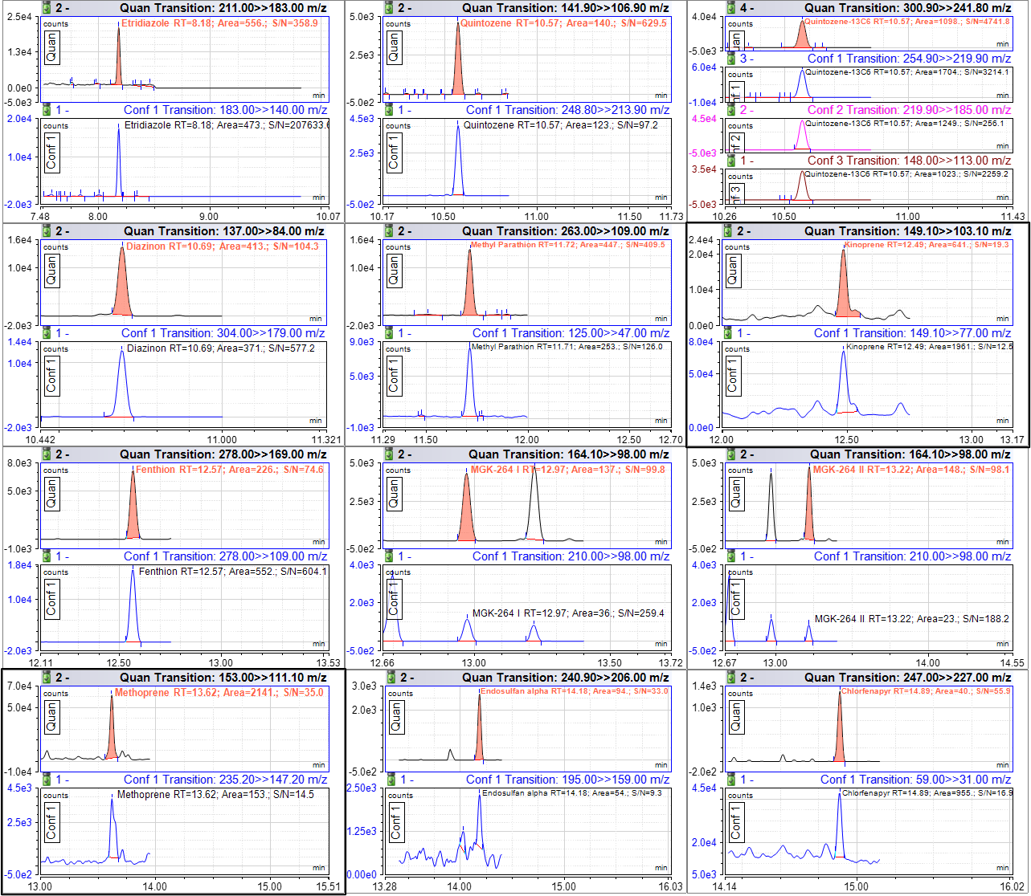

Figure S 22 - GC-MS/MS Selected Ion Chromatograms at 75 ppb (1 of 3). Note: Kinoprene and Methoprene, highlighted with a bold outline, are displayed at 1250 ppb.

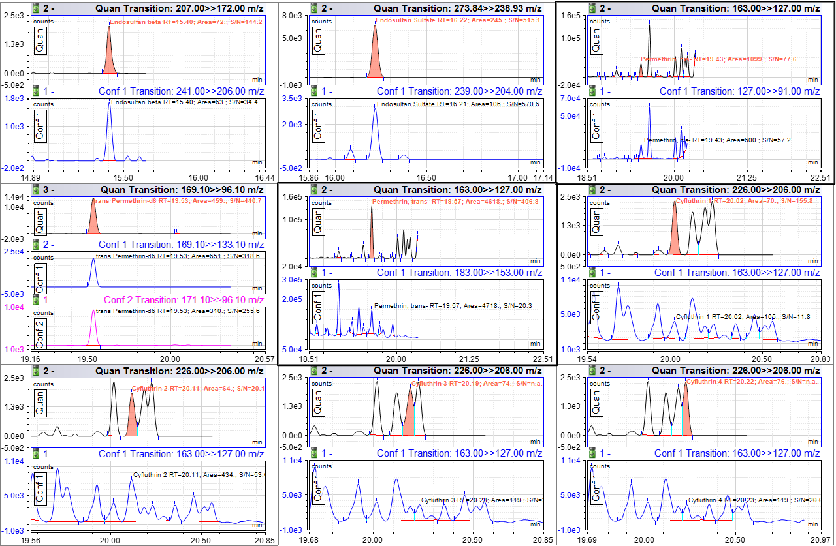

Figure S 23 - GC-MS/MS Selected Ion Chromatograms at 75 ppb (2 of 3). Note: cis and trans permethrins, highlighted with a bold outline, are displayed at 1250 ppb.

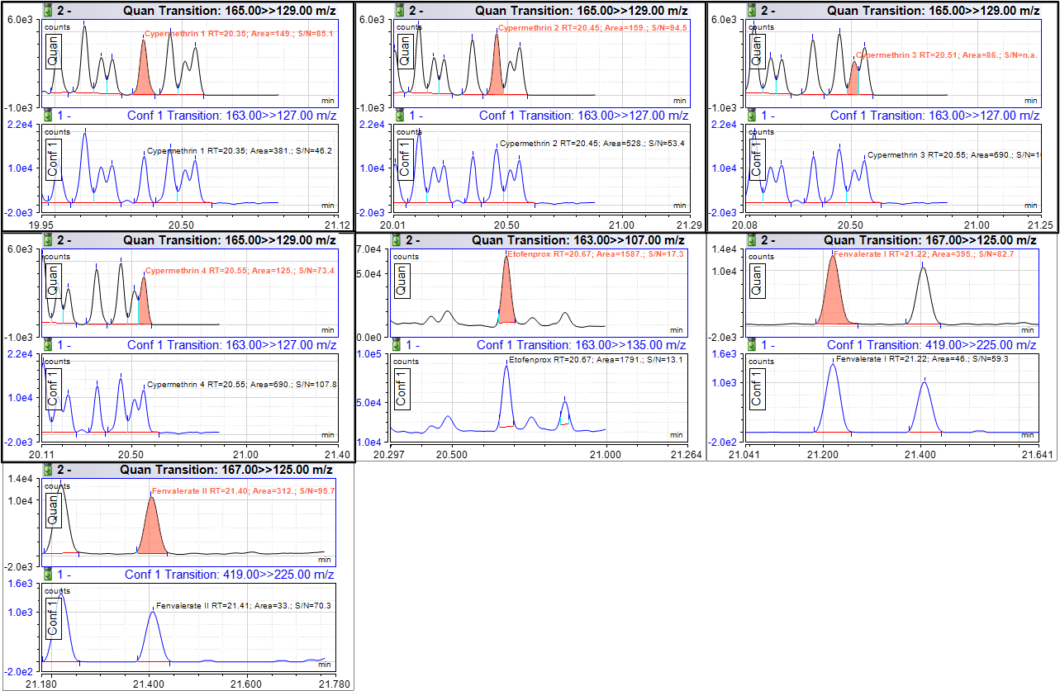

Figure S 24 - GC-MS/MS Selected Ion Chromatograms at 75 ppb. Note: Cypermethrins 1-4, highlighted with a bold border, are displayed at 250 ppb.

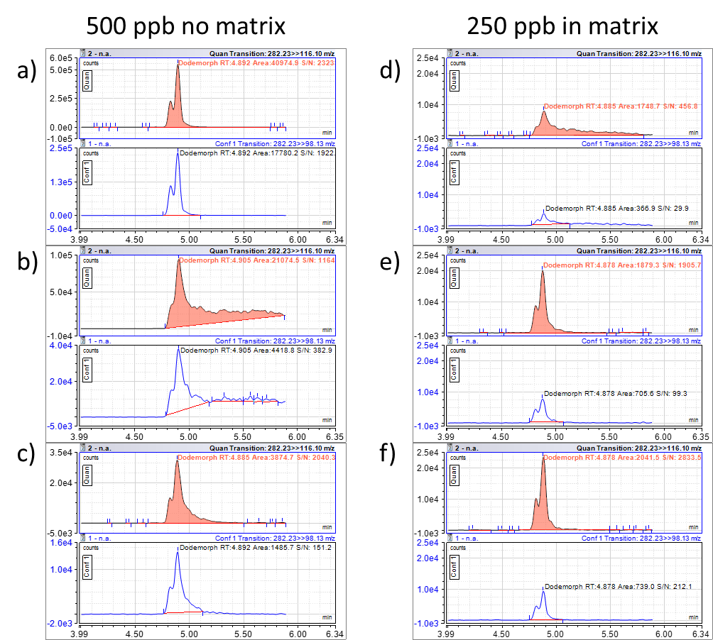
Figure S 25 - Effect of THCA and dilution on peak shape of dodemorph (RT = 4.9 min). a) 500 ppb dodemorph in clean solvent. b) Distorted peak shape of 500 ppb dodemorph in clean solvent with commercial THCA added. c) Partially restored peak shape of 500 ppb dodemorph in clean solvent with commercial THCA added diluted 10x. d) Distorted peak shape of 250 ppb dodemorph extracted from THCA-dominant cannabis cultivar. e) Peak shape of 250 ppb dodemorph extracted from a balanced cannabinoid cultivar. f) Peak shape of 250 ppb dodemorph extracted from a CBDA-balanced cultivar. Similar THCA-dependent peak shape behavior is observed for pesticides spiroxamine (RT = 5.5 min) and cyprodinil (RT = 6.8 min).

75 ppb spiked in matrix
Unspiked matrix
Figure S 26 - LC-MS/MS Chromatogram of Dodemorph, Spiroxamine, and Cyprodinil spiked at 75 ppb on matrix (left) vs unspiked cannabis matrix (right). Monitoring the SRM transitions in the blank matrix shows little to no interfering signals.

