Supplementary Material

A new HPLC method with multiple detection systems for impurity analysis and discrimination of natural versus synthetic cannabidiol

Virginia Brighentiª, Matilde Maraniª, Clarissa Caroli^{a,b}, Laura Bertarini^{a,b}, Alessio Gaggiotti^{c}, Federica Pollastro^{d}, Caterina Durante^{e}, Giuseppe Cannazzaª, Federica Pellati^{a*}

ªDepartment of Life Sciences, University of Modena and Reggio Emilia, via G. Campi 103, 41125, Modena, Italy
^{b}Clinical and Experimental Medicine PhD Program, University of Modena and Reggio, Via Giuseppe Campi 287, 41125 Modena, Italy
^{c}Farmech, Piazza Duomo 20, 20122 Milano, Italy
^{d}Department of Pharmaceutical Sciences, University of Eastern Piedmont, Largo Donegani 2, 28100 Novara, Italy
^{e}Department of Chemical and Geological Sciences, University of Modena and Reggio Emilia, Via G. Campi 103, Modena 41125, Italy

*Corresponding author:
Prof. Federica Pellati
Phone: +39-059-2058565
E-mail: federica.pellati@unimore.it

Table S1
Linearity ad sensitivity data of the HPLC-UV/Vis method
Compound | Concentration range (µg/mL) | Correlation coefficient  (r²) |  |  |  | LOD (µg/mL) | LOQ (µg/mL)
CBDV | 2.5-50.0 | 0.998 |  |  |  | 0.3 | 1.0
CBDB | 2.5-50.0 | 0.998 |  |  |  | 0.6 | 2.1
Δ⁹-THC | 2.5-50.0 | 0.999 |  |  |  | 0.3 | 0.8
Δ⁸-THC | 2.5-50.0 | 0.996 |  |  |  | 1.0 | 3.4
CBC | 1.7-66.5 | 0.998 |  |  |  | 1.6 | 5.2
CBD | 51.5-206.0 | 0.999 |  |  |  | 0.4 | 1.3

Table S2
Intra- and inter-day precision of the HPLC-UV/Vis method for the target analytes, expressed as mean of t_{R} (min) ± RSD and peak area (mAU×s) ± RSD (n = 9)
Compound | Day 1 |  |  |  | Day 2 |  |  | Day 3 |  |  |  | Inter-day
 | t_{R}  (min) | Area  (mAU×s) |  | t_{R}  (min) |  | Area  (mAU×s) |  | t_{R}  (min) | Area  (mAU×s) |  | t_{R}  (min) |  | Area  (mAU×s)
CBGV | 8.5±0.5 | 3750.9±3.3 |  | 8.5±0.1 |  | 3845.0±4.3 |  | 8.5±0.1 | 3991.9±8.8 |  | 8.5±0.2 |  | 3862.6±5.9
CBDV | 8.7±0.3 | 8431.9±4.5 |  | 8.7±0.1 |  | 9069.5±9.3 |  | 8.7±0.1 | 9186.6±6.7 |  | 8.7±0.2 |  | 8896.0±7.4
CBDB | 10.5±0.2 | 2627.7±5.7 |  | 10.5±0.1 |  | 2781.4±5.2 |  | 10.5±0.1 | 2834.8±6.3 |  | 10.5±0.2 |  | 2747.9±6.0
CBG | 12.1±0.2 | 5374.6±6.8 |  | 12.1±0.1 |  | 5661.7±5.7 |  | 12.1±0.1 | 5752.9±5.7 |  | 12.1±0.1 |  | 5596.4±6.1
CBD | 12.8±0.2 | 5976.9±4.8 |  | 12.8±0.1 |  | 6343.3±5.0 |  | 12.8±0.1 | 6515.2±6.5 |  | 12.8±0.1 |  | 6278.5±6.1
abn-CBD | 15.6±0.1 | 5007.0±4.6 |  | 15.6ª |  | 5334.9±5.6 |  | 15.6±0.1 | 5403.6±6.5 |  | 15.6±0.1 |  | 5284.5±6.1
CBCV | 16.4±0.1 | 1305.1±3.6 |  | 16.4ª |  | 1345.7±9.7 |  | 16.4±0.1 | 1377.2±8.4 |  | 16.4±0.1 |  | 1342.7±7.1
Δ⁹-THC | 20.4±0.1 | 7193.7±5.0 |  | 20.5ª |  | 7614.6±5.4 |  | 20.5±0.1 | 7735.1±5.4 |  | 20.5±0.1 |  | 7514.5±5.6
Δ⁸-THC | 20.9±0.1 | 2522.6±1.5 |  | 21.0ª |  | 2736.7±4.2 |  | 21.0±0.1 | 2788.0±7.0 |  | 21.0±0.1 |  | 2682.4±6.2
CBC | 23.2±0.1 | 967.9±5.2 |  |  | 23.3ª | 23.3±0.1 |  | 23.3±0.1 | 1043.0±5.8 |  | 23.3±0.1 |  | 1000.1±6.0
ª RSD < 0.05

Table S3
Accuracy data for the target compounds, expressed as % recovery ± RSD
Compound | % Recovery
CBDV | 93.9±4.5
CBDB | 94.0±3.9
Δ⁹-THC | 82.9±1.4
Δ⁸-THC | 96.6 ª
CBC | 91.9±0.1
CBD (synthetic) | 104.0±2.6
CBD (natural) | 106.2±0.4
ª RSD < 0.05

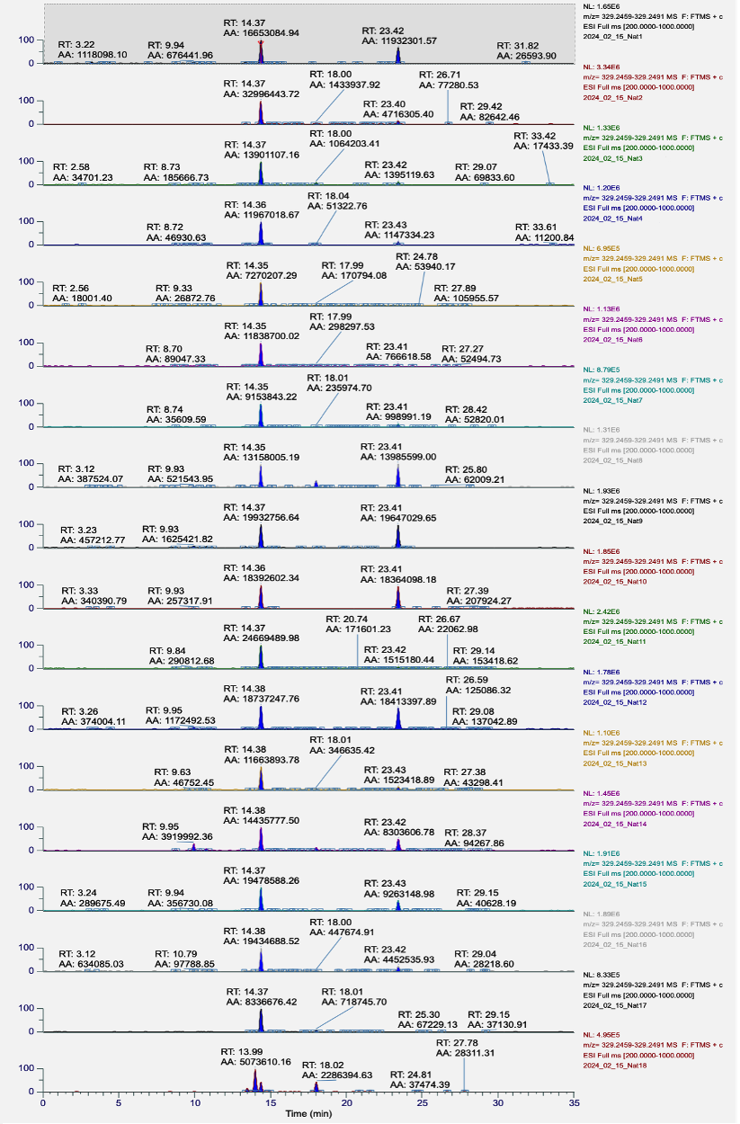
Fig. S1 Extracted Ion Chromatograms (EIC) of CBDH in samples of natural CBD. Area of the peaks were obtained by extracting the exact mass (mass tolerance: 5 ppm) of CBDH ([M+H]⁺ = 329.2473).
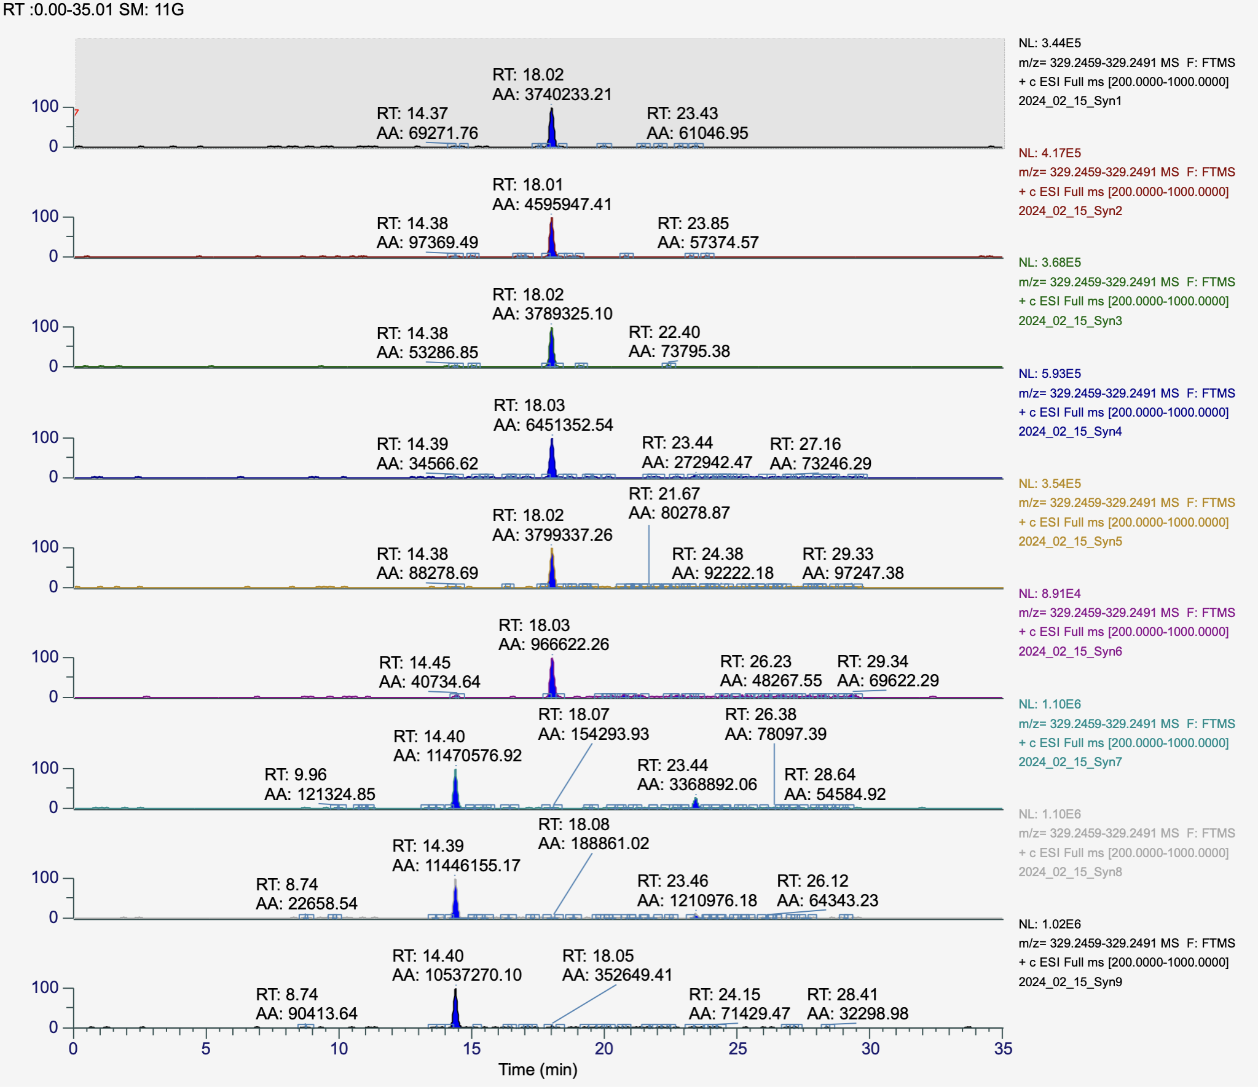
Fig. S2 Extracted Ion Chromatograms (EIC) of CBDH in samples of synthetic CBD. Area of the peaks were obtained by extracting the exact mass (mass tolerance: 5 ppm) of CBDH ([M+H]⁺ = 329.2473).

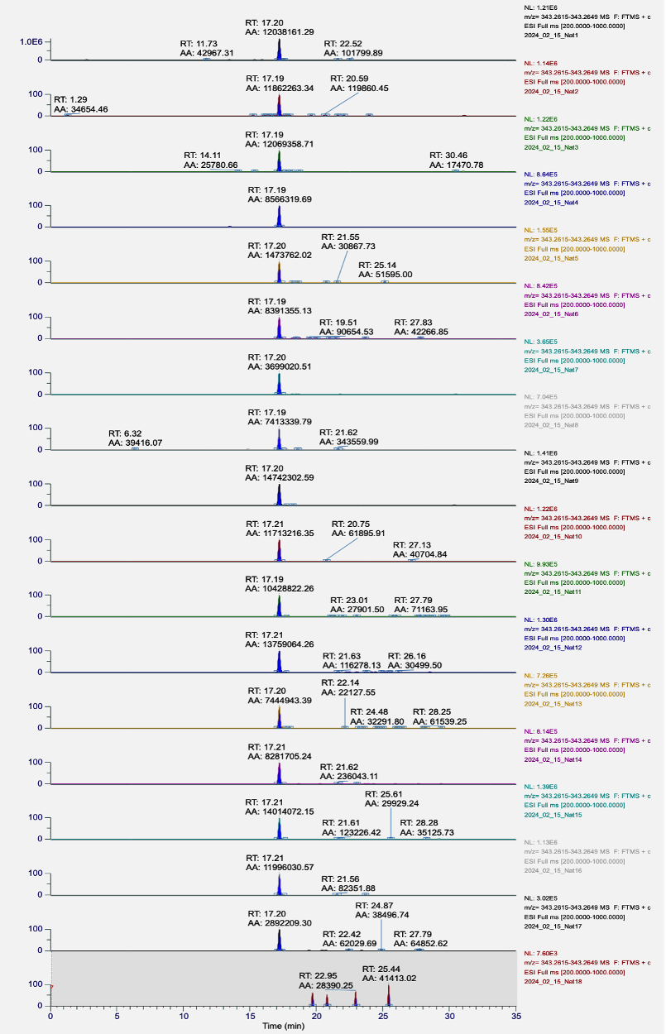
Fig. S3 Extracted Ion Chromatograms (EIC) of CBDP in samples of natural CBD. Area of the peaks were obtained by extracting the exact mass (mass tolerance: 5 ppm) of CBDP ([M+H]⁺ = 343.2630).

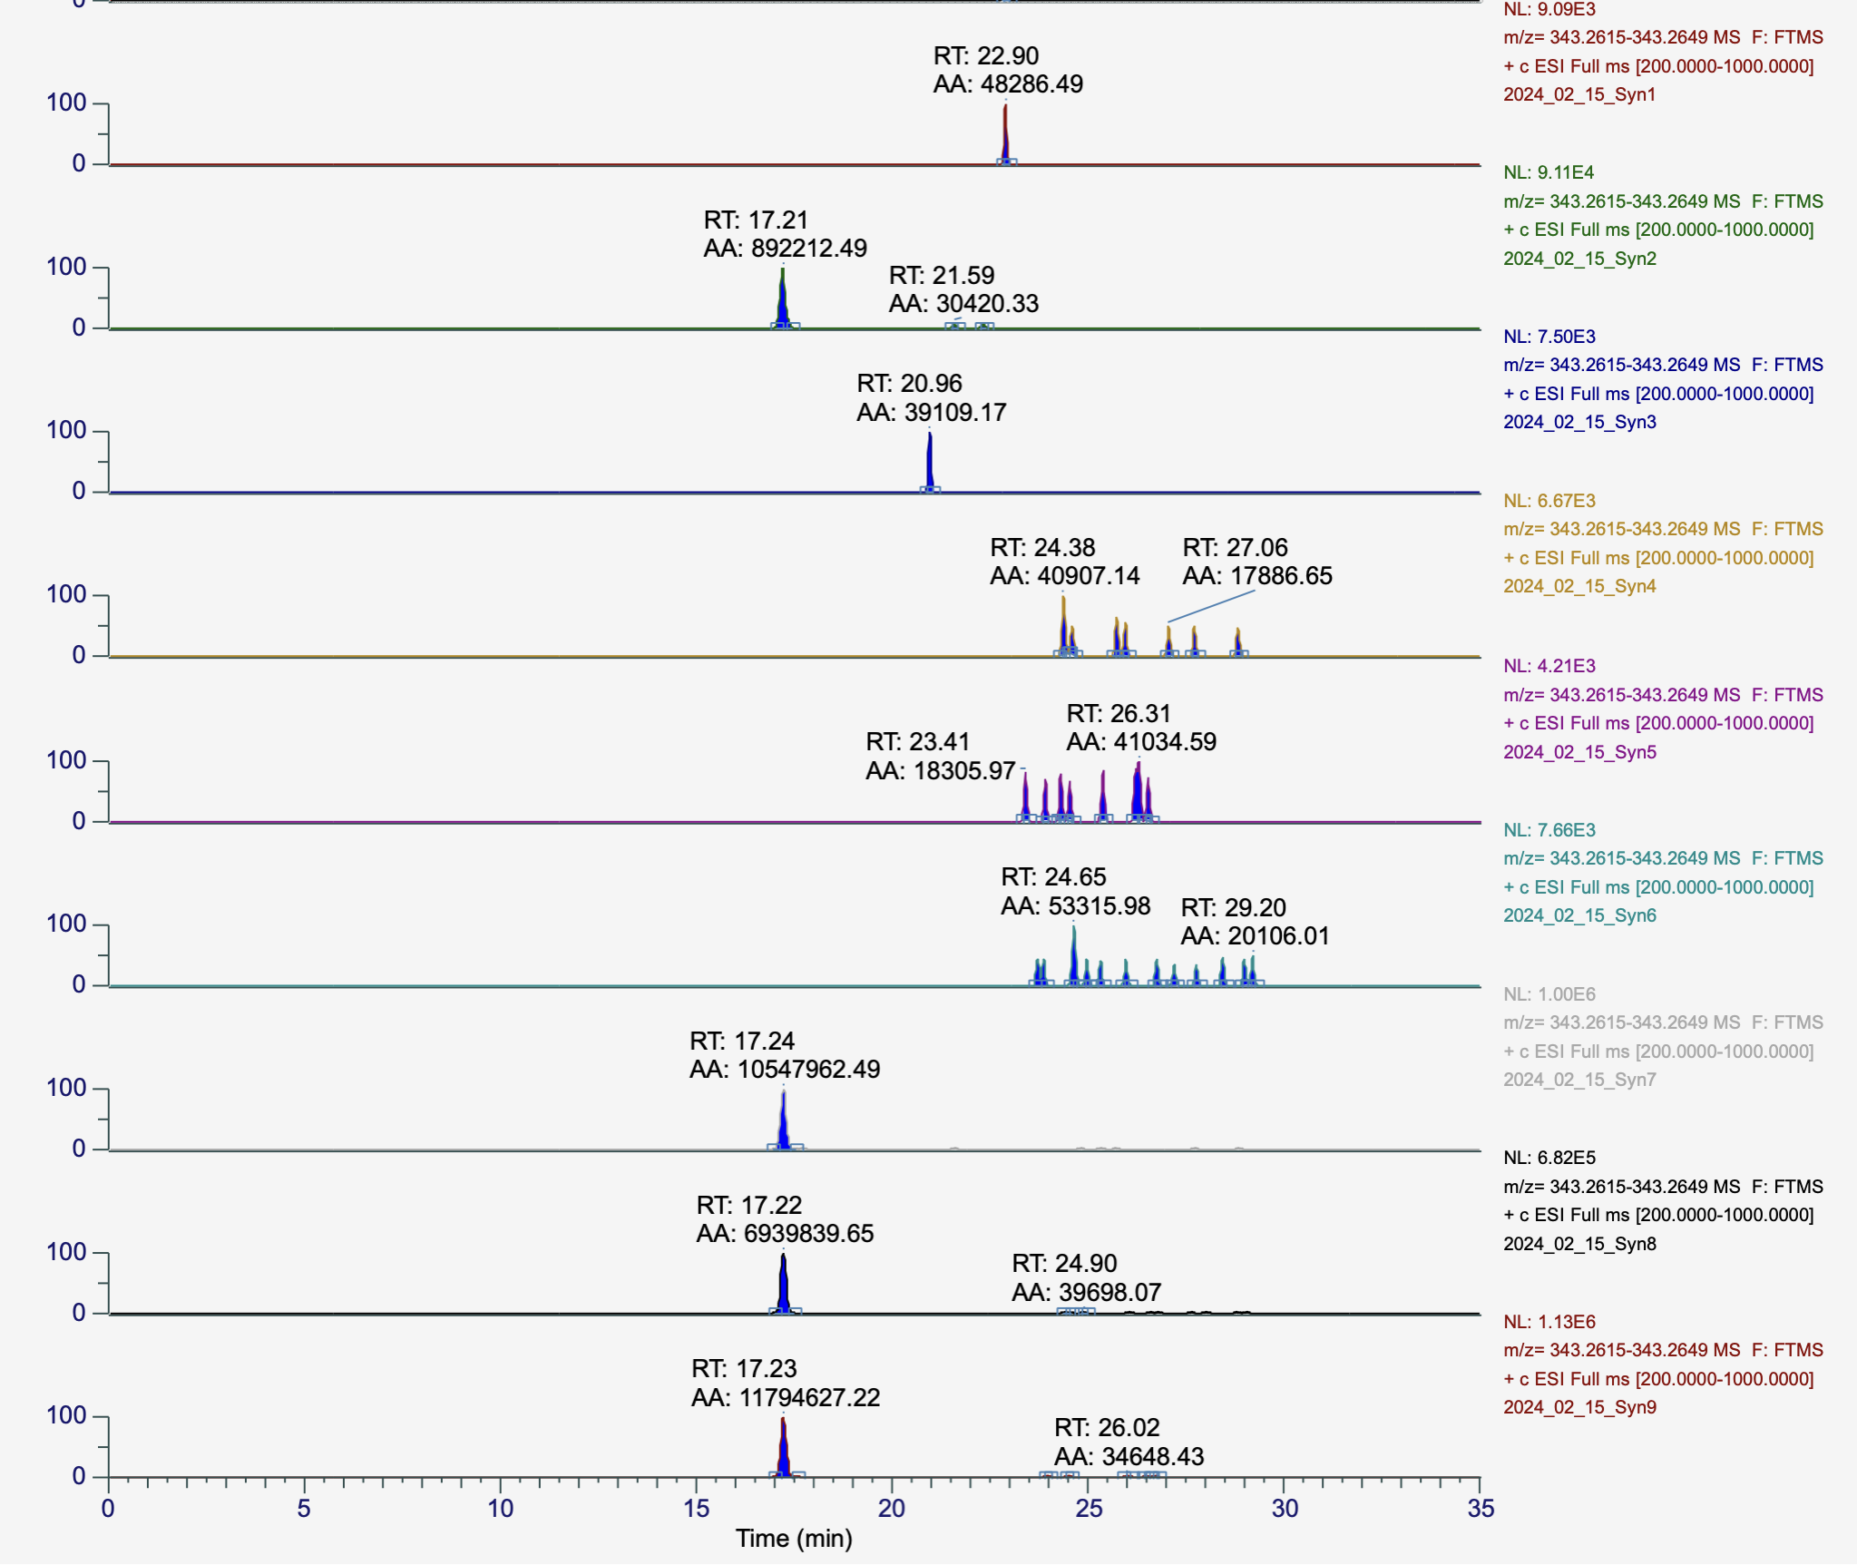
Fig. S4 Extracted Ion Chromatograms (EIC) of CBDP in samples of synthetic CBD. Area of the peaks were obtained by extracting the exact mass (mass tolerance: 5 ppm) of CBDP ([M+H]⁺ = 343.2630).

