Statistical analysis for pole test (Supplementary Figure 1)

No genotype effects were detected in either sex in the first week of testing (11 weeks of age) for either parameter investigated (i.e. latency to reach platform, latency to reach platform once turned). In male mice, three-way RM ANOVA revealed an ‘age’ by ‘genotype’ interaction [F(8,248) = 7.48, p < 0.0001] as SOD1^{G93A} transgenic mice regardless of treatment took increasingly longer to reach the bottom compared to WT males (no ‘age’ by ‘genotype’ by ‘treatment’ interaction, p > 0.05; Fig. S1A). A similar ‘age’ by ‘genotype’ interaction [F(8,248) = 2.72, p = 0.007] was evident when analysing the latency to reach the platform once turned (no ‘age’ by ‘genotype’ by ‘treatment’ interaction, p > 0.05; Fig. S1C). A strong trend for an ‘age’ by ‘treatment’ interaction [F(8,248) = 1.97, p = 0.05] indicated that pole test performance across weeks was better in CBD-fed males compared to controls (Fig. S1C).
In females, no significant main effects or interactions were detected when analysing the latency to reach the platform (all p’s > 0.05; Fig. S1B). However, an ‘age’ by ‘genotype’ interaction for the latency to reach the platform once turned [F(8,288) = 2.11, p = 0.035] indicated that SOD1^{G93A} transgenic females also developed a motor impairment across weeks when compared to WT mice (no ‘age’ by ‘genotype’ by ‘treatment’ interaction, p > 0.05; Fig. S1D). CBD had no effects on the pole test performance of females (all p’s > 0.05).

Supplementary Figures
Supplementary Figure 1A
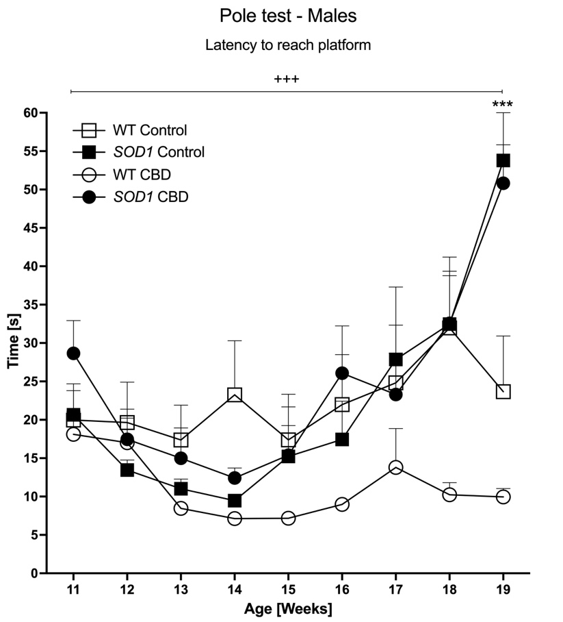
Supplementary Figure 1B
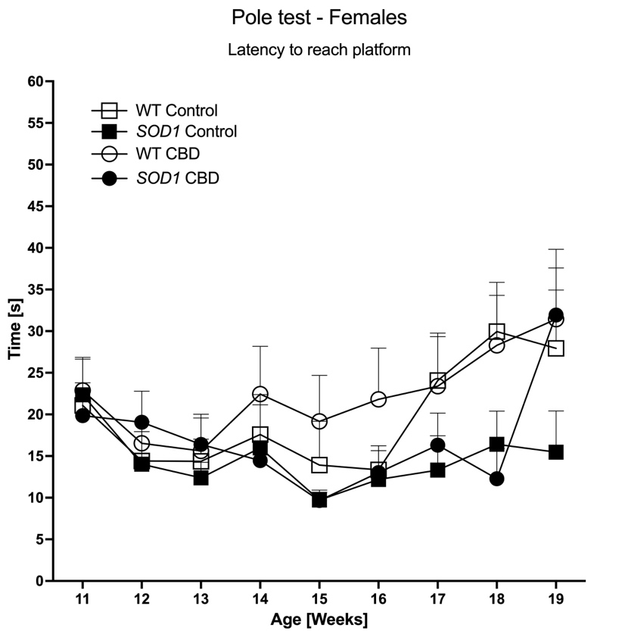

Supplementary Figure 1C
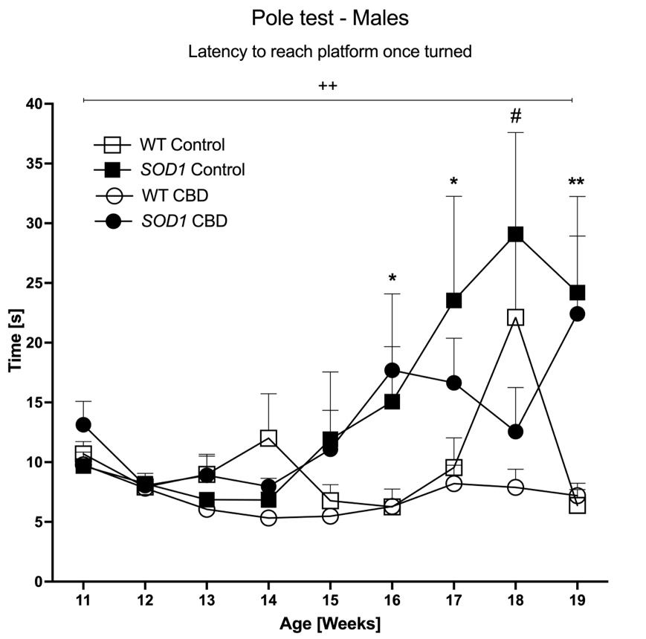
Supplementary Figure 1D
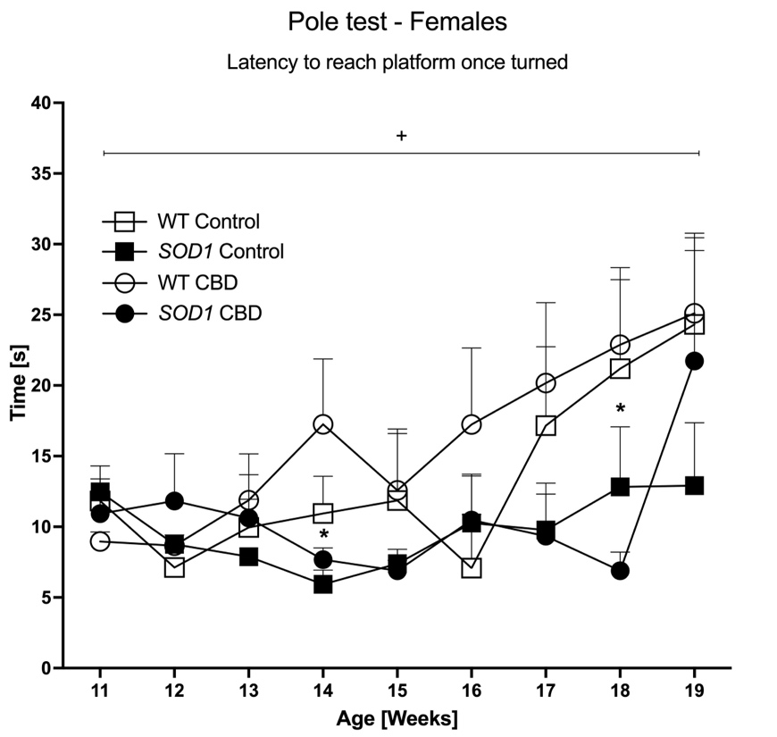

Supplementary Figure 1A-D - Motor function in the pole test: Latency [s] to (A-B) reach the platform or (C-D) reach the platform once turned are shown. (A/C) Male and (B/D) female SOD1^{G93A} transgenic (SOD1^{G93A}) and wild type-like (WT) mice were chronically fed with either a CBD-enriched (CBD) or standard chow (Control) diet. Data are shown as mean + SEM. Three-way RM ANOVA ‘age’ by ‘genotype’ interactions are indicated by ⁺p < 0.05, ⁺⁺p < 0.01, ⁺⁺⁺p < 0.0001. For each week, two-way ANOVA main effects of ‘genotype’ across treatment groups are indicated by *p < 0.05, **p < 0.01, ***p < 0.0001 and ‘treatment’ effects across genotype are indicated by #p < 0.05.

Supplementary Figure 2A
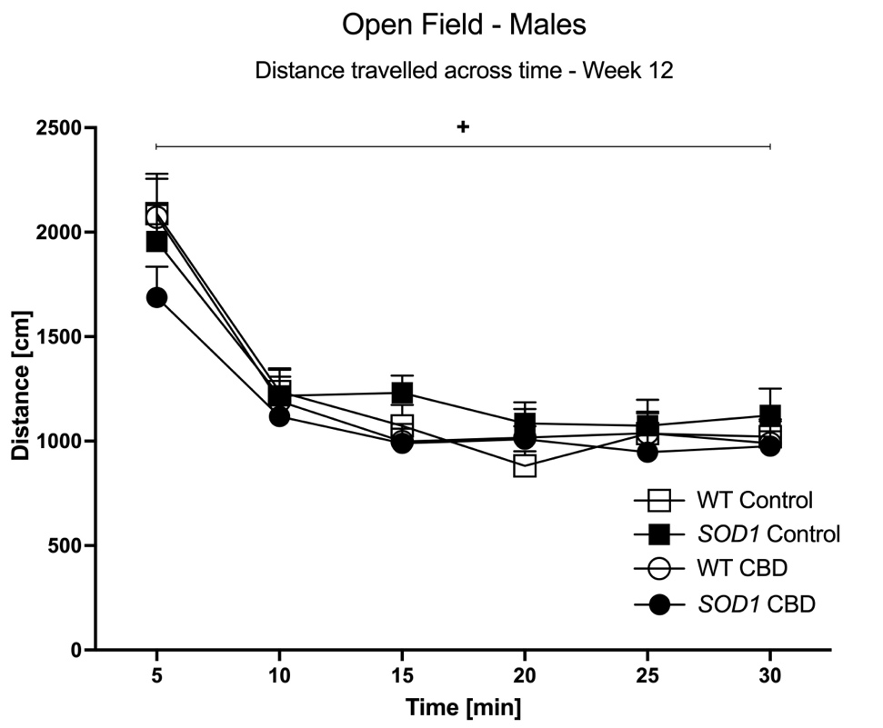
Supplementary Figure 2B
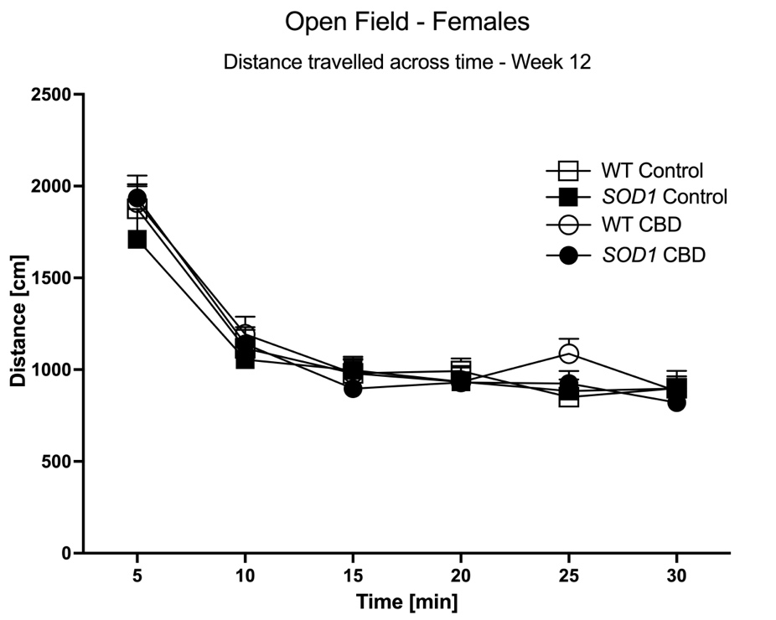

Supplementary Figure 2C
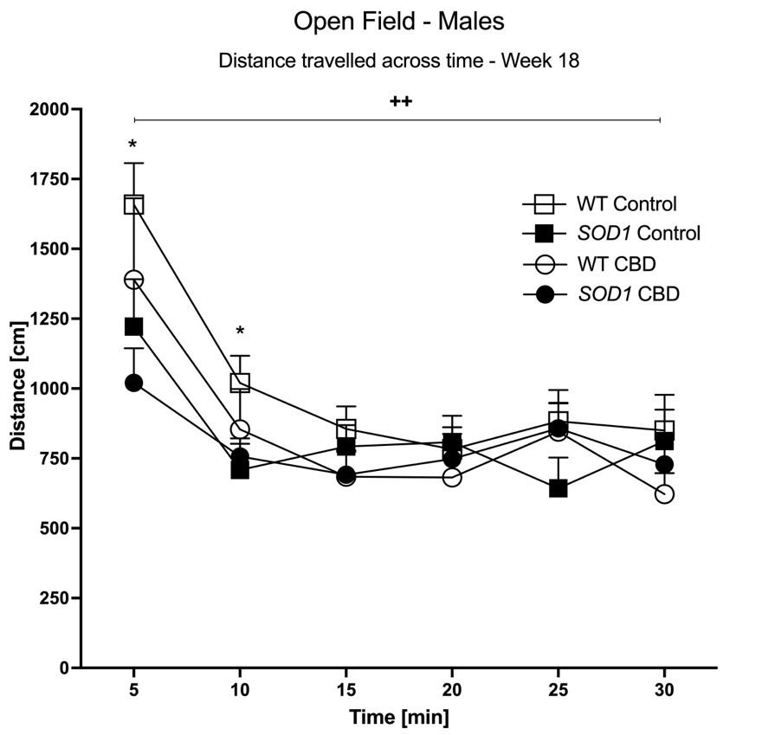
Supplementary Figure 2D
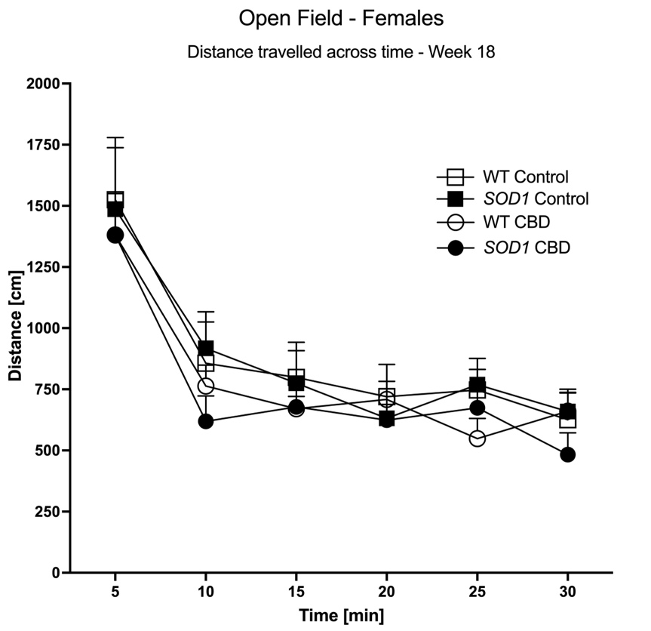

Supplementary Figure 2A-D - Open field locomotion: Distance travelled [cm] across 5-min blocks at (A/B) 12 weeks and (C/D) 18 weeks of age is shown. (A-C) Male and (B-D) female SOD1^{G93A} transgenic (SOD1^{G93A}) mice and wild type-like (WT) mice were chronically fed with either a CBD-enriched (CBD) or standard chow (Control) diet. Data are shown as mean + SEM. Three-way RM ANOVA ‘time’ by ‘genotype’ interactions in males are indicated by ⁺p < 0.05 and ⁺⁺p < 0.01. Two-way ANOVA ‘genotype’ effects across treatment groups for 5-min blocks are indicated by *p < 0.05.

