Supplementary information:

Title: Insight into the mechanism of action of ORG27569 at the cannabinoid type one receptor utilising a unified mathematical model.
Running Title: Insight into the mechanism of action of ORG27569 at the cannabinoid type one receptor utilising a unified mathematical model.

Authors: Hayley M. Greenª, Liang Yang^{b}, Xiao Zhu^{c}, David B. Finlayª, Stephen B. Duffull^{b,d}, Michelle Glassª*

ª Department of Pharmacology and Toxicology, School of Biomedical Sciences, University of Otago, Dunedin, New Zealand
^{b} Otago Pharmacometrics Group, School of Pharmacy, University of Otago, Dunedin, New Zealand
^{c} Department of Clinical Pharmacy and Pharmacy Administration, School of Pharmacy, Fudan University, Shanghai, China
^{d} Princeton, NJ, USA

*Corresponding author:
Professor Michelle Glass
Department of Pharmacology and Toxicology, University of Otago, PO Box 56, Dunedin, New Zealand 9054
+64 3 479 8524; michelle.glass@otago.ac.nz

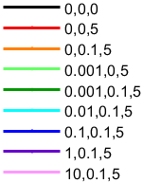
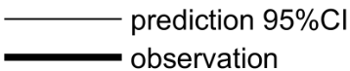
Figure S1: Validation of the model to simulate novel cAMP data of CP55940 and 100 nM ORG27569 at the cannabinoid type 1 receptor. Global sensitivity analysis compared to empirical data, such that 95% confidence intervals generated by full covariance metrics are shown as the shaded bands, and experimental data is shown by the thick line (A). Experimental results in (A) are combined in (B), and the corresponding model predictions are combined in (C).
CP, ORG, FSK (µM)
Observation
Prediction
A
C
B
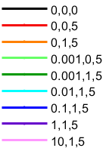
Figure S2: Validation of the model to simulate novel cAMP data of CP55940 and 1 µM ORG27569 at the cannabinoid type 1 receptor. Global sensitivity analysis compared to empirical data, such that 95% confidence intervals generated by full covariance metrics are shown as the shaded bands, and experimental data is shown by the thick line (A). Experimental results in (A) are combined in (B), and the corresponding model predictions are combined in (C).
CP, ORG, FSK (µM)
Observation
Prediction
A
C
B
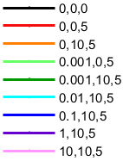
Figure S3: Validation of the model to simulate novel cAMP data of CP55940 and 10 µM ORG27569 at the cannabinoid type 1 receptor. Global sensitivity analysis compared to empirical data, such that 95% confidence intervals generated by full covariance metrics are shown as the shaded bands, and experimental data is shown by the thick line (A). Experimental results in (A) are combined in (B), and the corresponding model predictions are combined in (C).
Prediction
Observation
CP, ORG, FSK (µM)
A
B
C

