Additional file 3
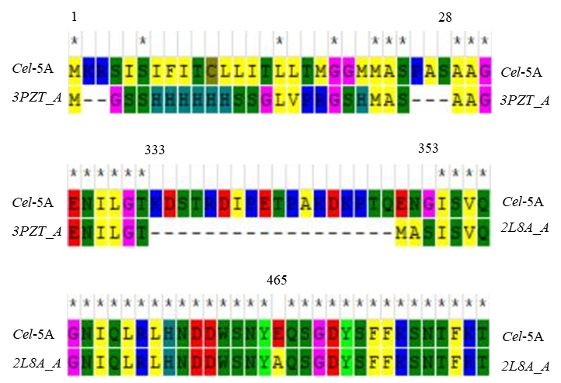
Fig S3. Difference of amino acids between Cel-5A with two templets after align. 3PZT_A for GH5 and 2L8A_A for CBM3.

