Supplemental text
Radioligand synthesis
¹¹C-Methane (¹¹C-CH₄) was produced in-target via the 14 N(p,α) ¹¹C reaction on nitrogen mixed with 10% of hydrogen, with 16.4 MeV protons using a GEMS PET trace cyclotron (GE, Uppsala, Sweden). Typically the target gas was irradiated for 15–20 min with a beam current of 35 μA. ¹¹C-Labeled methyl iodide, ¹¹C-CH₃I, was produced following the previously published method (1). In short, the produced ¹¹C-CH₄ was released from the target and collected in a Porapak Q trap cooled in liquid nitrogen. After collection, the ¹¹C-CH₄ was released from the trap by heating with flow of helium and subsequently ¹¹C-CH₄ was mixed with iodine vapor from of iodine crystals at 60 °C followed by a free radical reaction at 720 °C. The formed ¹¹C-CH₃I was collected in a porapak Q trap at room temperature and the unreacted ¹¹C-CH₄ was recirculated for 3 min. ¹¹C-CH₃I was released from the Porapak Q trap by heating the trap using a custom-made oven at 180 °C. ¹¹C-CH₃OTf was produced by online transfer of ¹¹C-CH₃I through a glass column packed with silver triflate at 165 °C.
Carbon-11 labeled ¹¹C-PF-06809247 was obtained by trapping ¹¹C-CH₃OTf at room temperature in a reaction vessel containing the desmethyl precursor PF-06819821, (0.5 – 1 mg, 1.2 µmol-2.4 µmol) and Cs₂CO₃ (10mg, 30 μmol) in dimethylformamide (DMF) (300-400 μL). After end of trapping, deprotection was performed by adding trifluoroacetic acid (TFA) with heating at 100°C for 5 minutes. The reaction mixture was diluted with sterile water (500 μL) before injecting to the built-in high performance liquid chromatography (HPLC) system for the purification of the desired radiolabeled product. The HPLC system consisted of a semi-preparative reverse phase (RP) ACE column (C18, 10 × 250 mm, 5 μm particle size) and a Merck Hitachi UV detector (λ = 254 nm) (VWR, International, Stockholm, Sweden) in series with a GM-tube (Carroll-Ramsey, Berkley, CA, USA) used for radioactivity detection. Acetonitrile / 0.1% Trifluoroacetic acid (TFA), 50:50 (v/v) was used as HPLC mobile phase with a flow rate of 6 mL/min. The radioactive fraction corresponding to pure ¹¹C-PF-06809247 was collected and evaporated to dryness. The final purified ¹¹C-PF-06809247 was formulated in 6 mL phosphate buffered saline; PBS (pH7.4) and found to be stable after 1 hour. The formulated product was then sterile filtered through a Millipore Millex® GV filter unit (0.22 μm) for further use in vivo. The incorporation yield of ¹¹C-CH₃I was >50% yielding >1000 MBq of the final product. Radiochemical purity was >98% at the time of injection. ¹¹C-PF-06809247 was found to be stable in the formulated solution up to 90 min after the end of synthesis. The total synthesis time including purification was 40 min.

1. Andersson J, Truong P, Halldin C. In-target produced [11C]methane: Increased specific radioactivity. Appl Radiat Isot. 2009;67(1):106–10.

The scheme of radiosynthesis of ¹¹C-PF-06809247

Figure S1

Time activity curves of [¹¹C]PF-06809247 in the NHP brain for putamen and frontal cortex at baseline and following pretreatment with a selective MAGL inhibitor (NHP4; 0.42 mg/kg)

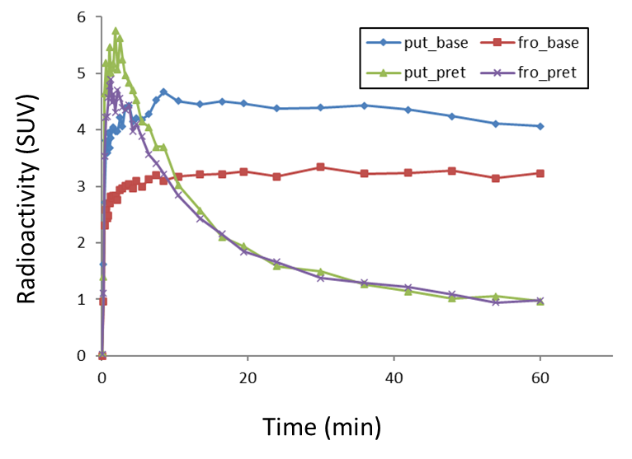

Figure S2

Time-course of plasma concentration of PF-06807893

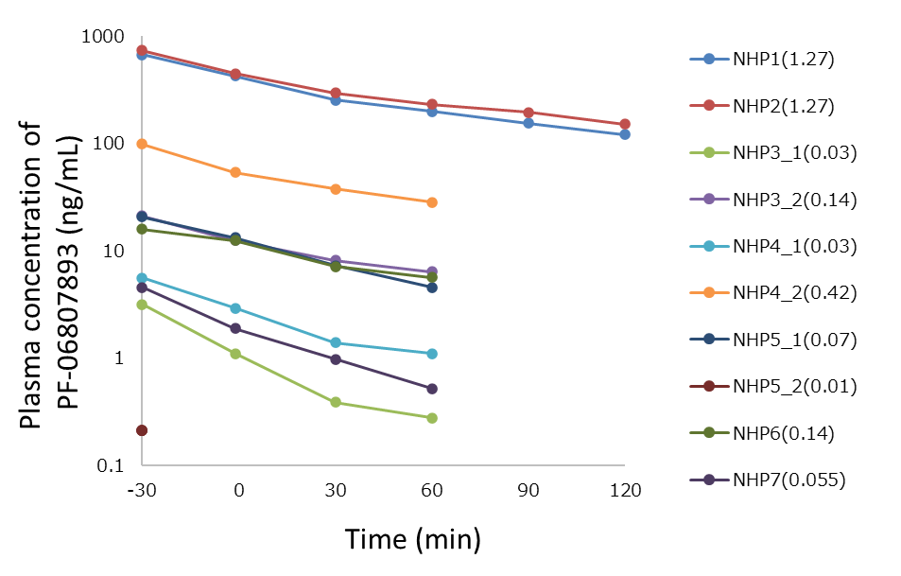

Figure S3

Representative plasma input functions at baseline and pretreatment conditions (NHP4; 0.42 mg/kg)

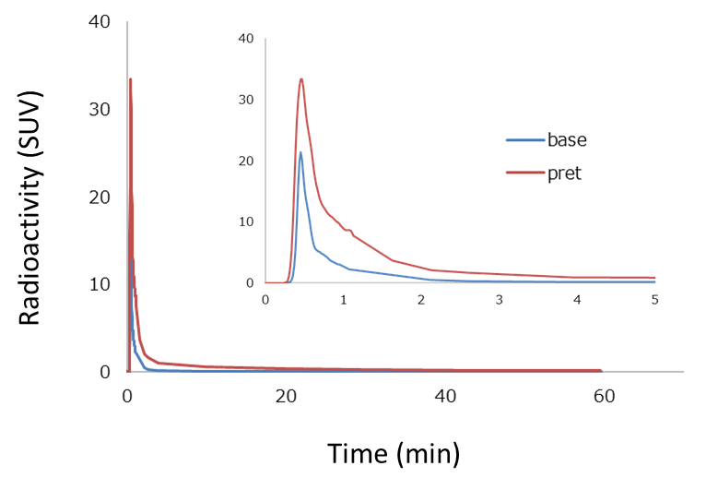

Figure S4

The ratio of brain (putamen) uptake to metabolite-corrected plasma on average (N=10) at baseline condition

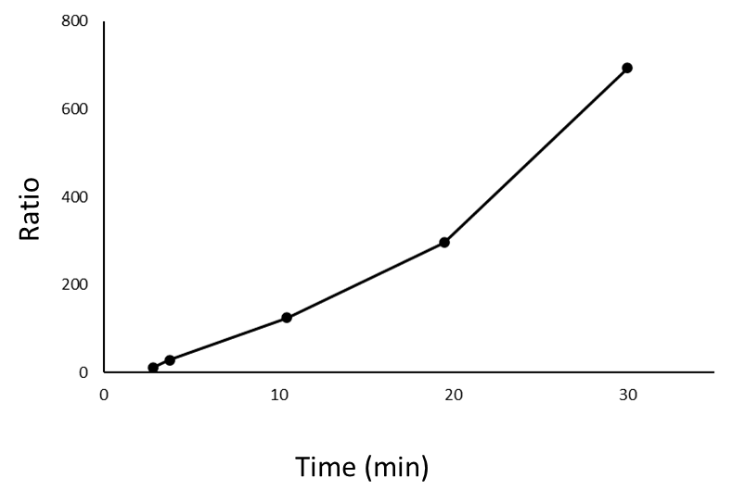

Figure S5

Representative Patlak slope at baseline in the frontal cortex (NHP4; 0.42 mg/kg)

