Machine learning for identification of silylated derivatives from mass spectra

Milka Ljoncheva †, ‡, Tomaž Stepišnik ∫, ‡, Tina Kosjek †, ‡, Sašo Džeroski ∫, ‡, *
† Jozef Stefan Institute, Department of Environmental Sciences, Jamova 39, 1000 Ljubljana, Slovenia
∫ Jozef Stefan Institute, Department of Knowledge Technologies, Jamova 39, 1000 Ljubljana, Slovenia
‡ Jozef Stefan International Postgraduate School, Jamova 39, 1000 Ljubljana, Slovenia
Additional file 6

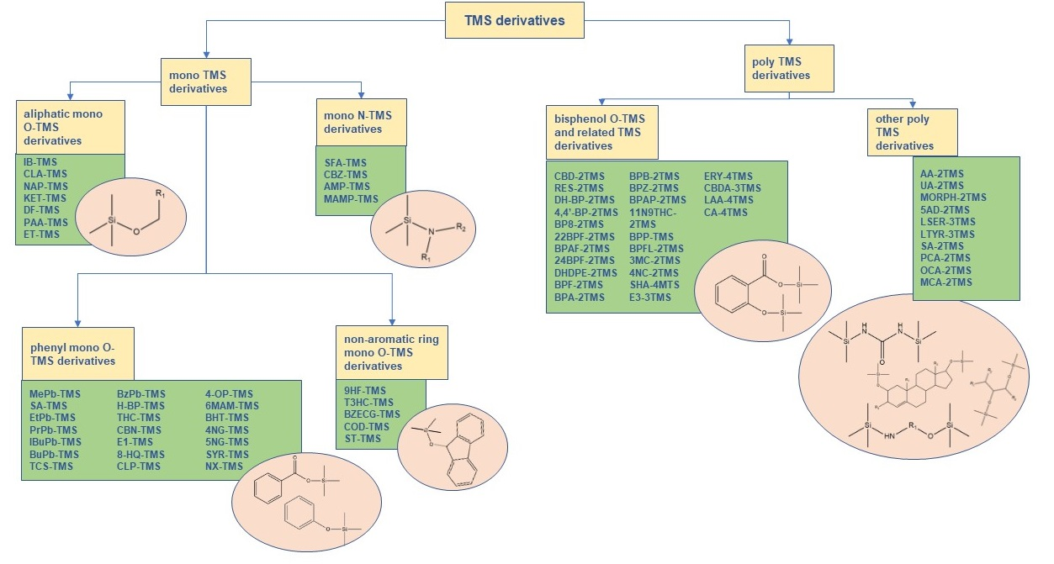
Structural classification of CEC-TMS derivatives

