Machine learning for identification of silylated derivatives from mass spectra
Milka Ljoncheva †, ‡, Tomaž Stepišnik ∫, ‡, Tina Kosjek †, ‡, Sašo Džeroski ∫, ‡, *
† Jozef Stefan Institute, Department of Environmental Sciences, Jamova 39, 1000 Ljubljana, Slovenia
∫ Jozef Stefan Institute, Department of Knowledge Technologies, Jamova 39, 1000 Ljubljana, Slovenia
‡ Jozef Stefan International Postgraduate School, Jamova 39, 1000 Ljubljana, Slovenia

Additional file 3
Representation of the environmental relevance evaluation

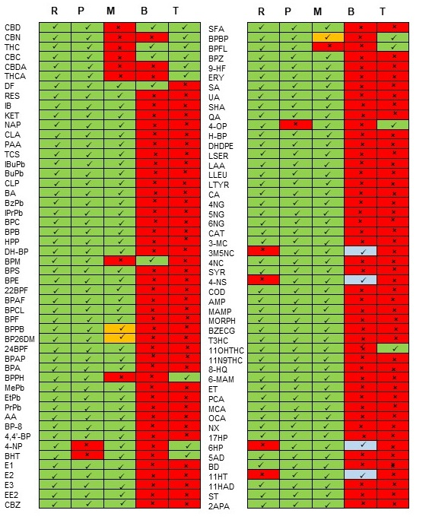
Environmental relevance evaluation according to the RPMBT system. Green fields with thick marks () indicate fulfillment of the criterium, yellow fields with marks indicate conditional fullfillment of criterium; blue fields with marks indicate compounds that do not fulfill the criteria, but according to the European Commission Regulation (EC) No.1907/2006 of the European Parliament and of the Council on the Registration, Evaluation, Authorisation and Restriction of Chemicals (REACH) can be considered as Persistent, Mobile and Toxic compounds; red fileds with () marks indicate not fullfilled criterium.

