SexAnnoDB, a knowledgebase of sex-specific regulations from multi-omics data of human cancers

Mengyuan Yang^{1, *}, Yuzhou Feng^{,2,3}, Jiajia Liu⁴, Hong Wang¹, Sijia Wu⁵, Weiling Zhao⁴, Pora Kim^{4, *}, Xiaobo Zhou^{4, *}

¹ School of Life Sciences, Zhengzhou University, Zhengzhou, 450001, China
² West China Biomedical Big Data Center, West China Hospital, Sichuan University, Chengdu 610041, China
³ Med-X Center for Informatics, Sichuan University, Chengdu 610041, China
⁴ Center for Computational Systems Medicine, McWilliams School of Biomedical Informatics, The University of Texas Health Science Center at Houston, Houston, 77030, USA
⁵ School of Life Sciences and Technology, Xidian University, Xi’an, 710126, China

*Corresponding author(s).
E-mail:Xiaobo.Zhou@uth.tmc.edu(Zhou X), Pora.Kim@uth.tmc.edu(Kim P),mengyuanyang@zzu.edu.cn (Yang M)

Supplementary figures
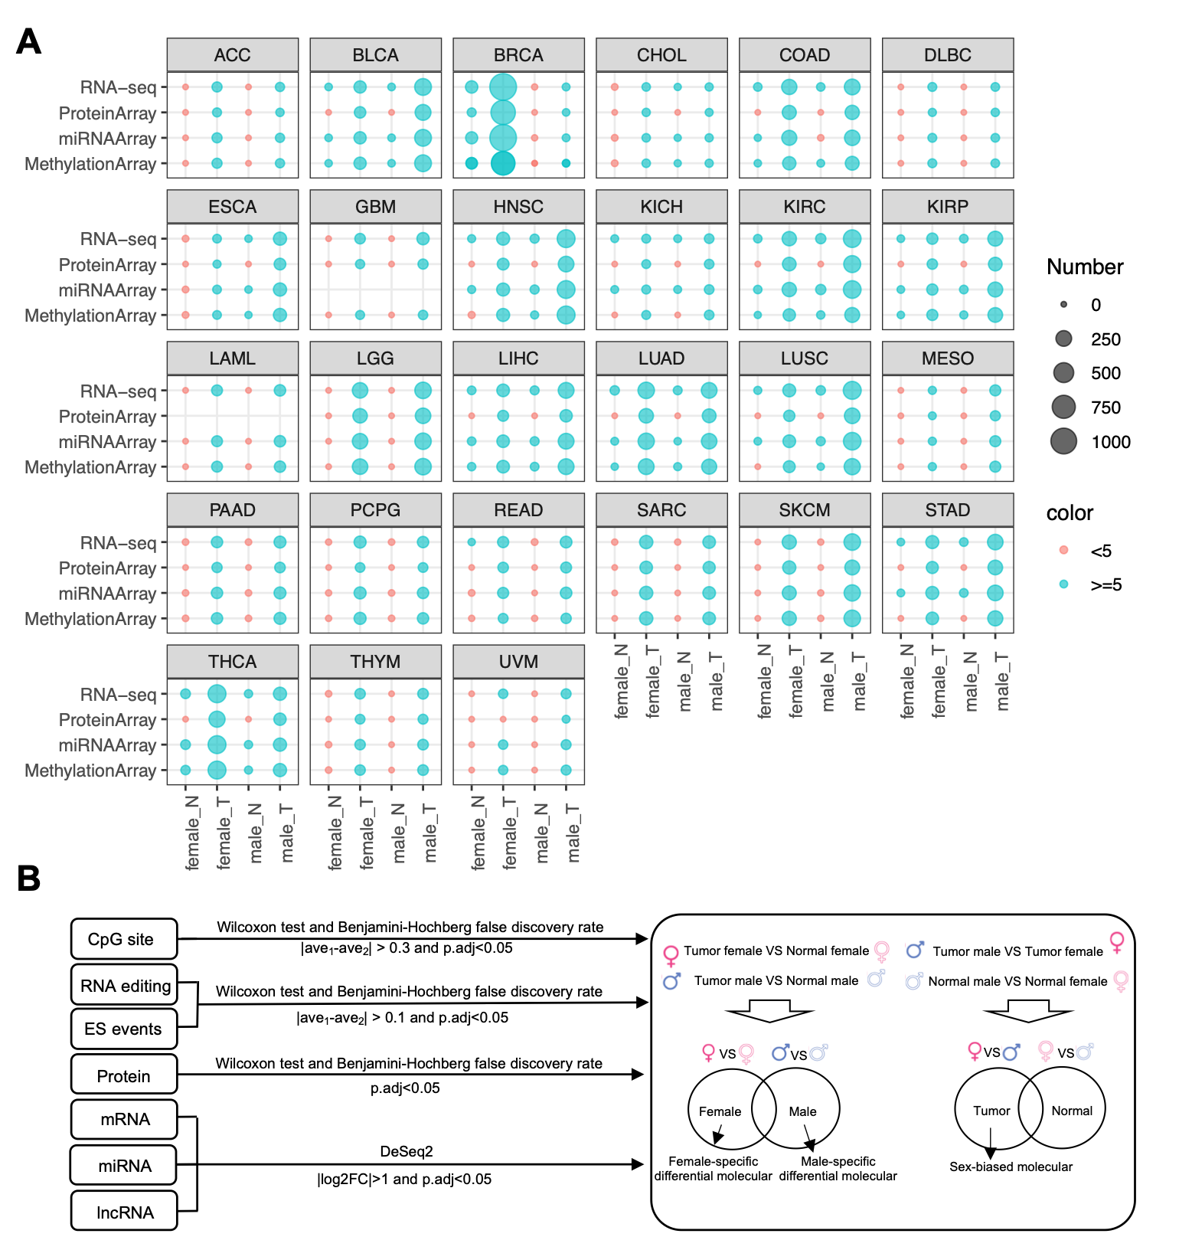
Supplementary figure 1. Sex-biased signatures and Sex-specific differental signatures. (A) The sample size of each group used to identify Sex-biased signatures. (B) The pipeline to identify the sex-biased signatures and sex-specific differential signatures.

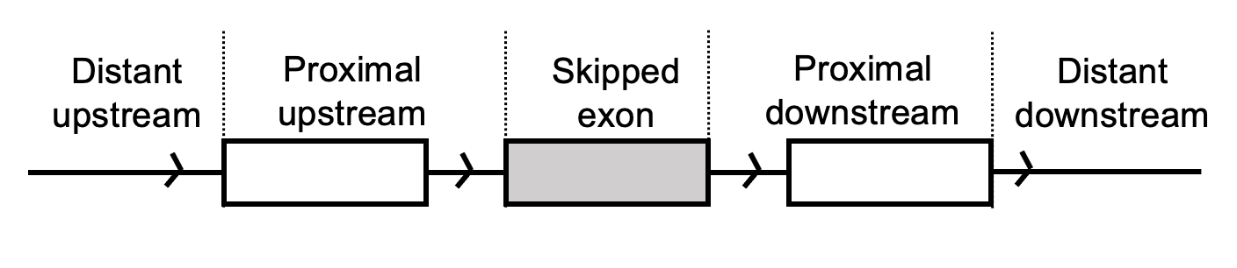
Supplementary figure 2. The structure of exon skipping events
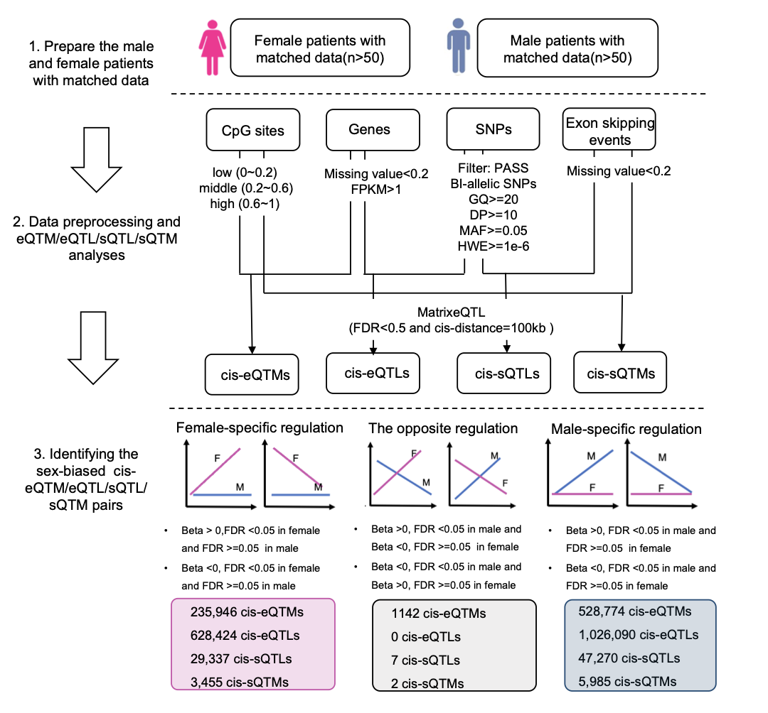
Supplementary figure 3. The pipeline to identify sex-biased cis-eQTM eQTL/sQTL/sQTM pairs

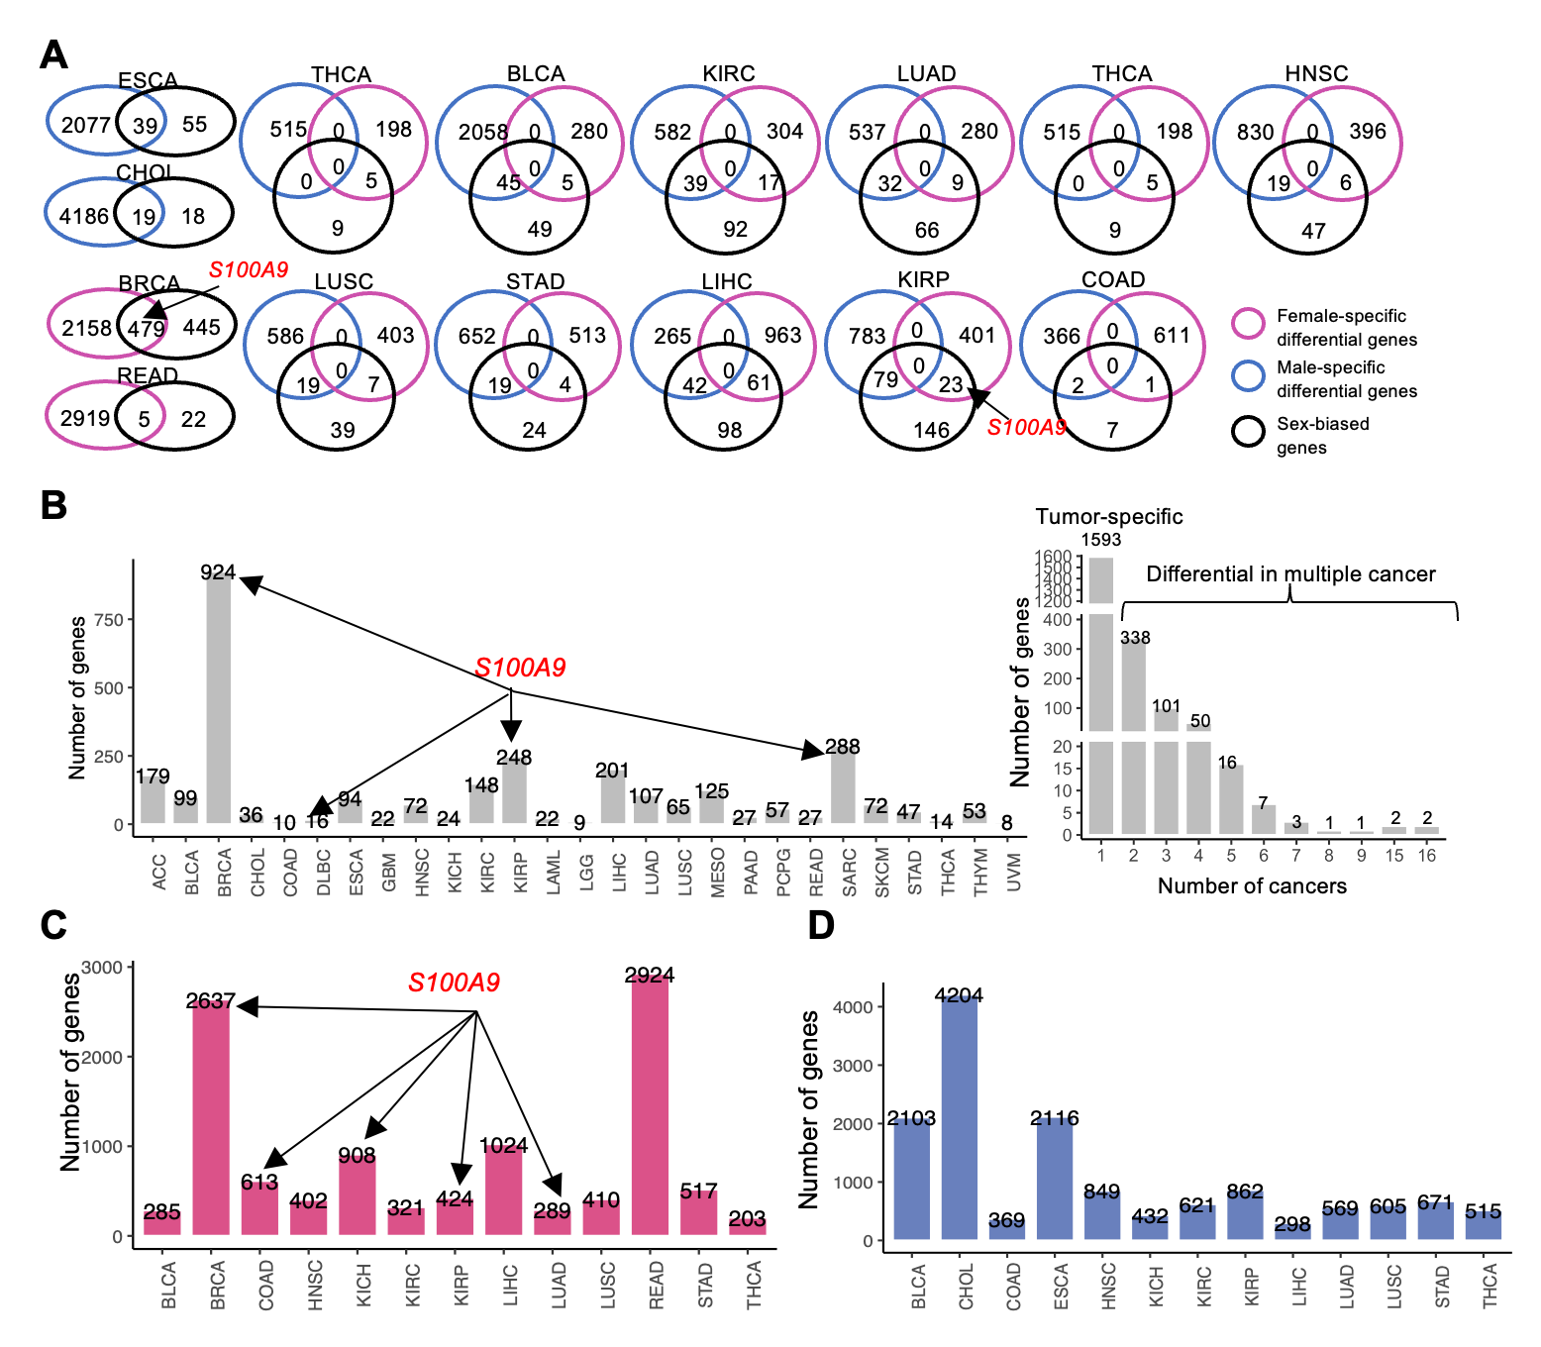
Supplementary figure 4 Sex-biased mRNAs and sex-specific differential mRNAs. (A) Depicts the overlap of sex-biased genes, female-specific differential genes, and male-specific differential genes across 27 cancer types. (B) On the left, it shows the distribution of sex-biased genes in 27 cancer types. On the right, it displays the overall distribution of sex-biased genes across multiple cancers. (C) Represents the number of differential genes between female tumors and female normal tissues. (D) Represents the number of differential genes between male tumors and male normal tissues.

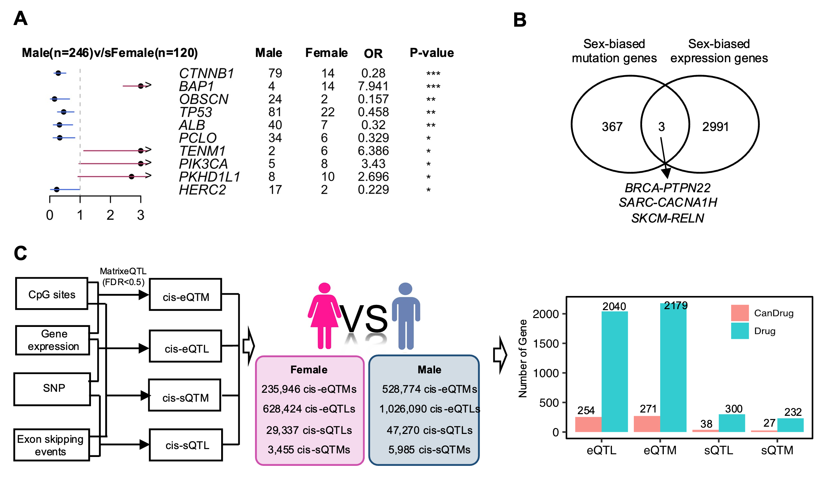
Supplementary figure 5. Sex-biased mutation. (A) The sex-biased mutation genes in LIHC. Odd ratio(OR) with 95% CI, OR = 1 represent no effects, OR<1 represent male-biased mutation, OR>1 represent female-biased mutation. (B) The overlap between sex-biased mutation genes and sex-bised expression genes in all cancer.(C) The pipeline of eQTL/sQTL/eQTM/sQTM analyses.
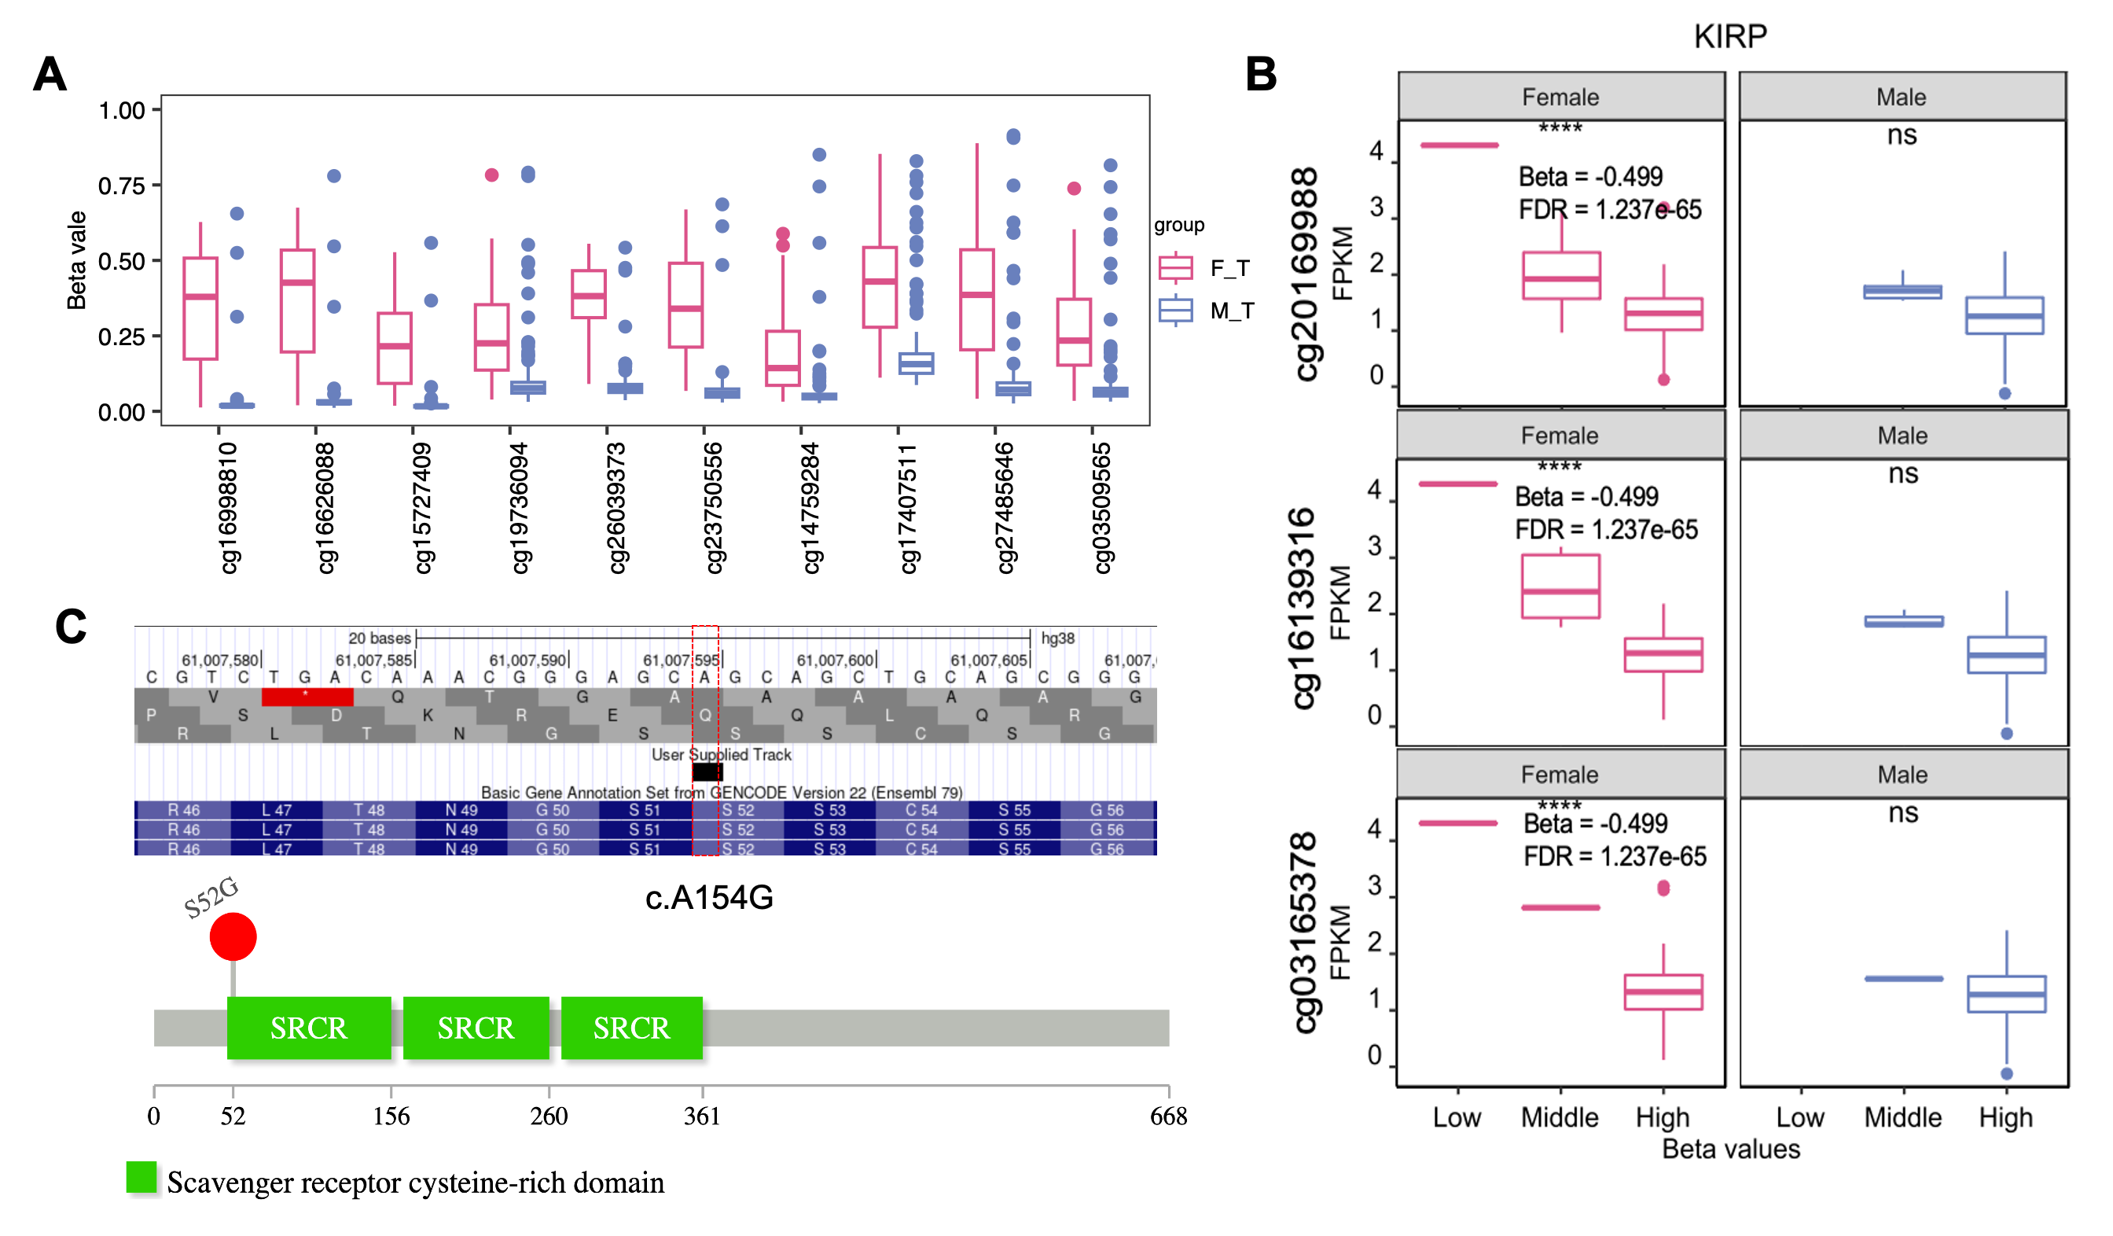
Supplementary figure 6. Sex-biased menthylation and RNA editing. (A) the boxplot of 10CpGsites in SRPX. (B)The sex-biased eQTM pairs related to S100A9.(C) RNA editing site in SRPX. (*FDR <0.05, ** FDR <0.01, *** FDR <0.001, **** FDR <0.0001).

Supplementary figure 7. An evaluation of PANDA’s performance in RBP-ES regulation.

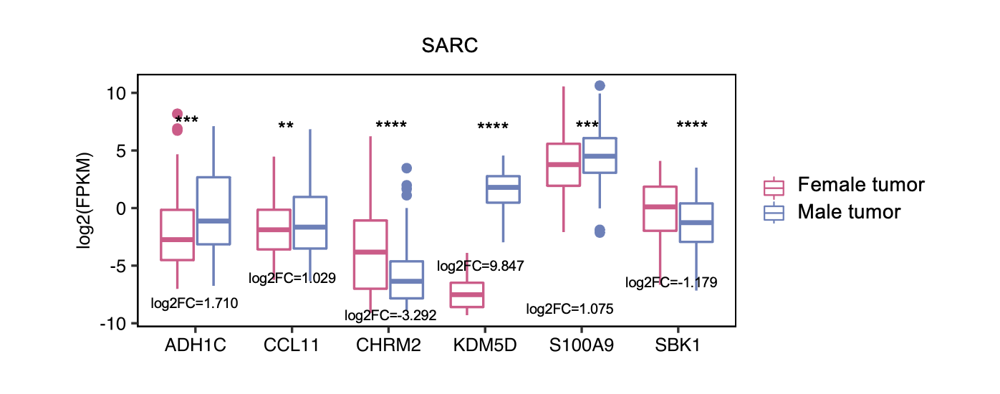
Supplementary figure 8. The sex-biased genes of TF-gene regulatory network in SARC
(*p. adjusted <0.05, **p.adjusted <0.01, ***p.adjusted <0.001, ****p.adjusted <0.0001).

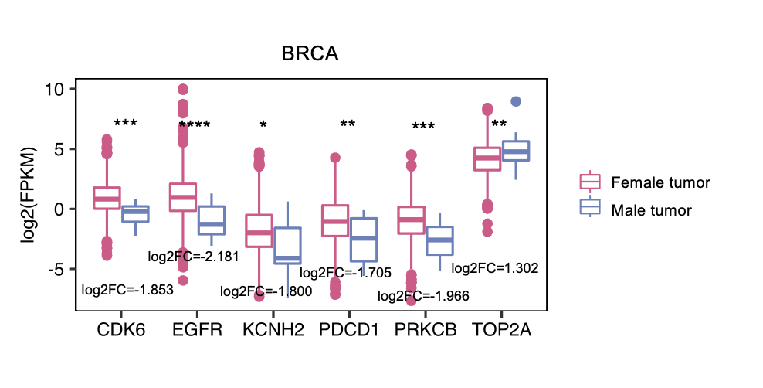
Supplementary figure 9. The sex-biased cancer therapeutic target genes in BRCA
(*p. adjusted <0.05, **p.adjusted <0.01, ***p.adjusted <0.001, ****p.adjusted <0.0001).

