Supplementary Figure S1. Time dependent protein expression of untreated and vehicle control. The Western blot images were shown in vehicle (acetonitrile) treatment. Vehicle treatment has no distinct effect on expression of cyclin proteins.

Supplementary Figure S2. Immunostaining of clathrin expression. Cells were treated with Δ⁹-THC and GW9662 for 24 hours and subjected to immunostaining.

Supplementary Figure S1.
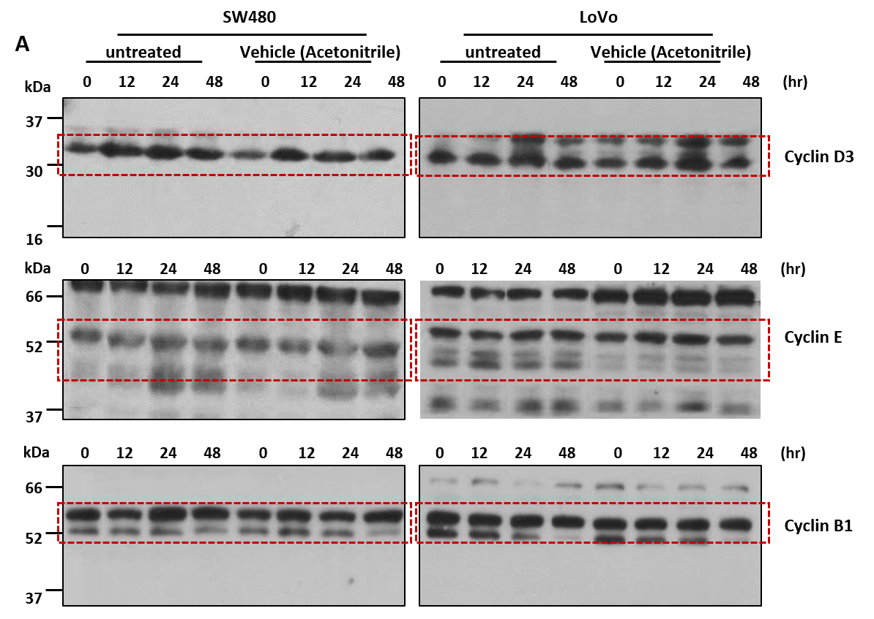

Supplementary Figure S2.
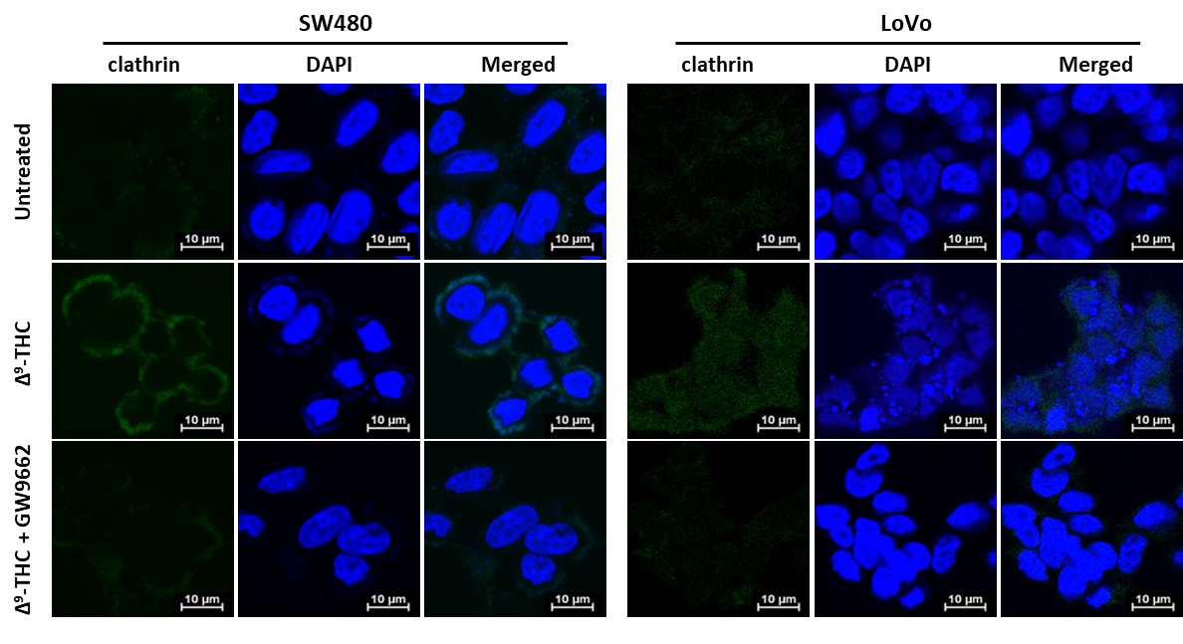

Supplementary Table S1. Primer sequences used in qRT-PCR
Gene name | Primer Sequence
PPARG(PPARγ) | Forward : GTT CTC ATA TCC GAG GGC CA
PPARG(PPARγ) | Reverse : TGC CAA GTC GCT GTC ATC TA
CLTC(Clathrin) | Forward : GTC TGC CAA CAT CCG TCA GA
CLTC(Clathrin) | Reverse : AAG TGC ACA TCT GGG TCC TG
ACTB(β-actin) | Forward : GGA TTC CTA TGT GGG CGA CGA
ACTB(β-actin) | Reverse : CGC TCG GTG AGG ATC TTC ATG

