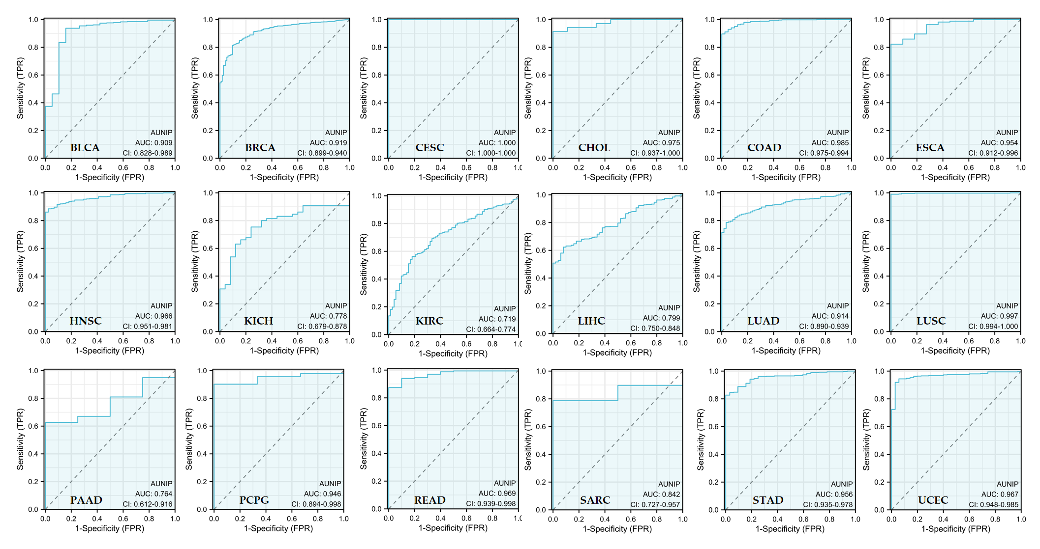
Figure S1 The diagnostic ROC of AUNIP in pan-cancer

