SUPPORTING INFORMATION TEXT
    - Hemolymph collection and hemocytes Identification (DIC, GIENSA and SEM)
Larvae (L₂₋₃) were briefly anaesthetised by the cold (-4°C) (± 3 min until they stopped moving), dried with a paper towel, and transferred to sterile dry Petri dishes. Larvae were beheaded with a sterile scalpel blade [1]. The pool of hemolymph was collected with a microcapillary tube (0.03 mm) coupled to a flexible rubber and then immediately inoculated onto a glass slide, followed by fixation in methanol PA (Sigma-Aldrich) and stained with Giemsa (Sigma-Aldrich), according to [2]. For Differential interference contrast (DIC) microscopy, the pool of hemolymph was collected and dried at room temperature, followed by methanol fixation for 3 minutes. The hemocytes were registered by a photography system (Olympus®, UC30) coupled to a microscope (Olympus® BX51, Tokyo, Japan). The hemocytes identification were according to [3] and [4].
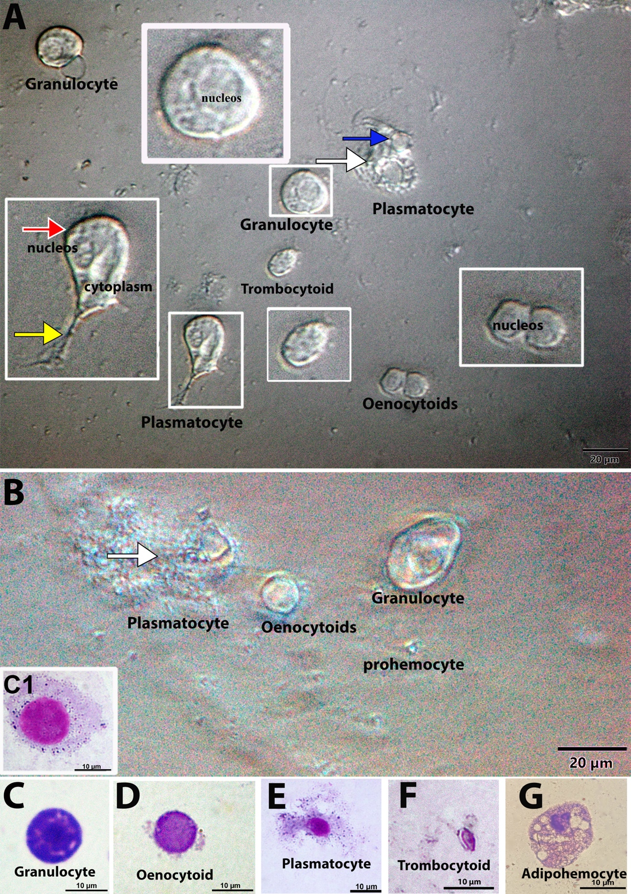
Figure 1 Differential interference contrast (DIC) microscopy (A, B) and light microscopy (C1, C, D, E, F, G). Plasmatocytes exhibiting spindle-shaped (red arrow) to round (blue arrow) and eccentric nucleus and the cytoplasmatic membrane exhibited irregular filopodia (yellow arrow) or pseudopodia (white arrows); Granulocytes exhibiting fusiform or circular shape with central nucleus with (C1) or without pseudopodia (C). Granulocytes with black dots in the cytoplasm (C1); Oenocytoids are small than granulocytes with homogenous cytoplasm without pseudopodia (E); Trombocytoids with piriform shape (F); adipohemocytes exhibiting oval shape and cytoplasm with vesicles similar to lipid droplets (G).

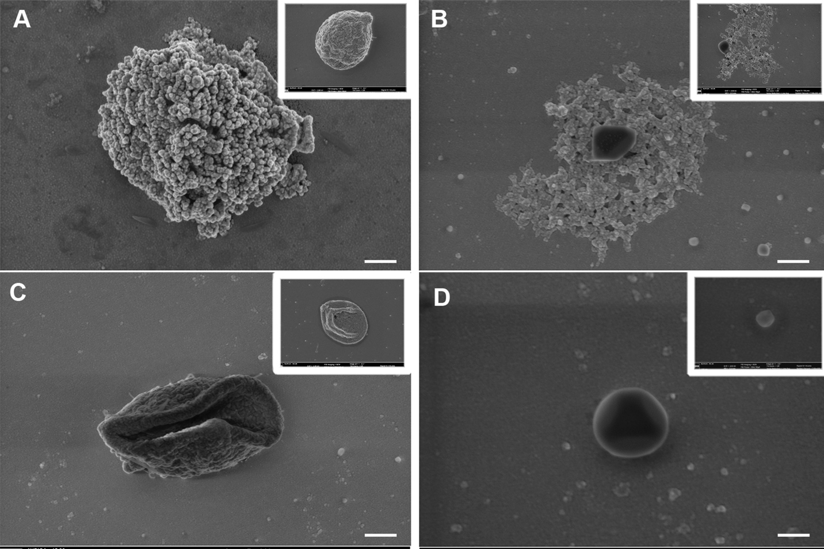
Figure 2 Identification of hemocytes from Aedes aegypti larvae by scanning electron microscopy. A= granulocytes; B= plasmatocytes; C= oenocytoids; D=prohemocytes. White bar = 200 nm. Hemocytes showed the following characteristics: Spherical granulocytes with a granular or rough surface; plasmatocytes exhibiting projections attached to the surface; oenocytoids with a smooth surface and concave shape; prohemocyte with smooth surface and spherical shape.

- Supporting information references

- Nunes FC. Estudo da atividade larvicida de Agave sisanala contra Aedes aegypti. Universidade Federal da Paraíba. João Pessoa, Paraíba; 2013. p.114.
- Fiorotti J, Menna-Barreto RFS, Gôlo PS, Coutinho-Rodrigues CJB, Bitencourt ROB, Spadacci-Morena DD, et al. Ultrastructural and cytotoxic effects of Metarhizium robertsii infection on Rhipicephalus microplus hemocytes. Front Physiol. 2019; 29:10:654.
- Araújo HC, Cavalcanti MG, Santos SS, Alves LC, Brayner FA. Hemocytes ultrastructure of Aedes aegypti (Diptera: Culicidae). Micron. 2008;39:184–189.
- Hillyer JF, Christensen BM. Characterization of hemocytes from the yellow fever mosquito, Aedes aegypti. Histochem Cell Biol. 2002; 117(5):431–40.

