Utilizing machine learning-based QSAR model to overcome standalone consensus docking limitation in beta-lactamase inhibitors screening: a proof-of-concept study.

Thanet Pitakbut^{1,3}, Jennifer Munkert^{1,2}, Wenhui Xi³, Yanjie Wei³, Gregor Fuhrmann^{1,2}

¹ Friedrich-Alexander-Universität Erlangen-Nürnberg, Department of Biology,
Pharmaceutical Biology, Staudtstr. 5, 91058 Erlangen, Germany

² FAU NeW – Research Center New Bioactive Compounds, Nikolaus-Fiebiger-Str. 10, 91058 Erlangen, Germany

² Shenzhen Key Laboratory of Intelligent Bioinformatics and Center for High
Performance Computing, Shenzhen Institute of Advanced Technology, Chinese
Academy of Sciences, Shenzhen 518055, China

Corresponding author: Gregor Fuhrmann (gregor.fuhrmann@fau.de)

List of FigureS

FigureS 1. Anti-beta-lactamase inhibitory screening of eighty-nine compounds in the FARM-BIOMOL chemical library. The red dashed line indicates a selection criterion for an active inhibitory effect at 50% inhibition (Left). All compounds are tested at the same concentration of 2 mg/ml. The result is present in a format of mean ± SD. 3
FigureS 2. AutoDock Vina docking protocol validation. Grey color represents beta-lactamase (PDB ID: 6F2N). Organce color indicates native ligands came with the crystal structure, and light blue color shows a re-docked native ligand that is back to its original position. The RMSD value of native and re-docked ligands is 2.769 Å. 4
FigureS 3. DOCK6 docking protocol validation. Grey color represents beta-lactamase (PDB ID: 6F2N). Organce color indicates native ligands came with the crystal structure, and green color shows a re-docked native ligand that is back to its original position. The RMSD value of native and re-docked ligands is 0.807 Å. 5
FigureS 4. Top ten important features from RF model 7, a non-selected model with the same best performance as RF model 1 used in the manuscript. For information can be found in TableS 3 below. 6

List of TableS

TableS 1. Anti-beta-lactamase inhibitory screening of eighty-nine compounds in the FARM-BIOMOL chemical library. 6
TableS 2. A list of descriptors used to train the machine learning-based QSAR model, excluding additional docking parameters. 9
TableS 3. Random Forest models evaluation. 14
TableS 4. Logistic regression models evaluation. 15

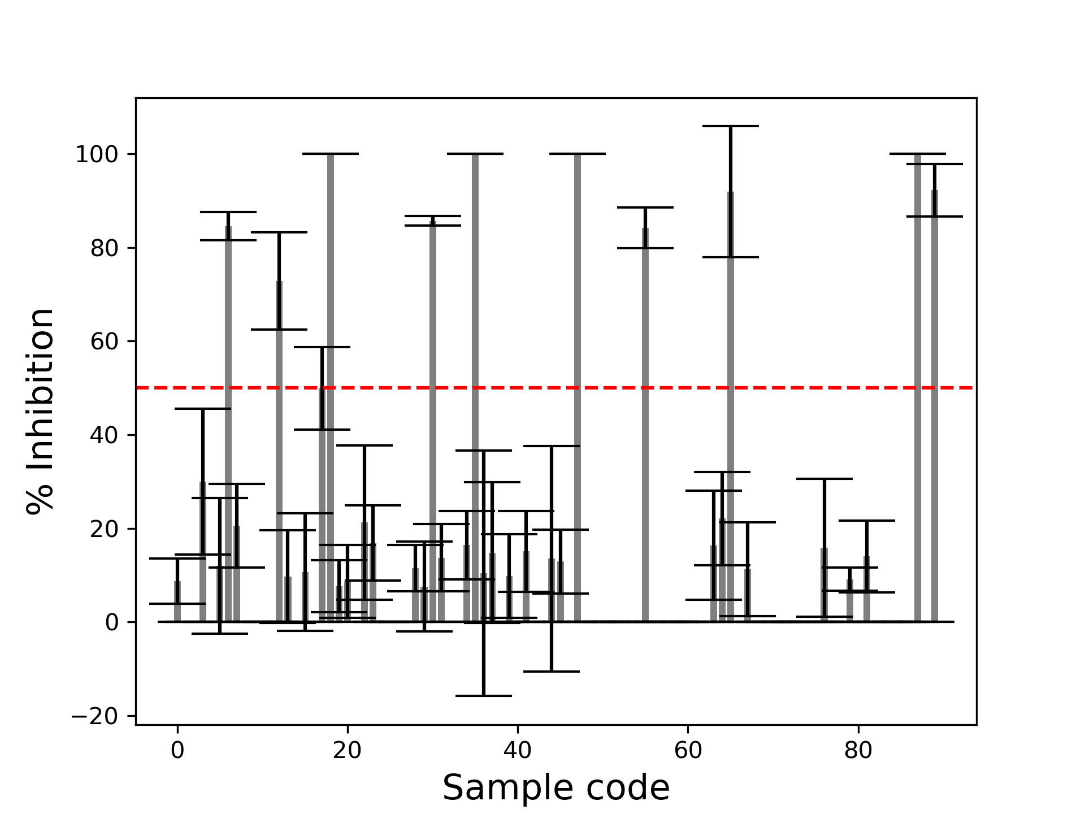

FigureS 1. Anti-beta-lactamase inhibitory screening of eighty-nine compounds in the FARM-BIOMOL chemical library. The red dashed line indicates a selection criterion for an active inhibitory effect at 50% inhibition (Left). All compounds are tested at the same concentration of 2 mg/ml. The result is present in a format of mean ± SD.

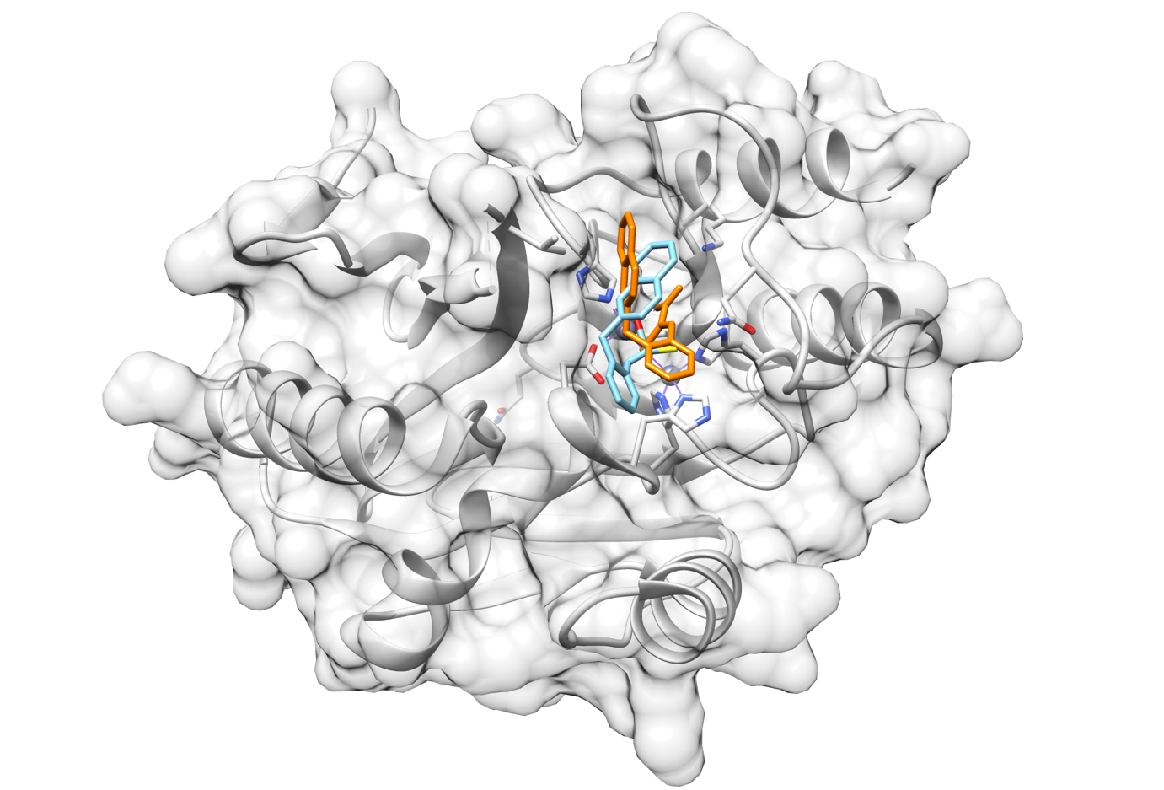
FigureS 2. AutoDock Vina docking protocol validation. Grey color represents beta-lactamase (PDB ID: 6F2N). Organce color indicates native ligands came with the crystal structure, and light blue color shows a re-docked native ligand that is back to its original position. The RMSD value of native and re-docked ligands is 2.769 Å.

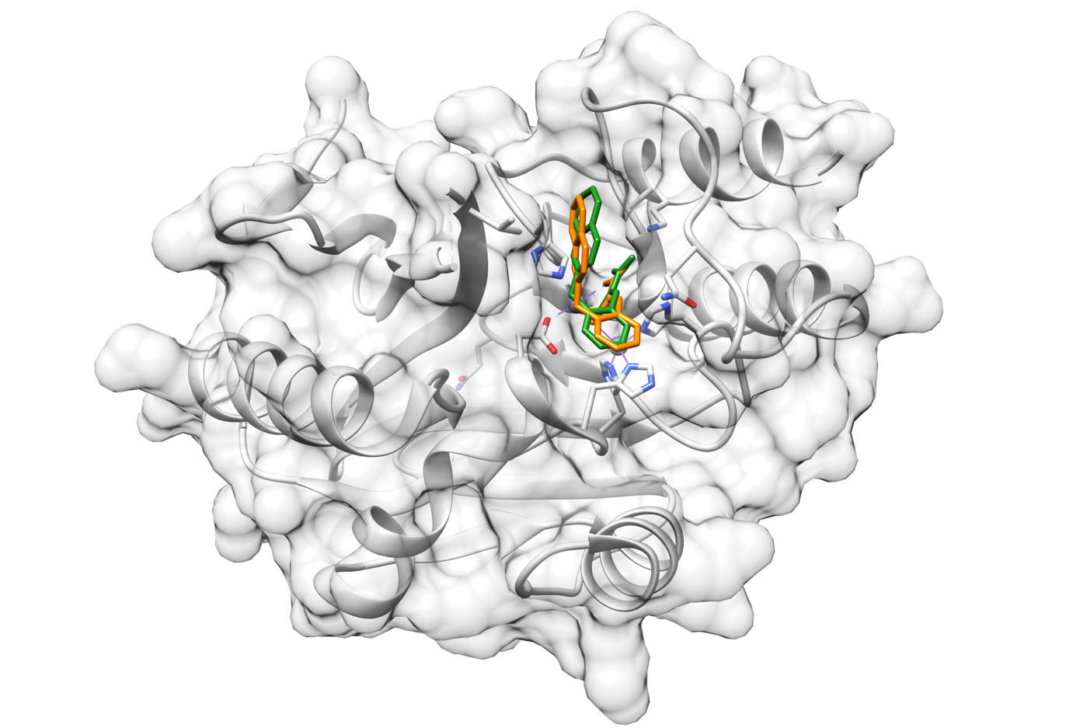

FigureS 3. DOCK6 docking protocol validation. Grey color represents beta-lactamase (PDB ID: 6F2N). Organce color indicates native ligands came with the crystal structure, and green color shows a re-docked native ligand that is back to its original position. The RMSD value of native and re-docked ligands is 0.807 Å.

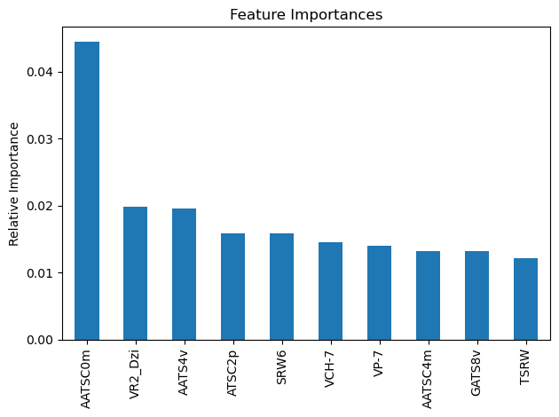

FigureS 4. Top ten important features from RF model 7, a non-selected model with the same best performance as RF model 1 used in the manuscript. For information can be found in TableS 3 below.

TableS 1. Anti-beta-lactamase inhibitory screening of eighty-nine compounds in the FARM-BIOMOL chemical library.
No | FARMBIOMOL ID. | % inhibition | SD | SE | Name
0 | 1 | 8,74 | 4,85 | 1,62 | thymol
1 | 4 | 0,00 | 0,00 | 0,00 | catechol
2 | 5 | 0,00 | 0,00 | 0,00 | carmine
3 | 6 | 29,93 | 15,57 | 5,19 | coumarin
4 | 7 | 0,00 | 0,00 | 0,00 | quinaldic acid
5 | 8 | 12,02 | 14,49 | 4,83 | Trans-cinnamic acid
6 | 9 | 84,57 | 2,98 | 0,99 | chlorogenic acid
7 | 12 | 20,57 | 8,89 | 2,96 | caffeine anhydrous
8 | 13 | 0,00 | 0,00 | 0,00 | caffeic acid
9 | 15 | 0,00 | 0,00 | 0,00 | ellagic acid
10 | 16 | 0,00 | 0,00 | 0,00 | esculin
11 | 17 | 0,00 | 0,00 | 0,00 | ferulic acid
12 | 18 | 72,87 | 10,39 | 3,46 | tannine
13 | 19 | 9,70 | 9,89 | 3,30 | hesperidin
14 | 20 | 0,00 | 0,00 | 0,00 | hydroquinone monomethyl ether
15 | 21 | 10,68 | 12,58 | 4,19 | 4-hydroxylbenzoic acid
16 | 22 | 0,00 | 0,00 | 0,00 | 2'-hydroxylflavone
17 | 23 | 49,87 | 8,80 | 2,93 | hydroquinone
18 | 24 | 100,00 | 0,00 | 0,00 | 2-hydroxy-1,4-naphtoquinone
19 | 25 | 7,66 | 5,53 | 1,84 | methyl-4-hydroxybenzoate
20 | 27 | 8,64 | 7,80 | 2,60 | m-Hydroxy-benzoic acid
21 | 28 | 0,00 | 0,00 | 0,00 | Khellin
22 | 29 | 21,25 | 16,49 | 5,50 | Kojic acid
23 | 32 | 16,86 | 8,02 | 2,67 | Methyl 2-Methoxybenzoate
24 | 33 | 0,00 | 0,00 | 0,00 | Nalidixic acid
25 | 34 | 0,00 | 0,00 | 0,00 | Narcotine Hydrochloride
26 | 35 | 0,00 | 0,00 | 0,00 | umbelliferone
27 | 36 | 0,00 | 0,00 | 0,00 | Vitexin
28 | 37 | 11,48 | 4,96 | 1,65 | Pyrogallo
29 | 39 | 7,58 | 9,61 | 3,20 | Phloroglucinol dihydrate
30 | 40 | 85,68 | 1,02 | 0,34 | Salcylic acid
31 | 41 | 13,71 | 7,19 | 2,40 | salicylic acid methyl ester
32 | 42 | 0,00 | 0,00 | 0,00 | D-salicin
33 | 43 | 0,00 | 0,00 | 0,00 | alpha-terpinene
34 | 44 | 16,41 | 7,34 | 2,45 | vanillin
35 | 49 | 100,00 | 0,00 | 0,00 | Homoprotocatechuic acid
36 | 50 | 10,40 | 26,21 | 8,74 | p-Hydroxyphenylpropionic acid
37 | 51 | 14,82 | 15,04 | 5,01 | m-Hydroxyphenylacetic acid
38 | 52 | 0,00 | 0,00 | 0,00 | Isoscopoletin
39 | 54 | 9,84 | 8,96 | 2,99 | Nicotinamide
40 | 55 | 0,00 | 0,00 | 0,00 | Nicotinic acid
41 | 56 | 15,12 | 8,64 | 2,88 | Rutin
42 | 58 | 0,00 | 0,00 | 0,00 | Eugenol
43 | 61 | 0,00 | 0,00 | 0,00 | papaverine
44 | 64 | 13,52 | 24,08 | 8,03 | rhein
45 | 65 | 12,91 | 6,78 | 2,26 | aloin
46 | 69 | 0,00 | 0,00 | 0,00 | emodin
47 | 74 | 100,00 | 0,00 | 0,00 | 6-hydroxyflavone
48 | 76 | 0,00 | 0,00 | 0,00 | atropamine
49 | 77 | 0,00 | 0,00 | 0,00 | nicotine
50 | 78 | 0,00 | 0,00 | 0,00 | L-Hyoscamine
51 | 84 | 0,00 | 0,00 | 0,00 | Aloe-emodin
52 | 86 | 0,00 | 0,00 | 0,00 | capsaicin
53 | 88 | 0,00 | 0,00 | 0,00 | thujone
54 | 89 | 0,00 | 0,00 | 0,00 | 1(s)-borneol
55 | 97 | 84,17 | 4,33 | 1,44 | spiraeoside
56 | 100 | 0,00 | 0,00 | 0,00 | chinchonine-hydrochloride
57 | 101 | 0,00 | 0,00 | 0,00 | psoralen
58 | 103 | 0,00 | 0,00 | 0,00 | Prunin
59 | 104 | 0,00 | 0,00 | 0,00 | Santonin
60 | 105 | 0,00 | 0,00 | 0,00 | Isopimpinellin
61 | 106 | 0,00 | 0,00 | 0,00 | Lobeline Hydrochloride
62 | 110 | 0,00 | 0,00 | 0,00 | Apigenin-7-glucoside
63 | 111 | 16,35 | 11,64 | 3,88 | Isoferulic Acid
64 | 112 | 22,08 | 9,97 | 3,32 | p-Arbutin
65 | 113 | 91,93 | 13,98 | 4,66 | Luteolin-7-Glucoside
66 | 114 | 0,00 | 0,00 | 0,00 | r-Atropine
67 | 115 | 11,26 | 10,03 | 3,34 | Eserine/Physostigmine
68 | 116 | 0,00 | 0,00 | 0,00 | Bergapten
69 | 117 | 0,00 | 0,00 | 0,00 | Formononetin
70 | 119 | 0,00 | 0,00 | 0,00 | Genistein
71 | 120 | 0,00 | 0,00 | 0,00 | Belladonna total alkaloids
72 | 121 | 0,00 | 0,00 | 0,00 | Rhaponticin
73 | 122 | 0,00 | 0,00 | 0,00 | Sennoside A
74 | 123 | 0,00 | 0,00 | 0,00 | Scopoletin
75 | 125 | 0,00 | 0,00 | 0,00 | Naringenin
76 | 137 | 15,84 | 14,69 | 4,90 | D-Amygdalin
77 | 138 | 0,00 | 0,00 | 0,00 | Amantadine
78 | 139 | 0,00 | 0,00 | 0,00 | (+)-Catechol hydrate
79 | 140 | 9,12 | 2,46 | 0,82 | Quinic acid
80 | 141 | 0,00 | 0,00 | 0,00 | m-Coumaric acid
81 | 142 | 13,99 | 7,71 | 2,57 | 4-Hydroxy-3-methoxycinnamic acid
82 | 145 | 0,00 | 0,00 | 0,00 | p-Coumaric acid
83 | 146 | 0,00 | 0,00 | 0,00 | Theophylline
84 | 147 | 0,00 | 0,00 | 0,00 | Curcumin
85 | 148 | 0,00 | 0,00 | 0,00 | Isoquercitrin
86 | 150 | 0,00 | 0,00 | 0,00 | Theobromine
87 | 151 | 100,00 | 0,00 | 0,00 | Quercetin
88 | 152 | 0,00 | 0,00 | 0,00 | Luteolin

TableS 2. A list of descriptors used to train the machine learning-based QSAR model, excluding additional docking parameters.
nAcid | ALogP | ALogp2 | AMR | apol
naAromAtom | nAromBond | nAtom | nHeavyAtom | nH
nC | nN | nO | ATS0m | ATS1m
ATS2m | ATS3m | ATS4m | ATS5m | ATS6m
ATS7m | ATS8m | ATS0v | ATS1v | ATS2v
ATS3v | ATS4v | ATS5v | ATS6v | ATS7v
ATS8v | ATS0e | ATS1e | ATS2e | ATS3e
ATS4e | ATS5e | ATS6e | ATS7e | ATS8e
ATS0p | ATS1p | ATS2p | ATS3p | ATS4p
ATS5p | ATS6p | ATS7p | ATS8p | ATS0i
ATS1i | ATS2i | ATS3i | ATS4i | ATS5i
ATS6i | ATS7i | ATS8i | ATS0s | ATS1s
ATS2s | ATS3s | ATS4s | ATS5s | ATS6s
ATS7s | ATS8s | AATS0m | AATS1m | AATS2m
AATS3m | AATS4m | AATS5m | AATS6m | AATS7m
AATS8m | AATS0v | AATS1v | AATS2v | AATS3v
AATS4v | AATS5v | AATS6v | AATS7v | AATS8v
AATS0e | AATS1e | AATS2e | AATS3e | AATS4e
AATS5e | AATS6e | AATS7e | AATS8e | AATS0p
AATS1p | AATS2p | AATS3p | AATS4p | AATS5p
AATS6p | AATS7p | AATS8p | AATS0i | AATS1i
AATS2i | AATS3i | AATS4i | AATS5i | AATS6i
AATS7i | AATS8i | AATS0s | AATS1s | AATS2s
AATS3s | AATS4s | AATS5s | AATS6s | AATS7s
AATS8s | ATSC0c | ATSC1c | ATSC2c | ATSC3c
ATSC4c | ATSC5c | ATSC6c | ATSC7c | ATSC8c
ATSC0m | ATSC1m | ATSC2m | ATSC3m | ATSC4m
ATSC5m | ATSC6m | ATSC7m | ATSC8m | ATSC0v
ATSC1v | ATSC2v | ATSC3v | ATSC4v | ATSC5v
ATSC6v | ATSC7v | ATSC8v | ATSC0e | ATSC1e
ATSC2e | ATSC3e | ATSC4e | ATSC5e | ATSC6e
ATSC7e | ATSC8e | ATSC0p | ATSC1p | ATSC2p
ATSC3p | ATSC4p | ATSC5p | ATSC6p | ATSC7p
ATSC8p | ATSC0i | ATSC1i | ATSC2i | ATSC3i
ATSC4i | ATSC5i | ATSC6i | ATSC7i | ATSC8i
ATSC0s | ATSC1s | ATSC2s | ATSC3s | ATSC4s
ATSC5s | ATSC6s | ATSC7s | ATSC8s | AATSC0m
AATSC1m | AATSC2m | AATSC3m | AATSC4m | AATSC5m
AATSC6m | AATSC7m | AATSC8m | AATSC0v | AATSC1v
AATSC2v | AATSC3v | AATSC4v | AATSC5v | AATSC6v
AATSC7v | AATSC8v | AATSC1i | AATSC2i | AATSC3i
AATSC4i | AATSC5i | AATSC6i | AATSC7i | AATSC8i
AATSC0s | AATSC1s | AATSC2s | AATSC3s | AATSC4s
AATSC5s | AATSC6s | AATSC7s | AATSC8s | MATS1c
MATS2c | MATS3c | MATS4c | MATS5c | MATS6c
MATS7c | MATS8c | MATS3m | MATS4m | MATS5m
MATS6m | MATS7m | MATS8m | MATS2v | MATS3v
MATS4v | MATS5v | MATS6v | MATS7v | MATS8v
MATS2e | MATS3e | MATS4e | MATS5e | MATS6e
MATS7e | MATS8e | MATS1p | MATS2p | MATS3p
MATS5p | MATS6p | MATS7p | MATS8p | MATS1i
MATS2i | MATS3i | MATS4i | MATS5i | MATS6i
MATS7i | MATS8i | MATS2s | MATS3s | MATS4s
MATS5s | MATS6s | MATS7s | MATS8s | GATS1c
GATS2c | GATS3c | GATS4c | GATS5c | GATS6c
GATS7c | GATS8c | GATS1m | GATS2m | GATS3m
GATS4m | GATS5m | GATS6m | GATS7m | GATS8m
GATS1v | GATS2v | GATS3v | GATS4v | GATS5v
GATS6v | GATS7v | GATS8v | GATS1e | GATS2e
GATS3e | GATS4e | GATS5e | GATS6e | GATS7e
GATS8e | GATS1p | GATS2p | GATS3p | GATS4p
GATS5p | GATS6p | GATS7p | GATS8p | GATS1i
GATS2i | GATS3i | GATS4i | GATS5i | GATS6i
GATS7i | GATS8i | GATS1s | GATS2s | GATS3s
GATS4s | GATS5s | GATS6s | GATS7s | GATS8s
SpAbs_DzZ | SpMax_DzZ | SpDiam_DzZ | SpAD_DzZ | SpMAD_DzZ
EE_DzZ | SM1_DzZ | VE3_DzZ | VR1_DzZ | VR2_DzZ
VR3_DzZ | SpAbs_Dzm | SpMax_Dzm | SpDiam_Dzm | SpAD_Dzm
SpMAD_Dzm | EE_Dzm | SM1_Dzm | VE3_Dzm | VR1_Dzm
VR2_Dzm | VR3_Dzm | SpAbs_Dzv | SpMax_Dzv | SpDiam_Dzv
SpAD_Dzv | SpMAD_Dzv | EE_Dzv | SM1_Dzv | VE1_Dzv
VE3_Dzv | VR1_Dzv | VR2_Dzv | VR3_Dzv | SpAbs_Dze
SpMax_Dze | SpDiam_Dze | SpAD_Dze | SpMAD_Dze | EE_Dze
SM1_Dze | VE3_Dze | VR1_Dze | VR2_Dze | VR3_Dze
SpAbs_Dzp | SpMax_Dzp | SpDiam_Dzp | SpAD_Dzp | SpMAD_Dzp
EE_Dzp | SM1_Dzp | VE1_Dzp | VE3_Dzp | VR1_Dzp
VR2_Dzp | VR3_Dzp | SpAbs_Dzi | SpMax_Dzi | SpDiam_Dzi
SpAD_Dzi | SpMAD_Dzi | EE_Dzi | SM1_Dzi | VE3_Dzi
VR1_Dzi | VR2_Dzi | VR3_Dzi | SpAbs_Dzs | SpMax_Dzs
SpDiam_Dzs | SpAD_Dzs | SpMAD_Dzs | EE_Dzs | SM1_Dzs
VE1_Dzs | VE3_Dzs | VR1_Dzs | VR2_Dzs | VR3_Dzs
nBase | BCUTw-1h | BCUTp-1l | BCUTp-1h | nBonds
nBonds2 | nBondsS | nBondsS2 | nBondsS3 | nBondsD
nBondsT | nBondsM | bpol | SpMax2_Bhm | SpMax3_Bhm
SpMax4_Bhm | SpMax5_Bhm | SpMax6_Bhm | SpMax7_Bhm | SpMax8_Bhm
SpMin2_Bhm | SpMin3_Bhm | SpMin4_Bhm | SpMin5_Bhm | SpMin6_Bhm
SpMin7_Bhm | SpMin8_Bhm | SpMax2_Bhv | SpMax3_Bhv | SpMax4_Bhv
SpMax5_Bhv | SpMax6_Bhv | SpMax7_Bhv | SpMax8_Bhv | SpMin2_Bhv
SpMin3_Bhv | SpMin4_Bhv | SpMin5_Bhv | SpMin6_Bhv | SpMin7_Bhv
SpMin8_Bhv | SpMax2_Bhe | SpMax3_Bhe | SpMax4_Bhe | SpMax5_Bhe
SpMax6_Bhe | SpMax7_Bhe | SpMax8_Bhe | SpMin2_Bhe | SpMin3_Bhe
SpMin4_Bhe | SpMin5_Bhe | SpMin6_Bhe | SpMin7_Bhe | SpMin8_Bhe
SpMax2_Bhp | SpMax3_Bhp | SpMax4_Bhp | SpMax5_Bhp | SpMax6_Bhp
SpMax7_Bhp | SpMax8_Bhp | SpMin2_Bhp | SpMin3_Bhp | SpMin4_Bhp
SpMin5_Bhp | SpMin6_Bhp | SpMin7_Bhp | SpMin8_Bhp | SpMax2_Bhi
SpMax3_Bhi | SpMax4_Bhi | SpMax5_Bhi | SpMax6_Bhi | SpMax7_Bhi
SpMax8_Bhi | SpMin2_Bhi | SpMin3_Bhi | SpMin4_Bhi | SpMin5_Bhi
SpMin6_Bhi | SpMin7_Bhi | SpMin8_Bhi | SpMax1_Bhs | SpMax2_Bhs
SpMax3_Bhs | SpMax4_Bhs | SpMax5_Bhs | SpMax6_Bhs | SpMax7_Bhs
SpMax8_Bhs | SpMin2_Bhs | SpMin3_Bhs | SpMin4_Bhs | SpMin5_Bhs
SpMin6_Bhs | SpMin7_Bhs | SpMin8_Bhs | C1SP2 | C2SP2
C3SP2 | C1SP3 | C2SP3 | C3SP3 | C4SP3
SCH-6 | SCH-7 | VCH-6 | VCH-7 | SC-3
SC-5 | VC-3 | VC-5 | SPC-4 | SPC-5
SPC-6 | VPC-4 | VPC-5 | VPC-6 | SP-0
SP-1 | SP-2 | SP-3 | SP-4 | SP-5
SP-6 | SP-7 | VP-0 | VP-1 | VP-2
VP-3 | VP-4 | VP-5 | VP-6 | VP-7
Sv | Sse | Spe | Sare | Sp
Si | CrippenLogP | CrippenMR | SpMax_Dt | SpDiam_Dt
SpAD_Dt | SpMAD_Dt | EE_Dt | VE3_Dt | VR1_Dt
VR2_Dt | VR3_Dt | ECCEN | nHBd | nHBa
nwHBa | nHBint2 | nHBint3 | nHBint4 | nHBint5
nHBint6 | nHBint7 | nHBint8 | nHBint9 | nHBint10
nHsOH | nHsNH2 | nHssNH | nHaaNH | nHdCH2
nHdsCH | nHaaCH | nHCsats | nHCsatu | nHAvin
nHother | nsCH3 | nssCH2 | nsssCH | ndssC
naasC | naaaC | nssssC | naaN | nsssN
naasN | ndO | nssO | naaO | SHBd
SHBa | SwHBa | SHBint2 | SHBint3 | SHBint4
SHBint5 | SHBint6 | SHBint7 | SHBint8 | SHBint9
SHBint10 | SHsOH | SHdsCH | SHaaCH | SHCsats
SHCsatu | SHAvin | SHother | SsCH3 | SdCH2
SssCH2 | SdsCH | SaaCH | SsssCH | StsC
SdssC | SaasC | SaaaC | SssssC | SsNH2
SssNH | SaaNH | StN | SaaN | SsssN
SaasN | SsOH | SdO | SssO | SaaO
minHBd | minHBa | minwHBa | minHBint2 | minHBint3
minHBint4 | minHBint5 | minHBint6 | minHBint7 | minHBint8
minHBint9 | minHBint10 | minHsOH | minHdsCH | minHaaCH
minHCsats | minHCsatu | minHAvin | minHother | minsCH3
minssCH2 | mindsCH | minaaCH | minsssCH | mindssC
minaasC | minaaaC | minssssC | minsssN | minsOH
mindO | minssO | maxHBd | maxHBa | maxwHBa
maxHBint2 | maxHBint3 | maxHBint4 | maxHBint5 | maxHBint6
maxHBint7 | maxHBint8 | maxHBint9 | maxHBint10 | maxHsOH
maxHdsCH | maxHaaCH | maxHCsats | maxHCsatu | maxHAvin
maxHother | maxsCH3 | maxssCH2 | maxdsCH | maxaaCH
maxsssCH | maxdssC | maxaasC | maxaaaC | maxsssN
maxsOH | maxdO | maxssO | sumI | meanI
hmax | gmax | hmin | gmin | LipoaffinityIndex
MAXDN | MAXDP | DELS | ETA_Alpha | ETA_Beta
ETA_BetaP | ETA_Beta_s | ETA_Beta_ns | ETA_BetaP_ns | ETA_dBeta
ETA_dBetaP | ETA_Beta_ns_d | ETA_Eta | ETA_EtaP | ETA_Eta_R
ETA_Eta_F | ETA_EtaP_F | ETA_Eta_L | ETA_Eta_R_L | ETA_Eta_F_L
ETA_Eta_B | ETA_Eta_B_RC | fragC | nHBAcc | nHBAcc2
nHBAcc3 | nHBAcc_Lipinski | nHBDon_Lipinski | HybRatio | IC0
IC1 | IC2 | IC3 | IC4 | IC5
TIC0 | TIC1 | TIC2 | TIC3 | TIC4
TIC5 | CIC0 | CIC1 | CIC2 | CIC3
CIC4 | CIC5 | MIC0 | MIC1 | MIC2
MIC3 | MIC4 | MIC5 | ZMIC0 | ZMIC1
ZMIC2 | ZMIC3 | ZMIC4 | ZMIC5 | Kier1
Kier2 | Kier3 | nAtomLC | nAtomP | nAtomLAC
MLogP | McGowan_Volume | MDEC-11 | MDEC-12 | MDEC-13
MDEC-14 | MDEC-22 | MDEC-23 | MDEC-24 | MDEC-33
MDEC-34 | MDEC-44 | MDEO-11 | MDEO-12 | MDEO-22
MDEN-23 | MDEN-33 | MLFER_A | MLFER_BH | MLFER_BO
MLFER_S | MLFER_E | MLFER_L | MPC2 | MPC3
MPC4 | MPC5 | MPC6 | MPC7 | MPC8
MPC9 | MPC10 | TPC | piPC1 | piPC2
piPC3 | piPC4 | piPC5 | piPC6 | piPC7
piPC8 | piPC9 | piPC10 | TpiPC | R_TpiPCTPC
nRing | n3Ring | n5Ring | n6Ring | nFRing
nF6Ring | nF7Ring | nF8Ring | nF9Ring | nF10Ring
nF12Ring | nFG12Ring | nTRing | nT6Ring | nHeteroRing
n5HeteroRing | n6HeteroRing | nF6HeteroRing | nF8HeteroRing | nF10HeteroRing
nFG12HeteroRing | nT6HeteroRing | nRotB | nRotBt | RotBtFrac
LipinskiFailures | topoRadius | topoDiameter | topoShape | GGI1
GGI2 | GGI3 | GGI4 | GGI5 | GGI6
GGI7 | GGI8 | GGI9 | GGI10 | SpMax_D
SpDiam_D | SpAD_D | SpMAD_D | EE_D | VE3_D
VR1_D | VR2_D | VR3_D | TopoPSA | VABC
VAdjMat | MWC2 | MWC3 | MWC4 | MWC5
MWC6 | MWC7 | MWC8 | MWC9 | MWC10
TWC | SRW2 | SRW3 | SRW4 | SRW5
SRW6 | SRW7 | SRW8 | SRW9 | SRW10
TSRW | MW | AMW | WTPT-1 | WTPT-3
WTPT-4 | WTPT-5 | WPATH | WPOL | XLogP
Zagreb

TableS 3. Random Forest models evaluation.

Exp No | Taregeted_test_compounds |  |  | Docking_Concensus |  | Model_Performance
Exp No | 30 | 35 | 87 | Yes | No | Accuracy | ROC_Score
1* | / | / | - | - | / | 0.69 | 0.67
2 | / | / | - | - | / | 0.60 | 0.59
3 | / | / | - | - | / | 0.60 | 0.59
4 | / | / | - | - | / | 0.65 | 0.63
5 | / | / | - | - | / | 0.65 | 0.63
6 | / | / | - | - | / | 0.60 | 0.59
7 | / | / | - | - | / | 0.69 | 0.67
8 | / | / | - | - | / | 0.60 | 0.59
9 | / | / | - | - | / | 0.60 | 0.59
10 | / | / | - | / | - | 0.60 | 0.59
11 | / | / | - | - | / | 0.60 | 0.59
12 | / | / | - | - | / | 0.60 | 0.59
13 | / | / | - | - | / | 0.60 | 0.59
14 | / | / | - | - | / | 0.60 | 0.59
15 | / | / | - | - | / | 0.56 | 0.56
16 | / | / | - | - | / | 0.56 | 0.56
17 | / | / | - | / | - | 0.56 | 0.56
18 | / | / | - | - | / | 0.65 | 0.63
19 | / | / | - | - | / | 0.60 | 0.59
20 | / | / | - | - | / | 0.65 | 0.63
21 | / | / | - | - | / | 0.60 | 0.59
22* | / | / | - | / | - | 0.65 | 0.63
23 | / | / | - | - | / | 0.60 | 0.59
24 | / | / | - | - | / | 0.56 | 0.56
25 | / | / | - | - | / | 0.60 | 0.59
26 | / | / | - | / | - | 0.60 | 0.59
27 | / | / | - | - | / | 0.56 | 0.56
28 | / | / | - | / | - | 0.56 | 0.56
29 | / | / | - | - | / | 0.56 | 0.56
30 | / | / | - | - | / | 0.60 | 0.59

Grey highlights the best models with and without consensus docking. The selected models are bold and designated with an asteroid (*). Models 1 and 7 exhibit the same performance level for the models without consensus docking. However, model 1 is selected because its important features correlate better with the best model with consensus docking (model 22).

TableS 4. Logistic regression models evaluation.

Exp No | Taregeted_test_compounds |  |  | Docking_Concensus |  | Model_Performance
Exp No | 30 | 35 | 87 | Yes | No | Accuracy | ROC_Score
1* | / | - | - | - | / | 0.56 | 0.56
2 | / | - | - | - | / | 0.52 | 0.52
3 | / | - | - | - | / | 0.52 | 0.52
4 | / | - | - | - | / | 0.52 | 0.52
5 | / | - | - | - | / | 0.52 | 0.52
6* | / | - | - | / | - | 0.52 | 0.50
7 | / | - | - | - | / | 0.52 | 0.52
8 | / | - | - | - | / | 0.56 | 0.56
9 | / | - | - | - | / | 0.52 | 0.52
10 | / | - | - | - | / | 0.52 | 0.52
11 | / | - | - | - | / | 0.52 | 0.52
12 | / | - | - | - | / | 0.52 | 0.52
13 | / | - | - | - | / | 0.52 | 0.52
14 | / | - | - | - | / | 0.52 | 0.52
15 | / | - | - | - | / | 0.52 | 0.52
16 | / | - | - | - | / | 0.52 | 0.52
17 | / | - | - | - | / | 0.52 | 0.52
18 | / | - | - | - | / | 0.56 | 0.56
19 | / | - | - | - | / | 0.52 | 0.52
20 | / | - | - | - | / | 0.52 | 0.52
21 | / | - | - | - | / | 0.52 | 0.52
22 | / | - | - | - | / | 0.52 | 0.52
23 | / | - | - | / | - | 0.52 | 0.50
24 | / | - | - | - | / | 0.52 | 0.52
25 | / | - | - | - | / | 0.52 | 0.52
26 | / | - | - | - | / | 0.52 | 0.52
27 | / | - | - | / | - | 0.52 | 0.50
28 | / | - | - | - | / | 0.52 | 0.52
29 | / | - | - | - | / | 0.52 | 0.52
30 | / | - | - | / | - | 0.52 | 0.50

Grey highlights the best models with and without consensus docking. The selected models are bold and designated with asteroid (*).

