Figure S1
Figure S1: The correlation between KLF13 with targeted genes based on the TCGA database.

Figure S2
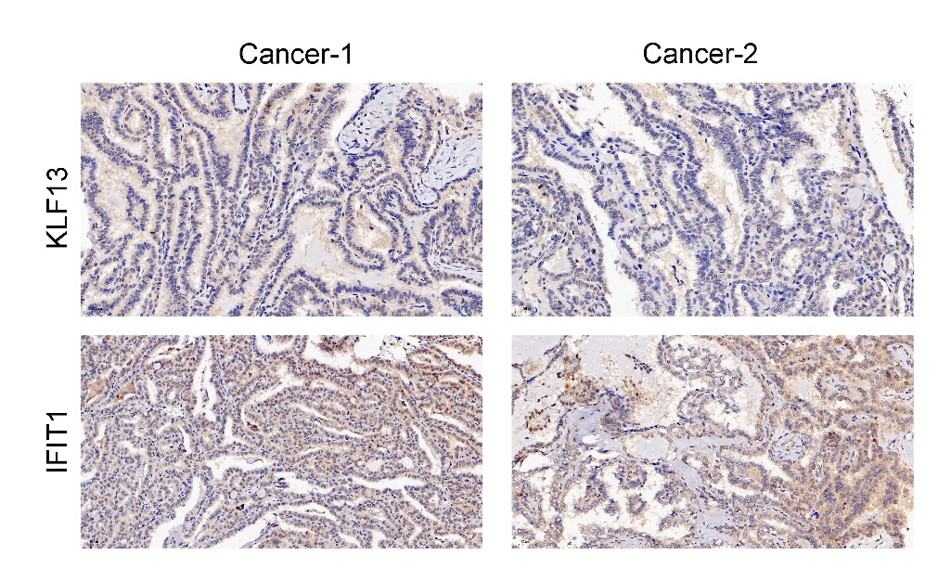
Figure S2: Typical IHC staining of KLF13 and IFIT1 in thyroid carcinoma.

