Additional file 1

VOT variables calculation
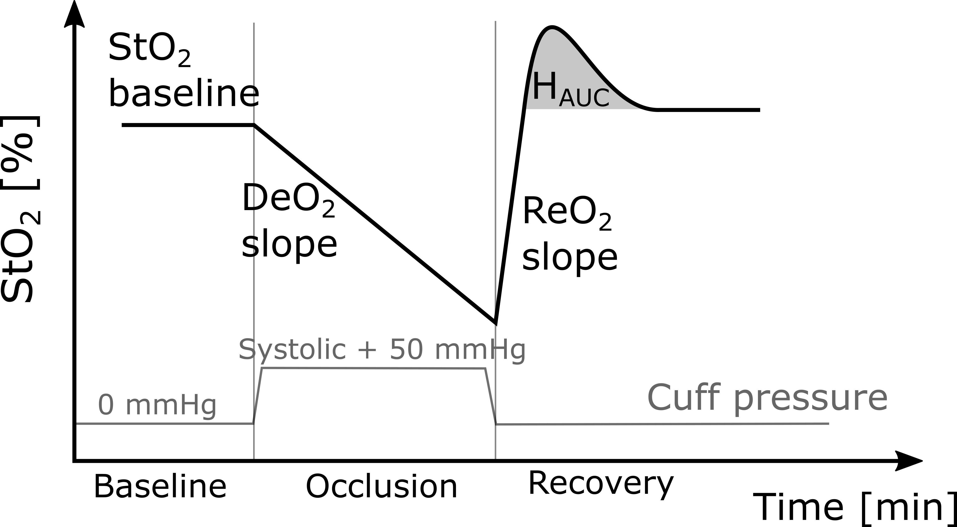
StO₂ [%]: Directly measured by the NIRS device
THC [µM/L]: Directly measured by the NIRS device
DeO₂ [%/min]: The deoxygenation slope has been calculated by linearly fitting the curve StO₂ [%] vs. Time [min] from the instant the occlusion started up to one minute after the occlusion started
ReO₂ [%]: The reoxygenation slope has been calculated by linearly fitting the curve StO₂ [%] vs. Time [min] from the instant the occlusion ended up to the instant the saturation reached the baseline value.
H_{AUC} [%∙min]: The hyperemic response has been calculated as the area defined by the hyperemic peak and the recovery baseline StO₂ level

