Additional Information

Discovery of a pyrano[2,3-b]pyridine derivative YX-2102 as a cannabinoid receptor 2 agonist for alleviating lung fibrosis

This file includes:
Additional Video Legends
Additional Figures 1-5
Additional Tables 1-4

Additional Video Legends

Video S1.
A Representative 3-dimensional (3D) structure and morphology of rat lung in the sham group at day 21 after drug administration.

Video S2.
A Representative 3D structure and morphology of rat lung in the YX-2102 group at day 21 after drug administration.

Video S3.
A Representative 3D structure and morphology of rat lung in the BLM group at day 21 after drug administration.

Video S4.
A Representative 3D structure and morphology of rat lung in the BLM+YX-2102 group at day 21 after drug administration.

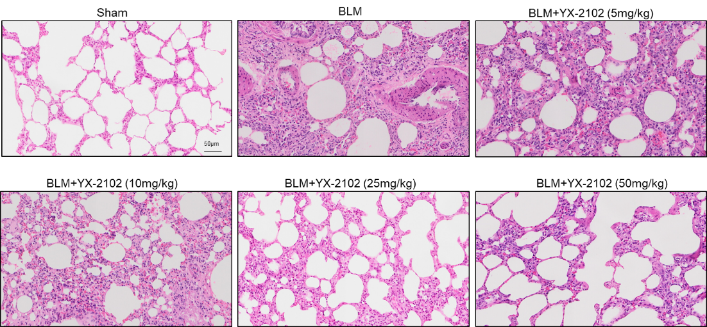

Figure S1. Representative H&E-stained images of lung harvested from the rats after various treatments for 21 days. n = 5 or 6 per group. Scale bar=50 μm.

A | B
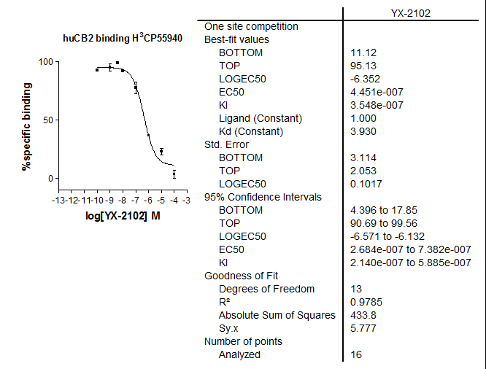 | 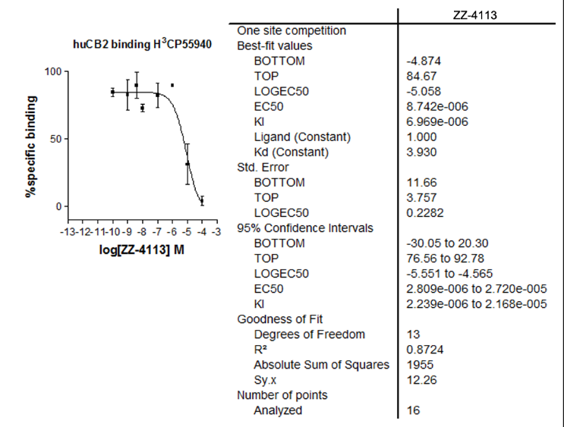
C | D
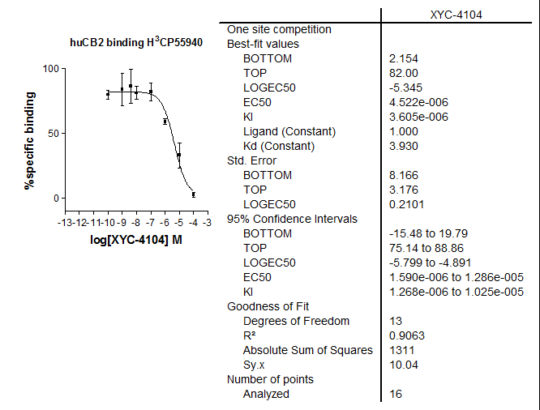 | 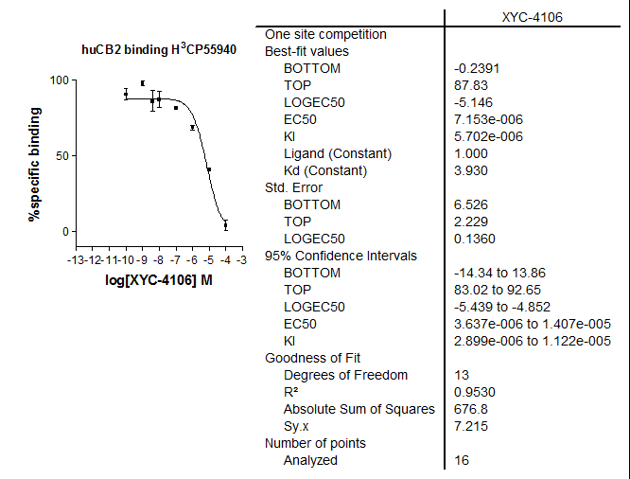

Figure S2. Binding affinities of compounds YX-2102 (A), ZZ-4113 (B), XYC-4104 (C) and XYC-4106 (D)
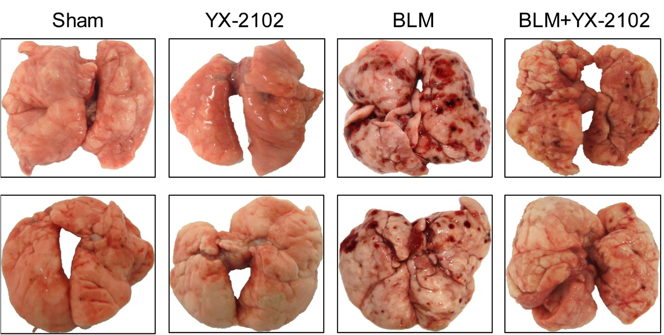

Figure S3. The representative gross-morphological images of rat lung from each group at day 21.

Figure S4. The changes in body weight for each experimental group; Data are expressed as mean ± SEM. n = 5 rats per group. **P < 0.001 versus BLM group.

Figure S5. YX-2102 improved the oxidative stress in rats with BLM-induced pulmonary fibrosis. Oxidative stress was assessed by measuring the activity of tissue superoxide dismutase (SOD) and the contents of malondialdehyde (MDA) and glutathione (GSH). The measurement was repeated three times and the data were represented as mean ± SD; ****P < 0.0001 versus sham group, #P < 0.05, ###P < 0.001 versus BLM group.
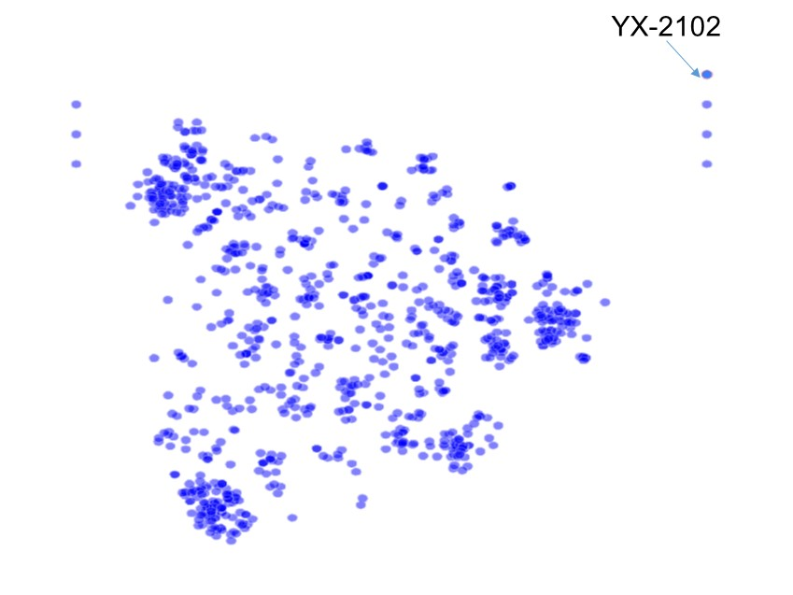
Figure S6. Structure similarity map of CB2R ligand. 1000 CB2R ligand were collected from CHEMBL (https://www.ebi.ac.uk/chembl/) whose binding affinity was lower than 10 nM. The shorter distance means to the more obvious similarity. The structures are outliers if similarity to other structures is less than 50%, meaning the similarity of YX-2102 to other structure is less than 50%.

Table S1. Purchase, dilution and storage conditions of primary and second antibodies.

Antibody | Cat.NO | Corporation | Dilution |  | Storage
Antibody | Cat.NO | Corporation | WB | IF/IHC | Storage
TGF-β1 | ab92486 | Abcam | 1:500 | 1:400 | -20 ºC
α-SMA | ab5694 | Abcam | 1:300 | 1:400 | -20 ºC
E-cadherin | sc-8426 | Santa Cruz | 1:200 | 1:100 | 4 ºC
Fibronectin | sc-8422 | Santa Cruz | 1:200 | 1:100 | 4 ºC
CB2R | ab3561 | Abcam | 1:500 | 1:200 | -20 ºC
CD206 | GB13438 | Servicebio | - | 1:200 | -20 ºC
CD68 | ab31630 | Abcam | - | 1:200 | -20 ºC
MPO | ab65871 | Abcam | - | 1:200 | -20 ºC
iNOS | PA1-036 | Invitrogen | - | 1:200 | -20 ºC
pSmad2 | ab188334 | Abcam | 1:1000 | - | -20 ºC
pSmad3  pSmad3  Smad4 | 9520  bsm-33357M  46535 | CST  Bioass  CST |  | 1:200  1:500 | -20 ºC  -20 ºC  -20 ºC
Smad2/3 | sc-398844 | Santa Cruz |  |  | 4 ºC
Smad7 | 42-0400 | Invitrogen | 1:1000 | 1:500 | -20 ºC
Nrf2 | ab89443 | Abcam | 1:1000 | 1:500 | -20 ºC
GAPDH | sc25778 | Santa Cruz | 1:500 |  | 4 ºC
HRP-linked Antibody | sc2357 | Santa Cruz | 1:1000 | - | 4 ºC

Table S2. Structural information and sources of the active molecules used in the manuscript.

Compound | Structure | Source
JWH-133 |  | Purchased from Sigma-Aldrich
XL-002 |  | Synthesized according to ACS Med. Chem. Lett. 2013, 4, 387.
ZZ-4113 |  | Synthesized according to Org. Lett. 2014, 16, 2370
XYC-4102 |  | Synthesized according to Org. Lett. 2014, 16, 3208
XYC-4104 |  | Synthesized according to Org. Lett. 2014, 16, 3208
XYC-4106 |  | Synthesized according to Org. Lett. 2014, 16, 3208
YX-2102 |  | Synthesized according to Chin. J. Chem. 2012, 30, 2669

Table S3. Primers used for real-time qPCR (h and r indicate human and rat species, respectively).
Gene | Forward (5' to 3') | Reverse (5' to 3')
Fibronectin (r) | TCGCCATCAGTAGAAGGTAGCA | TGTTATACTGAACACCAGGTTGCA
E-cadherin (h) | TGCACCAACCCTCATGAGTG | GTCAGTATCAGCCGCTTTCAG
E-cadherin (r) | GGGTTGTCTCAGCCAATGTT | CACCAACACACCCAGCATAG
α-SMA (h) | GACCGAATGCAGAAGGAGAT | CCACCGATCCAGACAGAGTA
α-SMA (r) | AGCCAGTCGCCATCAGGAAC | GGGAGCATCATCACCAGCAAAG
Slug (h) | GAGCATTTGCAGACAGGTCA | ACAGCAGCCAGATTCCTCAT
Snail1 (h) | GACTACCGCTGCTCCATTCCA | TCCTCTTCATCACTAATGGGGCTTT
Twist (h) | GGCCGGAGACCTAGATGTCATT | CCACGCCCTGTTTCTTTGAAT
ZEB1 (h) | GAAAATGAGCAAAACCATGATCCTA | CAGGTGCCTCAGGAAAAATGA
ZEB2 (h) | TTCCATTGCTGTGGGCCTT | TTGTGGGAGGGTTACTGTTGG
TGF-β1 (r) | AAGAAGTCACCCGCGTGCTA | TGTGTGATGTCTTTGGTTTTGTCA
CB2 (h) | TGGCAGCGTGACTATGAC | AAAGAGGAAGGCGATGAA
CB2 (r) | ACTGCCTGCTGCGGACATC | GCTGATTGGTCTTCTCACTGAACAC
Smad7 (h, r) | CCGCAGCAGTTACCCCATCT | CGAAAGCCTTGATGGAGAAACC
IL-1β (r) | CACCTCTCAAGCAGAGCACAG | GGGTTCCATGGTGAAGTCAAC
TNF-α (r) | CCAGGTTCTCTTCAAGGGACAA | CTCCTGGTATGAAATGGCAAATC
IL-6 (r) | GCCCTTCAGGAACAGCTATG | GCAGTGGCTGTCAACAACA
IL-4 (r) | CGTGATGTACCTCCGTGCTT | GTGAGTTCAGACCGCTGACA
MCP-1 (r) | CAGGTCTCTGTCACGCTTCTGG | AATGAGTAGCAGCAGGTGAGTGG
IL-10(r) | CACTGCTATGTTGCCTGCTCTTAC | GGGTCTGGCTGACTGGGAAG
iNOS (r) | GAGTGAGGAGCAGGTTGAGG | CCAAGGTGTTGCCCTTTTT
CD86 (r) | GACACCCACGGGATCAATTA | GCCTCCTCTATTTCAGGTTCAC
Ym-1 (r) | GATCACCACCCCTATGACCCT | GGGACCAGTTGGTGTAGTAGC
CD206 (r) | ACTGCGTGGTGATGAAAGG | TAACCCAGTGGTTGCTCACA
Arginase-1 (r) | TTGATGTTGATGGACTGGAC | TCTCTGGCTTATGATTACCTTC
GAPDH (h,r) | CATCCTGCACCACCAACTGCTTAG | GCCTGCTTCACCACCTTCTTGATG

Table S4. Components of the binding free energy (kcal/mol) calculated by MM/GBSA approach.*
Evdw | Eele | Ggb | Gnp | ΔGcal
-76.45 ± 3.07 | -9.99 ± 4.40 | 25.93 ± 4.27 | -9.45 ± 0.23 | -69.96 ± 4.15
*The statistical error was estimated based on stabilized 100 ns MD simulation trajectory. 1000 snapshots evenly extracted from the 40-140 ns MD trajectory of complex were used for MM/GBSA calculations.

