Additional material

Figure S1. Gene expression level of CTLA4 in 31 cancer types and in matched healthy controls. Asterisks indicate significant (p < 0.0001) difference.

Figure S2. Gene expression level of PD-1 in 31 cancer types and in matched healthy controls. Asterisks indicate significant (p < 0.0001) difference.

Figure S3. Gene expression level of PD-L1 in 31 cancer types and in matched healthy controls. Asterisks indicate significant (p < 0.0001) difference.

Figure S4. Gene expression level of LAG3 in 31 cancer types and in matched healthy controls. Asterisks indicate significant (p < 0.0001) difference.

Figure S5. Gene expression level of TIM3 in 31 cancer types and in matched healthy controls. Asterisks indicate significant (p < 0.0001) difference.

Figure S6. Gene expression level of OX40 in 31 cancer types and in matched healthy controls. Asterisks indicate significant (p < 0.0001) difference.

Figure S7. Gene expression level of GITR in 31 cancer types and in matched healthy controls. Asterisks indicate significant (p < 0.0001) difference.

Figure S8. Gene expression level of 4-1BB in 31 cancer types and in matched healthy controls. Asterisks indicate significant (p < 0.0001) difference.

Figure S9. Gene expression level of TIGIT in 31 cancer types and in matched healthy controls. Asterisks indicate significant (p < 0.0001) difference.

Figure S1

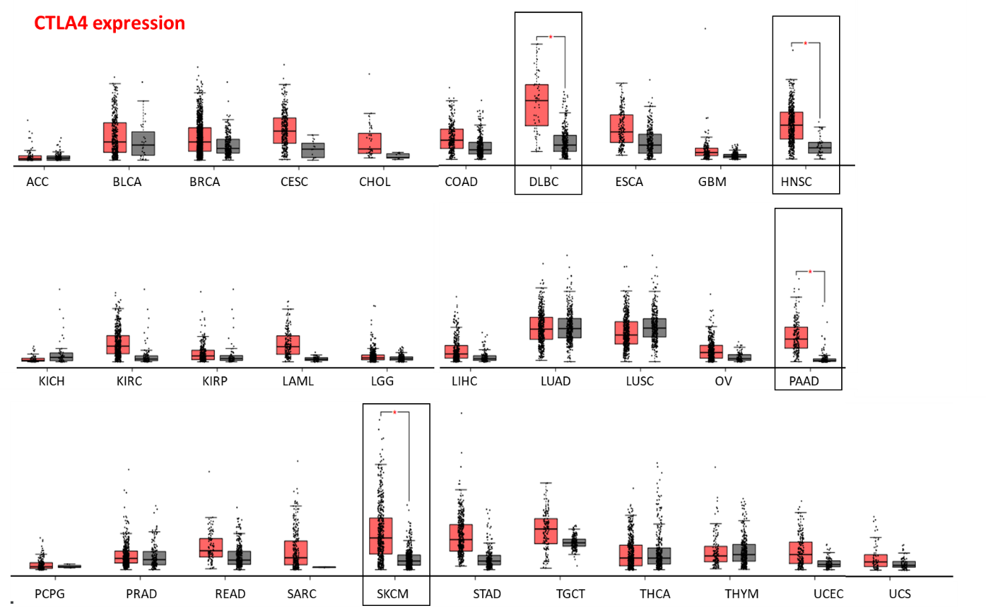

Figure S1. Gene expression level of CTLA4 in 31 cancer types and in matched healthy controls. Asterisks indicate significant (p < 0.0001) difference.

Figure S2

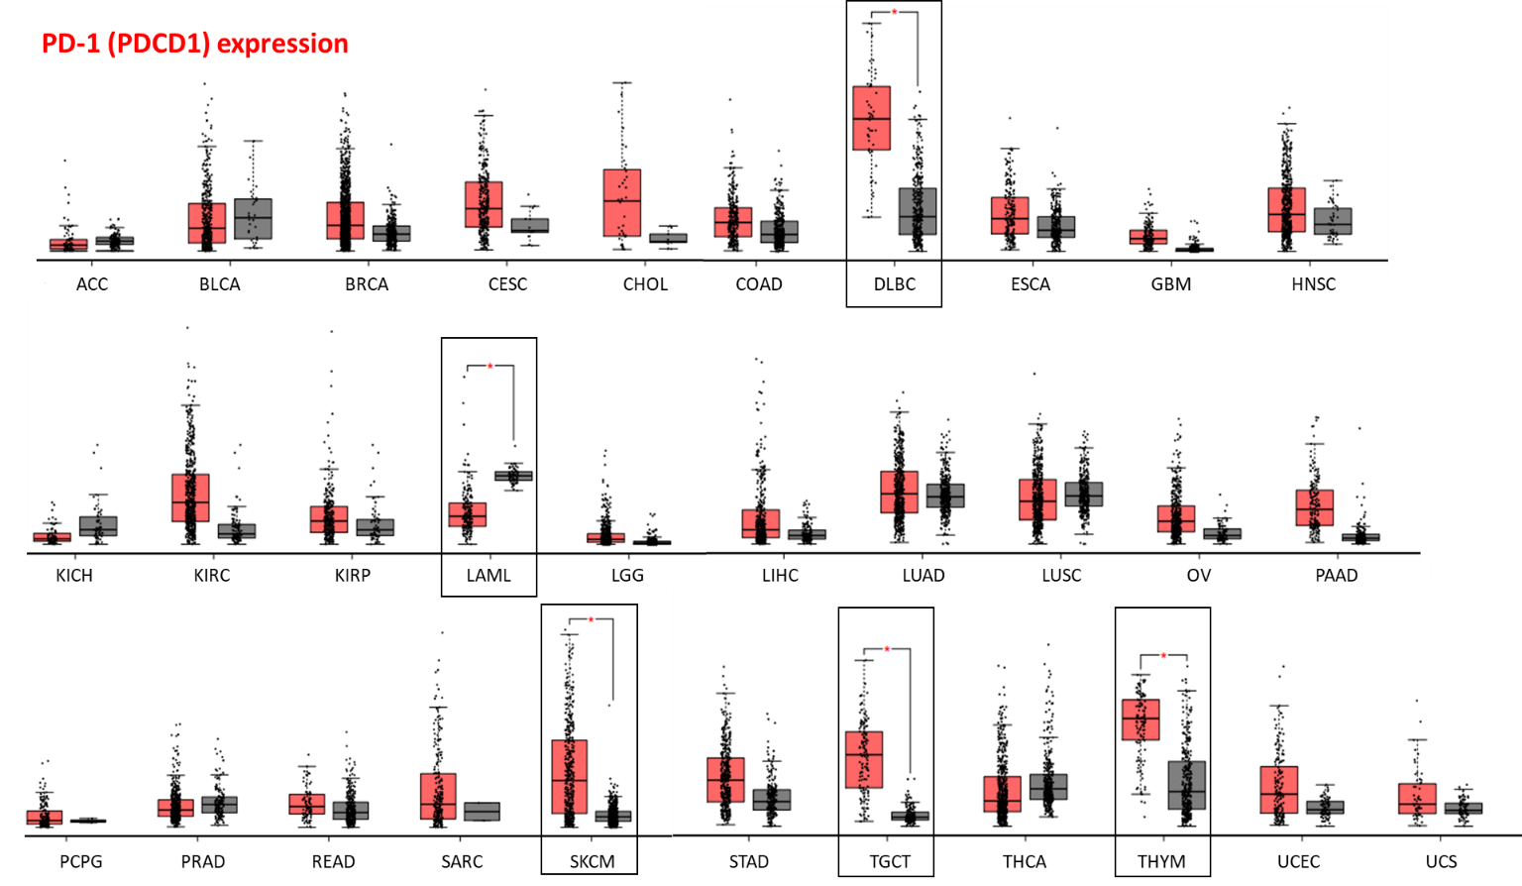

Figure S2. Gene expression level of PD-1 in 31 cancer types and in matched healthy controls. Asterisks indicate significant (p < 0.0001) difference.

Figure S3

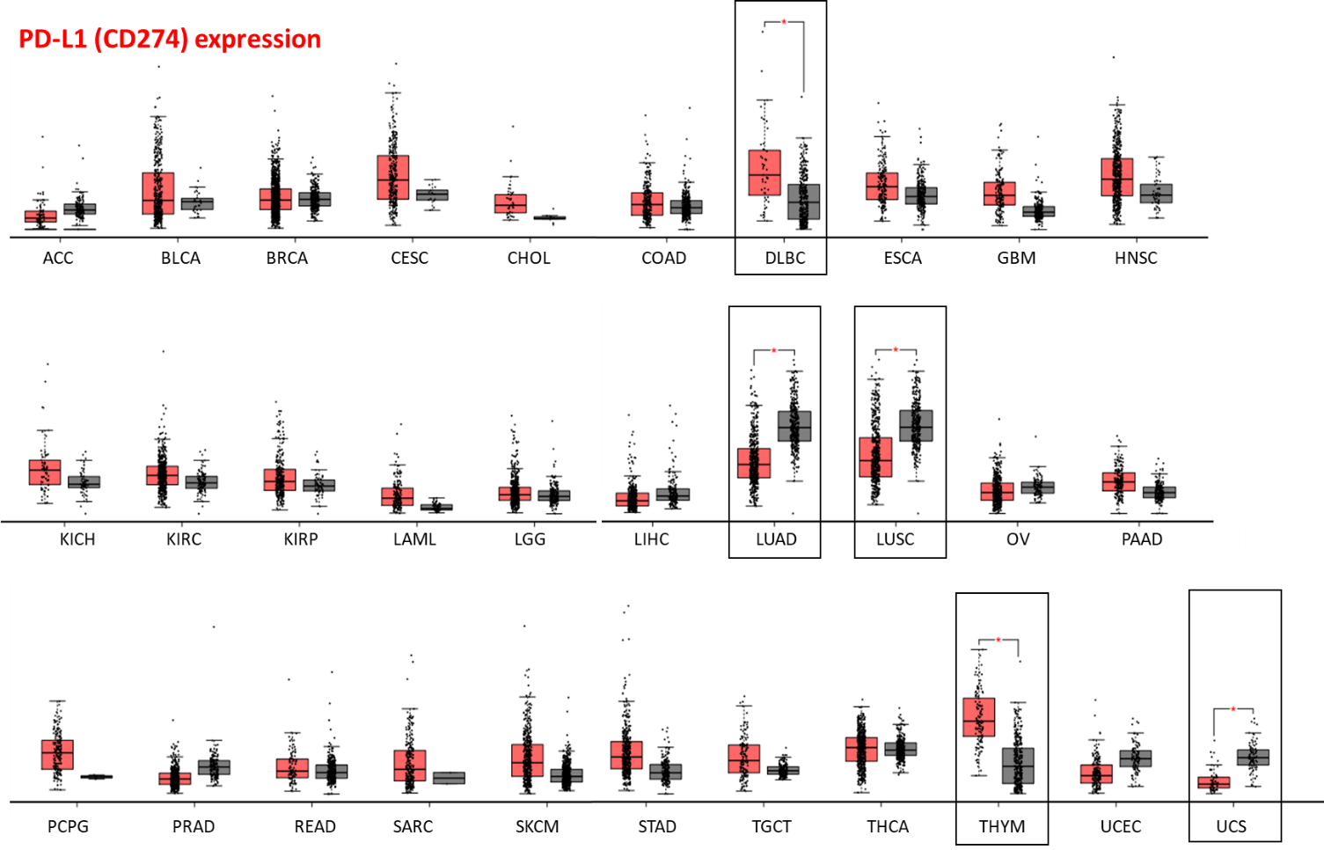

Figure S3. Gene expression level of PD-L1 in 31 cancer types and in matched healthy controls. Asterisks indicate significant (p < 0.0001) difference.

Figure S4

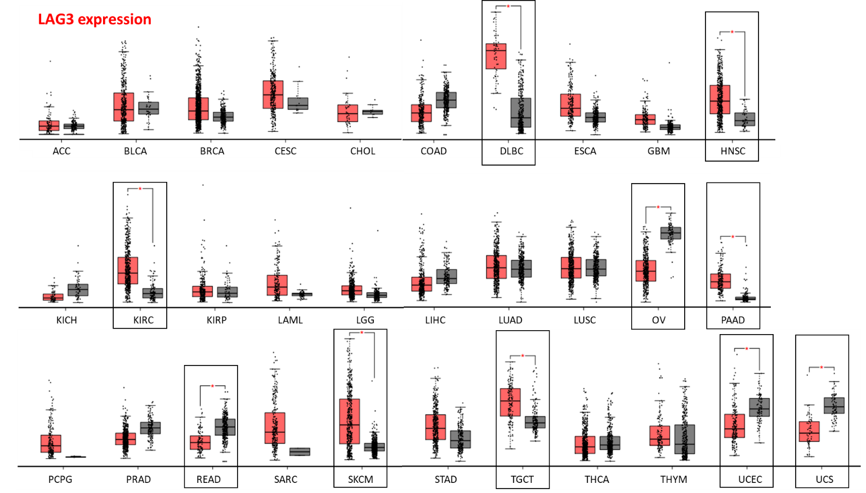

Figure S4. Gene expression level of LAG3 in 31 cancer types and in matched healthy controls. Asterisks indicate significant (p < 0.0001) difference.

Figure S5

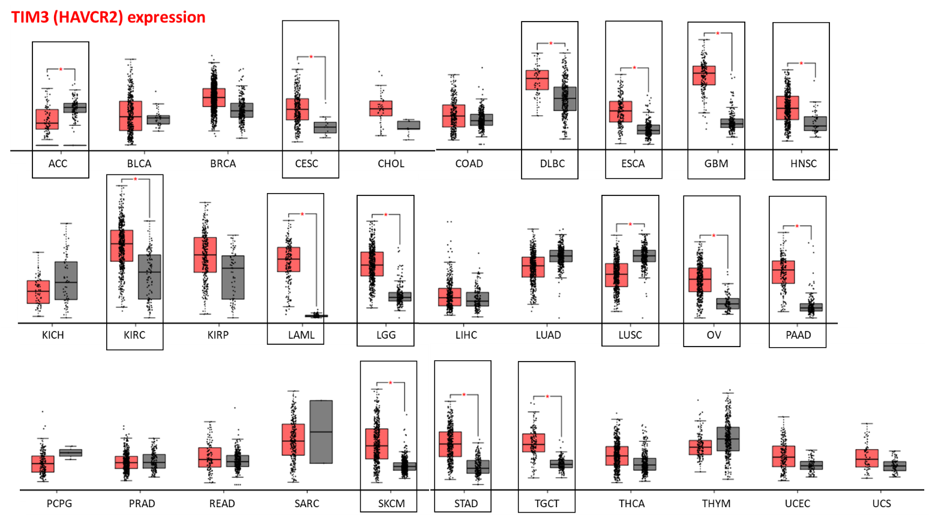

Figure S5. Gene expression level of TIM3 in 31 cancer types and in matched healthy controls. Asterisks indicate significant (p < 0.0001) difference.

Figure S6

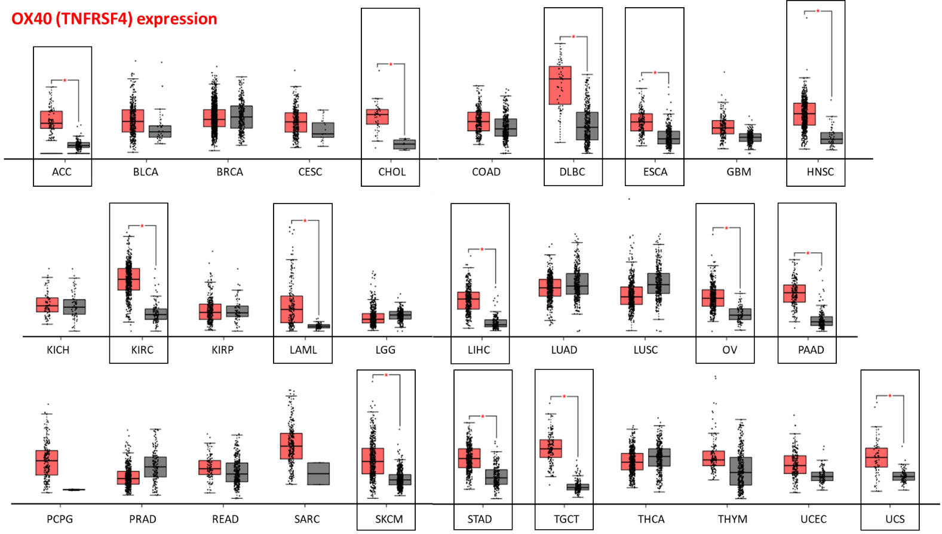

Figure S6. Gene expression level of OX40 in 31 cancer types and in matched healthy controls. Asterisks indicate significant (p < 0.0001) difference.

Figure S7

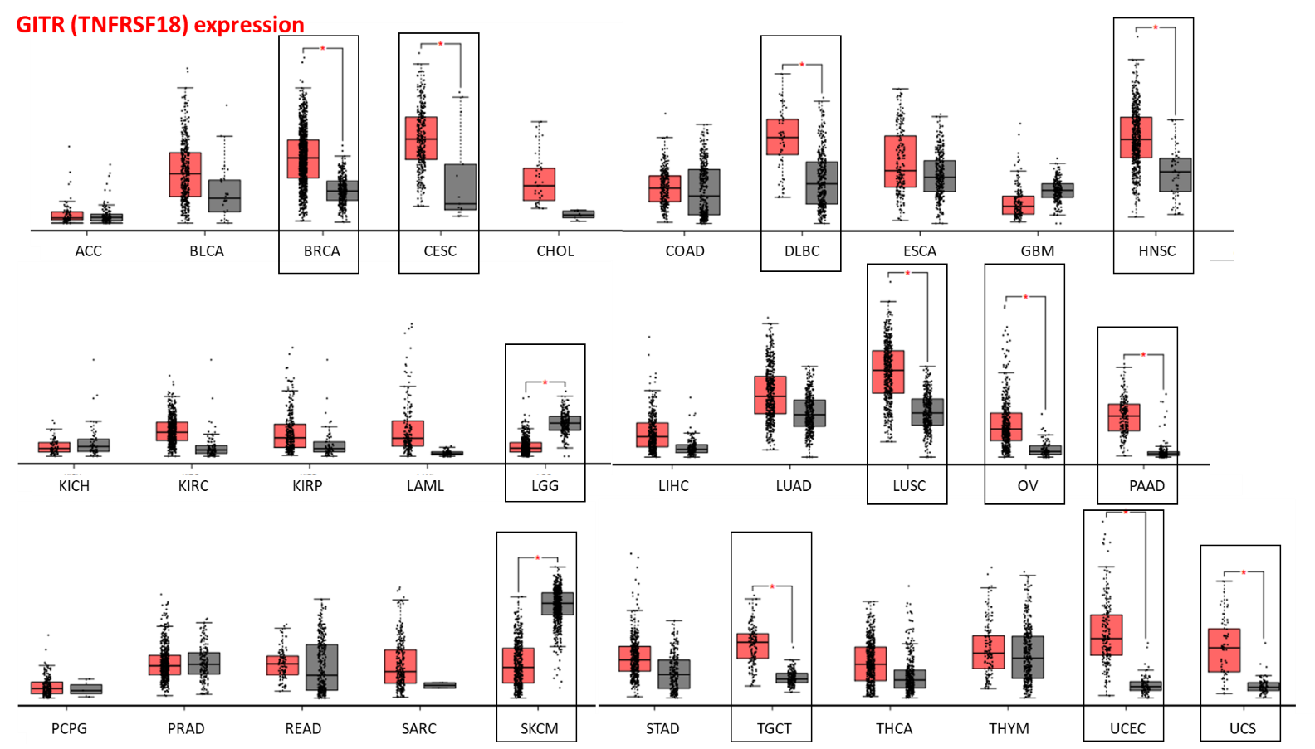

Figure S7. Gene expression level of GITR in 31 cancer types and in matched healthy controls. Asterisks indicate significant (p < 0.0001) difference.

Figure S8

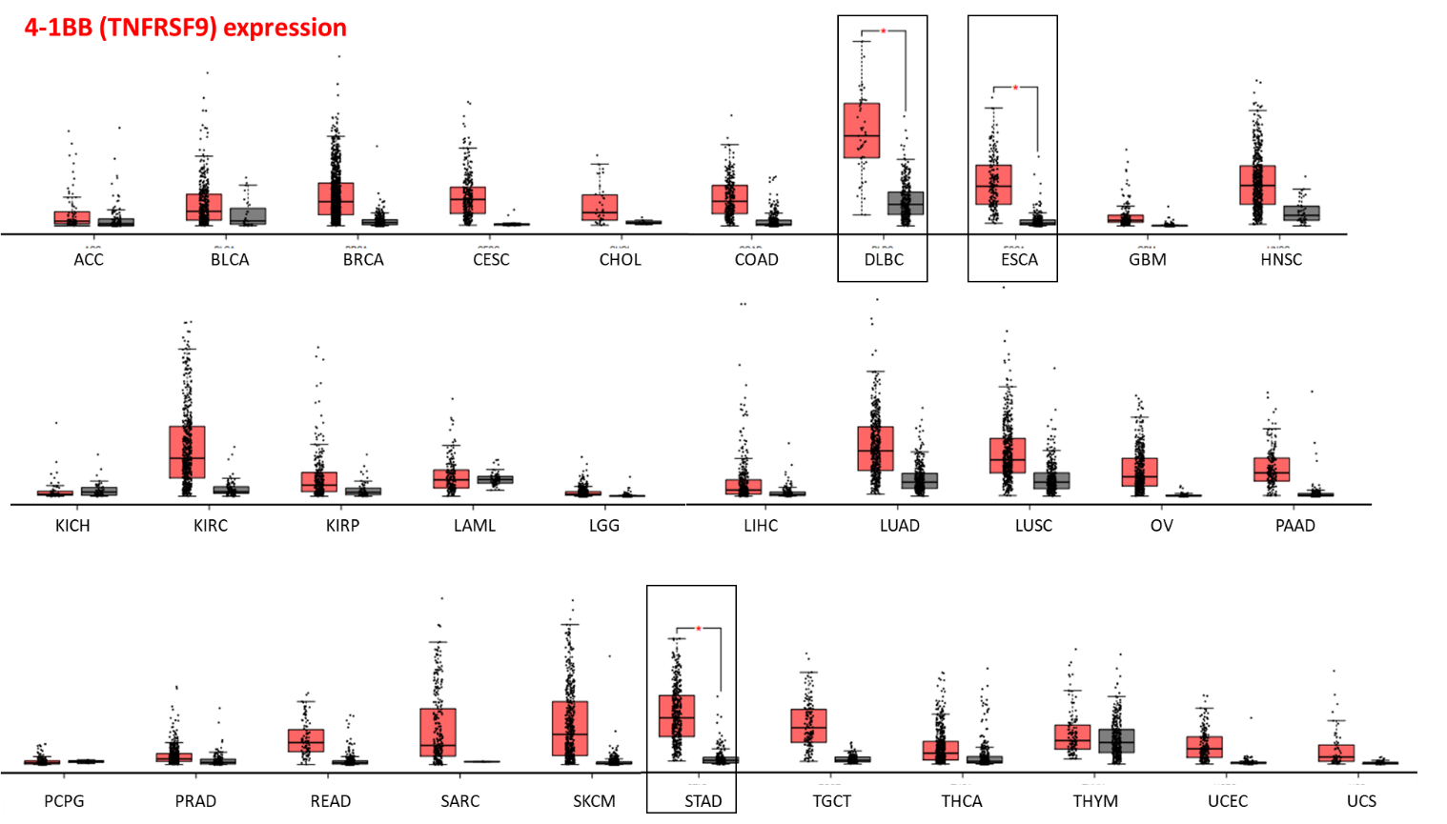

Figure S8. Gene expression level of 4-1BB in 31 cancer types and in matched healthy controls. Asterisks indicate significant (p < 0.0001) difference.

Figure S9

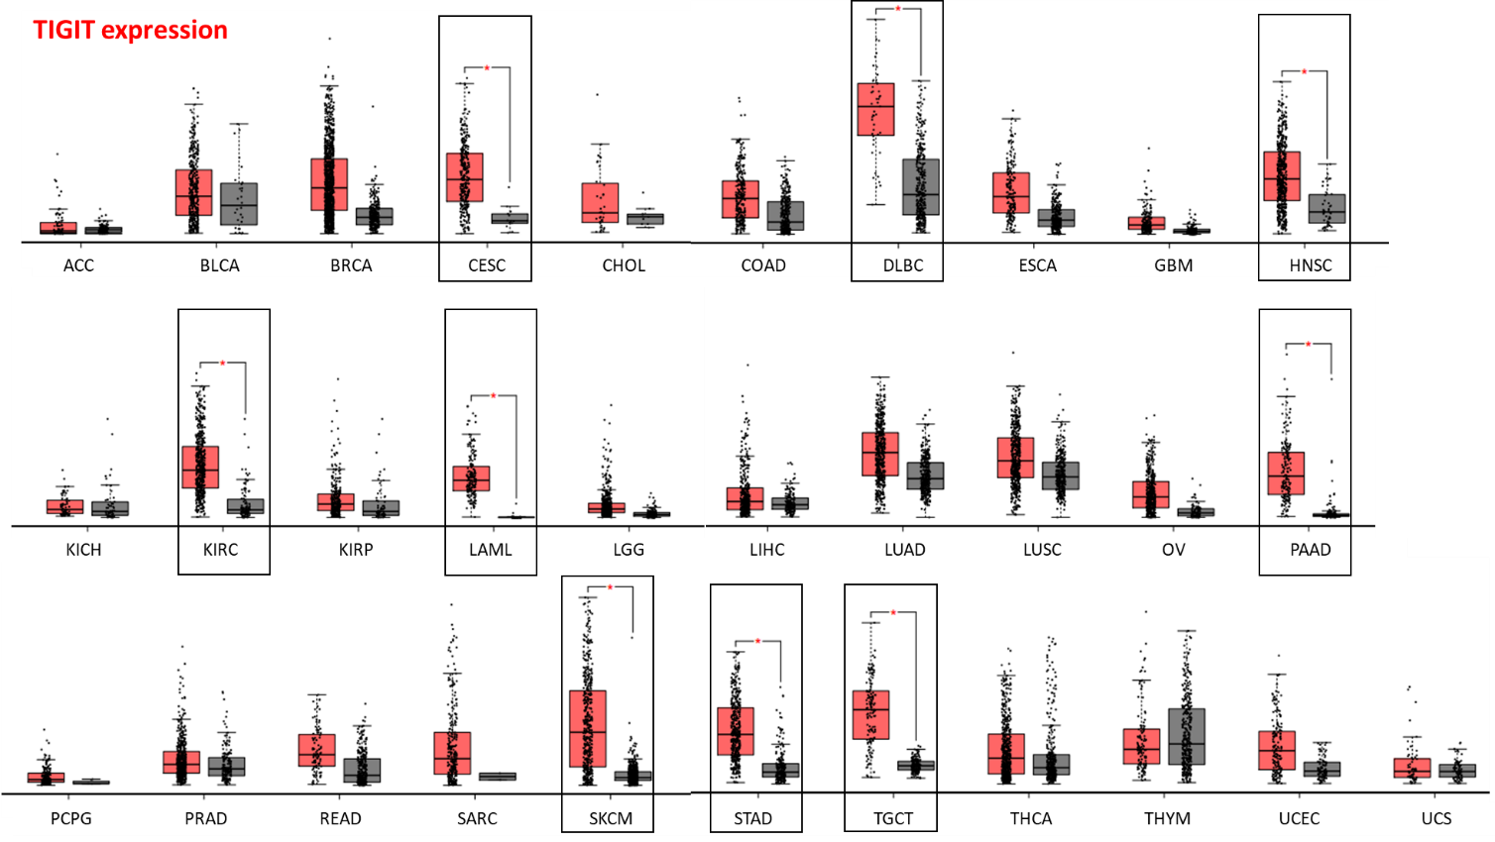

Figure S9. Gene expression level of TIGIT in 31 cancer types and in matched healthy controls. Asterisks indicate significant (p < 0.0001) difference.

Not shown Table S1.
Clinical trials reported in Clinicaltrials.gov referring to each ICR molecule investigated.

Molecule/target molecule | Clinical trials reported in Clinicaltrials.gov
CTLA4 | 665
PD-1 (PDCD1) | 3226
PD-L1 (CD274) | 2518
LAG3 | 121
TIM3 (HAVCR2) | 100
OX40 (TNFRSF4) | 78
GITR (TNFRSF18) | 25
TIGIT | 75
4-1BB (TNFRSF9) | 124

NOT Shown Table S2.
Number of clinical trials using an immunotherapy-related approach

Search formula:  “Cancer type” AND “immunotherapy” | N. Clinical Trials reported
Adernocortical cancer | 6
Bladder cancer | 146
Breast cancer | 355
Cervical cancer | 166
Cholangiocarcinoma | 55
Colon carcinoma | 85
Lymphoid neoplasm | 162
Esophageal cancer | 151
Gliobastoma | 159
Head and neck cancer | 205
Kidney cancer | 252
Leukemia | 365
Glioma | 207
Liver cancer | 253
Lung cancer | 927
Ovary cancer | 187
Pancreatic cancer | 197
Pheochormocytoma + Paraganglioma | 4
Prostate cancer | 202
Rectum cancer | 64
Sarcoma | 152
Melanoma | 574
Stomach cancer | 159
Testis cancer | 18
Thyroid | 22
Thymoma | 5
Uterine cancer | 94

NOT Shown Table S3.

Validation of ICRs expression in EBI Expression atlas, in melanoma samples. Up-regulation and down-regulation vs. controls, observed in EBI Expression atlas, reflects the regulation observed in GEPIA2 and reported in Table S2 and Figs S1 to S9.
Gene name | Expression level in melanoma (36 biological replicates) (TPM) | Expression level in normal skin, lower leg (141 biological replicates) (TPM) | Expression level in normal skin suprapubic (43 biological replicates) (TPM)
TIM3 (HAVCR2) | 11 | 2 | 2
OX40 (TNFRSF4) | 7 | 2 | 2
GITR (TNFRSF18) | 2 | 33 | 38
TIGIT | 2 | below cutoff | below cutoff
LAG3 | 4 | 1 | 2
PD-L1 (CD274) | 2 | 1 | 1
PD-1 (PDCD1) | 2 | 0.6 | 0.9
CTLA4 | 3 | 0.6 | 0.9
4-1BB (TNFRSF9) | 2 | below cutoff | below cutoff

NOT Shown Table S4.

Validation of ICRs expression in EBI expression atlas, in pancreatic adenocarcinoma samples. Up-regulation observed in EBI expression atlas, reflects the regulation observed in GEPIA2 and reported in Table S2 and Figs S1 to S9.
Gene name | Expression in pancreas adenocarcinoma (75 biological replicates) (TPM) | Expression in adjacent normal pancreas (70 biological replicates) (TPM)
TIM3 (HAVCR2) | 25 | 1
OX40 (TNFRSF4) | 5 | 1
GITR (TNFRSF18) | 4 | below cutoff
TIGIT | 3 | below cutoff
LAG3 | 2 | below cutoff
PD-L1 (CD274) | 6 | 2
PD-1 (PDCD1) | 6 | below cutoff
CTLA4 | 4 | below cutoff
4-1BB (TNFRSF9) | 4 | below cutoff

NOT Shown Table S5.

Validation of ICRs expression in EBI Expression atlas, in Thyroid carcinoma samples. The absence of -or marginally- differential regulation, observed for most ICRs in EBI Expression atlas, reflects the absence of differential regulation observed in GEPIA2 reported in Table S2 and Figs S1 to S9.
Gene name | Expression in pancreas thyroid carcinoma (47 biological replicates) (TPM) | Expression in adjacent thyroid pancreas (4 biological replicates) (TPM)
TIM3 (HAVCR2) | 3 | 3
OX40 (TNFRSF4) | 8 | 2
GITR (TNFRSF18) | 3 | 2
TIGIT | 0.8 | 3
LAG3 | 1 | 3
PD-L1 (CD274) | 4 | 5
PD-1 (PDCD1) | 2 | 4
CTLA4 | 0.8 | 2
4-1BB (TNFRSF9) | Below cutoff | 0.8

