Title: Tumors carrying BRAF-mutations over-express NAMPT that is genetically amplified and possesses oncogenic properties.

Authors: Valentina Audrito^{1,§}, Enrico Moiso^{2,3}, Filippo Ugolini⁴, Vincenzo Gianluca Messana¹, Lorenzo Brandimarte¹, Ilaria Manfredonia¹, Simonetta Bianchi⁴, Francesco De Logu⁴, Romina Nassini⁴, Anna Szumera-Ciećkiewicz^{5,6}, Daniela Taverna⁷, Daniela Massi⁴, and Silvia Deaglio^{1,}*

Affiliations: ¹Functional Genomic Unit, Department of Medical Sciences, University of Turin, Turin, Italy; ²Koch Institute for Integrative Cancer Research, Massachusetts Institute of Technology, Cambridge, MA, USA. ³Broad Institute of Harvard and MIT, Cambridge, MA, USA. ⁴Department of Health Sciences, University of Florence, Florence, Italy. ⁵Department of Pathology and Laboratory Medicine, Maria Sklodowska-Curie National Research Institute of Oncology, Warsaw, Poland. ⁶Diagnostic Hematology Department, Institute of Hematology and Transfusion Medicine, Warsaw, Poland. ⁷Molecular Biotechnology Center & Dept. Molecular Biotechnology and Health Sciences, University of Torino, Italy.
§Present address: Molecular Biotechnology Center & Dept. Molecular Biotechnology and Health Sciences, University of Torino, Italy

Keywords: NAMPT, oncogene, transformation, BRAF oncogenic signaling, MAPK, NAMPT inhibitors

*Corresponding author: Silvia Deaglio, MD, PhD, Laboratory of Functional Genomics, Department of Medical Sciences, University of Turin, Via Nizza, 52, 10126 Torino, Italy. Phone number: +390116709535; +390116706497. Emails: silvia.deaglio@unito.it.
Additional Methods
TCGA analysis
Clinical and genomic data of TCGA cancer samples and patients (release 2016_02_28) were downloaded from the Broad TCGA GDAC site (https://gdac.broadinstitute.org/), by means of firehose get Version: 0.4.1. The data refers to a cohort of 11158 cancer patients of 33 different tumor types (Coding Genes Expression: RNAseqV2_RSEM_genes_normalized__data_Level_3, Mutation data: Mutation_Packager_Oncotated_Calls), and Copy Number Alteration (CNA) data: derived from Level_3_segmented_scna_minus_germline_cnv.
Immunohistochemistry staining

Tissues samples
The samples included in the study were identified in the databases from 2010 to 2019. The use of Formalin-fixed and paraffin-embedded (FFPE) sections of human samples was approved by the Local Ethics Committee (16275_bio) according to the Helsinki Declaration. FFPE tissue sections, 3 μm in thickness, were stained with hematoxylin-eosin and reviewed to confirm the histopathological diagnosis and pathology tissue quality control.
Immunohistochemistry
FFPE whole slides sections of THCA were stained with BRAF V600E antibody (mouse monoclonal, clone VE1 ready to use; Ventana Medical Systems, Tucson, AZ) and then representative sections (n=84) were selected for NAMPT staining. After pretreatment with CC1, TMAs and tissue sections were incubated with primary antibodies on a Ventana Benchmark XT immunostainer. The signal was developed with the UltraMap DAB anti-Mouse Detection Kit (Ventana Medical Systems, Tucson, AZ). Sections were counterstained with hematoxylin.
NAMPT evaluation (H-score)
A semi-quantitative H-score analysis of NAMPT staining in BRAF-mutated and BRAF-WT cases of MM and THCA was performed. Briefly, the percentage of NAMPT positive cells (0% to 100%) was multiplied by the dominant intensity pattern of staining (1, weak; 2, moderate; 3, strong), with an overall score ranging from 0 to 300. In this system, <1% positive cells were considered a negative result.
Cell Culture
Cell lines were cultured in RPMI-1640 (Sigma, Milan, IT) or Dulbecco's Modified Eagle Medium (DMEM, from Thermo Fischer Scientific, Rodano MI, IT) supplemented with 10% of fetal calf serum (FCS), and 10 IU/ml of penicillin / streptomycin (all from Sigma). Cell lines were tested to confirm lack of mycoplasma contamination.
TaqMan Gene Expression Assays
The TaqMan Gene Expression Assays (Thermo Fisher Scientific) used were: Hs00237184_m1 (NAMPT), Hs00944470_m1 (NMRK1), Hs00376971_g1 (NAPRT), Hs00204757_m1 (QPRT) and Hs99999903_m1 (ACTB), used as housekeeping gene.
Antibodies used for Western blot analysis
Antibodies used were: anti-BRAF V600E (RM8, ab200535, Abcam, Cambridge, UK), anti-NAMPT (A300-779A, Bethyl Laboratories, Montgomery, TX), anti‐phospho-ERK1/2 (pT202/pY204, #612359), anti-pan-ERK1/2 (#610124) both from BD Biosciences (San Jose, CA), anti-β-Actin (sc-47778) from Santa Cruz Biotechnology (Dallas, TX). Secondary reagents were: goat anti‐mouse IgG‐HRP-conjugated (Perkin Elmer, Monza, IT) and goat anti‐rabbit HRP‐conjugated (Santa Cruz Biotechnology).

Additional Figures and legends
C
B
A
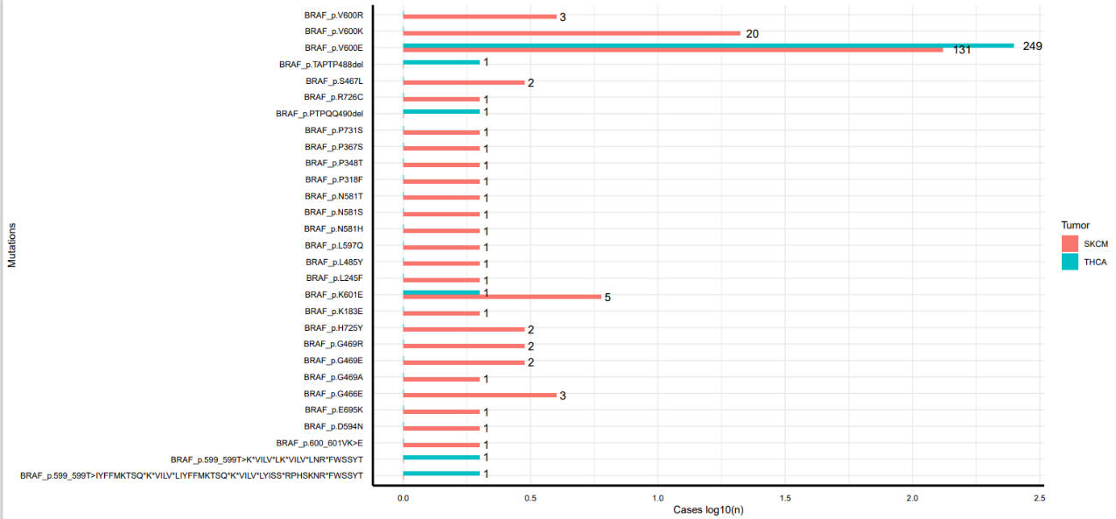

Fig. S1. NAMPT expression is associated with BRAF mutations in TCGA cohort. (A) Boxplots representing NAMPT expression per tumor type in the TCGA cohort, represented as Z score. Complete list of TCGA abbreviations is available at https://gdc.cancer.gov/resources-tcga-users/tcga-code-tables/tcga-study-abbreviations. (B) Bar-plot representing BRAF mutation frequency in the whole TCGA cohort. Melanoma (SKCM) and thyroid carcinoma (THCA) samples harbor the highest number of mutations (red bars). (C) Histogram plot showing the distribution of the different BRAF mutations in the patient cohort analyzed.

Fig. S2. Response to NAMPT inhibition in MM and THCA cell lines according to BRAF mutations. (A) Short-term proliferation assay of MM BRAF-mutated cell lines (shades of red) and THCA BRAF-mutated cell lines (shades of blue). Cells were treated for 72 hours with increasing concentrations of two NAMPTi (FK866 and GMX1778) and then cell viability was measured using MTT assay. Data represent the average and SEM of at least three biological replicates. Data were represented as % of cell viability over untreated condition. First data points of the curves represent the control.

Fig. S3. NAMPT copy number alterations (CNA) correlates with NAMPT expression in tumors. (A) Boxplots representing the detail of NAMPT CNA (upper panel) score and NAMPT expression (lower panel) per tumor type in the TCGA cohort. Complete list of TCGA abbreviations is available at https://gdc.cancer.gov/resources-tcga-users/tcga-code-tables/tcga-study-abbreviations. Tumor types are sorted by NAMPT expression levels. p-values on the upper panel represent the significance of the difference between the mean CNA score from zero in every tumor type.

