Additional Figure S1. Motion Artifact
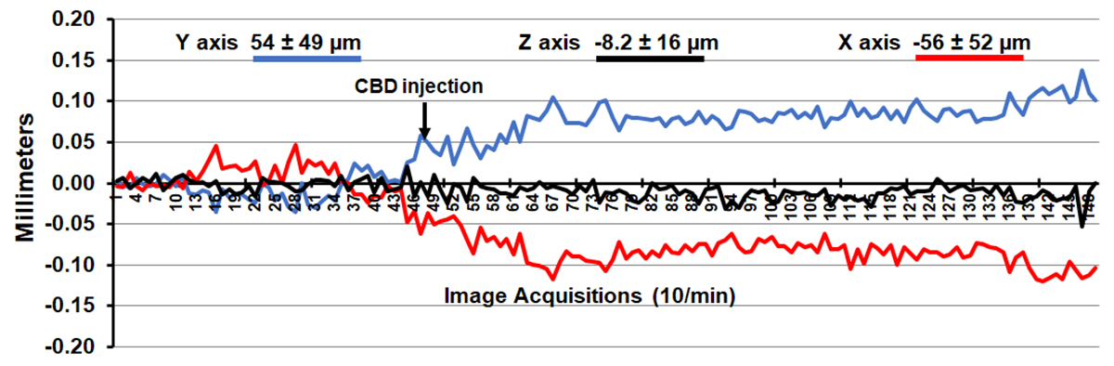
Shown is the degree of motion artifact recorded over the 15 min imaging protocol. The data are reported as the mean and standard deviation in micrometers for axis Y, Z and X for the 18 mice injected with CBD. The greatest movement was in the X and Y axis (left to right, up and down, respectively) and occurred within the first two min of injection (acquisitions 50-70) but stabilized over the remaining imaging session.

Additional Figure S2. Neuroanatomical fidelity
Shown are representative examples of brain images collected during a single imaging session using a multi-slice spin echo, RARE (rapid acquisition with relaxation enhancement) pulse sequence. The row on the top shows axial sections collected during the anatomical scan taken at the beginning of each imaging session using a data matrix of 128 × 128, 18 slices in a field of view of 1.8 cm. The row below shows the same images but collected for functional analysis using HASTE, a RARE pulse sequence modified for faster acquisition time. These images were acquired using the same field of view and slice anatomy but a larger data matrix of 96 × 96. Note the anatomical fidelity between the functional images and their original anatomical image. The absence of any distortion is necessary when registering the data to atlas to resolve 136 segmented brain areas.
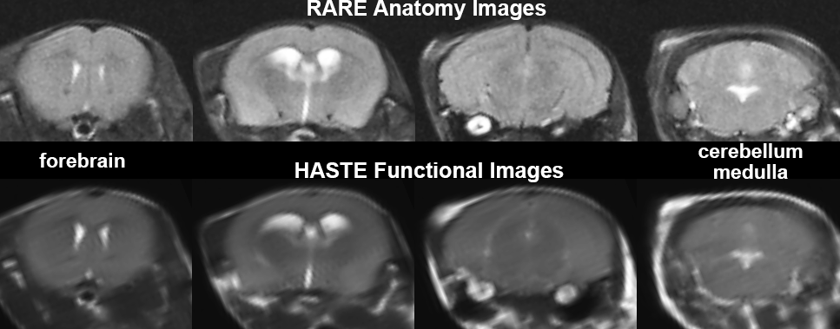

Additional Figure S3 CBD Dose Response
Shown are the mean (± SD) plasma levels of CBD (ng/ml) for each of the three doses. Samples were collected within 60 min of the initial injection following the imaging session. There are four samples per dose. B) shows the plasma levels of THC discovered in the same doses of CBD. The levels of CBD and THC were significantly different between doses (One way ANOVA F_{(2,9)} = 89.69, and 24.90 respectively, p<.0001). Tukey’s multiple comparisons showed a significant difference between the 3 and 30 mg doses and the 10 and 30 mg doses for both CBD and THC measures. *** p<0.001, ****p<0.0001.
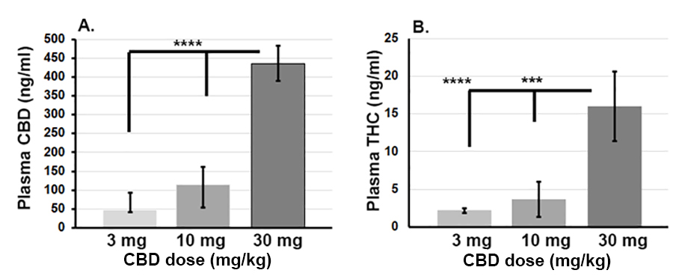
Additional Figure S4 ARAS Connectivity
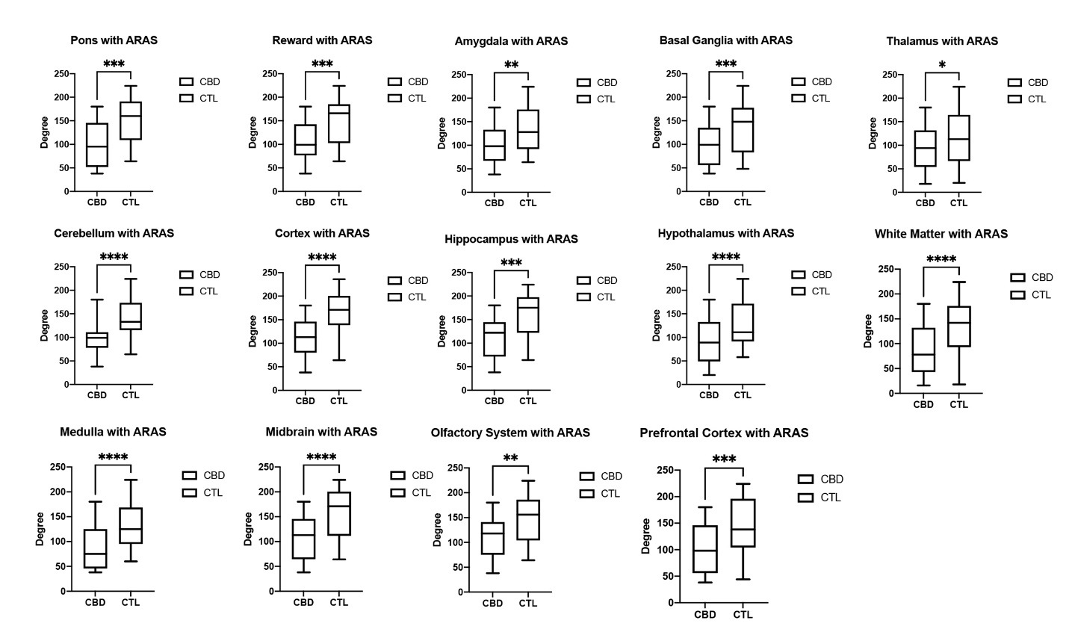
Shown are box and whiskers plots depicting differences in degree centrality in various subregions between vehicle (CTL) and rats treated with 10mg/kg CBD 60 min prior to imaging.

Additional Table S1
Positive BOLD
Brain Area | Veh | 3mg | 10mg | 30mg | P val | ω²
glomerular layer | 3 | 9 | 76 | 34 | 0.001 | 0.806
granular cell layer | 2 | 8 | 89 | 23 | 0.001 | 0.757
anterior olfactory area | 7 | 19 | 64 | 33 | 0.001 | 0.701
flocculus cerebellum | 29 | 41 | 10 | 19 | 0.001 | 0.635
medullary reticular ventral area | 0 | 27 | 5 | 0 | 0.001 | 0.578
reticulotegmental nucleus | 25 | 0 | 0 | 0 | 0.002 | 0.546
locus coeruleus | 0 | 25 | 0 | 0 | 0.002 | 0.537
frontal association ctx | 3 | 12 | 85 | 26 | 0.003 | 0.482
crus of ansiform lobule | 21 | 40 | 3 | 14 | 0.005 | 0.448
lateral lemniscus | 42 | 33 | 8 | 4 | 0.006 | 0.428
orbital ctx | 3 | 8 | 60 | 8 | 0.007 | 0.411
pontine area | 29 | 15 | 3 | 27 | 0.007 | 0.401
spinal trigeminal nuclear area | 22 | 33 | 9 | 38 | 0.007 | 0.4
infralimbic ctx | 0 | 0 | 73 | 56 | 0.008 | 0.386
prelimbic ctx | 0 | 5 | 53 | 2 | 0.009 | 0.384
cuneate area | 50 | 48 | 0 | 0 | 0.009 | 0.381
5th cerebellar lobule | 0 | 7 | 0 | 0 | 0.01 | 0.368
paramedian lobule | 10 | 33 | 0 | 8 | 0.01 | 0.368
6th cerebellar lobule | 17 | 38 | 0 | 3 | 0.011 | 0.364
pontine reticular nucleus caudal | 26 | 13 | 0 | 0 | 0.011 | 0.361
solitary tract area | 5 | 37 | 0 | 21 | 0.016 | 0.322
parvicellular reticular area | 31 | 30 | 4 | 27 | 0.017 | 0.318
vestibular area | 3 | 42 | 0 | 11 | 0.017 | 0.318
simple lobule cerebellum | 12 | 26 | 0 | 0 | 0.021 | 0.299
4th cerebellar lobule | 12 | 10 | 0 | 0 | 0.022 | 0.294
principal sensory n. trigeminal | 25 | 28 | 8 | 10 | 0.023 | 0.291
lemniscal area | 15 | 16 | 0 | 0 | 0.024 | 0.286
entorhinal ctx | 30 | 40 | 18 | 16 | 0.028 | 0.27
prepositus area | 0 | 9 | 0 | 14 | 0.031 | 0.26
3rd cerebellar lobule | 7 | 9 | 0 | 0 | 0.038 | 0.239
primary motor ctx | 10 | 14 | 50 | 19 | 0.04 | 0.235
inferior colliculus | 20 | 39 | 3 | 5 | 0.04 | 0.233
10th cerebellar lobule | 0 | 0 | 0 | 3 | 0.042 | 0.23
periaqueductal gray | 19 | 11 | 1 | 12 | 0.046 | 0.22
caudate putamen | 6 | 10 | 48 | 27 | 0.049 | 0.214
visual 1 ctx | 17 | 32 | 5 | 14 | 0.051 | 0.21
gigantocellularis reticular area | 31 | 23 | 1 | 26 | 0.052 | 0.208
subiculum | 18 | 22 | 5 | 6 | 0.066 | 0.185
stria medullaris | 0 | 0 | 0 | 33 | 0.068 | 0.182
cerebellar nuclear area | 0 | 9 | 0 | 0 | 0.074 | 0.173
intermediate reticular area | 23 | 28 | 3 | 28 | 0.075 | 0.171
forceps minor corpus callosum | 0 | 0 | 71 | 22 | 0.077 | 0.002
tenia tecta ctx | 21 | 19 | 47 | 29 | 0.077 | 0.169
olivary complex | 30 | 37 | 5 | 4 | 0.079 | 0.167
globus pallidus | 1 | 15 | 37 | 34 | 0.087 | 0.157
pontine reticular nucleus oral | 12 | 11 | 2 | 3 | 0.088 | 0.156
accumbens core | 6 | 4 | 56 | 19 | 0.095 | 0.148
parabrachial area | 0 | 17 | 0 | 0 | 0.105 | 0.138
facial nucleus | 55 | 23 | 0 | 25 | 0.106 | 0.137
secondary motor ctx | 4 | 13 | 65 | 9 | 0.107 | 0.136
2nd cerebellar lobule | 20 | 11 | 0 | 0 | 0.108 | 0.135
insular rostral ctx | 18 | 25 | 61 | 16 | 0.108 | 0.135
pedunculopontine tegmental area | 7 | 12 | 0 | 13 | 0.108 | 0.135
bed nucleus stria terminalis | 1 | 4 | 45 | 9 | 0.126 | 0.12
fornix | 0 | 13 | 0 | 0 | 0.129 | 0.117
fimbria hippocampus | 8 | 29 | 28 | 14 | 0.131 | 0.006
external capsule | 12 | 6 | 26 | 29 | 0.136 | 0.053
central medial thalamic area | 0 | 0 | 22 | 10 | 0.137 | 0.111
lateral septal area | 6 | 9 | 52 | 22 | 0.143 | 0.081
temporal ctx | 18 | 13 | 0 | 13 | 0.156 | 0.097
optic tract | 7 | 36 | 13 | 40 | 0.166 | 0.091
stria terminalis | 0 | 0 | 0 | 0 | 0.167 | 0.091
retrosplenial caudal ctx | 24 | 27 | 0 | 4 | 0.167 | 0.09
reuniens thalamic area | 2 | 23 | 17 | 0 | 0.18 | 0.103
caudal piriform ctx | 35 | 26 | 25 | 42 | 0.185 | 0.08
posterior hypothalamic area | 0 | 42 | 33 | 0 | 0.192 | 0.076
anterior cingulate area | 2 | 10 | 51 | 28 | 0.201 | 0.071
posterior thalamic area | 0 | 0 | 0 | 17 | 0.213 | 0.065
basal amygdaloid area | 18 | 30 | 0 | 35 | 0.216 | 0.064
dorsal hippocampal commissure | 22 | 14 | 0 | 0 | 0.218 | 0.087
lateral geniculate | 15 | 0 | 17 | 18 | 0.225 | 0.06
anterior hypothalamic area | 41 | 33 | 25 | 22 | 0.228 | 0.058
accumbens shell | 10 | 27 | 81 | 25 | 0.241 | 0.053
internal capsule | 5 | 15 | 36 | 30 | 0.248 | 0.049
paraventricular hypothalamic area | 0 | 13 | 0 | 0 | 0.254 | 0.002
anterior commissure | 0 | 21 | 33 | 0 | 0.263 | 0.043
parietal ctx | 0 | 10 | 8 | 8 | 0.289 | 0.104
dorsal raphe | 15 | 0 | 0 | 0 | 0.306 | 0.027
lateral paragigantocellular area | 45 | 43 | 33 | 31 | 0.311 | 0.015
primary somatosensory ctx | 16 | 23 | 44 | 10 | 0.326 | 0.02
lateral dorsal thalamic area | 0 | 17 | 5 | 19 | 0.339 | 0.016
paraventricular thalamic area | 0 | 15 | 0 | 0 | 0.353 | 0.011
dentate gyrus | 15 | 22 | 4 | 6 | 0.366 | 0.007
median raphe area | 7 | 19 | 0 | 0 | 0.367 | 0.007
ventral medial hypothalamic area | 17 | 39 | 15 | 9 | 0.377 | 0.004
mesencephalic reticular formation | 16 | 16 | 8 | 8 | 0.384 | 0.002
central amygdaloid area | 1 | 18 | 1 | 13 | 0.384 | 0.002
auditory ctx | 21 | 19 | 2 | 12 | 0.421 | 0.008
7th cerebellar lobule | 9 | 13 | 0 | 2 | 0.423 | 0.009
rostral piriform ctx | 18 | 17 | 52 | 24 | 0.447 | 0.015
lateral reticular area | 40 | 25 | 29 | 43 | 0.455 | 0.017
olfactory tubercles | 26 | 30 | 52 | 30 | 0.458 | 0.018
retrosplenial rostral ctx | 5 | 26 | 13 | 19 | 0.464 | 0.071
pituitary | 28 | 36 | 21 | 15 | 0.477 | 0.022
interpeduncular area | 26 | 30 | 0 | 0 | 0.505 | 0.029
superior colliculus | 25 | 33 | 5 | 4 | 0.516 | 0.031
medial amygdaloid area | 18 | 25 | 22 | 38 | 0.53 | 0.069
CA3 | 11 | 22 | 3 | 9 | 0.539 | 0.036
parafascicular thalamic area | 0 | 0 | 0 | 50 | 0.546 | 0.037
anterior pretectal thalamic area | 2 | 6 | 6 | 15 | 0.549 | 0.039
anterior thalamic area | 3 | 11 | 7 | 3 | 0.592 | 0.048
lateral preoptic area | 8 | 17 | 100 | 14 | 0.607 | 0.051
medial preoptic area | 35 | 24 | 28 | 19 | 0.627 | 0.055
reticular thalamic area | 3 | 6 | 41 | 29 | 0.628 | 0.055
substantia nigra | 39 | 45 | 27 | 5 | 0.629 | 0.042
secondary somatosensory ctx | 18 | 23 | 32 | 28 | 0.641 | 0.058
ambiguus area | 43 | 18 | 20 | 43 | 0.647 | 0.059
ventral tegmental area | 25 | 38 | 50 | 0 | 0.653 | 0.098
extended amygdala | 9 | 13 | 50 | 9 | 0.659 | 0.15
medial septal area | 12 | 0 | 0 | 0 | 0.663 | 0.031
corpus callosum | 15 | 25 | 51 | 19 | 0.673 | 0.038
9th cerebellar lobule | 7 | 18 | 3 | 15 | 0.693 | 0.067
ventral pallidum | 30 | 25 | 45 | 45 | 0.717 | 0.072
lateral amygdaloid area | 4 | 17 | 16 | 29 | 0.723 | 0.073
lateral caudal hypothalamic area | 23 | 38 | 33 | 15 | 0.728 | 0.049
zona incerta | 10 | 25 | 44 | 27 | 0.765 | 0.102
anterior amygdaloid area | 27 | 22 | 40 | 15 | 0.771 | 0.082
lateral posterior thalamic area | 0 | 6 | 0 | 8 | 0.819 | 0.09
8th cerebellar lobule | 3 | 9 | 0 | 0 | 0.856 | 0.097
ventral thalamic area | 7 | 3 | 32 | 15 | 0.858 | 0.014
endopiriform area | 22 | 11 | 66 | 24 | 0.862 | 0.098
habenular area | 0 | 8 | 0 | 0 | 0.872 | 0.048
diagonal band of Broca | 23 | 23 | 32 | 27 | 0.88 | 0.101
cortical amygdaloid area | 29 | 28 | 14 | 22 | 0.881 | 0.004
insular caudal ctx | 23 | 25 | 33 | 21 | 0.881 | 0.102
lateral rostral hypothalamic area | 20 | 32 | 31 | 20 | 0.883 | 0.102
CA1 | 12 | 12 | 8 | 10 | 0.905 | 0.083
dorsal medial hypothalamic area | 10 | 27 | 22 | 29 | 0.908 | 0.025
medullary reticular dorsal area | 21 | 25 | 15 | 11 | 0.94 | 0.113
medial mammillary area | 26 | 33 | 30 | 44 | 0.974 | 0.121
medial dorsal thalamic area | 6 | 5 | 13 | 5 | 0.983 | 0.016
medial geniculate | 18 | 19 | 26 | 14 | 0.99 | 0.055

Additional Table S2

Negative BOLD
Brain Area | Veh | 3mg | 10mg | 30mg | P val | ω²
anterior olfactory area | 44 | 46 | 4 | 0 | 0.001 | 0.691
glomerular layer | 50 | 60 | 4 | 20 | 0.001 | 0.672
granular cell layer | 39 | 61 | 0 | 7 | 0.001 | 0.653
frontal association ctx | 64 | 39 | 2 | 2 | 0.001 | 0.555
lateral geniculate | 0 | 22 | 9 | 0 | 0.002 | 0.448
2nd cerebellar lobule | 3 | 16 | 51 | 45 | 0.002 | 0.464
reticulotegmental nucleus | 3 | 17 | 66 | 0 | 0.003 | 0.519
parvicellular reticular area | 19 | 11 | 67 | 32 | 0.003 | 0.477
ventral medial hypothalamic area | 2 | 25 | 22 | 0 | 0.003 | 0.410
parabrachial area | 0 | 10 | 58 | 0 | 0.003 | 0.440
rostral piriform ctx | 24 | 27 | 6 | 7 | 0.004 | 0.387
orbital ctx | 25 | 42 | 1 | 8 | 0.004 | 0.444
medullary reticular ventral area | 30 | 7 | 58 | 0 | 0.005 | 0.456
simple lobule cerebellum | 4 | 17 | 58 | 39 | 0.006 | 0.413
3rd cerebellar lobule | 0 | 2 | 92 | 10 | 0.006 | 0.398
median raphe area | 4 | 4 | 56 | 2 | 0.008 | 0.350
accumbens shell | 11 | 17 | 0 | 2 | 0.009 | 0.330
flocculus cerebellum | 15 | 24 | 32 | 6 | 0.010 | 0.409
6th cerebellar lobule | 23 | 8 | 85 | 20 | 0.010 | 0.377
intermediate reticular area | 26 | 28 | 80 | 46 | 0.011 | 0.336
mesencephalic reticular formation | 1 | 14 | 24 | 3 | 0.011 | 0.312
7th cerebellar lobule | 62 | 22 | 89 | 0 | 0.012 | 0.308
ventral pallidum | 8 | 21 | 0 | 0 | 0.013 | 0.283
pontine reticular nucleus caudal | 3 | 12 | 61 | 12 | 0.014 | 0.342
crus of ansiform lobule | 24 | 16 | 86 | 37 | 0.014 | 0.351
spinal trigeminal nuclear area | 28 | 19 | 44 | 15 | 0.015 | 0.337
gigantocelllaris reticular area | 15 | 17 | 75 | 51 | 0.016 | 0.312
caudal piriform ctx | 23 | 23 | 24 | 5 | 0.016 | 0.292
dorsal raphe | 0 | 25 | 57 | 8 | 0.017 | 0.299
cuneate area | 0 | 10 | 64 | 0 | 0.017 | 0.325
4th cerebellar lobule | 0 | 1 | 46 | 15 | 0.018 | 0.311
pontine area | 3 | 32 | 51 | 0 | 0.022 | 0.306
paramedian lobule | 30 | 21 | 59 | 9 | 0.022 | 0.302
pedunculopontine tegmental area | 5 | 10 | 74 | 8 | 0.023 | 0.276
pontine reticular nucleus oral | 5 | 7 | 31 | 0 | 0.023 | 0.271
primary motor ctx | 14 | 24 | 2 | 3 | 0.024 | 0.278
vestibular area | 22 | 6 | 72 | 43 | 0.024 | 0.292
medullary reticular dorsal area | 31 | 41 | 41 | 0 | 0.025 | 0.230
olfactory tubercles | 25 | 27 | 7 | 2 | 0.026 | 0.236
insular rostral ctx | 27 | 22 | 4 | 14 | 0.026 | 0.257
5th cerebellar lobule | 25 | 2 | 92 | 87 | 0.028 | 0.301
lateral posterior thalamic area | 0 | 26 | 3 | 0 | 0.029 | 0.205
olivary complex | 4 | 28 | 56 | 8 | 0.031 | 0.245
diagonal band of Broca | 13 | 36 | 0 | 0 | 0.033 | 0.192
prepositus area | 34 | 3 | 100 | 64 | 0.034 | 0.276
primary somatosensory ctx | 10 | 24 | 2 | 4 | 0.037 | 0.214
subiculum | 3 | 15 | 28 | 11 | 0.041 | 0.226
inferior colliculus | 0 | 5 | 39 | 25 | 0.042 | 0.228
periaqueductal gray | 0 | 28 | 31 | 13 | 0.047 | 0.216
lemniscal area | 2 | 6 | 34 | 0 | 0.049 | 0.225
lateral preoptic area | 3 | 23 | 0 | 0 | 0.054 | 0.128
cerebellar nuclear area | 30 | 10 | 60 | 71 | 0.056 | 0.217
8th cerebellar lobule | 61 | 12 | 55 | 0 | 0.060 | 0.167
10th cerebellar lobule | 37 | 14 | 75 | 55 | 0.060 | 0.242
visual 1 ctx | 2 | 17 | 12 | 4 | 0.060 | 0.196
secondary motor ctx | 20 | 19 | 1 | 2 | 0.063 | 0.182
anterior hypothalamic area | 11 | 28 | 20 | 3 | 0.074 | 0.158
stria terminalis | 0 | 0 | 0 | 0 | 0.074 | 0.072
solitary tract area | 32 | 13 | 87 | 36 | 0.085 | 0.181
prelimbic ctx | 29 | 14 | 0 | 10 | 0.087 | 0.189
anterior pretectal thalamic area | 0 | 27 | 24 | 0 | 0.089 | 0.124
pituitary | 9 | 35 | 19 | 0 | 0.094 | 0.118
principal sensory nucleus trigeminal | 7 | 17 | 34 | 22 | 0.094 | 0.167
posterior thalamic area | 0 | 3 | 3 | 0 | 0.099 | 0.111
reticular thalamic area | 0 | 11 | 0 | 0 | 0.100 | 0.099
anterior commissure | 11 | 21 | 0 | 0 | 0.102 | 0.138
retrosplenial caudal ctx | 1 | 18 | 26 | 4 | 0.107 | 0.129
infralimbic ctx | 0 | 17 | 0 | 0 | 0.108 | 0.163
medial mammillary area | 11 | 27 | 24 | 0 | 0.115 | 0.083
9th cerebellar lobule | 22 | 33 | 53 | 0 | 0.117 | 0.109
facial nucleus | 8 | 30 | 50 | 11 | 0.124 | 0.124
auditory ctx | 6 | 13 | 9 | 3 | 0.127 | 0.102
interpeduncular area | 0 | 17 | 5 | 0 | 0.134 | 0.071
anterior amygdaloid area | 14 | 18 | 0 | 0 | 0.134 | 0.066
pyramidal tracts | 13 | 22 | 46 | 5 | 0.139 | 0.122
anterior cingulate area | 7 | 8 | 0 | 13 | 0.140 | 0.103
entorhinal ctx | 14 | 31 | 31 | 13 | 0.145 | 0.126
tenia tecta ctx | 18 | 20 | 7 | 2 | 0.157 | 0.105
endopiriform area | 11 | 25 | 0 | 4 | 0.167 | 0.061
secondary somaotsensory ctx | 14 | 23 | 2 | 4 | 0.182 | 0.065
anterior thalamic area | 6 | 20 | 4 | 5 | 0.187 | 0.066
central medial thalamic area | 0 | 3 | 5 | 0 | 0.188 | 0.055
ambiguus area | 28 | 15 | 33 | 0 | 0.217 | 0.041
lateral rostral hypothalamic area | 14 | 20 | 0 | 2 | 0.224 | 0.036
medial preoptic area | 4 | 35 | 0 | 0 | 0.247 | 0.030
superior colliculus | 1 | 12 | 11 | 7 | 0.249 | 0.038
accumbens core | 8 | 19 | 0 | 0 | 0.260 | 0.041
lateral dorsal thalamic area | 3 | 26 | 0 | 0 | 0.261 | 0.032
central amygdaloid area | 3 | 5 | 22 | 15 | 0.266 | 0.038
lateral lemniscus | 2 | 18 | 29 | 7 | 0.269 | 0.084
temporal ctx | 4 | 10 | 14 | 0 | 0.272 | 0.046
insular caudal ctx | 21 | 17 | 10 | 7 | 0.286 | 0.018
posterior hypothalamic area | 10 | 10 | 0 | 0 | 0.302 | 0.024
bed nucleus stria terminalis | 5 | 12 | 0 | 0 | 0.304 | 0.033
lateral reticular area | 23 | 9 | 28 | 0 | 0.311 | 0.012
paraventricular thalamic area | 0 | 18 | 6 | 5 | 0.312 | 0.049
fornix | 0 | 0 | 0 | 0 | 0.322 | 0.033
globus pallidus | 3 | 9 | 0 | 5 | 0.324 | 0.035
lateral amygdaloid area | 2 | 23 | 22 | 18 | 0.355 | 0.001
cortical amygdaloid area | 25 | 27 | 28 | 12 | 0.361 | -0.004
ventral thalamic area | 0 | 5 | 2 | 1 | 0.365 | -0.014
dentate gyrus | 7 | 20 | 24 | 6 | 0.373 | 0.005
basal amygdaloid area | 29 | 22 | 30 | 10 | 0.374 | 0.012
medial dorsal thalamic area | 3 | 16 | 27 | 0 | 0.384 | -0.016
internal capsule | 0 | 15 | 14 | 6 | 0.385 | 0.002
dorsal medial hypothalamic area | 27 | 22 | 0 | 0 | 0.392 | -0.025
parafascicular thalamic area | 0 | 10 | 0 | 0 | 0.404 | -0.037
stria medullaris | 0 | 0 | 0 | 0 | 0.404 | 0.005
caudate putamen | 3 | 23 | 10 | 9 | 0.419 | 0.019
forceps minor corpus callosum | 8 | 17 | 0 | 22 | 0.457 | -0.002
paraventricular hypothalamic area | 0 | 0 | 0 | 20 | 0.460 | -0.002
lateral paragigantocellular area | 7 | 18 | 17 | 6 | 0.463 | -0.015
fimbria hippocampus | 22 | 35 | 22 | 10 | 0.475 | -0.006
medial septal area | 0 | 23 | 0 | 0 | 0.495 | -0.031
medial geniculate | 0 | 7 | 15 | 2 | 0.512 | -0.055
substantia nigra | 2 | 6 | 27 | 10 | 0.525 | -0.042
corpus callosum | 11 | 10 | 13 | 16 | 0.532 | -0.038
CA3 | 14 | 28 | 20 | 14 | 0.535 | -0.036
locus ceruleus | 0 | 0 | 0 | 0 | 0.538 | 0.041
lateral caudal hypothalamic area | 3 | 9 | 17 | 0 | 0.554 | -0.049
dorsal hippocampal commissure | 0 | 0 | 0 | 0 | 0.632 | -0.087
habenular area | 5 | 27 | 43 | 0 | 0.645 | -0.048
medial amygdaloid area | 18 | 14 | 13 | 6 | 0.718 | -0.069
external capsule | 9 | 15 | 8 | 3 | 0.732 | -0.053
retrosplenial rostral ctx | 5 | 7 | 16 | 3 | 0.750 | -0.071
CA1 | 14 | 24 | 18 | 10 | 0.758 | -0.083
ventral tegmental area | 3 | 5 | 0 | 0 | 0.768 | -0.098
zona incerta | 0 | 3 | 6 | 0 | 0.818 | -0.102
lateral septal area | 8 | 20 | 13 | 8 | 0.901 | -0.081
parietal ctx | 3 | 0 | 0 | 0 | 0.978 | -0.104
reuniens thalamic area | 6 | 0 | 0 | 0 | 0.979 | -0.103
extended amydala | 0 | 4 | 0 | 0 | 0.998 | -0.150

Additional file: phMRI Analysis
The statistical significance of all changes was assessed for each voxel (~15,000 per subject, in their original reference system) with an independent Student t-tests, with a 2% threshold to account for normal fluctuations of BOLD signal in the awake rodent brain (1). As a result of the multiple t-tests performed, a false-positive detection controlling mechanism was introduced (2), to ensure that, on average, the false positive detection rate remained below 0.05. The following formula was used:
$$P_{i}≤ \frac{i}{V}\frac{q}{c\left(V\right)} ,$$ | (3)
where $P_{i}$ is the p-value from the t-test at the $i$-th pixel within the region of interest (ROI) containing $V$ pixels, each ranked based on its probability value. The false-positive filter value $q$ was set to 0.2 for our analysis, and the predetermined constant $c\left(V\right)$ was set to unity (3), providing conservative estimates for significance. Pixels that were statistically significant retained their relative percentage change values, while all other pixel values were set to zero. A 95% confidence level, two-tailed distributions, and heteroscedastic variance assumptions were employed for the t-tests.
Voxel-based percent changes in BOLD signal were combined across subjects within the same group to build representative functional maps. To this end, all functional images were skull stripped and co-registered (motion correction) using SPM12 (https://www.fil.ion.ucl.ac.uk/spm/software/ spm12/) with the following parameters: Quality: 0.97, Smoothing: 0.35 mm, Separation: 0.50 mm. Gaussian smoothing was performed with a FWHM of 0.8 mm. Functional Images were first registered to a 3D Mouse Brain Atlas© with 138 segmented and annotated brain regions (Ekam Solutions; Boston, MA). The image registration involved translation, rotation, and scaling, independently and in all three dimensions. All applied spatial transformations were compiled into a matrix $\left[T_{j}\right]$ for the $j$-th subject. Every transformed anatomical pixel location was tagged with a brain area to generate fully segmented representations of individual subjects within the atlas.
Next, composite maps of the percent changes in BOLD signal were built for each experimental group. Each composite pixel location (row, column, and slice) was mapped to a voxel of the $j$-th subject by virtue of the inverse transformation matrix ${[T_{j}]}^{-1}$. A tri-linear interpolation of subject-specific voxel values determined their contribution to the composite representation. The use of the inverse matrices ensured that the full composite volume was populated with subject inputs. The average of all contributions was assigned as the percent change in BOLD signal at each voxel within the composite representation of the brain for the respective experimental group. The number of activated voxels in each of the 138 regions was then compared between the control and CBD doses using a Kruskal-Wallis test statistic. Post hoc analyses were performed with a Wilcoxon rank-sum test. Brain regions were considered statistically different between experimental groups when p ≤ 0.05.

References
1. Brevard ME, Duong TQ, King JA, Ferris CF (2003): Changes in MRI signal intensity during hypercapnic challenge under conscious and anesthetized conditions. Magn Reson Imaging. 21:995-1001.
2. Genovese CR, Lazar NA, Nichols T (2002): Thresholding of statistical maps in functional neuroimaging using the false discovery rate. NeuroImage. 15:870-878.
3. Benjamini Y, Hochberg Y (1995): Controlling the false discovery rate: A practical and powerful approach to multiple testing. Journal of the Royal Statistical Society Series B (Methodological). 57:289-300.

Additional file: Resting State BOLD Functional Connectivity Analysis
Preprocessing was accomplished by combining Analysis of Functional NeuroImages (AFNI_17.1.12, http://afni.nimh.nih.gov/afni/), FMRIB Software library (FSL, v5.0.9, http://fsl.fmrib.ox.ac.uk/fsl/), Deformable Registration via Attribute Matching and Mutual-Saliency Weighting (DRAMMS 1.4.1,https://www.cbica.upenn.edu/sbia/software/drams/index .html) and MATLAB (MathWorks, Natick, MA). Brain tissue masks for rsFC images were manually drawn using 3DSlicer (https://www.slicer.org/) and applied for skull-stripping. While FSL is routinely used in human studies to extract the brain, we find the algorithm is inadequate for rodent studies. Pre-defined cerebrospinal fluid (ventricles) and white matter regions are segmented based on the 3D MRI mouse brain atlas. After registration, the averaged time-courses were extracted and normalized. Outliers (i.e., data corrupted by extensive motion) if detected in the dataset, the corresponding time points were recorded so that they could be regressed out in a later step. Functional data were assessed for the presence of motion spikes. Any large motion spikes, if identified, were removed from the time-course signals. This motion censoring step was followed by slice timing correction from interleaved slice acquisition order. Head motion correction (six motion parameters) was carried out using the first volume as a reference image. In these studies, six of the mice (4 for vehicle and 2 for CBD) were positioned in the coil such that the field of view included the neck and apex of the lungs adding unwanted and uncorrectable motion. These mice were eliminated from the study. We did not use framewise-displacement-based scrubbing commonly used in human imaging a method that sums the absolute values of the derivatives of the six realignment parameters to identify excessive head motion. Instead, motion censoring was achieved by AFNI 3dToutcount and outliers were defined as number of MAD (median absolute deviation) that are allowed. The output contains the fraction of voxels per volume (within the automask) that exceeds the outlier limits after 3rd degree legendre polynomial detrending. These time points are fed into AFNI 3dDeconvolve for nuisance regression.
Normalization was completed by registering functional data to the 3D MRI rat brain atlas using affine registration through DRAMMS (1-3). The same atlas was used for segmentation into 138 brain areas. Nonlinear registration was performed to register individual images to standard rat brain template. Then, regressors comprised of demeaned motion parameters, white matter, and cerebrospinal fluid time series were fed into general linear models for nuisance regression to remove unwanted effects. Band-pass filtering (0.01Hz ~ 0.1Hz) was performed to reduce low-frequency drift effects and high-frequency physiological noise for each subject. The resulting images were further spatially smoothed with full width at half maximum set at 0.8 mm. The region-to-region functional connectivity method was performed in this study to measure the correlations in spontaneous BOLD fluctuations. A network is comprised of nodes and edges; nodes being the brain region of interest (ROI) and edges being the connections between regions. Voxel time series data were averaged in each node based on the residual images using the nuisance regression procedure with motion parameters and mean time courses of white matter and ventricles. To acquire regional temporal correlations, Pearson’s correlation coefficients were measured among (N * (N-1))/2 region pairs. For statistical inference on significant correlation, FDR (q=0.1) was applied for multiple correction. Pearson’s correlation coefficients across all pairs of nodes (9,453 pairs) were computed for each subject among all three groups to assess the interregional temporal correlations. The r-values (ranging from -1 to 1) were z-transformed using the Fisher’s Z transform to improve normality. 138 x 138 symmetric connectivity matrices were constructed with each entry representing the strength of edge. Group-level analysis was performed to look at the functional connectivity in all experimental groups. The resulting Z-score matrices from one-group t-tests (against 0) were clustered using the K-nearest neighbors (KNN) method to identify clusters of nodes that form resting state networks reordering the brain areas to give symmetrical correlation matrices. The KNN algorithm generates an automatic clustering solution which reorders the nodes based on the distance between edge information so that smaller clusters are formed along the diagonal line of the matrix. A Z-score threshold of |Z|=2.3 was applied to remove spurious or weak node connections for visualization purposes. |Z|<2.3 equates to p<0.02145 for two-tailed hypothesis (connectivity significantly greater or less than 0). With an uncorrected p value = 0.001, an accepted threshold voxel-wise analysis, the corresponding Z is 3.09.

1. Honeycutt JA, Demaestri C, Peterzell S, Silveri MM, Cai X, Kulkarni P, et al. (2020): Altered corticolimbic connectivity reveals sex-specific adolescent outcomes in a rat model of early life adversity. Elife. 910.7554/eLife.52651.PMC7010412.
2. Kulkarni P, Morrison TR, Cai X, Iriah S, Simon N, Sabrick J, et al. (2019): Neuroradiological Changes Following Single or Repetitive Mild TBI. Frontiers in systems neuroscience. 13:34 10.3389/fnsys.2019.00034.PMC6688741.
3. Ferris CF, Cai X, Qiao J, Switzer B, Baun J, Morrison T, et al. (2019): Life without a brain: Neuroradiological and behavioral evidence of neuroplasticity necessary to sustain brain function in the face of severe hydrocephalus. Scientific reports. 9:16479 10.1038/s41598-019-53042-3.PMC6848215.

Additional file: Graph Theory Analysis

Degree centrality
Degree centrality analysis quantifies the number of connections a specific node has to the overall network. Degree centrality is defined as:
$$C_{D}(j)=\sum_{j=1}^{n}{A_{ij}}$$
where n is the number of rows in the matrix in the adjacency matrix A and the elements of the matrix are given by A_{ij}, the number of edges between nodes i and j.
Statistics
All statistical analysis for the graph theory analysis was performed using GraphPad Prism version 9.0.0 (86) for macOS, GraphPad Software, San Diego, California USA, www.graphpad.com. Normality tests between group subregions performed to determine if parametric or non-parametric assumptions were needed. Shapiro-Wilk’s tests were performed to analyze normality assumption. Subregion degree centrality p-values that were greater than 0.05 were assumed to be normal. After assumptions of normality were validated, paired t-tests were used to compare degree centrality of the CBD and vehicle groups in various subregions. When necessary, a nonparametric Wilcoxan signed rank (WSR) test is performed if there is evidence against the normality assumption.
Visualization of the ARAS connections to the olfactory system following CBD treatment
Differences in degree between CBD and control groups were visualized using Gephi software. Nodes that had a higher degree centrality in CBD than treatment were colored red and nodes that had a higher degree centrality in control were colored blue. The size of the node is scaled to reflect the relative difference in degree centrality between groups. The ARAS was designated as the following: dorsal raphe, gigantocelllaris reticular area, lateral paragigantocellular area, locus ceruleus, mesencephalic reticular formation, parabrachial area, parvicellular reticular area, pedunculopontine tegmental area, pontine reticular nucleus (caudal), and the pontine reticular nucleus (oral). The neighboring nodes of the ARAS of the CBD treated group were highlighted prior to merging into a single node. For visualization purposes, the weight of the edges was fixed and the network model was organized in a dual circle layout, displaying the olfactory system’s neighboring nodes (outside circle) with the ARAS (inside, colored grey) of the CBD treated group, with self-loops filtered.

