SUPPLEMENTAL MATERIAL

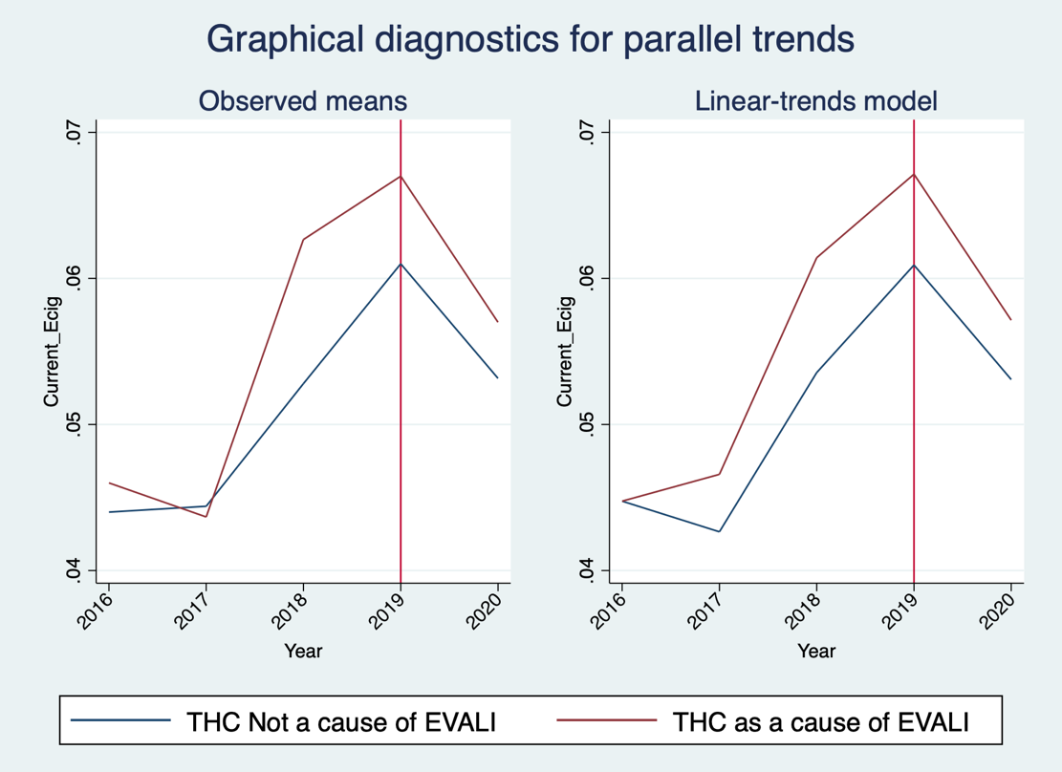
Figure S1. Graphical Confirmation of Parallel Trends, E-Cigarette Use

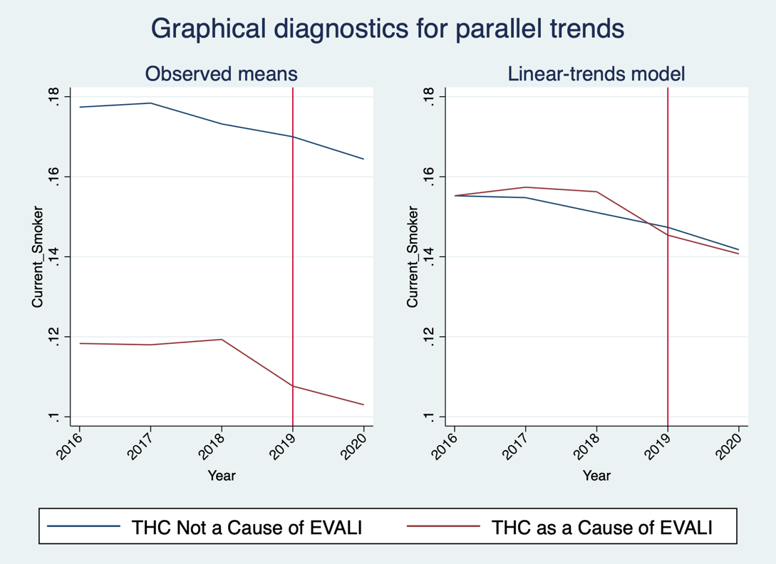
Figure S2. Graphical Confirmation of Parallel Trends, Cigarette Use

Table S1. Availability of EVALI Information at Each Time Point

State | August 2019 | January 2020 | September 2021 | All Three?
Alabama | No | Yes | Yes
Alaska | Not archived | Yes | No
Arizona | Yes | Yes | Yes | Yes
Arkansas | No | News Article | Yes
California | Yes | Yes | Yes | Yes
Colorado | Yes | Not Archived | Yes
Connecticut | Yes | Yes | Yes | Yes
Delaware | No | Yes | Yes
DC | Yes | Not Archived | Yes
Florida | No | Yes | Yes
Georgia | Yes | Yes | Yes | Yes
Hawaii | Yes | News Article | Yes | Yes
Idaho | News Article | Not Archived | No
Illinois | Yes | Yes | Yes | Yes
Indiana | News Article | News Article | Yes | Yes
Iowa | Yes | Yes | Yes | Yes
Kansas | Yes | Yes | No
Kentucky | News Article | News Article | Yes | Yes
Louisiana | Yes | Yes | Yes | Yes
Maine | Yes | Yes | Yes | Yes
Maryland | Yes | Not Archived | Yes
Massachusetts | Yes | News Article | Yes | Yes
Michigan | No | Yes | Yes
Minnesota | Yes | Not Archived | Yes
Mississippi | Yes | Yes | Yes | Yes
Missouri | Yes | Not Archived | Yes
Montana | Yes | Yes | Yes | Yes
Nebraska | Yes | Not Archived | Yes
Nevada | News Article | News Article | No
New Hampshire | No | Not Archived | Yes
New Jersey | Yes | Yes | Yes | Yes
New Mexico | No | Yes | Yes
New York | Yes | Yes | Yes | Yes
North Carolina | Yes | Yes | Yes | Yes
North Dakota | Yes | Not Archived | Yes
Ohio | Yes | Not Archived | Yes
Oklahoma | Yes | Not Archived | Yes
Oregon | Yes | Yes | Yes | Yes
Pennsylvania | Yes | Not Archived | No
Rhode Island | Yes | Not Archived | No
South Carolina | No | Yes | Yes
South Dakota | News Article | Yes | Yes | Yes
Tennessee | Yes | Yes | Yes | Yes
Texas | Yes | News Article | Yes | Yes
Utah | Yes | Yes | Yes | Yes
Vermont | Yes | Not Archived | Yes
Virginia | Yes | Yes | Yes | Yes
Washington | Yes | Yes | Yes | Yes
West Virginia | News Article | Not Archived | No
Wisconsin | No | Yes | Yes
Wyoming | Yes | Not Archived | Yes

