Additional Material

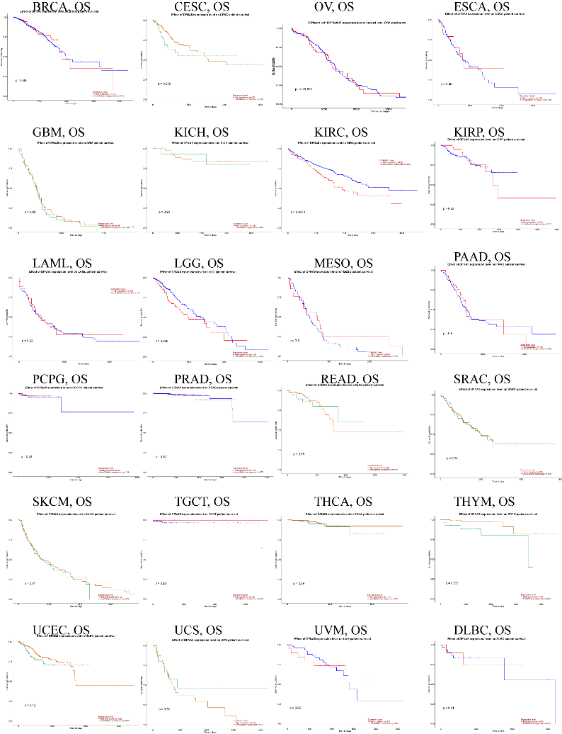
S1. Survival curves of diverse cancers in Kaplan-Meier
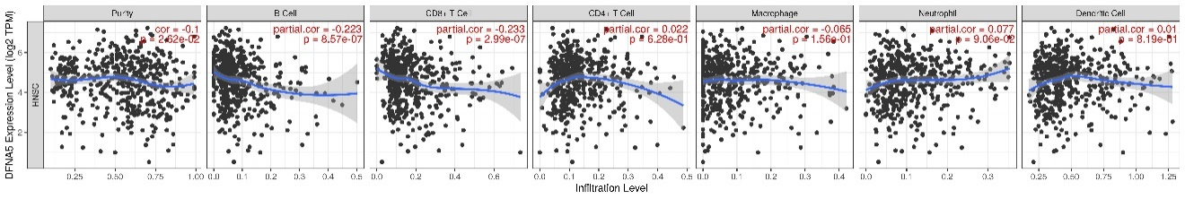

S2. (A) DFNA5 expression is significantly negatively related to tumor purity and has significant positive correlations with infiltrating levels of CD8+ T cells .

