Supplementary Materials
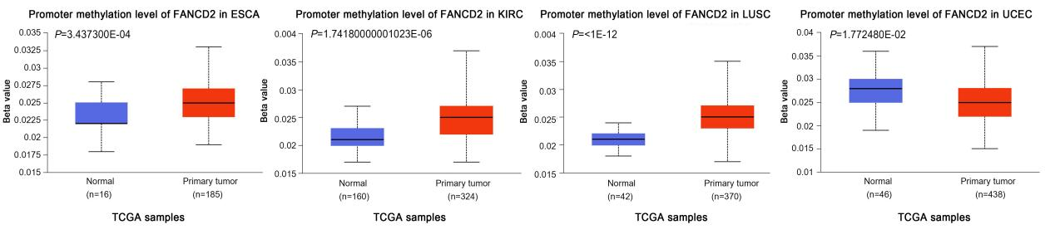
Supplementary Figure 1: Promoter methylation levels of FANCD2 in pan-cancer obtained from the UALCAN database. *P <0.05, **P < 0.01, and ***P < 0.001.

