

The ARRIVE Guidelines Checklist
Animal Research: Reporting In Vivo Experiments
Carol Kilkenny¹, William J Browne², Innes C Cuthill³, Michael Emerson⁴ and Douglas G Altman⁵
¹The National Centre for the Replacement, Refinement and Reduction of Animals in Research, London, UK, ²School of Veterinary Science, University of Bristol, Bristol, UK, ³School of Biological Sciences, University of Bristol, Bristol, UK, ⁴National Heart and Lung Institute, Imperial College London, UK, ⁵Centre for Statistics in Medicine, University of Oxford, Oxford, UK.

 |  | ITEM | RECOMMENDATION | Section/  Paragraph
 |  |  |  | Title
Abstract
NA
 | INTRODUCTION
 | 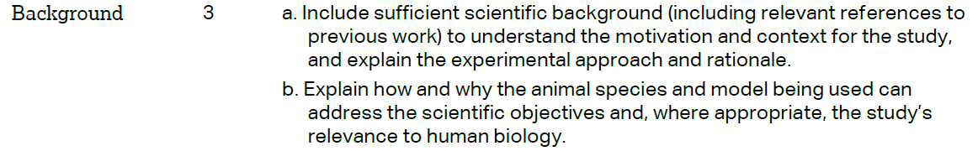 |  |  | Background Paragraphs 1 & 2 (a)  Results - Confirmational evidence Paragraph 4 (b)
 |  |  |  | Paragraph 3
 | METHODS
 |  |  |  | Declaration paragraph 1
 | 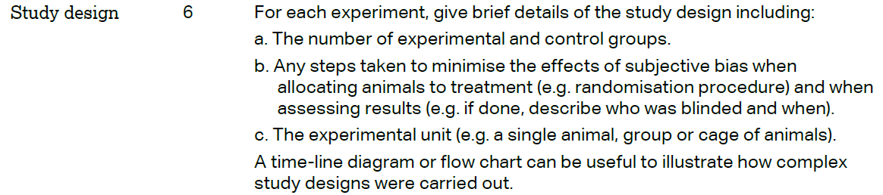 |  |  | NA
 | 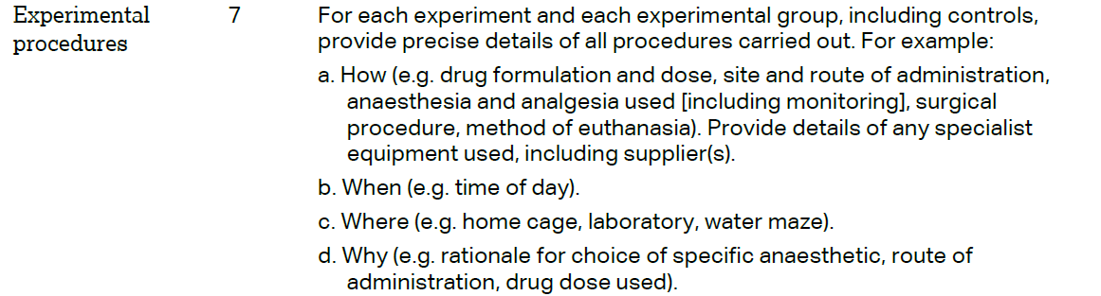 |  |  | Methods - Mice paragraph 1 (c) &  Methods - Generation of mutation-specific T cells in ABabDII mice paragraph 1 (a)  (b) (c) NA
 | 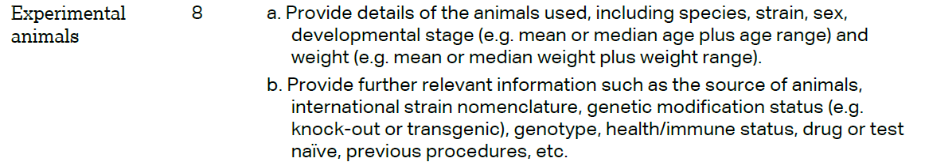 |  |  | Methods - Generation of mutation-specific T cells in ABabDII mice paragraph 1  (a) (b)
The ARRIVE guidelines. Originally published in PLoS Biology, June 2010¹
 | 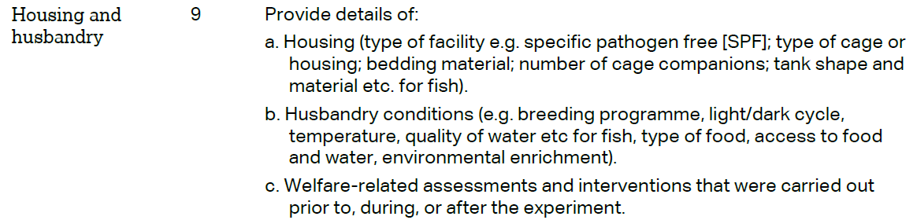 | Methods - Mice paragraph 1  (a) (b)  (c) NA
 | 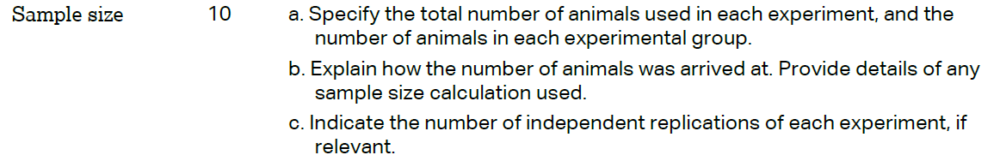 | Methods - Generation of mutation-specific T cells in ABabDII mice paragraph 1  (a)
 | 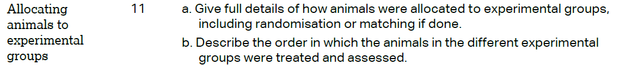 | NA
 |  | Results - Confirmational evidence paragraph 4
 | 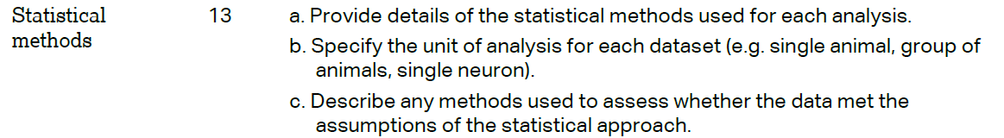 | NA (Sample size as judged from overlapping complete TCR repertoire)
 | RESULTS
 |  | NA
 |  | Methods - Generation of mutation-specific T cells in ABabDII mice paragraph 1
 |  | Results - Confirmational evidence paragraph 4
 |  | NA
 | DISCUSSION
 | 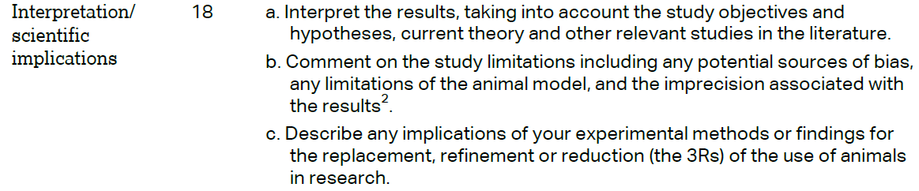 | Discussion paragraph 5 (a)  NA (b)  NA (c)
 |  | Results - Confirmational evidence paragraph 4
 |  | Declaration paragraph 5

