Supplementary material
Supplementary table

Table S1 qPCR primers
Target | Primer sequences (5'-3') | References
Total bacteria | CGGCAACGAGCGCAACCC | Denman and McSweeney, (2006)
 | CCATTGTAGCACGTGTGTAGCC | Denman and McSweeney, (2006)
Methanobacteriales | GGGCTTGCTTTGGAAACTGTT | Yu et al., (2005)
 | CCCACCGATGTTCCTCCTAA | Yu et al., (2005)
Fibrobacter succinogenes | GGTATGGGATGAGCTTGC | Koike and Kobayashi, (2001)
 | GCCTGCCCCTGAACTATC | Koike and Kobayashi, (2001)
Ruminococcus albus | CCCTAAAAGCAGTCTTAGTTCG | Denman et al., (2007)
 | CCTCCTTGCGGTTAGAACA | Denman et al., (2007)
Ruminococcus flavefaciens | TCTGGAAACGGATGGTA | Yu et al., (2005)
 | CCTTTAAGACAGGAGTTTACA A | Yu et al., (2005)
Megasphaera elsdenii | GACCGAAACTGCGATGCTAGA | Ouwerkerk et al., (2002)
 | TCCAGAAAGCCGCTTTCGCCACT | Ouwerkerk et al., (2002)

Table S2 In vitro cumulative gas production of diet supplemented with different dose levels of Cannabis sativa L. residue (CSR) powder at various incubation times.
Parameters | Treatment¹ |  |  |  | SEM | Contrast²
Parameters | T1 | T2 | T3 | T4 | SEM | L | Q | C
In vitro cumulative gas production, ml/0.5 g DM
GP2h | 6.75ª | 7.68ª | 6.72ª | 3.77^{b} | 0.57 | 0.006 | 0.009 | 0.959
GP4h | 9.21ª | 9.81ª | 7.70ª | 4.46^{b} | 0.83 | 0.007 | 0.055 | 0.647
GP6h | 14.05ª | 14.16ª | 11.97ª | 7.25^{b} | 1.12 | 0.007 | 0.074 | 0.962
GP8h | 19.49ª | 20.33ª | 18.63ª | 11.54^{b} | 1.38 | 0.006 | 0.021 | 0.585
GP10h | 23.24ª | 24.79ª | 22.40ª | 15.32^{b} | 1.45 | 0.008 | 0.023 | 0.896
GP12h | 25.24ª | 30.60ª | 26.09ª | 17.32^{b} | 1.87 | 0.009 | 0.006 | 0.406
GP24h | 38.17^{cb} | 44.68ª | 40.58^{ab} | 32.58^{c} | 1.76 | 0.041 | 0.010 | 0.393
GP48h | 75.82 | 77.02 | 75.29 | 70.49 | 1.22 | 0.128 | 0.220 | 0.988
GP72h | 101.19 | 100.84 | 97.27 | 92.64 | 1.63 | 0.065 | 0.456 | 0.861
GP96h | 115.45ª | 113.91^{ab} | 110.49^{ab} | 104.61^{b} | 1.86 | 0.039 | 0.461 | 0.963
¹ Treatment: T1; without CSR, T2; 0.5% CSR, T3; 1.0% CSR, T4; 2.0% CSR. ² Contrast: L; linear contrast, Q; quadratic contrast, C; cubic contrast. ^{a–c} Means with different superscript letters show differences among treatments at each incubation time (P < 0.05). SEM; standard error of means.

Table S3 In situ DM and OM disappearance of diet supplemented with different dose levels of Cannabis sativa L. residue (CSR) powder in the rumen at various incubation times.
Parameters | Treatment¹ |  |  |  | SEM | Contrast²
Parameters | T1 | T2 | T3 | T4 | SEM | L | Q | C
In Situ DM disappearance , %
3 h | 25.91 | 27.38 | 28.14 | 26.83 | 0.69 | 0.257 | 0.062 | 0.153
6 h | 32.18 | 30.96 | 31.66 | 31.60 | 0.39 | 0.819 | 0.576 | 0.559
12 h | 35.60 | 37.57 | 37.80 | 37.57 | 0.43 | 0.116 | 0.185 | 0.699
24 h | 43.98 | 44.41 | 46.81 | 46.54 | 0.58 | 0.067 | 0.718 | 0.318
48 h | 59.06 | 58.18 | 58.85 | 58.36 | 0.42 | 0.774 | 0.860 | 0.596
72 h | 71.94 | 71.02 | 71.71 | 71.25 | 0.41 | 0.783 | 0.834 | 0.587
96 h | 74.66 | 73.76 | 74.43 | 73.99 | 0.40 | 0.784 | 0.828 | 0.585
In Situ OM disappearance, %
3 h | 22.75 | 23.79 | 24.39 | 22.92 | 0.65 | 0.508 | 0.076 | 0.146
6 h | 29.68 | 27.46 | 28.53 | 27.97 | 0.51 | 0.442 | 0.483 | 0.362
12 h | 33.95 | 34.88 | 34.89 | 34.66 | 0.94 | 0.586 | 0.509 | 0.856
24 h | 43.07 | 42.59 | 45.33 | 45.34 | 0.61 | 0.104 | 0.822 | 0.263
48 h | 60.62 | 59.37 | 59.91 | 59.47 | 0.49 | 0.618 | 0.752 | 0.637
72 h | 75.32 | 74.22 | 74.78 | 74.41 | 0.12 | 0.703 | 0.770 | 0.652
96 h | 78.28 | 77.22 | 77.77 | 77.43 | 0.46 | 0.718 | 0.772 | 0.654
¹ Treatment: T1; without CSR, T2; 0.5% CSR, T3; 1.0% CSR, T4; 2.0% CSR. ² Contrast: L; linear contrast, Q; quadratic contrast, C; cubic contrast. SEM; standard error of means.

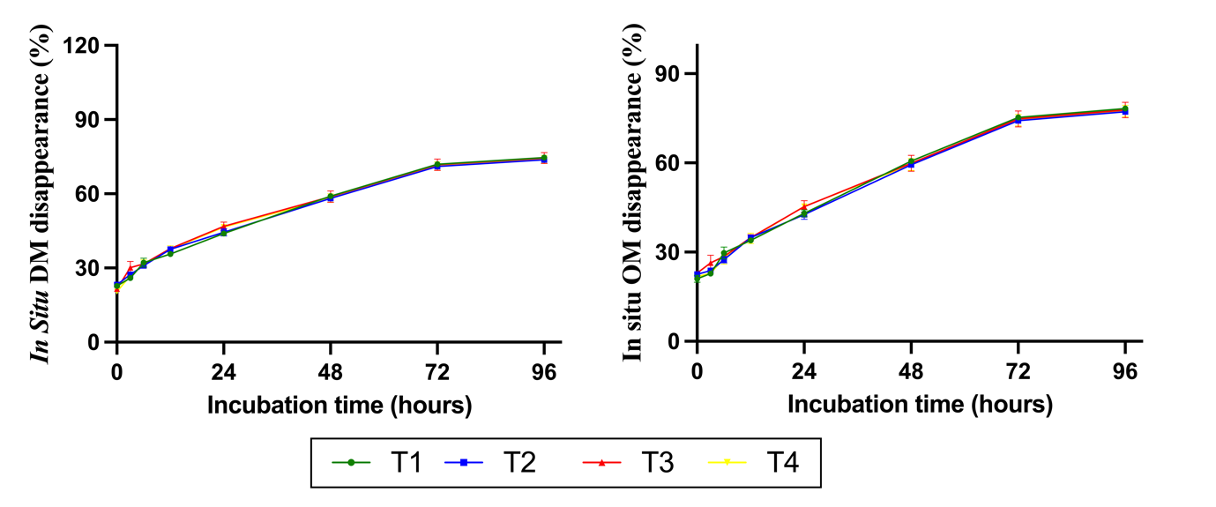

Figure 1. Effect of the Cannabis sativa L. residue (CSR) powder supplementation level on in situ (A) DM disappearance (%) and (B) OM disappearance (%) after 0–96 h of incubation in the rumen. The dietary treatments (T1-T4) were supplemented with CSR powder at concentrations of 0%, 0.5%, 1%, and 2% of the total DM substrate, respectively.

Reference
Denman SE, McSweeney CS. Development of a real-time PCR assay for monitoring anaerobic fungal and cellulolytic bacterial populations within the rumen. FEMS Microbiol Ecol. 200; 658:572-582.
Denman SE, Tomkins NW, McSweeney CS. Quantitation and diversity analysis of ruminal methanogenic populations in response to the antimethanogenic compound bromochloromethane. FEMS Microbiol Ecol. 2007; 62: 313-322.
Koike S, Kobayashi Y. Development and use of competitive PCR assays for the rumen cellulolytic bacteria: Fibrobacter succinogenes, Ruminococcus albus and Ruminococcus flavefaciens. FEMS Microbiol. 2001; 204: 361-366.
Ouwerkerk D, Klieve AV. Enumeration of Megasphaera elsdenii in rumen contents by real‐time Taq nuclease assay. J Appl Microbiol. 2002; 92: 753-758.
Yu Y, Lee C, Kim J, Hwang S. Group-specific primer and probe sets to detect methanogenic communities using quantitative real-time polymerase chain reaction. Biotechnol Bioeng. 200; .89: 670-679.

