Supplementary Material: Immunohistofluorescence images show all separate channels and merged images for target antibodies, and corresponding isotype controls demonstrating minimal non-specific staining.
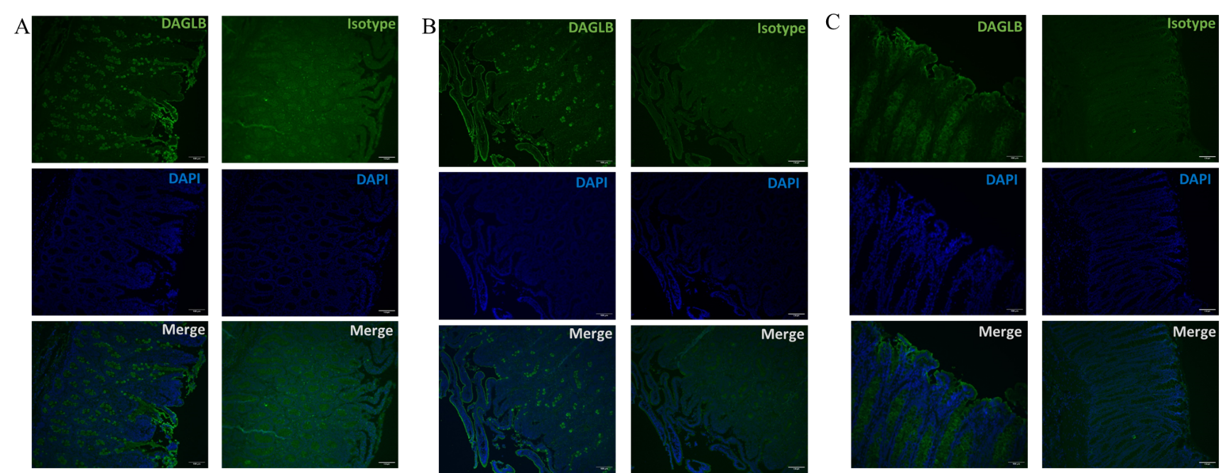
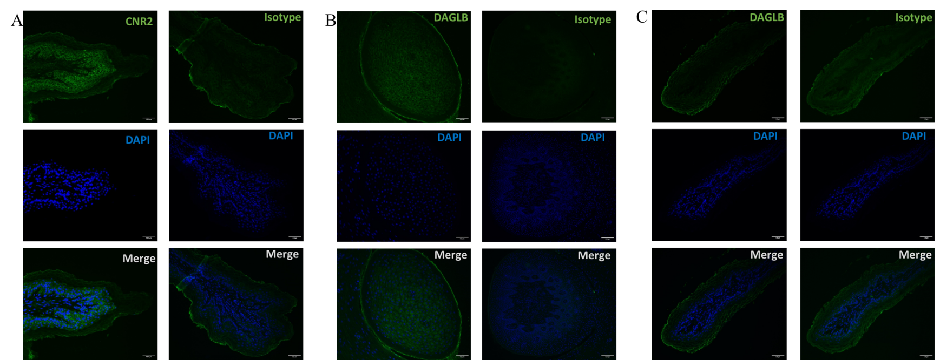
Supplementary Figure 2. Immunohistofluorescent staining of DAGLB and Isotype Control in duodenum (A), ileum (B) and colon (C). Nuclei are counterstained with DAPI (blue).
Supplementary Figure 1. Immunohistofluorescent staining of CNR2 and Isotype control in ruminal epithelium (A), and of DAGLB and Isotype Control in tongue (B) and ruminal epithelium (C). Nuclei are counterstained with DAPI (blue).

