Forest plots for secondary outcomes stratified by type of cannabinoids

Supplementary Figure 22. Forest plot for retention

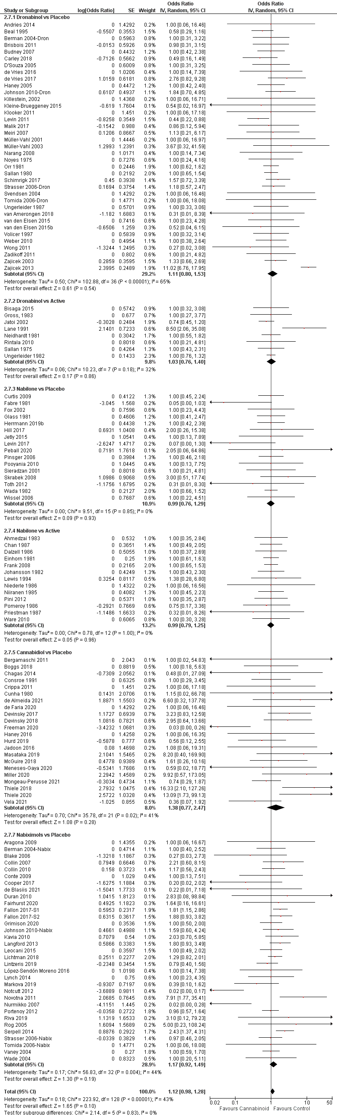

Supplementary Figure 23. Forest plot for adverse events
