Forest plots for relevant medical conditions (primary outcomes) stratified by type of cannabinoids

Supplementary Figure 9. Forest plot for nausea and vomiting
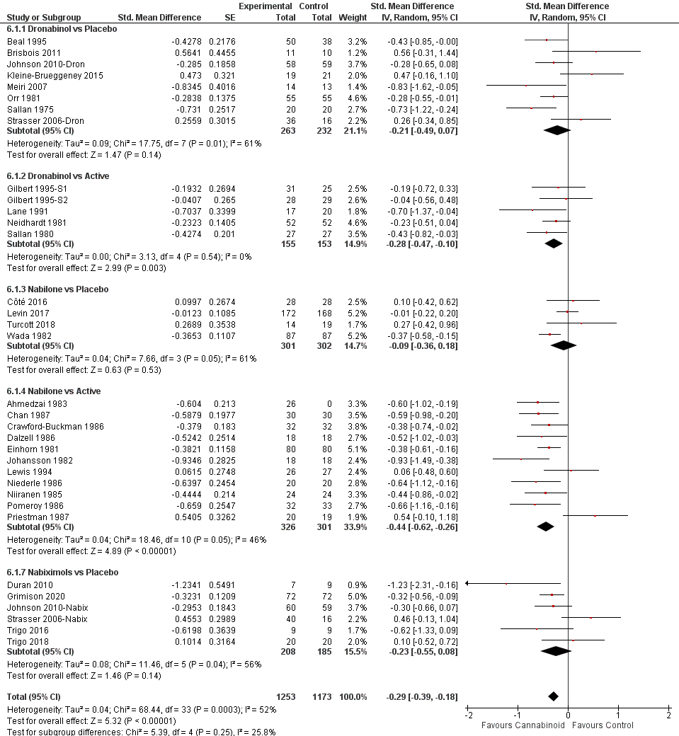

Supplementary Figure 10. Forest plot for amyotrophic lateral sclerosis
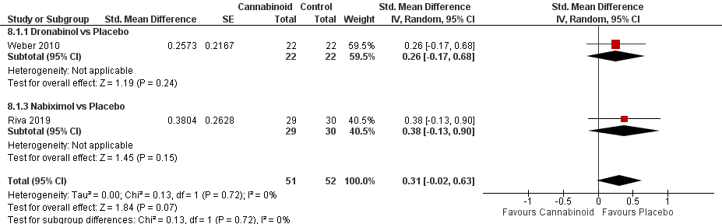

Supplementary Figure 11. Forest plot for Chorea Huntington
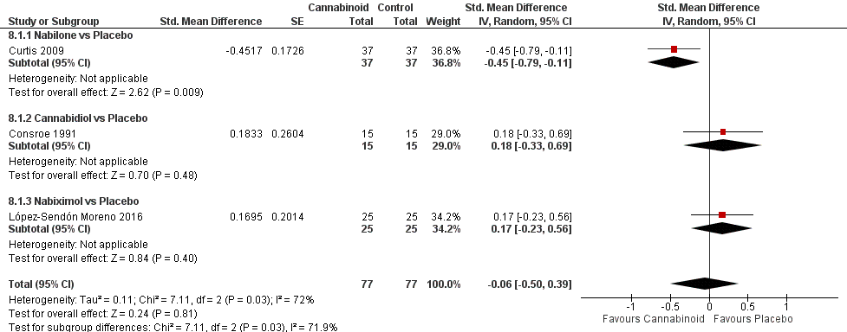

Supplementary Figure 12. Forest plot for dystonia
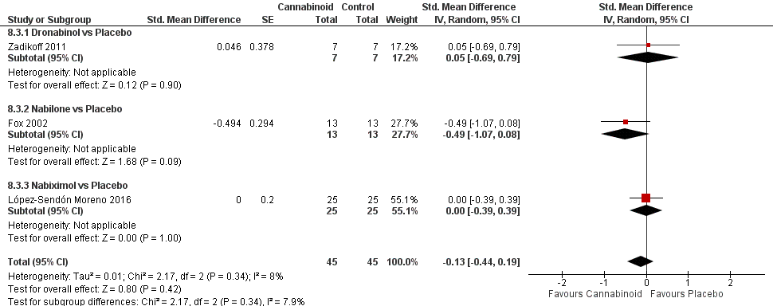

Supplementary Figure 13. Forest plot for glaucoma
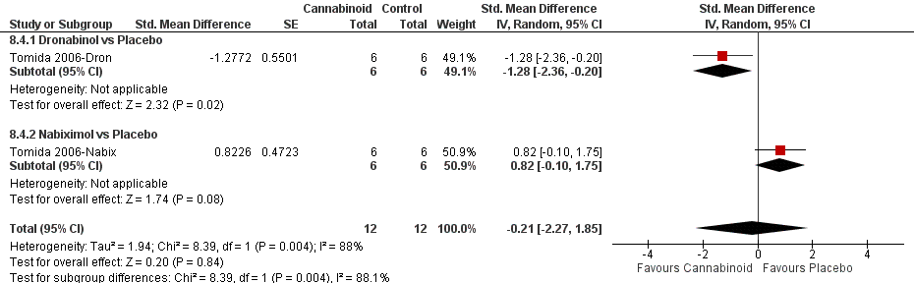

Supplementary Figure 14. Forest plot for irritable bowel syndrome
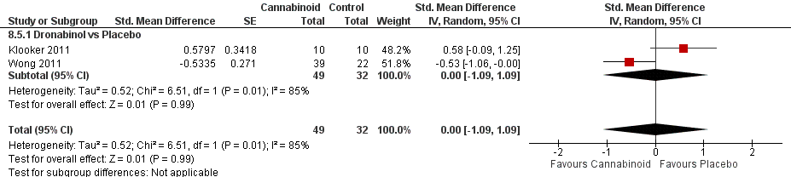

Supplementary Figure 15. Forest plot for multiple sclerosis
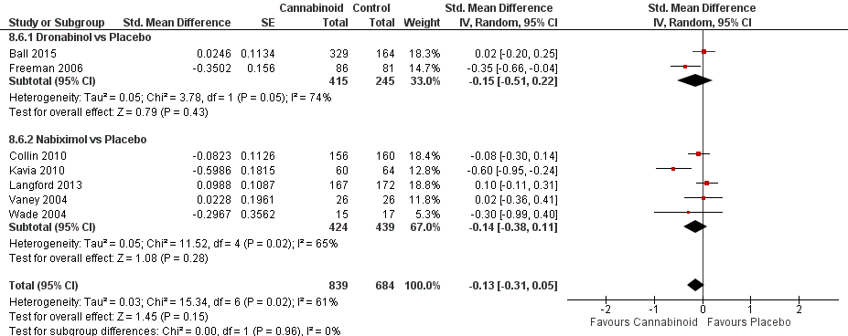

Supplementary Figure 16. Forest plot for anorexia nervosa
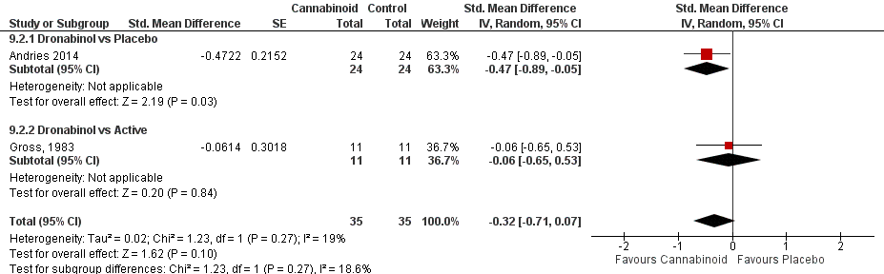

Supplementary Figure 17. Forest plot for anxiety
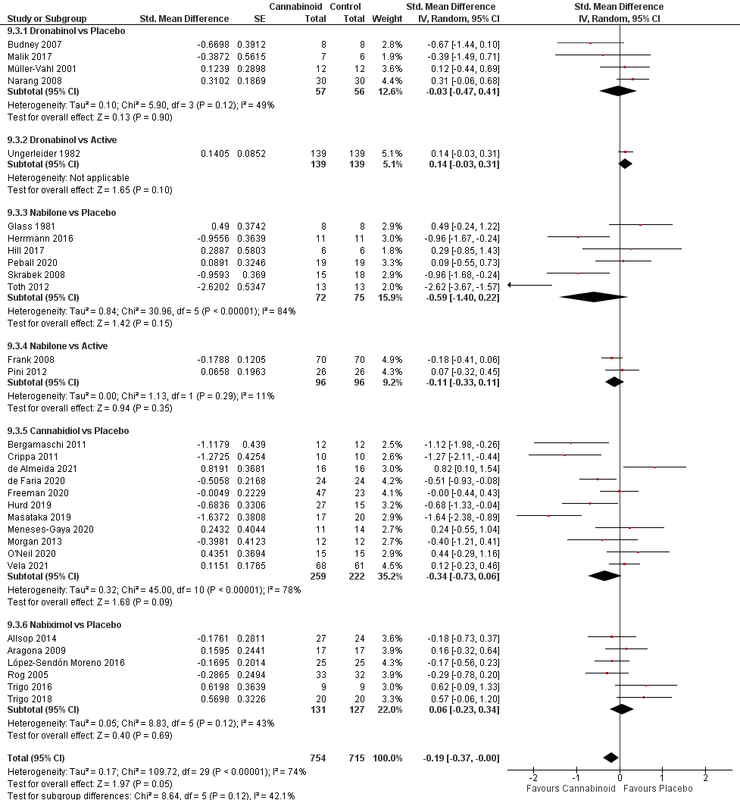

Supplementary Figure 18. Forest plot for dementia
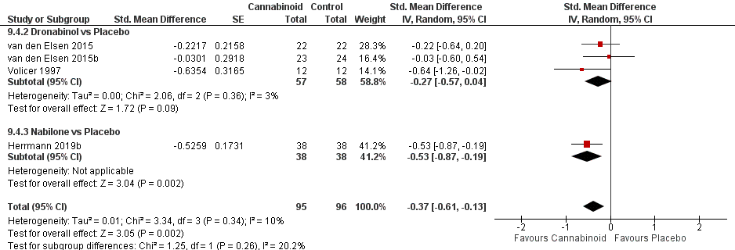

Supplementary Figure 19. Forest plot for depression
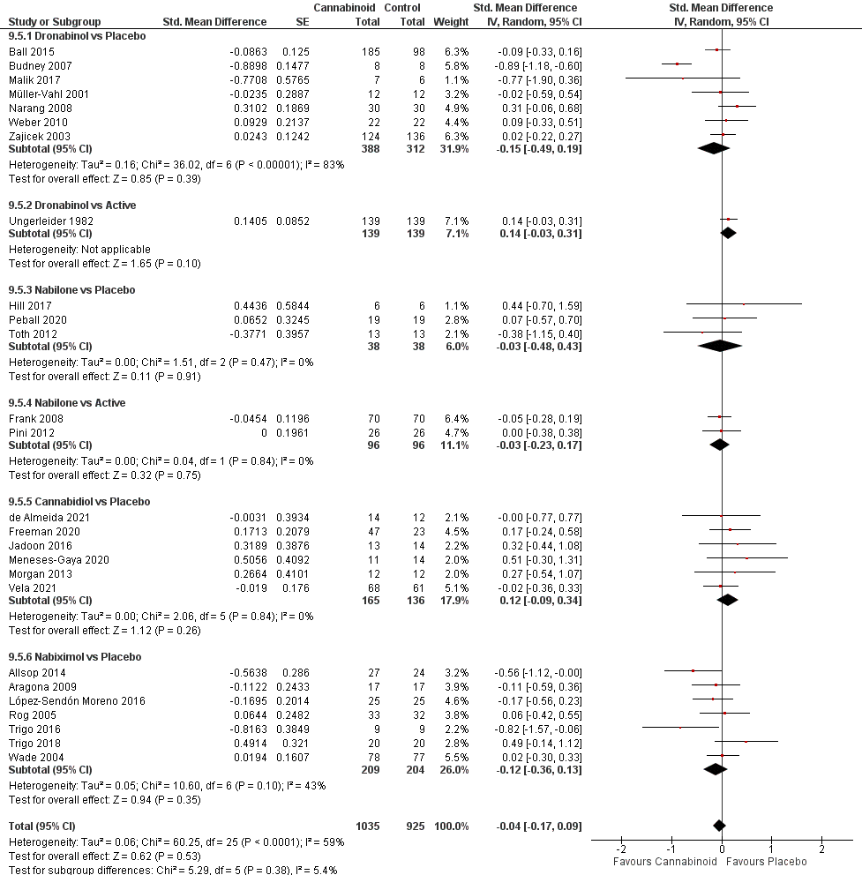

Supplementary Figure 20. Forest plot for PTSD
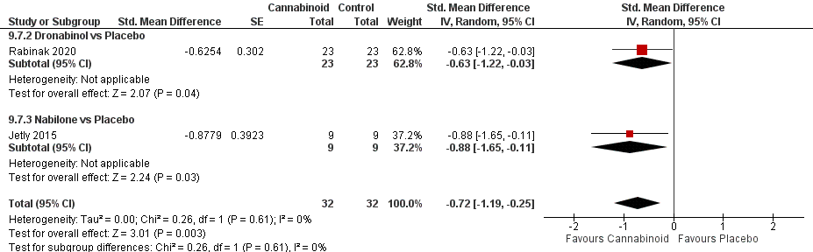

Supplementary Figure 21. Forest plot for schizophrenia and psychosis
