Talent Management in Volatility, Uncertainty, Complexity, and Ambiguity (VUCA) Health Environment, Nurses’ Psychological Contract Fulfillment, Cordial Relation and Generation: Moderation-Mediation Model
Supplementary file:
Exploratory factor analysis

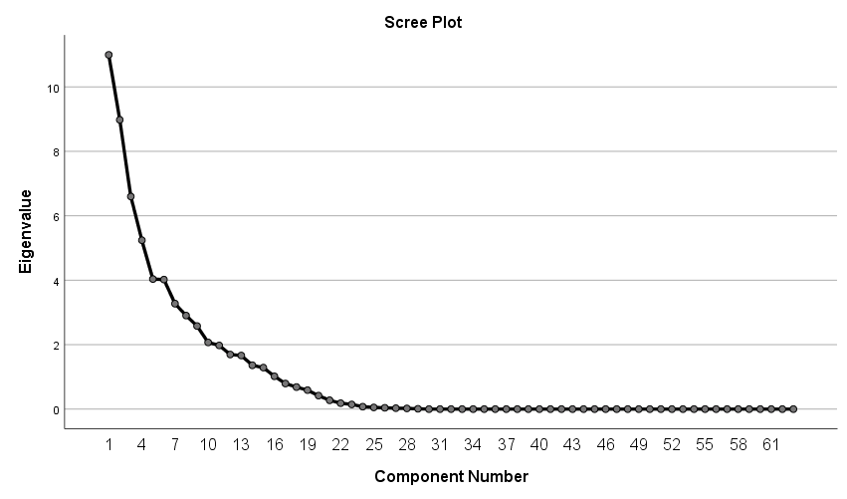

Figure (3) Component factor loading with varimax (1), and correlation coefficient at 0.30 of the developed cordial relations

Table 7Rotated Component Matrix

 | Component
 | 1 | 2 | 3 | 4
- Concern for my personal welfare | .491
- Be responsive to employee concerns |  |  | -.787
- Make decisions with my | .470
- Concern for my long-term well-being | .633
- Limited involvement in the organization | -.624
- Support me to attain higher levels | .644
- Help me respond to each greater | .733
- Support me in meeting higher goals | .713
- Developmental opportunities within this firm | .749
- Advancement within the firm | .703
- Opportunities for promotion | .735
- Help me develop extremely marketable skills | .701
- Job assignments that enhance | .786
- Potential job opportunities outside | .583
- I have no future obligations(r)
- Leave at any time I choose(r) |  |  |  | .795
- I have much fewer commitments(r) |  | .718
- Make personal sacrifices for this organization |  |  | .614
- Take this organization's concerns personally ) |  | -.451
- Protect this organization's image |  |  |  | .728
- Commit myself personally |  |  |  | .571
- Seek out assignments that enhance the value |  |  |  | .486
- Build skills to increase my value in this organization |  |  |  | .874
- Make myself increasingly valuable to this employer |  |  |  | .609
- Actively seek internal opportunities |  |  |  | .371
- Accept increasingly challenging performance standards |  |  |  | .675
- Take personal responsibility |  |  |  | .837
- Continually exceed my formal accomplishments |  |  |  | .680
- Build contacts outside firm | .375
- Increase my visibility |  | .613
- Building skills to increase future employment |  | .666
- Seek out assignments that enhance my employability |  |  |  | .579
- Withholds information from me(r) |  |  |  | .394
- Doesn't trust me(r) |  |  | .339
- Introduces changes without involving me (r) |  |  | -.607
- Doesn't share important information with me (r) |  |  |  | .441
- Difficult to predict future direction of its relations with me (r) |  |  |  | -.442
- An uncertain future regarding its relations with me (r) | -.688
- Uncertainty regarding its commitment to employees (r) |  | -.700
- Uncertainty regarding its commitment to me (r) |  | -.628
- Demands more from me while giving me less in return (r) |  | -.397
- Decreasing benefits over the next few years (r) |  |  | -.546
- Stagnant or reduced wages the longer I work here (r) |  |  | -.500
- More and more work for less pay (r) | -.488
- Contracts that create employment opportunities elsewhere | .577
- Perform only required tasks(r) |  | .504
- Do only what I am paid to do( r) |  | .797
- Fulfill a limited number of responsibilities(r) |  | .615
- Only perform specific duties(r) |  | .530
- Quit whenever I want(r) |  | -.564
- I cannot believe what this employer tells me (r) |  |  | -.375
- I have no trust in this employer (r) |  | .748
- Inconsistency exists between what this employer says and does (r) | .549
- I'm getting less pay for more work (r) |  | .371
- I'm doing more for less (r) |  |  | .404
- I expect increasing demands from this employer for little return (r) |  |  | .683
- It's difficult to predict the future of this relationship (r) |  |  | .752
- I cannot anticipate what my future relationship (r) |  |  | .566
- It's difficult to anticipate my future commitments (r) |  |  | .574
- My commitments to this employer are uncertain (r) |  |  | .665
Extraction Method: Principal Component Analysis.
Rotation Method: Varimax with Kaiser Normalization.
a. Rotation converged in 8 iterations.

Confirmatory factor analysis to the developed Cordial Relations questionnaire
Table 7 Standardized Regression Weights
 |  |  | Estimate | S.E. | C.R. | P | Label
Employee commitment | <--- | Cordial relations | .948
Employer commitment | <--- | Cordial relations | .743 | .052 | 17.876 | *** | par_1
Employee trust | <--- | Cordial relations | .889 | .019 | 23.318 | *** | par_2
Employer caring | <--- | Cordial relations | -.026 | .018 | -.478 | .633 | par_3

Figure (4) of CFA of cordial relations questionnaire
