Supplementary file:
Work Ethics and its Relationship with Workplace Ostracism and Counterproductive Work Behaviors among Nurses: A Structural Equation Model

Supplementary Table 1. Exploratory Factors loading

Factors | Rotation sum squared loading
1 | 12.898
2 | 9.853
3 | 8.968
4 | 7.421
5 | 6.770
6 | 6.650
7 | 6.312
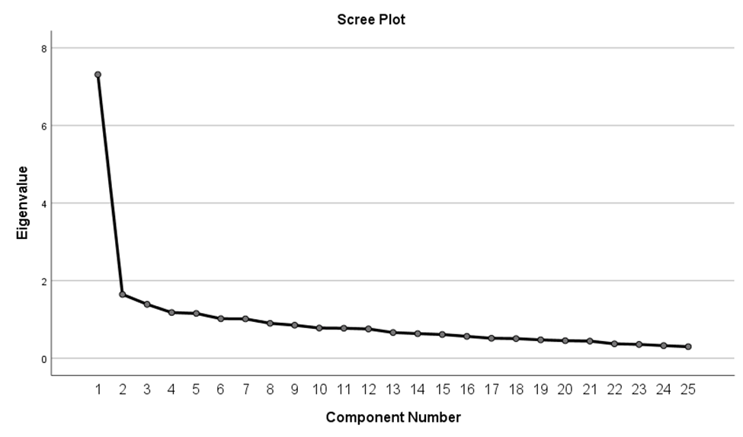
Supplementary Figure 1: Exploratory Factor Analysis

Supplementary table 2. Standardized Regression Weights: (Group number 1 - Default model)
variables |  |  | Beta | R² | S.E. | C.R. | P
Work_ethicsª | <--- | total.Ostracism | -.044 | -.151 | .016 | -2.707 | .005
Counterproductive_Work_Behaviour^{b} | <--- | Work_ethics | -.482 | -.149 | .179 | -2.691 | .005
Counterproductive_Work_Behaviour^{c} | <--- | total.Ostracism | .035 | .038 | .048 | .737 | .021
Instrument1 | <--- | Work_ethics | .653 | .510 | .071 | 9.262 | ***
Regulation | <--- | Work_ethics | .911 | .745 | .067 | 13.657 | ***
Independent1 | <--- | Work_ethics | .596 | .602 | .054 | 10.988 | ***
Ethics code | <--- | Work_ethics | .771 | .654 | .064 | 11.961 | ***
Care1 | <--- | Work_ethics | .664 | .671 | .054 | 12.277 | ***
Hard work | <--- | Work_ethics | .746 | .716 | .057 | 13.118 | ***
Work goal | <--- | Work_ethics | 1.000 | .742
CWB Directed at the organization | <--- | Counterproductive_Work_Behaviour | 1.000 | 1.014
CWB directed at individuals | <--- | Counterproductive_Work_Behaviour | .738 | .947 | .076 | 9.756 | ***
Note. a(r=-0. 127, p= 0.01), b(r=-0.141, p= 0.001), c(r=0.114, p= 0.001). Model ﬁt parameters RFI, NFI; IFI; RMSEA.806.853.973.032 respectively
r = Pearson correlation; R²= regression coefficient; CFI = Comparative fit index; and RMSEA = Root Mean Square Error of Approximation. * p significant ≤ 0.05

