Appendix A – Cannabis Health Literacy Questionnaire (CHLQ)

To what extent do you agree or disagree with the following statements:

- I am confident I know where to find information about cannabis.
- Strongly Disagree
- Disagree
- Neither disagree nor agree
- Agree
- Strongly agree.

- I am confident I can ask questions to a health care provider about cannabis.
- Strongly Disagree
- Disagree
- Neither disagree nor agree
- Agree
- Strongly agree

- I am confident I know where to find information on how to manage unpleasant side effects with cannabis use.
- Strongly Disagree
- Disagree
- Neither disagree nor agree
- Agree
- Strongly agree

- I am confident in using the cannabis information I find to make cannabis health-related decisions.
- Strongly Disagree
- Disagree
- Neither disagree nor agree
- Agree
- Strongly agree

- According to the label displayed below, what is the total THC in this product?
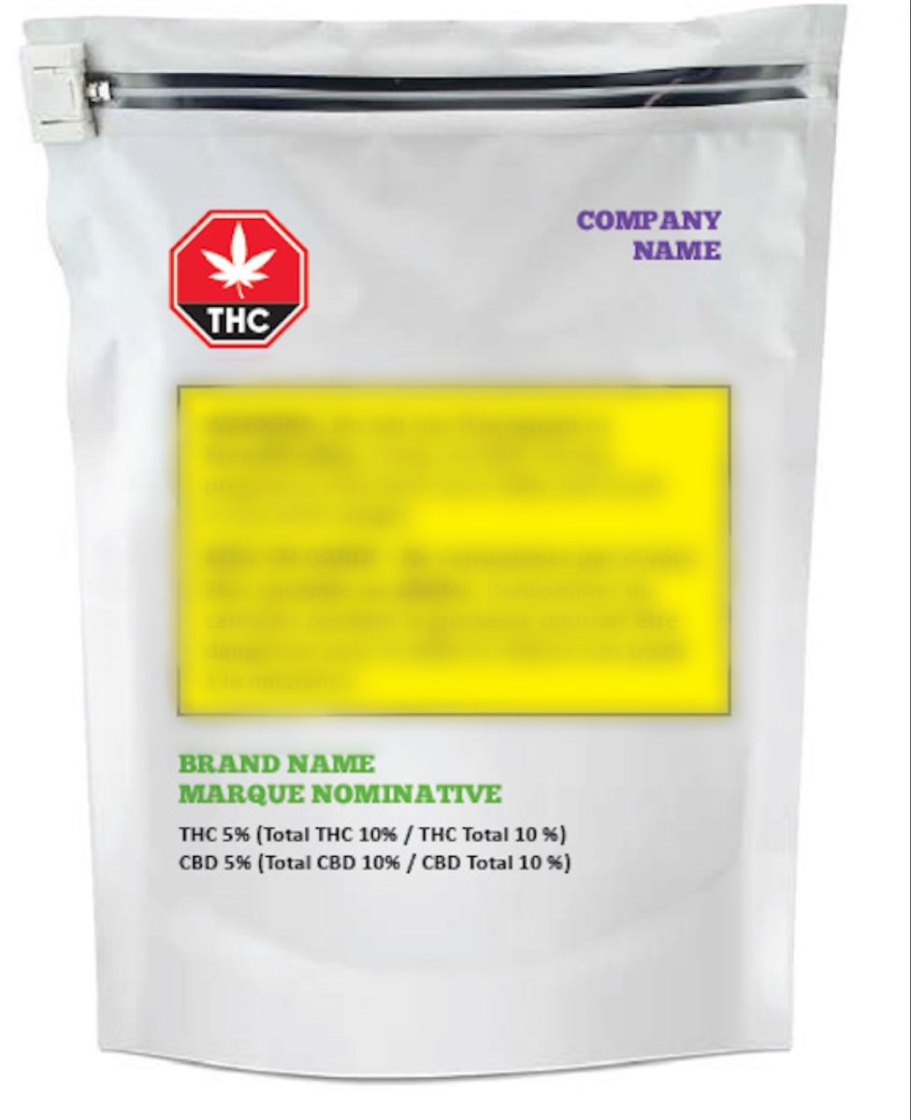
Image source: Health Canada
- 5 %
- 10%
- 15%
- 20%
- I don’t know.

- According to the product label displayed below, how many milligrams (mg) of cannabinoids are in one soft gel?
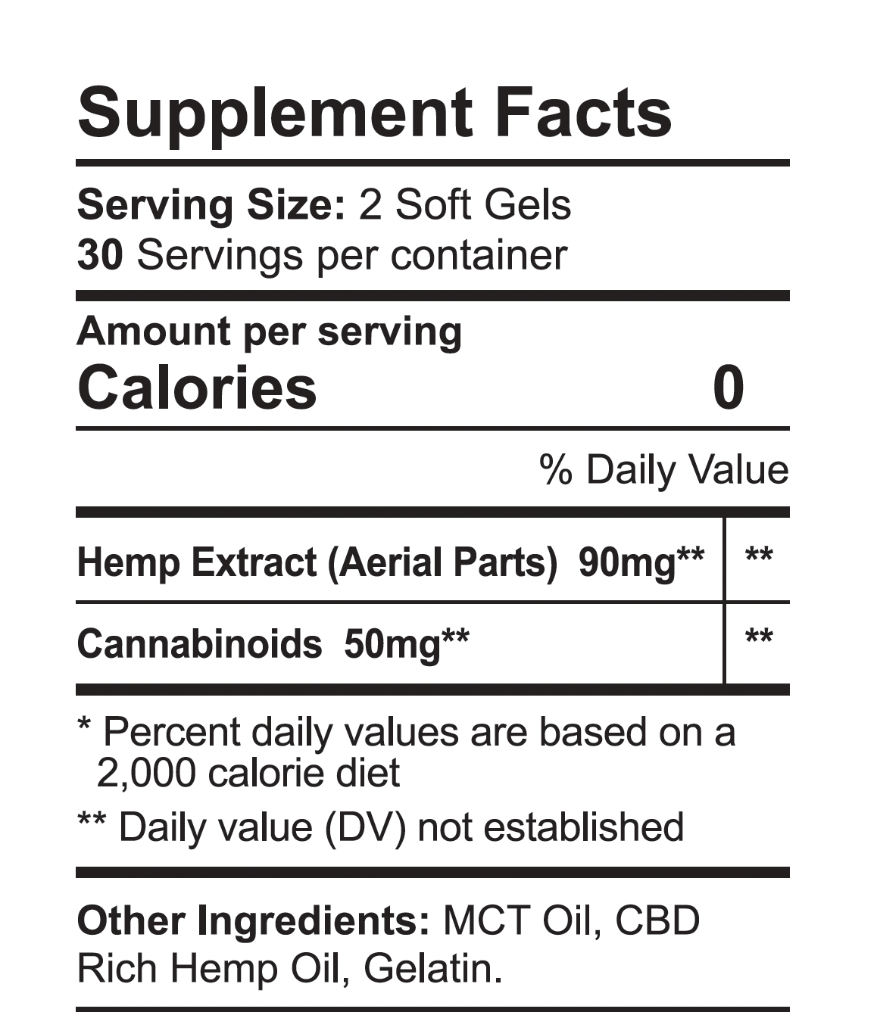
Image source: CBDFX

- 15 mg
- 25 mg
- 50 mg
- 100 mg
- I don’t know

- If one drop of CBD oil = 1.1mg, how many drops would you need to have 16.5 mg of CBD?
- 10 drops
- 15 drops
- 20 drops
- 25 drops
- I don’t know
- If a syringe of 1 mL has 20 mg of CBD (i.e., 1 mL = 20 mg of CBD), how many mL would you need to have 5 mg of CBD?
- 0.2 mL
- 0.25 mL
- 4 mL
- 5 mL
- I don’t know

- Which of the ingredients of cannabis produces the feeling or experience of being “high”?
- THC (Tetrahydrocannabinol)
- CBD (Cannabidiol)
- CBG (Cannabigerol) & CBN (Cannabinol)
- Terpenes
- I don’t know

- Too much of which ingredient in cannabis products can most likely lead to cannabis poisoning?
- Terpenes
- CBG (Cannabigerol) & CBN (Cannabinol)
- CBD (Cannabidiol)
- THC (Tetrahydrocannabinol)
- I don’t know.

- Which method of cannabis consumption typically has the longest delay before experiencing the feeling or experience of being high?
        - Eating edibles or drinking cannabis beverages
        - Lotions or oils for skin
        - Smoking or vaping
        - Sprays or Tinctures
        - I don’t know.

- Which of the ingredients in cannabis products is most likely to give rise to adverse (i.e., unpleasant) side effects?
- CBD (Cannabidiol)
- Terpenes
- THC (Tetrahydrocannabinol)
- CBG (Cannabigerol) & CBN (Cannabinol)
- I don’t know

- After smoking cannabis, what is the minimum amount of time a person should wait before driving?
- less than 1 hour
- 1 to 3 hours
- 4 to 8 hours
- more than 10 hours
- I don’t know.

- People can experience harm to brain development from cannabis use when they start consuming cannabis any time before the age of ______.
        - 19
        - 21
        - 25
        - 30
        - I don’t know.

To what extent do you agree or disagree with the following statements:

- Smoking Cannabis can be harmful.
- Strongly Disagree
- Disagree
- Neither disagree nor agree
- Agree
- Strongly agree

- Using cannabis when pregnant or breastfeeding can be harmful.
- Strongly Disagree
- Disagree
- Neither disagree nor agree
- Agree
- Strongly agree

- Cannabis can be addictive.
- Strongly Disagree
- Disagree
- Neither disagree nor agree
- Agree
- Strongly agree

- Driving or operating machinery after cannabis use is dangerous.
- Strongly Disagree
- Disagree
- Neither disagree nor agree
- Agree
- Strongly agree

- Regular cannabis use can increase the risk for psychosis or schizophrenia.
- Strongly Disagree
- Disagree
- Neither disagree nor agree
- Agree
- Strongly agree

- Teenagers are at a greater risk of harm from using cannabis than adults.
- Strongly Disagree
- Disagree
- Neither disagree nor agree
- Agree
- Strongly agree

In your opinion, how common are the following side effects with THC consumption?
 | Uncommon | Common | I don’t know
- Hallucinations
- Dry mouth/ red eyes
- Rapid heart rate
- Low appetite

Answer Key:

Note: For Likert-type items analyzed using a Rasch Rating Scale Model, higher agreement (e.g., Strongly Agree) reflects stronger endorsement of the construct and is considered the preferred response.

Questions 1 – 4: Agreement is preferred for a rating scale model (e.g., Strongly agree & Agree)
Question 5: b) 10%
Question 6: b) 25 mg
Question 7: b) 15 drops
Question 8: b) 0.25 mL
Question 9: a) THC (Tetrahydrocannabinol)
Question 10: c) THC (Tetrahydrocannabinol)
Question 11: a) Eating edibles or drinking cannabis beverages
Question 12: c) THC (Tetrahydrocannabinol)
Question 13: c) 4 to 8 hours
Question 14: c) 25
Question 15 – 20: Agreement is preferred for a rating scale model (e.g., Strongly agree & Agree)
Question 21: Uncommon
Question 22: Common
Question 23: Uncommon
Question 24: Common

