SUPPORTING INFORMATION

Figure S1: Example of a Discrete Choice Experiment Choice Scenario
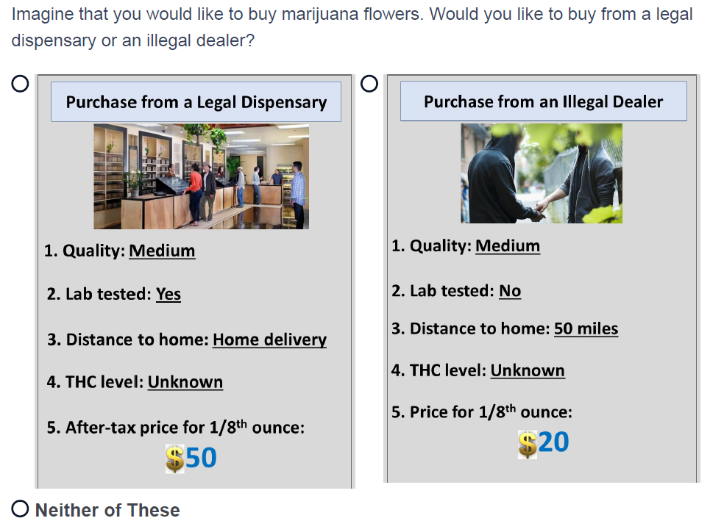
Notes: THC stands for Tetrahydrocannabinol.

Technical Note S1. Definitions of Cannabis Quality Levels
- Low-quality marijuana flowers are very dry, full of seeds and stems, and more brown than green.
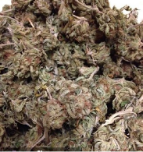
- Medium-quality marijuana flowers can be identified by their spectrum of green hues and the presence of colorful pistils. Seeds and stems are minimal, but the flowers can suffer from a number of quick-to-market techniques like improper flushing of nutrients, quick curing methods, and sloppy trim jobs.
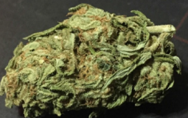
- High quality marijuana flowers are primarily green in color with a brilliant array of vibrant colors. Seeds and stems are extremely rare. The flowers themselves are typically dense and chunky.
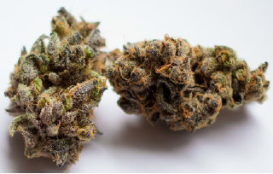
Figure S2. Factors Not Described by the DCE Attributes
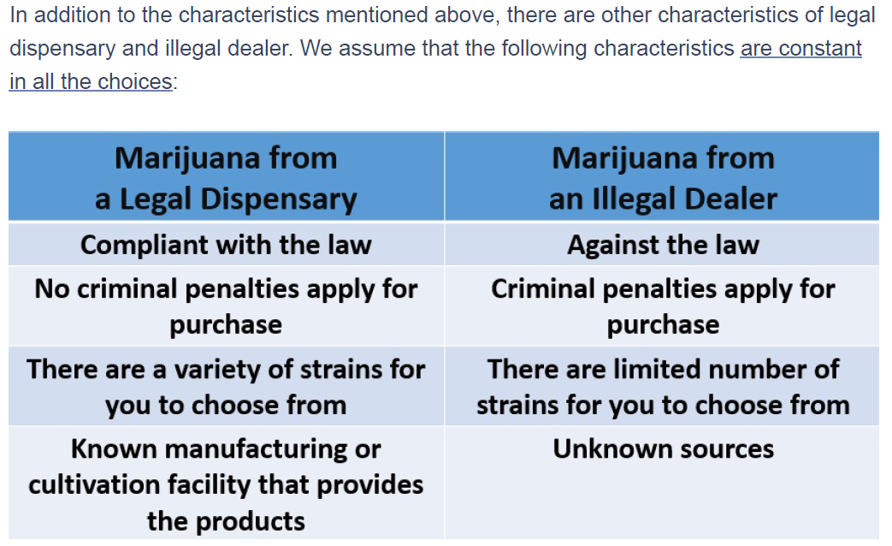
Technical Note S2. Assumptions in the Benchmark Policy Scenario
- For both legal and illegal cannabis, low, medium, and high qualities are evenly distributed (1/3 each).
- For both legal and illegal cannabis, lab test is not present.
- For both legal and illegal cannabis, equal number of sellers are located 1-, 10-, and 50-mile away (1/3 each). Deliveries are not allowed.
- For legal cannabis, 10%, 20%, 30%, and unknown THC levels are evenly distributed (1/4 each). All illegal cannabis has unknown THC level.
- For both legal and illegal cannabis, $20, $30, $40, and $50 prices are evenly distributed (1/4 each).
Table S1. Study Sample Characteristics and Comparison to 2019 National Survey on Drug Use and Health (NSDUH)
Variable | Study Sample | 2019 NSDUH
 | %
Age
21-34 | 50.26 | 46.95
35+ | 49.74 | 53.05
Sex
Male | 58.57 | 57.70
Female | 41.43 | 42.30
Educational Attainment
High School Degree or Less | 33.02 | 31.50
Some College/Associate Degree or College Graduate | 66.98 | 68.50
Race and Ethnicity
Hispanic | 14.33 | 13.32
Non-Hispanic White | 70.72 | 67.06
Non-Hispanic Black | 8.00 | 13.24
Non-Hispanic Other Minorities | 6.96 | 6.38
Cannabis Use Purposes
Medical-only | 18.07 | NA
Recreational-only | 40.08 | NA
Dual-purpose | 41.85 | NA
Cannabis Use Frequency
Occasional Use | 58.88 | 70.08
Regular Use | 41.12 | 29.92
Number of Participants | 963 | 8,405
Notes:
- The analysis of 2019 NSDUH was restricted to past-year cannabis users.
- The statistics of cannabis use purposes are not reported for NSDUH because its definitions are not comparable with our study.
Figure S3: Relative Importance of Attributes for Legal Cannabis
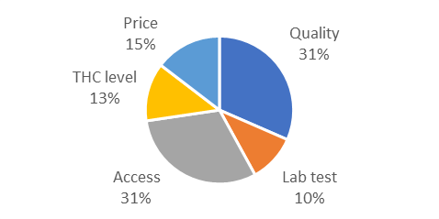  - All | 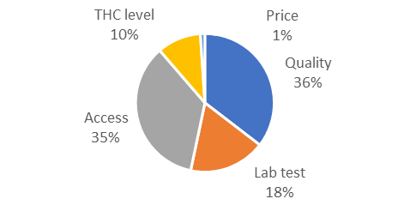  - Medical-only User
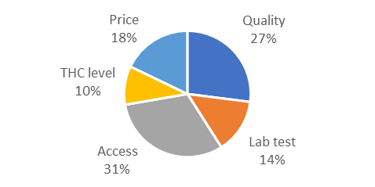  - Recreational-only User | 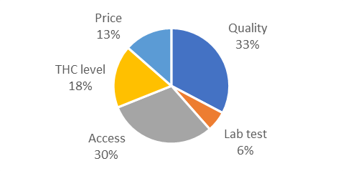  - Dual-purpose User
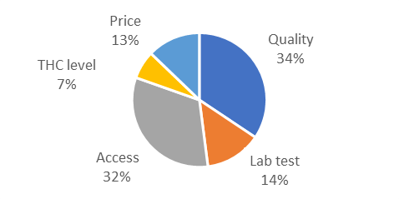  - Occasional User | 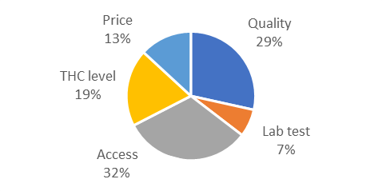  - Regular User
Notes: THC stands for Tetrahydrocannabinol.

Figure S4: Relative Importance of Attributes for Illegal Cannabis
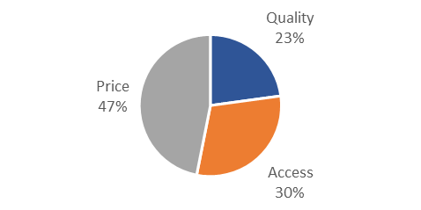  - All | 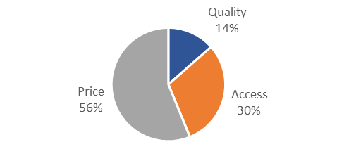  - Medical-only User
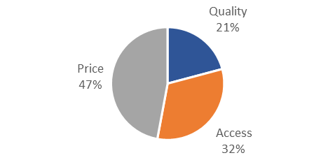  - Recreational-only User | 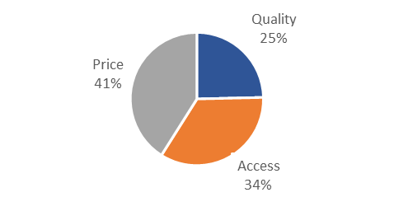  - Dual-purpose User
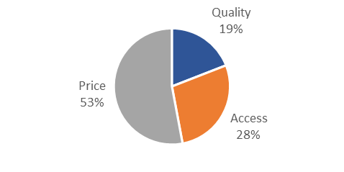  - Occasional User | 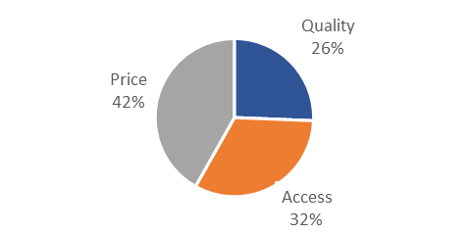  - Regular User
Notes: THC stands for Tetrahydrocannabinol.

