Appendix 4
Fig 4. Forest plot for estimated pooled risk difference comparing viral suppression among those receiving health facility based care (HFBC) and non-health facility based care (nHFBC), including results from randomized controlled trials and observational studies.

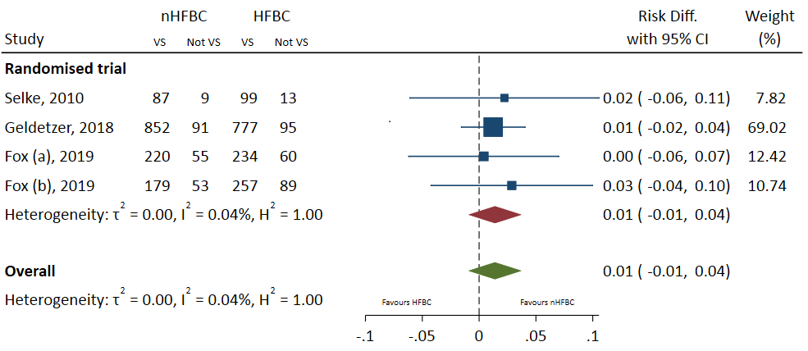

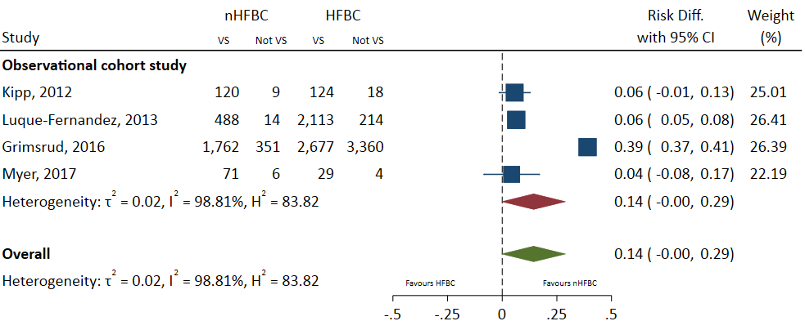

VS – virally suppressed

