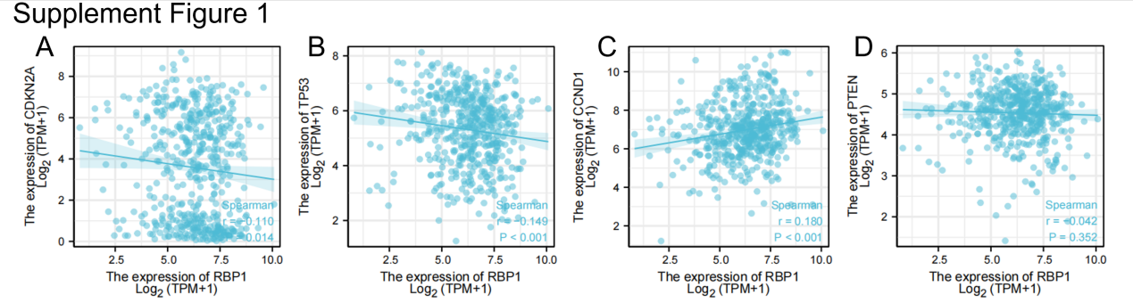
Supplement figure 1. The correlation of mRNA expression between RBP1 and HNSCC driver genes. (A) Associations between RBP1 expression and CDKN2A. (B)Associations between RBP1 expression and TP53. (C)Associations between RBP1 expression and CCND1. (D) Associations between RBP1 expression and PTEN.

